COLORADO VOTERS FOR ANIMALS
Data Entry
CVA Email Database
Our email database is stored on our website, using a platform called Nationbuilder. Here, we import all of the names, phone numbers, emails and addresses we receive from tabling events. People can also sign up for this list on our website.

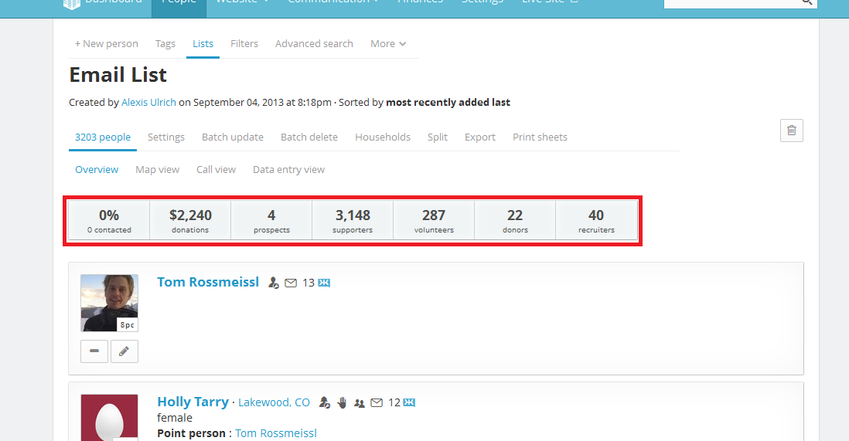
Keeping our email list online helps to keep track of how many email members we have, how many of those people are donors and how many are volunteers.

Looking up Nine-Digit Zip Codes
After any tabling event, a board member or volunteer will collect pages of names, phone numbers, addresses and emails to input into our database. This is done by typing in the information into an Excel spreadsheet, then importing the Excel spreadsheet to our online database.
First, you will need to type all of the information from the physical pages into Excel. If someone has left information blank, leave it blank in Excel. Most of the time, the person who signed up will give us their address with the five digit zip code. We need the nine-digit zip code in order for Nationbuilder to generate the person’s Federal District, House District and Senate District information.
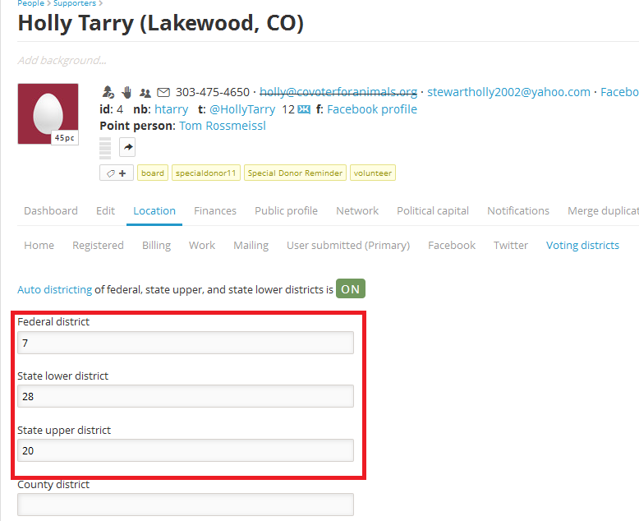By having this district information, we can send district-specific emails to groups of people.
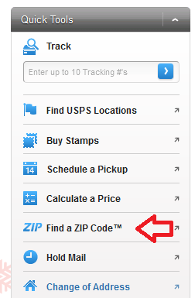
Go back to the top of your list and begin to search every person’s nine-digit zip code. To look up someone’s nine-digit zip code, go the United States Postal Service website: https://www.usps.com/
On the left hand side of the page, click on the link “Find a ZIP code”
Looking at the Excel spreadsheet you just created, find their address and type in their full address into the fields (include apartment/building, city, state, and zip code if they’ve provided it).
The USPS website will generate their nine-digit zip code. Then, type this zip code into the Excel spreadsheet with this format: XXXXX-XXXX. Save the document and go to the next person.
Zip Code Troubleshooting
What if the person didn’t provide a city/zip code?
Type in as much information as you can into the USPS Zip Code generator.
If it cannot find a location, or says you have to have a city or zip code, go to Google and type in the address. Google will find the city and zip code for you, and you can add that information into the Excel spreadsheet.
What if the USPS website says there is no such address?
Chances are the address was written down wrong or a street misspelled. Again, go to Google and type in the information you have. Google should autocorrect it for you. If there is no address, leave the zip code in its 5-digit format and move on to the next one.
What if the person didn’t provide a full address?
There is nothing we can do – skip it and move on to the next one.

