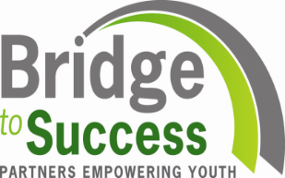
Join us for the release
Childcare Accessibility and Enrollment in Waterbury, 2016
Commissioned by The Leever Foundation
Written by Mary Buchanan, DataHaven

A report that provides information on the number of young children by zip code and neighborhood, available infant toddler and preschool childcare slots by cost and type (family, center, school based) and the relative adequacy or shortage by neighborhood.
Tuesday, September 27, 2016
3:30 P.M.
Veterans Hall, 235 Grand Street, Waterbury

RSVP by September 22nd to Director@waterburybridgetosuccess.org
or call 203-754-0040
Waterbury Bridge to Success (BTS) is a partnership of 93 local organizations and over 200 community members working together to prepare Waterbury’s youth for success from cradle to career. With a shared passion and by joining forces, local public and private organizations, families and volunteers ensure the city’s youth – from 0-21 – have access to the quality healthcare, education and support they need to become responsible adults. Together, they are building a strong bridge to connect Waterbury’s youth to a brighter future. For more information, see our website at www.waterburybridgetosuccess.org

