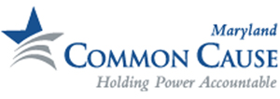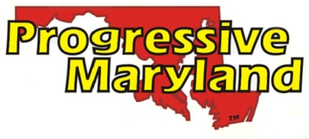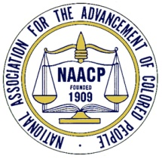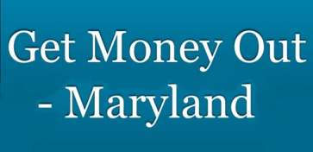

March 21, 2014
Dear Speaker Busch and Senate President Miller,

We are writing to urge you to pass SJ 6/HJ 7, “United States Constitutional Convention - Democracy Amendment”, this legislative session. Our organizations advocate for a range of progressive, good government, and civil rights issues. All of these are threatened by the flood of money in politics, a flood that has been powered by the Citizens United case and will potentially grow even worse when the Supreme Court issues its decision in McCutcheon. The problem has been further compounded by the recent action by the Supreme Court to strike down Section 5 of the Voting Rights Act and the actions in states across the country to restrict access to voting.

SJ 6/HJ 7 comprises an application to Congress under Article V of the US Constitution for a convention of the states to draft the 28th Amendment – The Democracy Amendment. It limits the scope of the convention (and what Maryland’s delegates thereto may propose) to these topics: “affirm every citizen’s individual right to vote, reject the doctrine that artificial entities have inalienable political rights, regulate campaign contributions and electioneering expenditures . . .”

Maryland and all the states are suffering because of the system of campaign contributions and outside election spending. But Maryland has an opportunity to be in the forefront of states that are responding forcefully to the crisis. The California Assembly has passed a similar amendment. Debates are taking place right now in New Hampshire, Vermont, and Illinois.

We applaud the progress made by the legislature in passing stricter campaign finance reporting laws and sending a letter to our Congressional Delegation calling for reform. Now we must take the next step and pass SJ 6/HJ 7, to force Congress to act on this critical issue.

We are confident that there is support in the House and Senate to pass this legislation. And we know that the citizens of Maryland are looking for action on this critical reform. Thank you for your leadership and for fighting for true democracy – where every voice really is equal.

Sincerely,

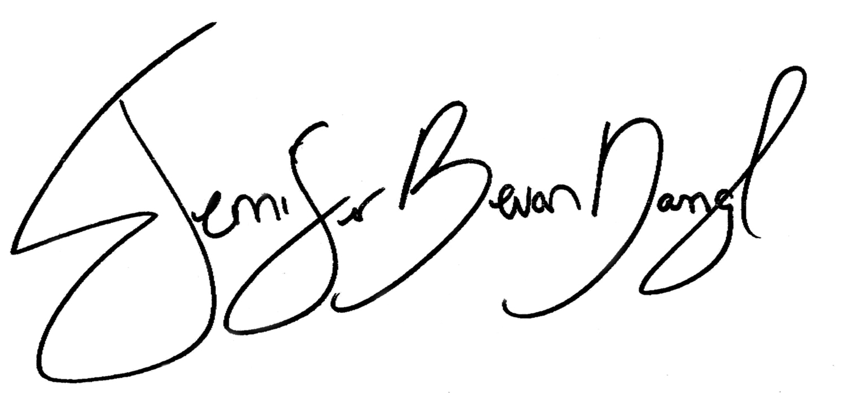
Jennifer Bevan-Dangel
Common Cause Maryland
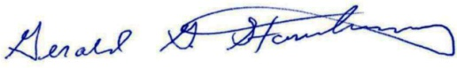
Gerald Stansbury
NAACP – Maryland State Conference

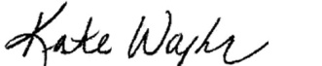
Kate Planco-Waybright
Progressive Maryland
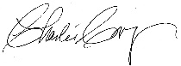
Charlie Cooper
Get Money Out - Maryland

CC: Delegate Healey, Delegate Hixson, Senator Conway, and Senator Raskin

Fact Sheet on Threats to Free and Fair Elections
March 20, 2014

- Citizens United v. FEC absolutely capsized several precedents plus dozens of state laws to say that corporations have speech rights as private citizens. Dark money rose from $91 million nationally in the 2008 election cycle to $622 million in 2012. The corruption of big money in federal politics is directly undermining Maryland’s economy.
  - Even before Citizens United v. FEC, the repeal of Glass-Steagall and regulatory laxity led directly to the real estate bubble and its bursting. Six years of Maryland structural budget deficits ensued.
  - Boehner and the Republican caucus in Congress capitulated to 30 members to contrive a government shutdown that hurt Maryland’s economy and suppressed State revenues. Why? The answer is that they are afraid of dark money challenges to sitting Republicans in Congress in the upcoming primaries.

- The Supreme Court has said in three cases (Bush v. Gore, Richardson v. Ramsey, and Alexander v. Daley) that there is no federally-guaranteed right to vote in the Constitution.
  - In 2011 alone, 14 states passed laws to restrict voting.
  - FL and TX restricted voter registration drives.
  - FL, ME, OH, and WI limited registration locations.
  - FL, GA, OH, TN, and WV restricted early voting window.
  - FL and MI have improperly purged rolls.
  - TX, SC, WI, KS and TN require photo ID.
  - FL and IA have revoked ex-felon voting rights.

- Voters are angry and cynical, but free and fair election reforms are popular with voters regardless of party.
  - In a 2012 poll by AP and Roper, 67% support limits on the amount of money individuals can contribute to campaigns for federal office, and 83% think there should be limits on the amount of money corporations, unions and other organizations can contribute to outside organizations trying to influence campaigns for federal office.
  - 79% of voters in a June 2013 Gallup Poll would vote for a law that would put a limit on the amount of money candidates for the U.S. House and Senate can raise and spend on their political campaigns.
  - Gallup also found “10% confidence in Congress – the lowest for any institution that we have tested in our Gallup Poll history.”

Only 0.08% of the households give 63% of campaign contributions. Radical, growing Income inequality and campaign finance form a vicious cycle in which only those with access to big money can get elected and legislation favors their interests.
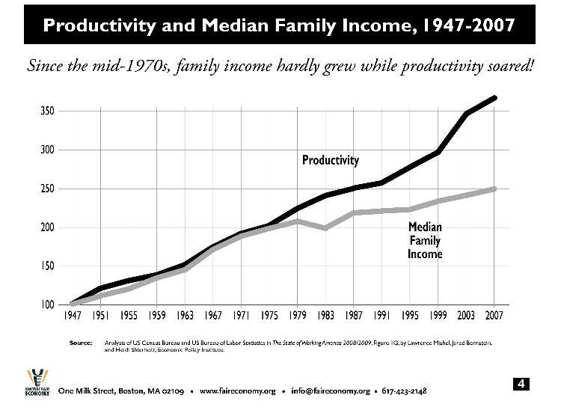
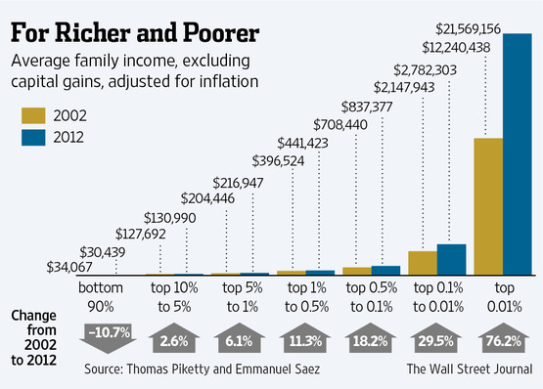
Dark money is growing at an alarming rate and may soon crowd out traditional campaign funding.
“Independent Expenditures” by Disclosure Status (Excluding Parties) – Millions of Nominal Dollars, Opensecrets.org

“Only” $6.25 billion spent in 2-year 2012 federal election cycle, but one year of corporate profits is over $3 trillion – a factor of 500-1. Money torrent has barely begun to flood the system.

