

EASTER EGG PACKAGING:
ANNUAL PROGRESS REPORT 2009

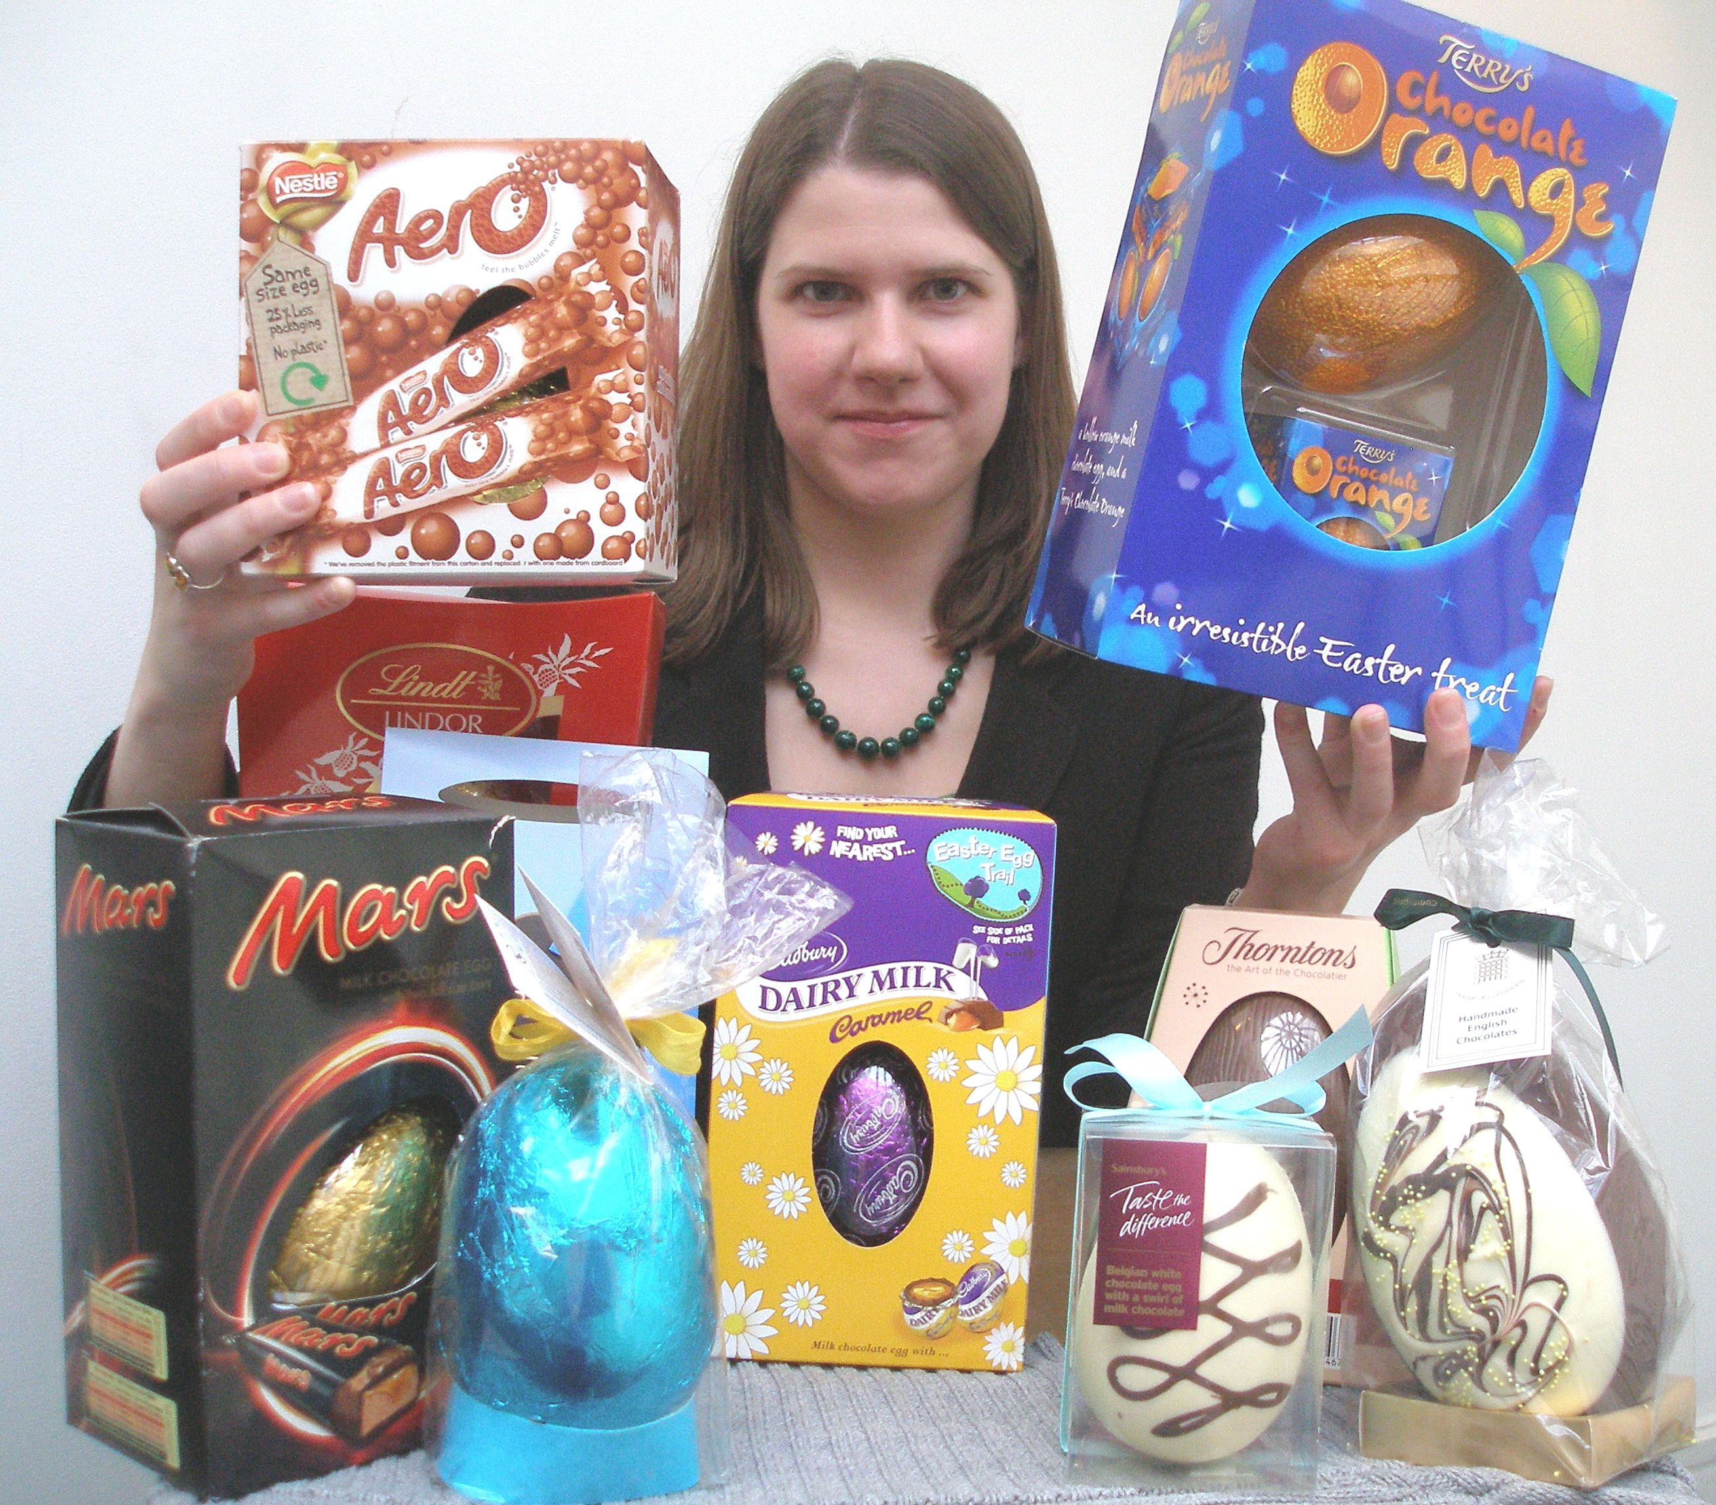

Jo Swinson MP
Executive Summary

Few would dispute that Easter eggs are a prime example of excessive packaging, and recent research has shown that 59% of British adults believe Easter eggs to be over-packaged and would like to see it reduced.

This study makes comparisons between ten Easter eggs measured in 2007, 2008 and 2009, including both major manufacturers’ products and supermarkets’ own brands. The dimensions and weights of the eggs and their packaging have been measured, and the packaging material examined and environmental information recorded.

The study has found:

- Companies have reduced the weight of their Easter egg packaging by an average of 33.5% compared to last year.

- Nestlé and Green & Black’s have all taken the initiative of removing all plastic from their packaging and replacing it with cardboard, which is more widely recycled.

- Thorntons and Green & Black’s have also redesigned their boxes creatively to use less cardboard, moving away from the standard cuboid box.

- Considerable improvements have been made in the amount and detail of environmental information included on Easter egg packaging.

- Several companies advertise their packaging reductions prominently in their marketing campaigns, suggesting they believe this is important to consumers.

- Lindt has maintained its title for a third year running as the company whose packaging is the most excessive, with an Easter egg which takes up only 9% of the volume of the packaging.

- Sainsbury’s, Terry’s, Cadbury and Green & Black’s eggs all produce no landfill waste.

- While Marks & Spencer have reduced their packaging by removing cardboard, they have replaced it with plastic wrapping which is not recyclable, thereby increasing landfill waste.

- The manufacturer who showed the most improvement on last year was Nestlé, and the one who showed least improvement was Terry’s, whose packaging has actually increased since 2008.

- The average total weight of packaging for an Easter egg was 84g in 2007 and 82.6g in 2008, but shrunk to 45.7g this year.

Background

As environmental concerns have increasingly become a part of our everyday lives, people in Britain are becoming more and more aware of the effect the products we consume, and their packaging, may have on our surroundings. Easter eggs provide some of the worst examples of excess packaging that can be found on supermarket shelves. That is why, since 2007, I have carried out an annual study of packaging produced by a broad range of Easter egg manufacturers.

The 2007 report uncovered some bad cases of excess, with one egg taking up just 9% of the volume of the total package, and most using three different types of packaging material and lacking clear guidance on recyclability. Some improvements were noted in the 2008 report, particularly in the amount and detail of recycling information printed on the packaging, but there was little evidence that most manufacturers had taken seriously the need to cut down on the amount of packaged they were using.

According to WRAP, over 92% of the UK grocery market has signed up to the DEFRA-brokered Courtauld Commitment, which aims to deliver absolute reductions in packaging waste by 2010. Of the manufacturers surveyed here, Marks & Spencer, Sainsbury's, Cadbury, Mars and Nestlé have all signed the agreement. In 2008, the first target was met, which was to design out packaging waste growth. Last year, despite an increase in sales, there was no growth in the amount of packaging waste produced in the UK. We can do more, however, by not just eliminating growth but actually decreasing the amount of waste we produce. Moreover, it is not only waste which must be reduced – even the packaging we recycle takes energy to produce, transport and recycle, so the more we can reduce it the better.

The Courtauld Commitment is a voluntary agreement, but manufacturers are also bound by EU laws which have been introduced into UK legislation. In UK law, the responsibilities of manufacturers are laid out in the Producer Responsibility Obligations (Packaging Waste) Regulations 1997 (as amended) and the Packaging (Essential Requirements) Regulations 2003.
The Producer Responsibility Obligations (Packaging Waste) Regulations oblige businesses with an annual turnover over £2million who handle more than 50 tonnes of packaging per year to register with the Environment Agency or a compliance scheme. They must recover specified amounts of packaging, certify that their obligations have been met and, if they are retailers, inform consumers of how they are increasing recovery and recycling.
The Packaging (Essential Requirements) Regulations require all packaging put on the market to meet certain minimum standards, including:
- Packaging should be designed such that its volume and weight be limited to the minimum amount necessary for safety, hygiene and acceptance by consumers.
- Packaging should be designed and produced to permit its reuse or recovery, including recycling, and to minimise the impact on the environment of any waste.
- Packaging should be designed to minimise the levels of hazardous substances which may cause damage to the environment when the packaging is incinerated, put in landfill or otherwise disposed of.
However, as a study I conducted last year revealed, the Trading Standards Offices who are expected to enforce these regulations are woefully under-equipped to do so, with the result that only four prosecutions have taken place since this legislation was introduced.

Each year, DEFRA sets recycling and recovery targets for businesses, which set out how much of each type of packaging material must be recovered. However, Friends of the Earth argues that these targets are not high enough to tackle the problem of climate change by prompting businesses to redesign their packaging. Having producer responsibility measures in place means that government has the power to oblige producers to make their products recyclable, but without raising our targets this will have little impact. For example, while the government’s target for plastic recycling is set to increase by 2% each year until 2012, Friends of the Earth estimate that a 5% annual increase is needed to make a significant difference. In addition, setting targets for recovery is not always helpful, as recovered materials may be burned, which often has negative impacts on the environment. Obliging companies to recycle more of their recovered packaging would do much more to reduce greenhouse gas emissions.

Clearly, excess packaging and the need for recycling is not just an issue with Easter egg packaging, but one which affects many of the products we buy every day. I have chosen Easter eggs as they present some of the most obvious examples of over-packaging in the food industry, and their annual appearance on supermarket shelves provides a good opportunity to review what progress has been made in the year gone by.

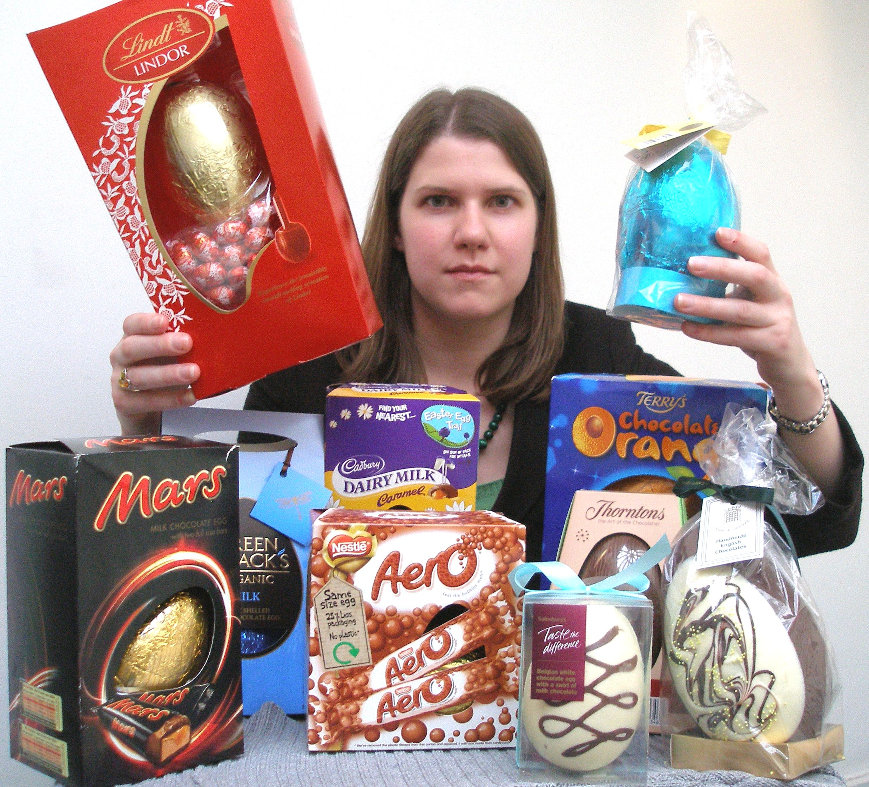

Results

This year, it is clear that some of the biggest chocolate manufacturers have made efforts to reduce the amount of packaging included with their Easter eggs. No doubt the economic downturn has caused businesses to look for ways to cut their costs, and reducing packaging is one way of doing that. However, several manufacturers have made their reduced packaging an integral part of their marketing campaigns, which suggests that they also believe that consumers care about the issue of excess packaging.

Packaging Reduction Plans & Marketing

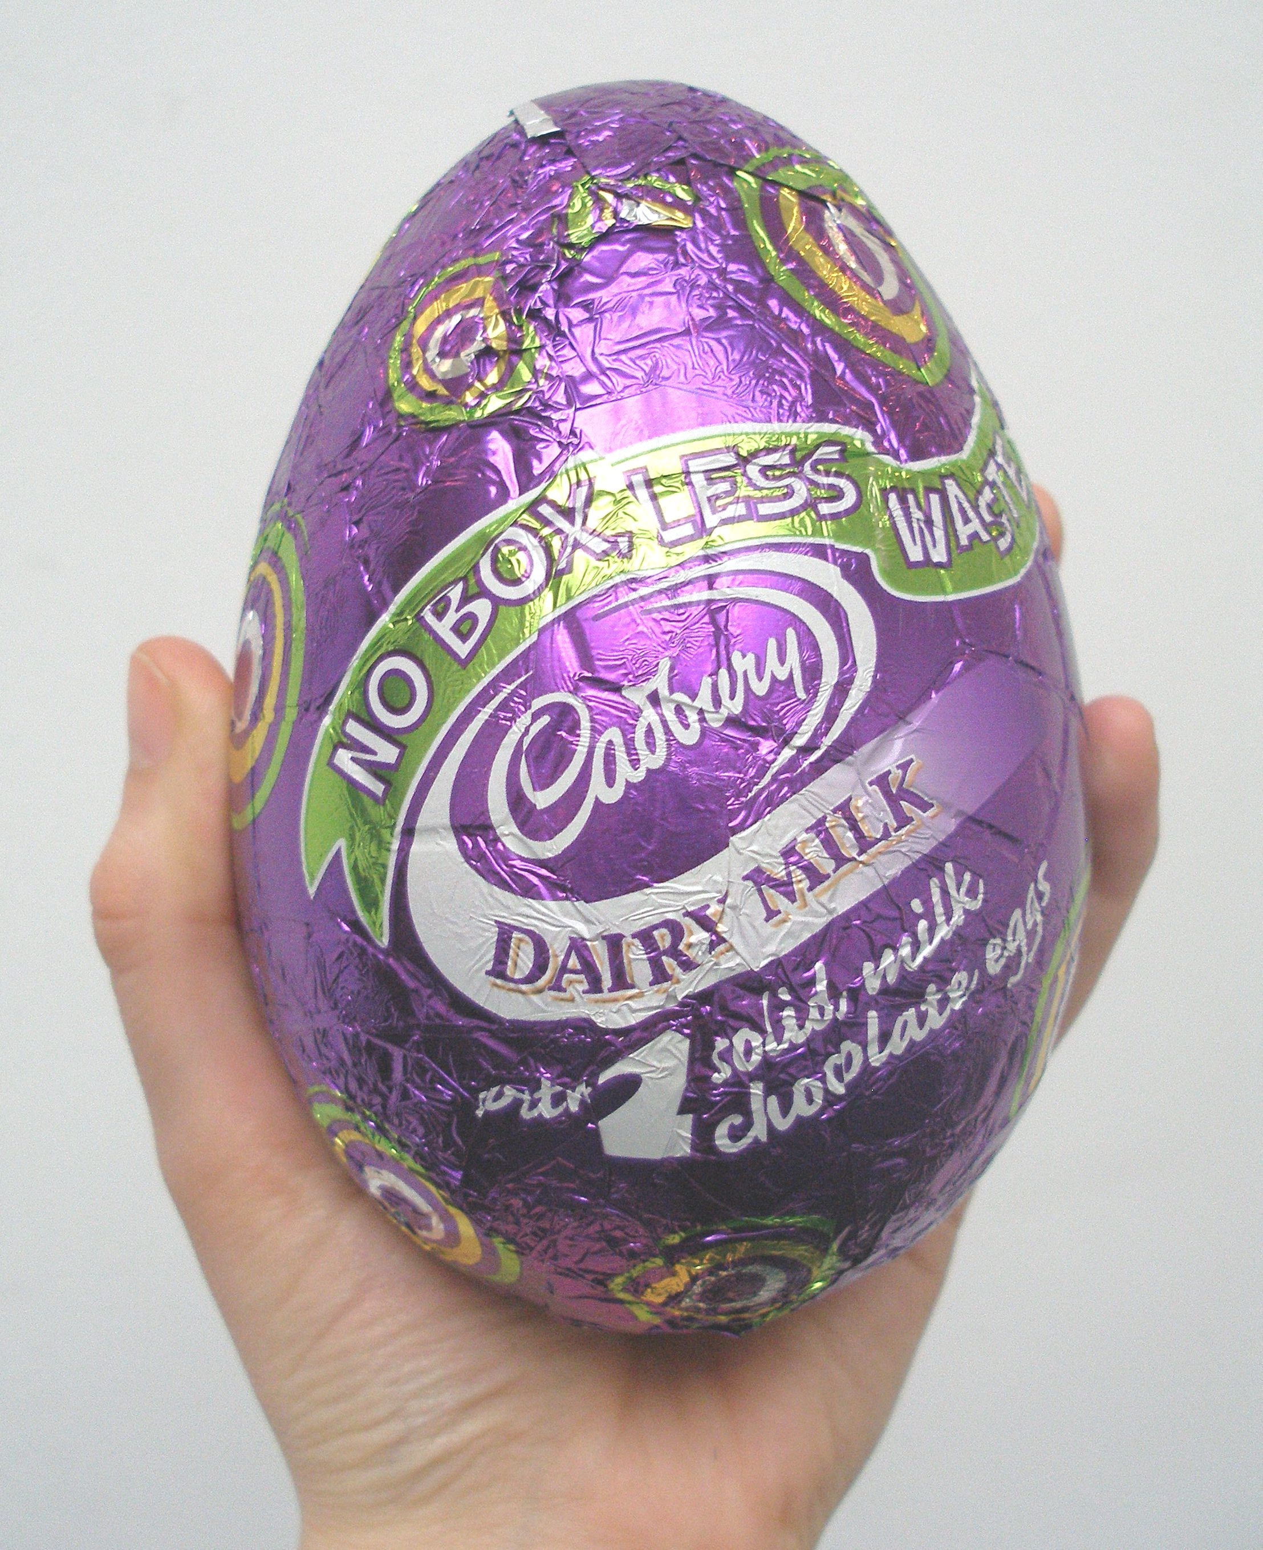
Signs alongside Cadbury’s Easter eggs on supermarket shelves advertise that their medium and large egg ranges use 20% and 30% less packaging respectively. This forms part of Cadbury’s ‘Purple Goes Green’ initiative launched in July 2007, which commits them to a 25% reduction in packaging for seasonal goods by 2020. Last year, Cadbury launched their ‘Eco Eggs’ (left); eggs with only foil wrapping which contain additional chocolates inside the egg. Cadbury claim the eggs represent a reduction of over 75% plastic and 65% cardboard than was previously used. I noted in last year’s report that none of the stores I visited to purchase the eggs actually stocked Eco Eggs, although 2.3 million were sold. Happily this year they are more widely available (Cadbury expects to sell 4.5 million) and I was able to buy one. However, as Eco Eggs still make up a minority of Cadbury’s eggs, I have measured one of their usual medium-range boxed eggs in this study.

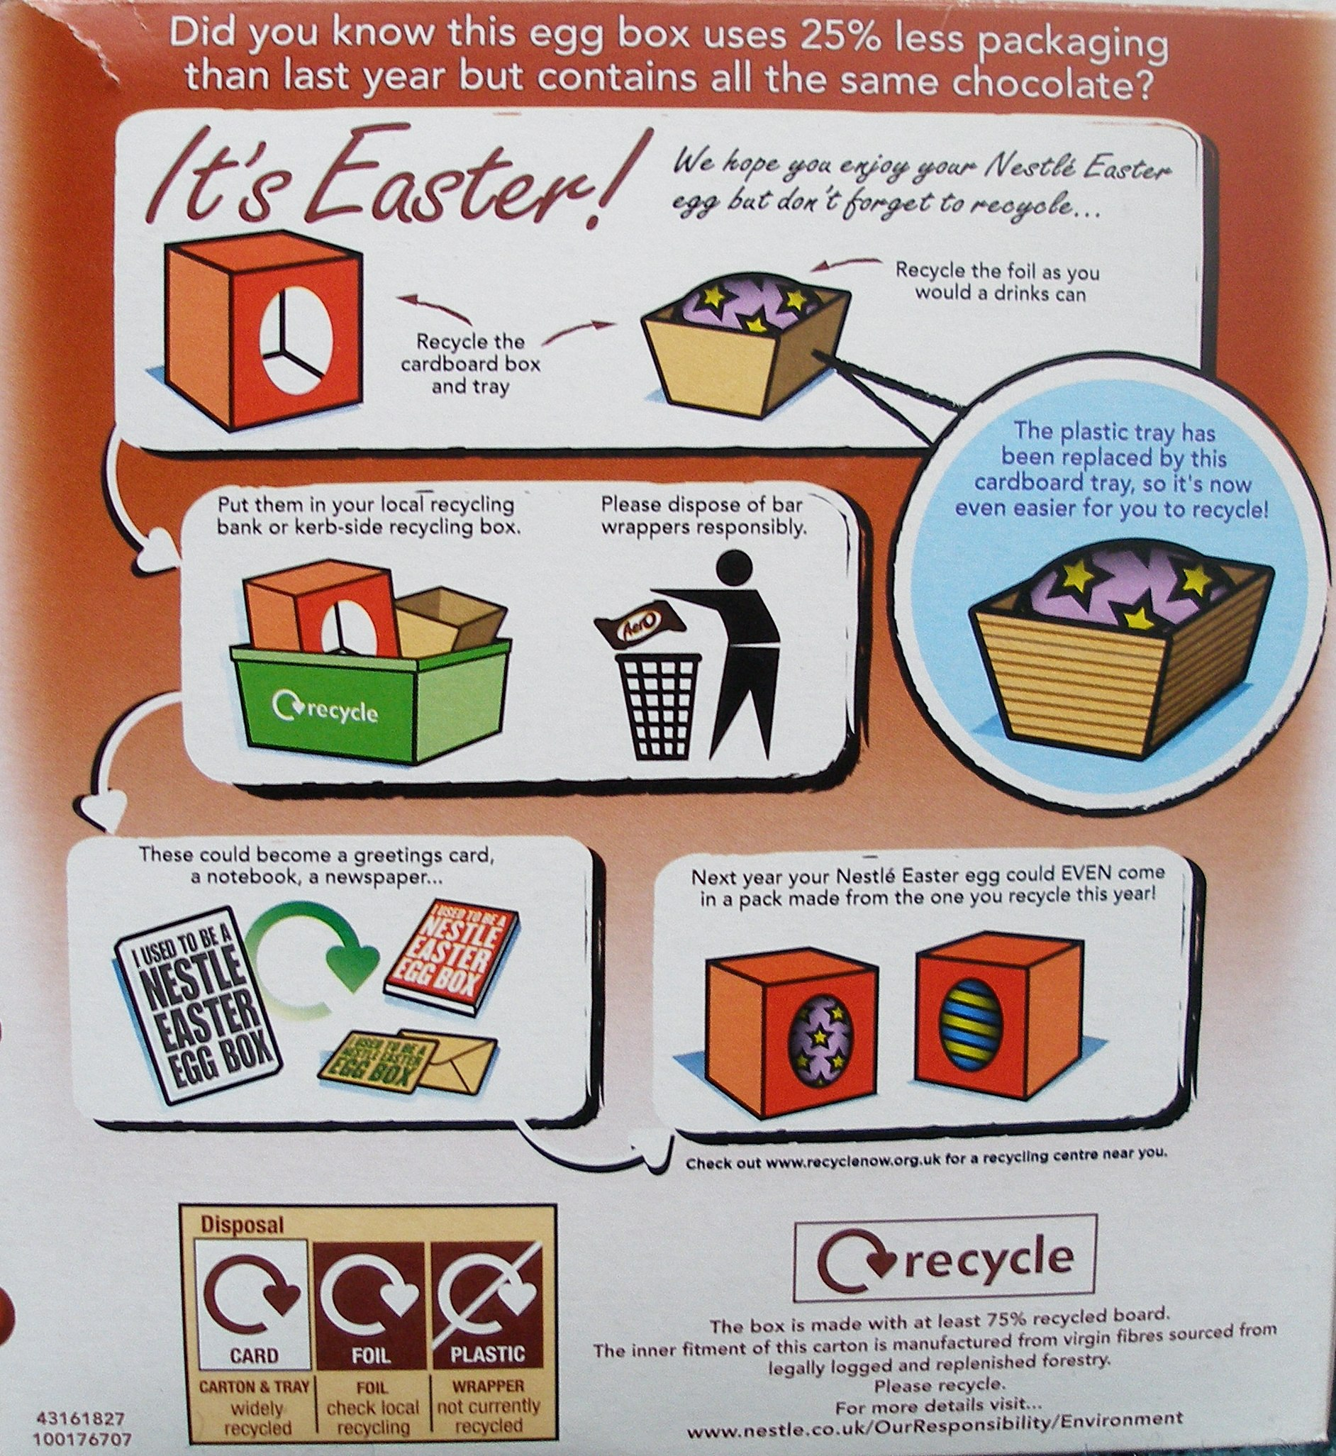
Nestlé this year is advertising on the Easter egg packaging itself (right) that it is the “same size egg, 25% less packaging, no plastic” and carries the Recycle Now logo prominently on the front. Nestlé aims to reduce its packaging by 10% by 2010, from a 2006 baseline. Nestlé contacted me in December to explain the measures it has taken this year to reduce its packaging, which it claims it has reduced by 700 tonnes this Easter compared to last year. They told me that the new packaging range was shown to a number of consumer groups, who welcomed the reduction in packaging and found the new card ‘basket’, which has replaced plastic in the medium-range egg boxes examined here, to be “significantly more environmentally friendly and more gift-worthy.” The cardboard is 100% recycled, and where plastic is used, it is now made from recycled drinks bottles. When I asked why plastic is still used to package some of the eggs and not others, Nestlé told me that 20% of them still use plastic because they are heavier as they contain other items such as mugs or money boxes. They are working on a technical solution which would allow them to avoid using plastic for these in future. Nestlé’s promotional material also makes the important point that reducing packaging also means more efficient transportation of Easter eggs, which has meant 440 fewer planned trailer-loads of eggs to be transported this year.

Thorntons claim to have saved 73 tonnes of packaging across its Easter range this year through an overall reduction of 22%, and have also incorporated this into their marketing strategy, including statements about reduced packaging on the front of the egg boxes. According to their website, Green & Black’s are currently working on their packaging policy to produce targets for reduction, but in the meantime the site gives detailed information on the environmental credentials of the packaging for each product.

Supermarkets are also sitting up and taking notice, and waste reduction plans by Sainsbury's and Marks and Spencer are reflected in their high performances in this study.

Other companies do not appear to be taking the issue as seriously: Lindt’s website reveals no information about packaging or environmental initiatives, which comes as no surprise given that their Easter eggs are the most over-packaged products surveyed in this study. Terry’s (part of Kraft Foods), also have no information on their website about efforts to reduce packaging, and the inefficiency of their Easter egg packaging this year suggests this is not an issue of great concern to them.

Last year’s report stated that:

“Packaging disposal is one of the great frustrations of modern consumers, which is why more responsibility must be placed on supermarkets to dispose of unwanted packaging material. By providing waste points in-store, consumers could deposit unwanted packaging before leaving, making it the responsibility of supermarkets to get rid of packaging that is both unnecessary and unwanted.”

After the report was published, Nestlé and Sainsbury’s launched a pilot scheme in which special Easter egg packaging bins for both cardboard and plastic were placed outside Sainsbury’s stores for a period of three weeks after Easter. This marks a clear intention on the part of both companies to address the need for producers to provide help to consumers in disposing of packaging. However, in order to make this an integral part of our everyday shopping experience, supermarkets must look at providing such facilities all year round, to accommodate the many different kinds of packaging purchased there, and not just seasonal goods.

Direct Comparisons

Easter egg | Change in packaging 2008-2009
Mars | Volume of cardboard box reduced by 33%. Now includes instructions on how to recycle packaging.
Green & Black’s | Volume of cardboard box reduced by 5%, and plastic inner tray removed. The egg is in a triangular prism-shaped cardboard box, which uses 49% less cardboard (by weight) than last year’s cuboid box.
Lindt | The egg still takes up only 9% of the volume of the box, the same as 2007 and 2008. No significant improvement in recycling information.
Cadbury | Volume of cardboard box reduced by 34%. No significant improvement in recycling information.
Sainsbury’s | Same materials as last year (just a clear plastic box). Egg takes up 53% of the volume of the box, down from 58% last year, but both egg and box are smaller than last year, so 4g less plastic is used.
Marks & Spencer | Cardboard box has been removed, replaced with a thin plastic wrapper and small cardboard base. Less packaging is used but the plastic is not recyclable whereas the cardboard box was. Now carries the Forest Stewardship Council logo.
Terry’s | Egg now takes up only 11% of the volume of the box, down from 13% last year. The volume of the box has increased by 36% to accommodate a 16% bigger egg. Total weight of the packaging has increased by 39%, using more cardboard and more plastic than last year. Chocolate orange bars have been replaced by a Terry’s Chocolate Orange, which is inside its own box insider the bigger box. No longer says what percentage of the packaging is recycled, but plastic is still made from post-consumer recyclate.
Nestlé | Volume of cardboard box reduced by 60% and plastic tray removed. Egg now takes up 22% of the volume of the box, up from 9% last year. Much more detailed recycling information.
Thorntons | The box has been made in a triangular prism shape this year which uses 61% (42g) less cardboard than last year’s box. The egg now takes up 45% of the volume of the box, up from 24% last year. Environmental information is provided on the packaging this year, which uses 50% recycled plastic.
House of Commons | No significant change from 2008 packaging.

Notes on results above:
The eggs measured represent medium-range products, though an extensive range of larger and smaller eggs were also available. The eggs used above are the closest direct equivalent to those measured in 2007 and 2008. In some cases, direct equivalents were no longer available. For example, Cadbury’s Dairy Milk eggs do not belong to the medium-sized range this year, so Cadbury’s Dairy Milk Caramel was used instead.
2009 League Table

Rank | Highest volume of egg to volume of packaging ratio (2008 rank) | Highest weight of edible contents to total weight (2008 rank) | Most overall improvement | Landfill waste
1 | Marks & Spencer (3)  House of Commons (1) | Marks & Spencer (2)  House of Commons (1) | Nestlé | None:  Green & Black’s, Sainsbury’s, Terry’s, Cadbury
2 |  |  | Green & Black’s | None:  Green & Black’s, Sainsbury’s, Terry’s, Cadbury
3 | Sainsbury’s (2) | Thorntons (4) | Thorntons | None:  Green & Black’s, Sainsbury’s, Terry’s, Cadbury
4 | Thorntons (4) | Sainsbury’s (3) | Mars | None:  Green & Black’s, Sainsbury’s, Terry’s, Cadbury
5 | Mars (6) | Green & Black’s (9) | Cadbury | None:  Green & Black’s, Sainsbury’s, Terry’s, Cadbury
6 | Nestlé (9) | Cadbury (4)  Nestlé (10) | Sainsbury’s | Some:  Mars, Lindt, Marks & Spencer, House of Commons, Nestlé, Thorntons.
7 | Green & Black’s (5)  Cadbury (7) |  | Marks & Spencer
8 |  | Mars (6) | Lindt  House of Commons
9 | Terry’s (7) | Terry’s (7)
10 | Lindt (9) | Lindt (8) | Terry’s

Notes on results above:
The ‘most overall improvement’ is based on a combination of reductions in packaging, improvements in recyclability and improvements in environmental information. The ranking is based on a subjective judgement of the combination of these factors and not a precise weighting. In the ‘highest volume of egg to volume of packaging ratio’ column, the volume of the egg has been used rather than the volume of all edible contents because in most cases the other contents could be put inside the egg, as it has been in the cases of Cadbury’s Treasure Eggs, Marks & Spencer, House of Commons and Thorntons.
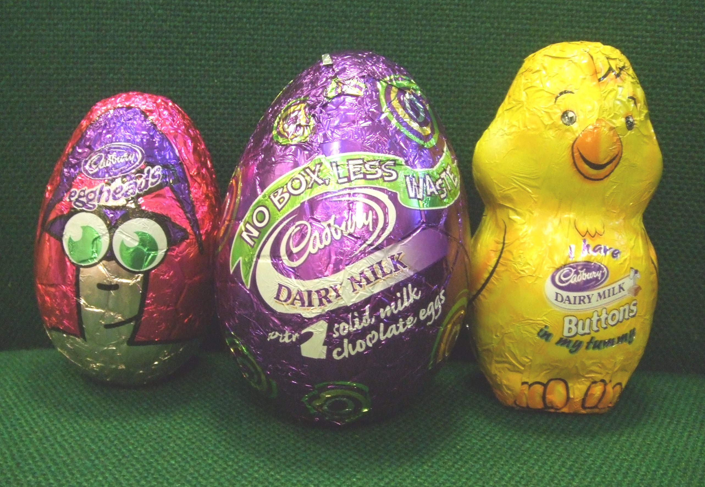
Cadbury also deserves an honourable mention as its Eco Eggs use less packaging than any other eggs measured here. Cadbury’s rank in this league table is based on measurements for its medium-range eggs, however, because the boxless Eco Eggs (including Treasure Eggs, Eggheads and Chicks, pictured on the right) still only make up approximately 20% of its total Easter egg production.

Round-up of Results

Sainsbury’s Easter egg was praised in last year’s report for using only a clear plastic box around the egg, which takes up 58% of its volume. This year the egg takes up slightly less space (52%), but it is still the 3rd most efficient in that respect. Although Marks & Spencer beat that this year with an egg that takes up 100% of the volume of the packaging, it did this by using cellophane wrapping, which is not currently recyclable. Therefore, Sainsbury’s still comes out better because even if it has more packaging, it is recyclable and so nothing ends up in landfill.

The Marks & Spencer egg, which was praised last year for reducing the amount of cardboard used, has got rid of the cardboard box entirely this year, instead sitting the egg on a small cardboard base. However, the foil wrapping which was removed in 2008 has returned in 2009, along with plastic wrapping which, unlike the cardboard, is not recyclable. This is a good example of the kind of trade off sometimes made between reducing the total amount of packaging and ensuring that which is used is recyclable. M&S continues to set a good example, however, by packing the additional chocolates inside the egg rather than separately.

The worst offender for the past two years has been the Lindt egg, which took up just 9% of the volume of the packaging in both years. There is no evidence that Lindt has made any effort to reduce its packaging this year, as this ratio has remained constant at 9%, meaning the Lindt egg maintains its title for the third year running as the worst example of packaging in the survey. As in previous years, there is also no recycling information printed on the packaging.

The other poor performer this year is Terry’s, who have expanded their packaging to accommodate a Terry’s Chocolate Orange, which is packaged in its own foil, plastic and cardboard inside the bigger box. If it wasn’t in its own box, the Chocolate Orange could easily have been put inside the egg. Terry’s are also the only manufacturer to include less environmental information on the box in 2009 than they did in 2008. However, despite the large amount of packaging, it is all recyclable and so no landfill waste is produced.

Last year’s report criticised Nestlé for having increased the size of their packaging since 2007. Happily, this year Nestlé have clearly made efforts to reduce their packaging, now ranking in 6th place for the egg taking up 22% of the volume of the box, up from joint last place with Lindt last year. All plastic has been removed, meaning only recyclable (and 75% recycled) cardboard is used, and the environmental information on the box has been vastly improved.

Major chocolate manufacturers Mars and Cadbury were criticised in last year’s report for having made no effort to reduce their packaging. This year, both have reduced the size of their cardboard boxes. The Mars egg now includes recycling instructions, whereas the Cadbury egg still does not. There is still significant room for improvement for both Mars and Cadbury eggs, which take up just 23% and 17% of their respective boxes.

Many of the manufacturers have improved again on the amount of environmental information shown on the packaging. This includes information on how much of the packaging is made from recycled materials, the source of those materials (e.g. whether cardboard comes forests managed in a sustainable way), instructions on how to recycle the packaging, and the organic credentials of the chocolate itself. Nestlé in particular have improved drastically in this respect, and now devote the whole of the back of the box to recycling information.

Conclusions

From 2008 to 2009, there has been a noticeable improvement in efforts by producers to significantly reduce the amount of packaging on Easter eggs.

While there are still cases of small eggs being housed inside the big, attention-grabbing boxes I noted last year, many producers, including major ones such as Nestlé and Cadbury, have clearly given thought to the issue of excess packaging and begun to make adjustments.

On average, Easter eggs in 2009 took up 39.7% of the volume of their packaging compared to 29.4% last year, which is a significant improvement. The average total weight of packaging for an Easter egg last year was 84g in 2007 and 82.6g in 2008, but shrunk to 45.7g this year. The overall trend is positive, with the average Easter egg reducing the weight of its packaging by 33.5% on last year. There is still room for improvement, however, as even the products whose packaging has been reduced this year still contain empty space which could be squeezed out to make them even more efficient. Referring back to the Packaging (Essential Requirements) Regulations, which require producers to limit the volume and weight of packaging to the minimum amount necessary, even with the improvements I have recorded this year much of the packaging could not be described as the “minimum necessary”.

Last year I reported an overall improvement in the environmental information provided on packaging, and this year some further improvements have been made. In 2008, only 4 out of 10 of the eggs surveyed carried information on whether the packaging material was recycled, while this year 5 out of 10 do so. Five out of 10 also give instructions for recycling the packaging, whereas only 1 out of 10 did so last year. Following WRAP’s campaign to improve recycling information, there appears to be a trend from simply stating ‘Please recycle’ to indicating which materials are likely to be collected for recycling by local councils and which may need to be taken to a local recycling centre. This is certainly a positive step forward, although there is plenty of room for improvement as there are still no instructions on 50% of the eggs surveyed. Going forward, the emphasis needs to be not just on reducing packaging, but also ensuring it is recyclable, as 6 out of 10 of the products surveyed here still use some materials which will end up in landfill.

Appendix: Research Tables

Descriptive & environmental information

Brand of Easter egg | Price of product (£)* | Description of packaging | Environmental information on packaging
Mars | £1.99 | Card box, plastic inner tray, foil-wrapped egg, 2x Mars bar | Green dot logo.  100% recycled cardboard.  “This carton is fully recyclable and can be disposed of at your local recycling centre or placed in your domestic recycling collection box. To recycle the foil and plastic insert please ask your local recycling centre for details.”
Green & Black’s | £4.99 | Card box, foil-wrapped egg, small card w/ ribbon string | Green Dot logo  Soil Association Organic Standard logo  Forest Stewardship Council logo.  “The card we use to create our perfectly formed eggs is created from forests that have been sustainably managed – where the same care is taken to harvest and replant trees as it is to create our chocolate, but we haven’t stopped there; this Easter we have also removed the plastic from our packaging. Truly Green and Beautiful. We’ve taken time and care over our chocolate and packaging – we’d love you to do the same. Please recycle this pack.”
Lindt | £6 | Card box, plastic inner tray, foil-wrapped egg, foiled wrapped mini eggs in plastic packet | Green Dot logo.  No other recycling information.
Cadbury’s | £2 | Card box, plastic inner tray, foil-wrapped egg, 2x mini foiled wrapped eggs | Green Dot logo  Recycling logo.  No other recycling information.
Sainsbury’s | £2 | Clear plastic box, ribbon | Marked as 1-PET  Recycling logo  “Most councils will collect this for recycling.”
Marks & Spencer | £5.25 | Plastic wrapper on card base, foil-wrapped egg, small card, ribbon, 8 small plastic-wrapped eggs | Forest Stewardship Council logo (mixed sources).  “Paper: widely recycleable  Foil: check local recycling  Plastics: not currently recyclable”
Terry's | £5 | Card box, plastic inner tray, foil-wrapped egg, chocolate orange foil wrapped in plastic inner tray and card box | Large section on side of box for recycling information.  Forest Stewardship Council logo.  “Foil: 100% recyclable. Most councils will collect this for recycling.  Carton: 100% recyclable. Board made from managed, sustainable forests. Most councils will collect this for recycling.  Plastic insert: 100% recyclable. Most councils will collect this for recycling.  rPET: Plastics made from post consumer recyclate (PCR).”  Suggests checking Recycle Now website to find the nearest recycling facility.
Nestlé | 99p | Card outer, card inner tray, foil-wrapped egg, 2x chocolate bars | Whole back of box is dedicated to recycling information.  “The box is made with 75% recycled board. The inner fitment of this carton is manufactured from virgin fibres sourced from legally logged and replenished forestry. Please recycle.”  “Card: widely recycled  Foil: check local recycling  Plastic wrapper: not currently recycled.”
Thorntons | £4.99 | Card box, plastic inner tray, 6x mini eggs in plastic packet | Forest Stewardship Council logo  Paper recycling logo  Plastic 1-PET  “The fitment is made from 50% recycled plastic”  “40% less packaging, 100g more chocolate compared to 175g Classic Egg 2008”  “We would love you to recycle this packaging. For more guidance visit www.recyclenow.com”
House of Commons | £11 | Egg in plastic wrapper on card base, chocolates in plastic packet, white paper inside the egg | No recycling information.

Notes on results above:
- Prices indicated are those paid for eggs though not necessarily the RRP of the eggs. Eggs were paid for personally by Jo Swinson MP.
- The Green Dot logo has no meaning in the UK, however it is printed on products which are exported to European member states implementing EC Directive 94/62/EC 1994, which sets recovery and recycling targets for those states.
- The recycling logo indicates that a product is recyclable.
- The Forest Stewardship Council logo indicates that the product has met FSC criteria for meeting the “social, economic, ecological, cultural and spiritual needs of present and future generations.”
- 1-PET is a recyclable plastic.
- rPET is recycled plastic which is also recyclable.

Weight measurements of Easter eggs

Brand of Easter egg | Weight of total product (g) | Weight of total packaging (g) | Weight of card packaging (g) | Weight of plastic packaging (g) | Weight of chocolate egg (g) | Weight of other contents (g)
Mars | 304 | 63 | 43 | 20 | 124 | 115
Green & Black’s | 224 | 38 | 38 | 0 | 184 | 0
Lindt | 322 | 106 | 60 | 46 | 118 | 99
Cadbury | 261 | 52 | 35 | 17 | 128 | 81
Sainsbury’s | 122 | 18 | 0 | 18 | 102 | 0
Marks & Spencer | 237 | 5 | 3 | 2 | 176 | 54
Terry's | 420 | 118 | 72 | 46 | 126 | 178
Nestlé | 293 | 64 | 64 | 0 | 171? | 62
Thorntons | 347 | 52 | 27 | 25 | 213 | 83
House of Commons | 567 | 12 | 7 | 5 | 440 | 108
Average | 309.7 | 52.8 | 34.9 | 17.9 | 156.9 | 78

Dimensions of Easter eggs

Brand of Easter egg | Height of packaging (mm) | Width of packaging (mm) | Depth of packaging (mm) | Height of chocolate egg (mm) | Width of chocolate egg (mm) | Circumference of chocolate egg (mm)
Mars | 215 | 125 | 95 | 130 | 80 | 285
Green & Black’s | 235 | 133 | 110 | 131 | 85 | 290
Lindt | 300 | 162 | 93 | 121 | 75 | 260
Cadbury | 215 | 125 | 95 | 132 | 85 | 290
Sainsbury’s | 118 | 85 | 75 | 115 | 85 | 267
Marks & Spencer | 130 | 90 | 90 | 130 | 90 | 300
Terry's | 275 | 185 | 105 | 135 | 90 | 285
Nestlé | 162 | 151 | 95 | 130 | 91 | 285
Thorntons | 185 | 113 | 67.5 | 115 | 100 | 330
House of Commons | 175 | 110 | 110 | 175 | 110 | 360
Average | 201 | 128 | 94 | 131.4 | 89.1 | 295.2

Volume and relative measurements of Easter eggs

Brand of Easter egg | Volume of packaging (ml) | Volume of chocolate egg (ml) | % weight of edible contents to total weight | % of volume of egg to packaging | Any landfill waste?
Mars | 2553 | 590 | 79% | 23% | Chocolate bar wrapper
Green & Black’s | 3438 | 580 | 82% | 17% | No
Lindt | 3718 | 350 | 67% | 9% | Plastic sweet wrapper
Cadbury | 2553 | 430 | 80% | 17% | No
Sainsbury’s | 752 | 400 | 84% | 53% | No
Marks & Spencer | 500 | 500 | 97% | 100% | Plastic sweet wrapper
Terry's | 5341 | 580 | 72% | 11% | No
Nestlé | 2324 | 500 | 80% | 22% | Chocolate bar wrapper
Thorntons | 1655 | 750 | 85% | 45% | Plastic sweet wrapper
House of Commons | 1210 | 1210 | 97% | 100% | Plastic sweet wrapper
Average | 2404 | 589 | 82.3% | 39.7%

Comparisons over time

Brand of Easter egg | 2007  % weight of edible contents to total weight | 2008  % weight of edible contents to total weight | 2009  % weight of edible contents to total weight | 2007  % of volume of egg to packaging | 2008  % of volume of egg to packaging | 2009  % of volume of egg to packaging
Mars | 75% | 73% | 79% | 16% | 16% | 23%
Green & Black’s | 63% | 64% | 82% | 18% | 17% | 17%
Lindt | 70% | 69% | 67% | 9% | 9% | 9%
Cadbury | 75% | 77% | 80% | 14% | 13% | 17%
Sainsbury’s | 85% | 82% | 84% | 100% | 58% | 53%
Marks & Spencer | 72% | 83% | 97% | 14% | 35% | 100%
Terry's | 67% | 70% | 72% | 14% | 13% | 11%
Nestlé | 73% | 57% | 80% | 16% | 9% | 23%
Thorntons | 75% | 77% | 85% | 27% | 24% | 45%
House of Commons | 96% | 96% | 97% | 100% | 100% | 100%
Average | 75.1% | 74.8% | 82.3% | 32.8% | 29.4% | 39.8%

