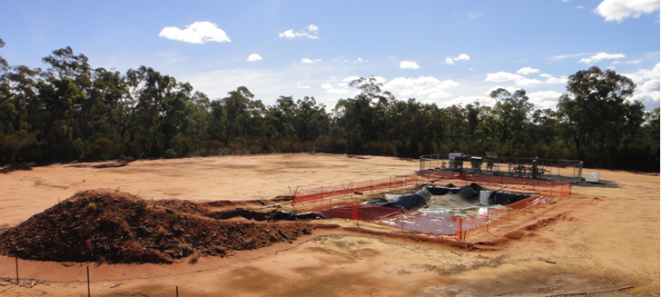

THE FIGHT TO PROTECT OUR LAND, WATER AND COMMUNITIES FROM DESTRUCTIVE MINING AND GAS DEVELOPMENT IS ABOUT TO GET HARDER

The NSW Government has recently released draft legislation that will make it even harder for local communities to take a stand against coal mining and coal seam gas proposals.

If passed, the Planning Bill 2013 will make sweeping changes to the planning system, including removing the principles of ecologically sustainable development and restricting the community’s right to challenge unlawful development approvals in the courts.

This is the most significant backward step on public participation and environmental protection in more than a generation. This is worse than Part 3A.

TAKE ACTION: Register today for a crucial community lobby day on 20 August. Residents from across NSW will be meeting with MPs to call for protection of our land, water and communities and demanding the O’Farrell Government strengthen, not weaken, community rights in the new planning laws. ; law. Join us!

WHAT: Briefing, lobby training, meeting with your MP
WHERE: Parliament House, 9 Macquarie Street, Sydney
WHEN: 20 August 2013, 8:30am-2:30pm

Click here to RSVP to this event.
Once you register you will receive further background and details on setting up a meeting with you MP. For more information please contact Kate Smolski on
(02) 9516 1488 or ksmolski@nccnsw.org.au.
