Pledge in Defense of our Homes and Our Neighborhoods
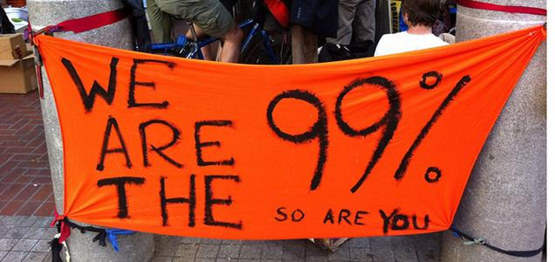
We are the 99%. We are homeowners, renters, students and community members.
It was the banks, not us, that distorted the housing market with reckless lending and caused home values to crash and foreclosures to sky-rocket. As a result, there are now 11 million homeowners underwater across the country – owing more on the home than its current value. Until the banks fix this problem they created, by reducing mortgages down to market value, we cannot fix the economy.
A growing number of homeowners and supporters are standing up to the banks and demanding that they write-down mortgage principal to market value. We are all standing together, and taking collective action, to make the banks start doing the right thing.
I hereby pledge that until the banks do their part to help homeowners and to fix the economy, by writing down mortgage principal to current home values, I will:
- Resist any attempt by the bank to take my home. If they come to foreclose, I will not go
- Support homeowners standing up and resisting wrongful foreclosure evictions by signing petitions, making phoning calls and taking action to support their defense of their home
Name | Phone | Email | Address

For more info visit www.occupyourhomes.org or call 877-633-9251

