Get Involved

By joining the Methodist Tax Justice Network, you will receive regular email updates about our events, media appearances and opportunities to get on the campaign trail.

All you need to do is provide us with your name, your email address and your church and circuit (if applicable), either using the sign-up form provided or by emailing Matthew Jones at mtjncoordinator@gmail.com, and we’ll add you to the mailing list. If you do not have an email address, then please provide a postal address and we will send you updates and event publicity materials. We will not pass on your details to any third parties.

If you are interested in learning more about tax justice, why not have an MTJN member give a talk, presentation or workshop at your church or small group? For any enquiries, get in touch at the above email address.
Name: .................................................................................................
Email Address:....................................................................................
Address (if no email): ........................................................................
..............................................................................................................
..............................................................................................................
..............................................................................................................
Church:................................................................................................
Circuit:..................................................................................................
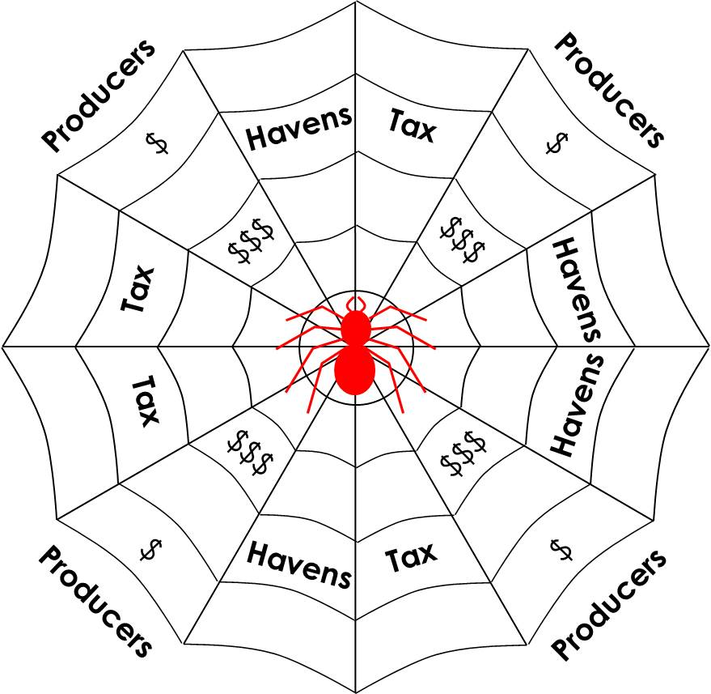
Untangling the
Web of Tax Dodging
Methodist Tax Justice Network

The Tax Dodging Problem

According to Christian Aid, $160bn a year are denied to poor countries through complex tax avoidance strategies.
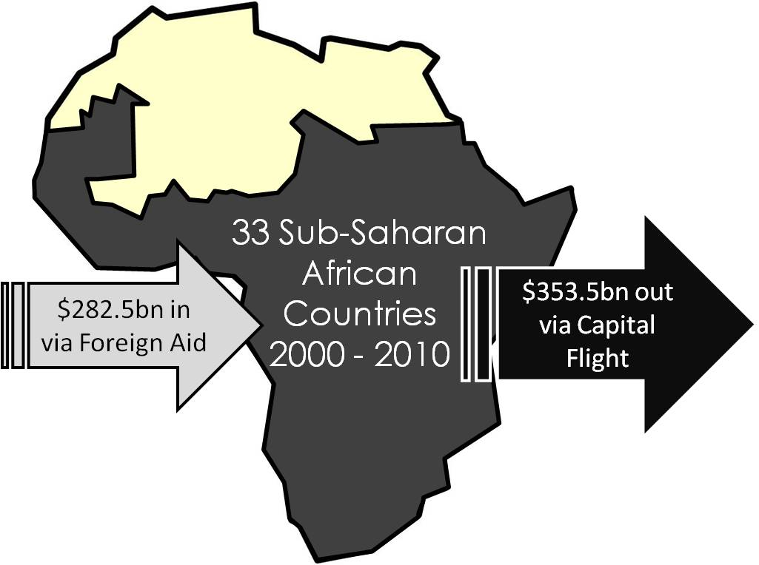
Corporations avoid paying taxes in countries where their production operations are based, by artificially shifting their profits into tax havens with low tax rates and high financial secrecy. The phenomenon of profits and revenues leaving the country where they are made is known as capital flight. The effects of this phenomenon on Sub-Saharan Africa can be seen above.

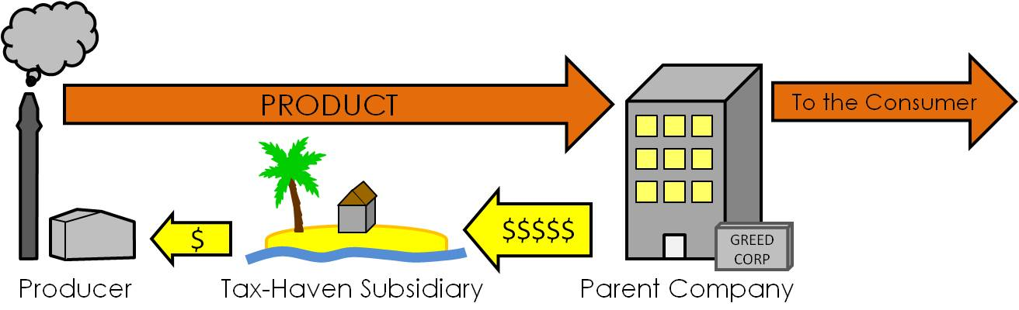
One of the most common ways of shifting profits into tax havens is ‘transfer pricing’. Raw materials are bought cheaply from the producer by a tax-haven based subsidiary, which then sells them on for a much higher figure. This lowers the tax bill in the country of production, and increases profits in the tax haven. When the producer and subsidiaries are owned by the same parent company, this is known as transfer mispricing. This is illegal, but almost impossible to trace. It is therefore crucial that the veil of secrecy over tax havens is removed, and a fairer system implemented.
MTJN – Our Mission

MTJN was set up in order to encourage the Methodist Church to become an internationally recognised advocate for tax justice.

MTJN has a global vision of a fairer world economy where:
- Democratically elected governments set the tax system, not transnational corporations.
- Individuals and companies alike pay their taxes.
- Automatic information exchange and beneficial ownership create complete transparency, so governments can see where they’re losing out.
- Country-by-country reporting allows governments to know who is paying tax and where, how much they’re paying and whether that reflects their scale of operations.
- Tax havens cease to exist as a result of the above.
- The Methodist Church takes on tax justice as a fundamental mission objective worldwide.

Our network includes ministers, lay staff, international partners and representatives of partner organisations including Christian Aid and the Tax Justice Network – but most importantly, it includes passionate individuals who want to make a difference. By working within the Methodist Connexion to educate, communicate and inspire, supporting tax justice campaigns and forming partnerships overseas, we hope to see the Methodist Church become a vigorous voice for change.

Our Patrons: Bishop Ivan Abrahams; Lord Paul Boateng; Rev Dr. Colin Morris; Hayley Moss; Baroness Kathleen Richardson OBE; Revd Alison Tomlin; Dr. Pauline Webb.

