Fair and Transparent
Appendix A
This is the order in which alternates will be elevated at State Convention in the 14th District Oakland County portion.

State Alternate # 1. Farmington Hills - Alt #1
2. West Bloomfield – Alt #1
3. Lathrop Village, Southfield City, Oak Park, Royal Oak Township (LSOR) – Alt #1
4. Keego Harbor, Orchard Lake, Pontiac, Sylvan Lake (KOPS) – Alt #1
5. Farmington Hills – Alt #2
6. West Bloomfield – Alt #2
7. LSOR – Alt #2
8. KOPS – Alt #2
9. Farmington Hills – Alt #3
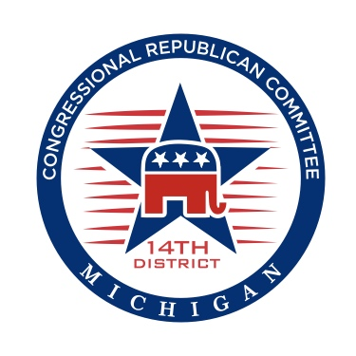
10. West Bloomfield – Alt #3
11. LSOR – Alt #3
12. KOPS – Alt #3
13. Farmington Hills – Alt #4
14. West Bloomfield – Alt #4
15. LSOR – Alt #4
16. KOPS – Alt #4
17. Farmington Hills – Alt #5
18. West Bloomfield – Alt #5
19. LSOR – Alt #5
20. KOPS – Alt #5
21. Farmington Hills – Alt #6
22. West Bloomfield – Alt #6
23. LSOR – Alt #6
24. Farmington Hills – Alt #7
25. West Bloomfield – Alt #7
26. LSOR – Alt #7
27. Farmington Hills – Alt #8
28. West Bloomfield – Alt #8
29. LSOR – Alt #8
30. Farmington Hills – Alt #9
31. West Bloomfield – Alt #9
32. Farmington Hills – Alt #10
33. West Bloomfield – Alt #10
34. Farmington Hills – Alt #11
35. West Bloomfield – Alt #11
36. Farmington Hills – Alt #12
37. West Bloomfield – Alt #12
38. Farmington Hills – Alt #13
39. Farmington Hills – Alt #14
40. Farmington Hills – Alt #15
41. Farmington Hills – Alt #16
42. Farmington Hills – Alt #17
43. Farmington Hills – Alt #18
44. Farmington Hills – Alt #19

