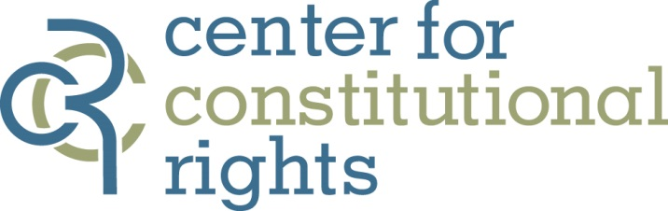

Contact:
Fatima Khan, (617) 216-7089, media@muslimadvocates.org
Jen Nessel, (212) 614-6449, jnessel@ccrjustice.org

New Jersey Muslims Appeal Ruling on NYPD Surveillance
Plaintiffs challenge federal court’s decision allowing blanket spying

March 21, 2014, New York – Today, a group of New Jersey Muslims represented by Muslim Advocates and the Center for Constitutional Rights (CCR) appealed a federal district court’s dismissal of Hassan, et al v. City of New York, which challenges the discriminatory New York Police Department (NYPD) spying program that targets innocent American Muslims because of their faith. Last month, Judge William Martini ruled, in a summary, 10-page opinion and without oral argument, that any harm the plaintiffs suffered was not the result of NYPD surveillance of the American Muslim community, but of Pulitzer Prize-winning reporting by the Associated Press revealing the secret practice. Judge Martini also dismissed plaintiffs’ claims of discrimination as implausible because, in his words, the “[NYPD] could not have monitored New Jersey for Muslim terrorist activities without monitoring the Muslim community itself.”

“Today, we take this important legal fight against police discrimination to the next round,” said Glenn Katon, Legal Director of Muslim Advocates. “Just as many historic civil rights cases have required appeal from lower court rulings to address systemic discrimination, we are not surprised that the Hassan case needs to push through to the higher courts. These brave American Muslims are determined and ready to stand up for their rights and every American’s right to equal treatment, regardless of faith.”

Hassan v. City of New York is the first lawsuit challenging the NYPD spying program, initially filed by Muslim Advocates and later joined by CCR, and represents a broad group of American Muslims from a variety of backgrounds – including a decorated Iraq war soldier and the former principal of a grade school for Muslim girls – who have been subjected to invasive spying. Since 2002, the NYPD has spied on at least 20 mosques, 14 restaurants, 11 retail stores, two grade schools, and two Muslim Student Associations on college campuses in New Jersey. This monitoring has included video surveillance, photographing, and community mapping. Moreover, internal documents, including a list of 28 “ancestries of interest,” reveal that the NYPD used racial and ethnic backgrounds as proxies to identify and target adherents of the Muslim faith. Not a single lead has come out of the extensive spying program.

“The district court's ruling gives legal sanction to targeted, religious discrimination by law enforcement without limitation,” said Center for Constitutional Rights Legal Director Baher Azmy. “The decision suggests that 9/11 justifies an exemption for Muslims in our Constitution. That ruling cannot stand.”

Ravinder S. Bhalla of Florio, Perrucci, Steinhardt & Fader, LLC serves as local counsel for Hassan v. City of New York. For more information on the case, visit www.muslimadvocates.org/endspying and http://www.ccrjustice.org/hassan.

Muslim Advocates is a national legal advocacy and educational organization working on the frontlines of civil rights to guarantee freedom and justice for Americans of all faiths. Through high impact lawsuits, policy advocacy, and community education, Muslim Advocates serves as a resource to empower communities and ensures that the American Muslim community is heard by the courts and leaders at the highest level of government. Visit Muslim Advocates at www.muslimadvocates.org and follow @muslimadvocates.

The Center for Constitutional Rights is dedicated to advancing and protecting the rights guaranteed by the United States Constitution and the Universal Declaration of Human Rights. Founded in 1966 by attorneys who represented civil rights movements in the South, CCR is a non-profit legal and educational organization committed to the creative use of law as a positive force for social change. Visit www.ccrjustice.org and follow @theCCR.

###

