
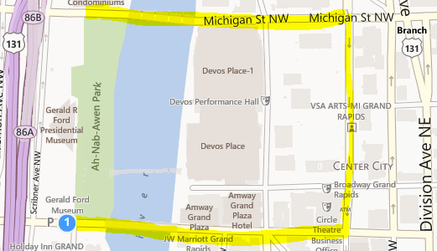
May 25, 2pm
Ah-Nab-Awen Park
Grand Rapids

Join the World in protesting against the use of GMO’s in our food supply!

Free Community Awareness Event
following the March.
Music, Healthy & Local Vendors, and Sustainable Workshops

Please show up early to gather, organize, and distribute signs (between 1:30 -2:00)

