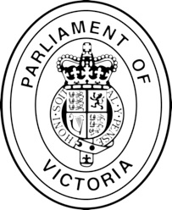
The Petition of

Residents in the Murray Plains electorate draws to the attention of the House

That the Andrews Labor Government is treating Echuca commuters as second class
citizens in terms of rail transport

The petitioners therefore request that the Legislative Assembly of Victoria ensure
that the Andrews Labor Government immediately upgrades the Echuca to Bendigo train
from Class 4 to Class 2 to increase the line speed and equate the train’s performance to other V/Line services

Name | Address | Signature | Mobile Phone or Email

