-DRAFT Site Plan- | 2014-2015  Single Plan for Student Achievement  LEA Plan Update

NAME: Jill Stansbury | POSITION: Head of School

PHONE #: 1-510-842-1181 x. 3 | EMAIL: jill@urbanmontessori.org

ADDRESS: 5238 Brann Ave. Oakland, CA 94619

Data Analysis
Academic Performance Data
Assessment | Results | ANALYSIS
AYP/API (current 3rd grade-45 students) | API: 676  Afam: 516  Hispanic/Latino: 585  White 886  SED 478  ELL 518 | Year 1 was a challenging year. UMCS staff and leadership focused entirely on stabilizing school culture and developing support strategies at tier 3 for behaviorial and social-emotionally challenged students. It took the entire school year for students (>70%) who had never had any Montessori experiences prior to Urban Montessori to become normed to the Montessori environment. UMCS leadership believes that year 1 CST data and the achievement gaps represent student baseline data for the current third grade students and reflect the wide diversity of the student population UMCS attracted. Moving forward, UMCS will need to collect regular academic benchmarking data to track and monitor the achievement gap and to ensure we are closing that gap in 3rd grade. Additionally, UMCS will regularly benchmark K-2 students to prevent this level of underperformance .
California State Test (CST) | 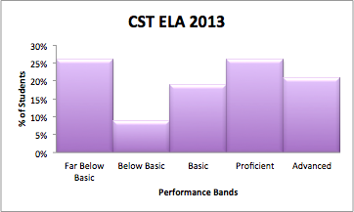  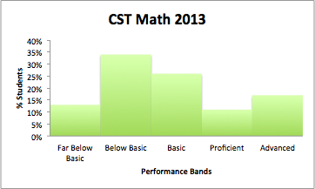 | Again, the CST data is a baseline that represents the performance levels of our current 3rd graders. Because of the extreme student turnover between 12-13 and 13-14, and because it only reflective of approximately 15% of the student population, this data is not a useful baseline around which to inform our larger instructional program moving forward.
Site Reading Assessments | 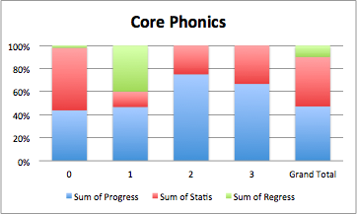  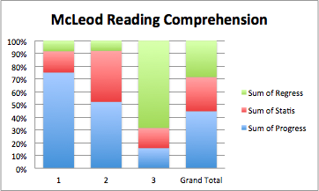  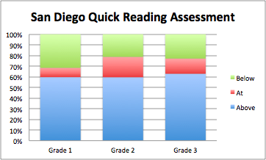 | The Core Phonics and McLeod data shows how many students made growth between the beginning of the year and middle of the year on these two assessments. The Core Phonics is generally not given to students who have some level of fluency. So, not all students were given the Core Phonics. This is an assessment that evaluates a student’s phonemic awareness.  The McLeod assesses reading comprehension and is generally only given to students who can read at least at the first grade level with some fluency.  The San Diego Quick is an oral reading assessment that assesses fluency for those who have enough phonemic awareness and sight word vocabulary to read passages. The data here is winter proficiency data.  As we look at the site reading assessments, it’s important to recognize that not all of the students had both beginning of the year and middle of the year data. In one class, teacher turnover disabled the class from completing all assessments earlier in the year. In another class, new teacher teams struggled to both stabilize the classroom environment and complete all the testing. Additionally, there was some student turnover throughout the school year. So, a significant percentage of current students are not reflected in these charts.  Since kindergarten reflects the first year of transition to Montessori classroom culture, much of the energy in the first half of that year is focused on teaching students the executive functioning skills foundational to operating in a Montessori classroom and being successful in an academic environment. As a result, the end of year kindergarten data will be looked at with greater scrutiny. The school does not necessarily expect students to make one year’s progress in half a year. The most concerning group in this data set is the “regress” group, particularly large in the 1st grade on the Core Phonics and in the 3rd grade on the McLeod. Many students in the 3rd grade group came to Urban Montessori as second graders were significantly academically behind (reflected in the CST data). In addition, older students new to Montessori have a harder time transitioning to the more self-directed model than younger students. Consequently, UMCS will need to pay particular attention to the older students who are still not making growth to ensure strong support plans are in place. The SD Quick assessment highlights again that there is a cluster of students at every grade level (25-30%) who are reading below grade level. Supporting teachers to intervene for those students and providing intensive interventions for 3rd grade students who are dramatically behind will be critical in 2014-15.
Site Math Assessments | 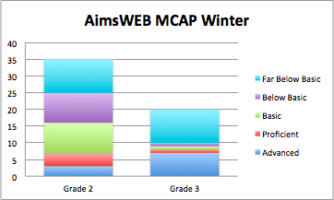  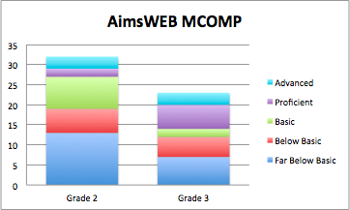  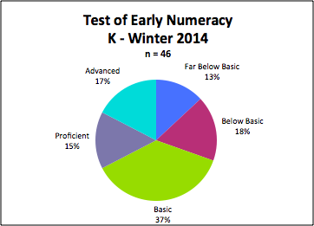 | Overall, UMCS students underperform in mathematics relative to ELA (also observed on the CST). We anticipate that some of this underperformance is because the assessments given do not mirror the mathematical work facilitated in Montessori classrooms. Students are given very concrete tools to learn mathematics with little traditional computation work. Since the AIMSweb assessments are CST-aligned, UMCS will use the data to develop support plans for students regressing, but we will not deviate from the Montessori approach. Moving forward, as UMCS transitions to Common Core Standards and Common Core aligned assessments, we will monitor student progress closely to evaluate whether the Montessori math program needs to be supplemented to ensure students can demonstrate mastery of the Common Core Standards.
CELDT  (inc reclassification data) | 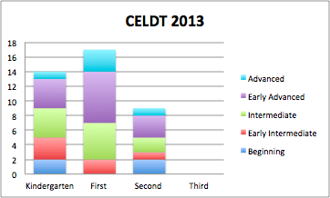  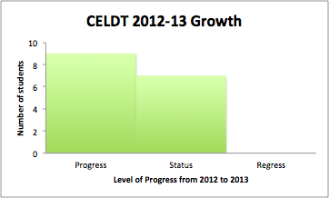 | CELDT data indicated a wide range of performance at every grade level with the exception of first grade. 40 students were tested this school year, and 10 scored at the beginning or early intermediate levels and almost half scoring at early advanced or advanced. 9 of 16 students who had 2012 and 2013 CELDT data at UMCS made 1-2 years of growth on the assessment, and 7 of 16 did not make progress with none regressing. Because Montessori teachers are not explicitly trained in ELD, ELD training and support will be necessary moving forward to ensure all students make a year of progress.
2nd grade NWEA

School Culture
Attendance/ Matriculation  (inc chronic absenteeism & Middle School dropout rates) | Average Daily Attendance: 94%  % of students with <90% attendance: 1% | Overall ADA at UMCS is still relatively low relative to elementary schools in Oakland. The low truancy rate indicates that the low ADA is the not result of the chronic absenteeism of a few students.
Discipline  (discipline/referral data, suspension/expulsion) | 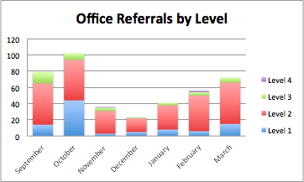  Suspensions: 4 | While referrals and suspensions are dramatically lower this year relative to last year, the number of office referrals remains high, particularly with level 2 offenses. Teachers need ongoing support to build stronger management systems in their classrooms, to ensure there are high expectations for behavior communicated and that systems to manage behavior throughout the school continue to develop to meet the needs of the students in the program.
School Climate  (inc parent/community, student and staff survey data that highlights safety and school connectedness) | 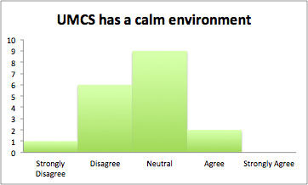  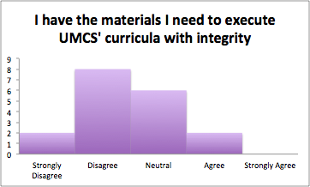 | The UMCS staff survey confirms what is messaged by the referral data above - that school climate while dramatically improved remains a challenge for teachers. Very few staff members messaged that they felt the climate was calm. There are two distinct challenge areas. The first is supporting teachers to manage classrooms with strong accountable cultures. Again, while this has generally dramatically improved, teachers are still struggling and need additional tier 1 strategies in their classrooms. The second is students for whom UMCS needs intensive support plans at both tiers 2 and 3.  The UMCS staff also communicated that they feel challenged by the lack of curricular resources and the lack of clarity around the larger instructional program. UMCS needs to align Montessori practice across the classrooms and build teacher capacity to integrate the Common Core standards. The Common Core standards will require teachers to teach close reading of grade-level novels, integrate more informational text, and explicitly teach writing. Teachers indicate the need for greater alignment around the instructional program, the need for time to make the Montessori materials, and the need for reading resources.

Needs Assessment: Overall Analysis & Resulting Priorities
o Include what needs/priorities have been identified based on the data analysis?

English Language Arts | - Training in consistent core curricular instruction in handwriting, spelling and literature group instruction (reading and writing curriculum)  - Identify and implement tier 2 interventions for students, particularly in grade 4, scoring far below basic on formative assessments  - Adequate curricular resources to implement the approved Montessori literacy curricula in alignment with the Common Core standards  - English language arts assessment aligned to the Common Core Standards that can inform the instructional program and create a culture of data inquiry and responsiveness to data
Mathematics | - Analysis of core curriculum and identification of Common Core Standards not addressed by the Montessori curriculum to deliver consistent instruction in mathematics  - Regular opportunities to engage in abstract math applications so that students are able to apply their knowledge on standardized assessments  - School-wide tier 2 interventions for students scoring far below basic on formative assessments  - Math assessments aligned to the Common Core Standards that can inform our instructional program and create a culture of data inquiry and responsiveness to data
English Language Learners | - Adequate curricular resources and training to provide quality ELD instruction to meet the needs of all English Language Learners
Technology | - Acquire enough computers to give local and state assessments to leverage technology as a means to differentiate and personalize learning
Attendance & Enrollment | - Improve student achievement by improving attendance
Discipline & School Climate | - Consistent classroom expectations and cultures  - Improve teacher effectiveness in classroom discipline and positive classroom culture  - Increase teacher knowledge base for working with students with special needs and students from non-dominant groups  - Tier 1, 2 and 3 supports for students struggling with social emotional and behavioral challenges
Design Thinking (charter priority) | - Develop student creative competency
World Languages (charter priority) | - Preparation for high school, college and the job market through foreign language studies  - Implement a state standards aligned Montessori based language curriculum
Performance Goals for 2014-2015 School Year
o Goals must address identified priorities. However, one goal may address multiple priorities. School sites should identify goals that target all students as well as those that target specific subgroups. For each goal indicate “all” if goal applies to all students or identify applicable subgroups.
o Describe annual goals and expected and actual progress towards meeting goals. This section must include specifics projected
Note: The Aligned State Priorities Column is for reference only

Goals | Description of 2014-2015 School Year Goal | 2015-2016 | 2016-2017 | Aligned State Priorities
#1  English Language Arts |  |  |  | o Conditions of Learning  o Pupil Outcomes: Pupil Achievement
#2  Mathematics |  |  |  | o Conditions of Learning  o Pupil Outcomes: Pupil Achievement
#3  English Language Learners  ( inc CELDT & reclassification goals) |  |  |  | o Conditions of Learning  o Pupil Outcomes: Pupil Achievement
#4  School Culture (attendance and enrollment) |  |  |  | o Engagement: Pupil Engagement
#4  School Culture (discipline, suspension, KPIs) |  |  |  | o Engagement: School Climate
#5  School Climate (must include goal for safety and school connectedness) |  |  |  | o Engagement: School Climate
#5  Target Subgroups: (above and beyond goals for ALL students)  o Ethnic Subgroups  o Students w/ Disabilities  o Foster Youth  o RFEP students |  |  |  | o Conditions of Learning  o Pupil Outcomes: Pupil Achievement
#6
Design Thinking
#6  World Languages |  |  |  | o Conditions of Learning:  ___________________  o Pupil Outcomes:  ___________________  o Engagement:  ___________________

2014-2015 Professional Development/Coaching Plan Summary

o Describe the site’s plan to develop teachers around the above goals, high priority practices and instructional Implementation goals.
o How will you differentiate in format and content? What are the time structures? Who will provide professional development?

Description
Teacher Institute
-Goals:
-Activities: Train summer camp academic staff on Number Worlds

Wednesday PD sessions
-Goals:
-Activities:

Staff collaborative planning - when?
-Goals:
-Activities:

October PD day
-Goals:
-Activities:

November PD days
-Goals:
-Activities:

January PD days
-Goals:
-Activities:

April PD days
-Goals:
-Activities:

June PD days
-Goals:
-Activities:
Action Plan: Actions, Services, & Expenditures
o Identify annual actions to be performed to meet the goals described above. Describe expenditures to implement each action/service and estimated costs. Actions may describe a group of services implemented to achieve identified goals. Reference fund sources used to support actions and services.
o For each action/service, note the aligned goal(s) number.

Description of Specific Actions / Services | Related Expenditures | Estimated Costs | Funding Sources
#1 English Language Arts

#5
School Climate
Extended Learning Time
(including summer school, before and after school, extended day, etc)

Increased Access to Technology
(including hardware and IT)

Auxiliary Services for students and parents
(including parent coordinator, family resource centers, etc.)
Staff Development and Professional Collaboration
(including coaches, PD, summer staff development, collaboration time, etc.)
Targeting services and programs to lowest-performing student groups

Strategic services and programs for targeted subgroups
(above and beyond goals for all students)

Any additional services tied to student academic needs

Stakeholder Engagement
o Describe the process to engage parents, students (if appropriate), and community the in development, review and implementation of this plan. Include specific actions to elicit participation, the engagement timeline (calendar of meetings and agenda items), what data was shared and how, summary of feedback/revision loop and plans to update community on progress on plan implementation.
o Briefly describe the impact on this level of community engagement on the plan (goals, priority practices and strategic actions).

Description
Dates | Stakeholders engaged | Goals | Impact of Stakeholder Feedback
May 5, 2014 | Board of Directors | 1. Present 13-14 academic, climate, and culture data  2. Identify needs/priorities identified by the data  3. Present the 14-15 budget assumptions to understand constraints
May 13, 2014 | Family Advisory Council and Student Support Committee | 1. Present 13-14 academic, climate, and culture data  2. Identify needs/priorities identified by the data  3. Present the 14-15 budget assumptions to understand constraints
May 15, 2014 | English Learner Advisory Council | 1. Present 13-14 academic, climate, and culture data  2. Identify needs/priorities identified by the data  3. Present the 14-15 budget assumptions to understand constraints
May 15, 2014 | CARE Team | 1. Present 13-14 academic, climate, and culture data  2. Identify needs/priorities identified by the data  3. Present the 14-15 budget assumptions to understand constraints
May 20,2014 | Board Academic Oversight Committee | 1. Draft clear direction on solutions
May 21, 2014 | Faculty/Staff | 1. Present 13-14 academic, climate, and culture data  2. Identify needs/priorities identified by the data  3. Present the 14-15 budget assumptions to understand constraints
May 22, 2014 | Family Advisory Council Family Meetings with Student Support Committee | 1. Clarify priorities for 14-15 budget  2. Present potential solutions; elicit feedback
May 28, 2014 | Board of Directors | 1. Clarify priorities for 14-15 budget  2. Present potential solutions; elicit potential solutions  3. Provide clear direction on solutions for 14-15
May 28, 2014 | Faculty/Staff | 1. Clarify priorities for 14-15 budget  2. Present potential solutions; elicit feedback
Week of June 2-6, 2014 | Board of Directors | 1. Present final 14-15 budget with aligned site plan (Shoot for a special meeting the first week of June. LCAP due 6/15 budget due 6/24.)

Signatures Page

Printed or typed name of Head of School Date Signature

Printed or typed name of Teacher Date Signature

Printed or typed name of Teacher Date Signature

Printed or typed name of FAC Representative Date Signature

Printed or typed name of FAC Representative Date Signature

Printed or typed name of Board Chair Date Signature

