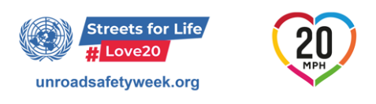
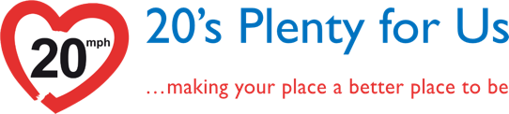
Dear Candidate
www.20splentyforus.org
@20splentyforus
We are asking you to pledge that, if elected as a councillor, you will #ActOn20mph and support wide area 20mph speed limits on urban and village streets in [place].
As well as being popular, effective and value for money, 20mph wherever people and motor vehicles mix is endorsed by the World Health Organisation. In May 2021, the United Nations Global Road Safety Week focus is on 20mph as the default limit where people mix with motor vehicles under the banner “Streets for Life #Love20”.
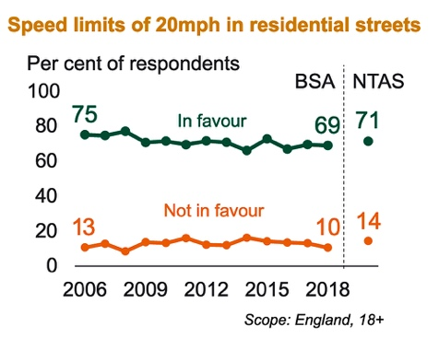
Speeding traffic is a huge concern of people in surveys across the country and support for 20mph is both strong and growing. According to the National Travel Attitudes Survey, 7 out of 10 people in the UK consistently support 20mph in residential streets and once implemented, support for 20mph rises.
In the UK, 21 million people already live in a place where 20mph is seen as the norm and not the exception. 20’s Plenty for [place] says that now is the time for our council to embrace this best practice.
When implemented across wide areas, 20mph speed limits:
- Reduce the number and severity of traffic collisions;
- Increase active travel and improve community well-being and quality of life; and
- Lower air and noise pollution in urban and residential areas.
Will you choose #ActOn20mph as a Manifesto Pledge that is popular,
achievable and value for money?
If so, please take a selfie with the poster attached and email it back to us at this [email address]
with your #ActOn20mph pledge. We will publish preferences expressed by all candidates for the Local Elections on 6th May and we will make this available to 20’s Plenty supporters and to our wider network.

We look forward to hearing from you.

Best wishes

20’s Plenty for [place]

