Daily Telegraph - London 17 Nov 2014

Premature babies: How 24 week-old babies are now able to survive

The number of babies being born prematurely is on the increase, and so is their chance of surviving. Jessica Salter discovers how advances in neonatal care – and sandwich bags – are giving hope to even the tiniest newborns
Facebook 14K | Twitter | Pinterest 0 | LinkedIn 16 | Share 14K | Email
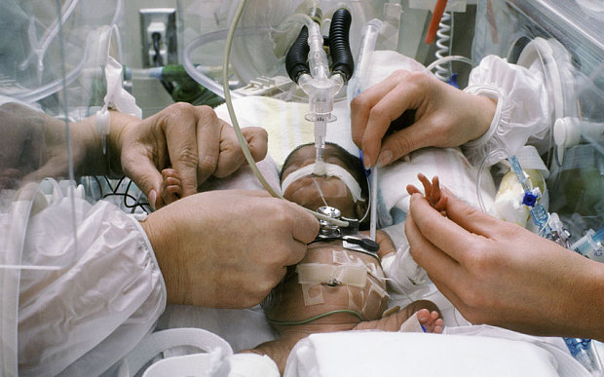
More premature babies than ever before are surviving in the UK Photo: Corbis
By Jessica Salter
3:23PM GMT 17 Nov 2014
Comment
In 1974 the outlook for a baby born before 26 weeks – two thirds of the way through a normal pregnancy – was poor. ‘They almost certainly wouldn’t have survived,’ Dr Mike Smith, a paediatric consultant who started working with premature babies that year, says.
Before 1995 evidence about the survival and care of premature babies was – like this – largely anecdotal. Then a groundbreaking study called EPICure recorded all births in the UK between 20 and 25 weeks, six days. Out of 4,001 births, the first EPICure study (another study took place in 2006 and the latest, following the original children, now aged 19, is due to be finished next year) found that 311 babies survived and were eventually discharged, including two babies born at 22 weeks, six at 23 weeks, 100 at 24 weeks and 186 babies at 25. The study concluded that babies born before 24 weeks who survived were still ‘unusual’.
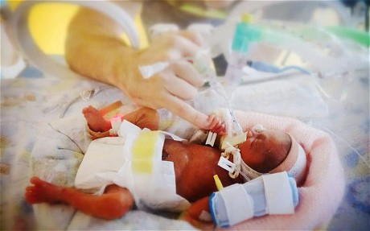
Daisy-Mae Little, born 25 weeks early, holding her mother's finger Photo: CATERS
‘I came into paediatrics straight from adult medicine,’ Dr Smith, who worked in Bristol and London before heading up the neonatal department at the Royal Hallamshire Hospital in Sheffield, says, ‘and your first reaction is “cor blimey”, because of the size of them. Some of these babies are very small – about 500g [1lb 1oz]. Their bodies are little more than a couple of fingers’ worth. A pre-term baby has very thin skin, so it seems very red because you can see all the blood. I think we’re programmed to find [full-] term babies attractive – there are strong evolutionary reasons to think a little fat baby looks great. But pre-term babies look so delicate and vulnerable – you just know they aren’t going to be able to do very much for themselves for a while.’

Related Articles
- Parents' joy after premature twins are saved
07 Feb 2015
- Premature babies survival rate 'rises' but health issues remain
05 Dec 2012
- Premature babies: The pregnant elephant in the room is stress
17 Dec 2012
- Premature babies dying because of inadequate care
08 Mar 2014
- Premature birth: a father's story
27 Sep 2014
- ‘Professional parent’ pressure drives mothers to exhaustion
27 Sep 2014
READ: The premature baby girl who became an internet sensation
From the 1970s to the 1990s doctors typically would not treat a baby born before 23-24 weeks – apart from perhaps ventilating the baby, it would be left to see if it could survive on its own. The problems a pre-term baby encountered – from unformed lungs to a damaged brain to tissue in the gut dying – were too severe to treat. But now, thanks to medical advances (some as simple as using a plastic sandwich bag to prevent water loss immediately after birth), more of these tiny babies are managing to survive. According to the latest figures released by the Office for National Statistics in 2011, 80 per cent of babies born extremely prematurely survived. ‘We found that babies born at 27, 28, 29 weeks, which had really high mortality rates when I was doing the first study, are now doing well and living normal lives,’ Prof Neil Marlow, a consultant neonatologist at University College London Hospital and one of the authors of the EPICure studies, says.
Not only are more premature babies surviving, but more are being born. Along with a steady rise in birth rates, there are increasing numbers of older mothers and those using fertility treatments – two groups of women who are more likely to have premature babies. Now, according to data from 2011, those born alive at 27 weeks have an 87 per cent chance of surviving, at 28 weeks it is 92 per cent and at 29 weeks, 95 per cent. It means that doctors are working on tinier babies, typically with more complications, than ever before.
‘The smallest baby I ever treated was called Jessica and she weighed 460g [1lb] at birth,’ Dr Smith says. ‘This baby was born and, actually, she had good lung function, probably because of the stress of the birth – stress produces steroids that have a lung-maturing effect on a baby. But the day after the birth her bowel had perforated; that’s quite a common problem with premature babies. She went into surgery and the surgeons took out a big lump of colon that had infarcted [the tissue had died]. But she came through and did well – I’ve got a photograph of a very happy-looking toddler.’
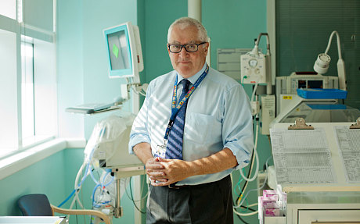
Prof Neil Marlow consultant neonatologist at University College London Hospital. PHOTO: Laura Pannack
It is astonishing that a premature baby survives at all. At 24 weeks – the age a foetus is considered ‘viable’ – alveoli (small balloon-like structures on the lungs) are only starting to develop, along with cells that produce surfactant, a compound that stops your lungs fully deflating when you breathe out (making it easier to breathe in again). High numbers of babies used to die from a lack of surfactant, including President John F Kennedy’s youngest child, Patrick, who was born five and a half weeks early in 1963, weighing about 4lb 10oz.
READ: Abortion legal time limit: Why we feminists owe it to ourselves to not ignore this uncomfortable issue
‘At the end of expiration the lung starts to collapse and the body has to work very hard to inflate it,’ Dr Smith explains. ‘Then you get secretions building up, the work of breathing increases and the babies become hypoxic [deprived of oxygen]. I saw a lot of babies die that way. It was pretty devastating.’
In 1992 steroids were introduced into the treatment of pre-term babies. ‘That was a sea change,’ Prof Marlow says. He remembers reading about the first trial of surfactant on premature babies when he was a medical student in the late 1970s. ‘I was really excited by it, but when I came to practice in 1980, no one was using it. When I asked why, people said they didn’t believe the research.’
Now if a baby is born showing any sign of respiratory deficiency, it is also given surfactant through a tube inserted into the lungs, and then ventilated by hand using a bag and mask. Dr Smith demonstrates the process. ‘You need a laryngoscope [a torch on a stick], and you put it in the baby’s mouth to look down the opening of the larynx. Then you put a plastic endotracheal tube through the larynx, and the surfactant is flushed from a syringe down the tube into the trachea and ventilated down into the lungs.’ Pregnant women can also now be given corticosteroid injections, which help to mature the foetus’s lungs if a premature birth is predicted.
READ: Premature babies: The pregnant elephant in the room is stress
‘We’ve learnt lately – in the last five years – not to be too aggressive when getting their oxygen sorted out,’ Prof Marlow adds. ‘We’ve learnt the dangers of over-oxygenation [which can, among other problems, lead to damaged eyesight] and stretching the lungs [which can permanently damage them].’
Another big killer of premature babies used to be hypothermia. In the womb a foetus will gain between a third to half of its birth weight after 32 weeks, growing from, on average, 1,800g (4lb) at 32 weeks to about 3,600g (8lb) at full term. If they are born early, babies lack insulating layers of fat. In 1997 plastic sandwich bags were introduced into the delivery room to help insulate premature babies who weighed less than 1,500g (3lb 5oz). ‘It reduces evaporative water loss and thereby heat loss,’ Dr Smith explains. ‘It’s very simple but very effective.’
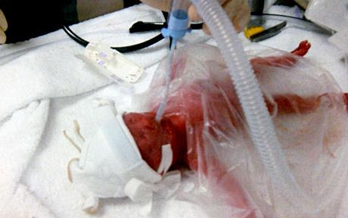
A seismic change happened in 2002. ‘The idea was that we would try to get all these small and sick babies transferred to regional centres where we had clinical expertise,’ Prof Marlow says. It meant directing families in England to the 46 hospitals that had ‘level three’ care, led by consultants with specialist intensive care facilities, out of the 182 hospitals offering maternity care in total. There was plenty of resistance to the idea. Parents did not like having to travel farther, and doctors in smaller hospitals wanted to keep providing treatment.
But the new system worked. In April 2014 Prof Marlow published a paper showing that ‘bigger intensive care units did significantly better than the smaller ones in terms of survival’. The chances of a baby born 10-15 weeks early dying in a level three centre were 50 per cent lower than being treated in a standard obstetric unit.
It helps further if the babies are born in the larger units, with immediate access to the best care, rather than being transferred. Doctors are increasingly better at predicting premature births, by using swab tests and an assessment of the woman’s cervix. Now 60 per cent of premature births take place in level three care. ‘It’s good but it’s still not enough,’ Prof Marlow says. ‘In Sweden and France they do much better [at getting babies to be born in the right place] and that brings benefits in terms of survival.’
Survival is important, but so too is a life without major impairment. The 2006 EPICure study found that despite all the medical improvements, ‘the number of babies leaving neonatal units with abnormalities on their brain showing on ultrasound scans, and with lung, bowel and eye problems are very similar to what we found in 1995’.
When researchers tracked a group of babies born before 27 weeks to the age of six, they found 22 per cent had a severe disability (for example, cerebral palsy and an inability to walk, low cognitive scores, blindness or profound hearing loss) and 24 per cent had moderate disability (such as cerebral palsy but able to walk or cognitive scores in the special needs range). ‘Things are improving, but we haven’t really improved those with severe disability,’ Prof Marlow says.
Up to 24 weeks it is up to the doctors’ discretion whether they treat a baby. ‘I did worry about treating 23-weekers because the results were so poor,’ Dr Smith says. And he was ‘very reluctant’ to treat a 22-week-old baby, although he did have one baby born at 22 weeks who survived care and was a healthy, happy toddler. (Even now the chances of surviving at 22 weeks are extremely slim; in 2011, when 178 were born alive, only 10 survived.)
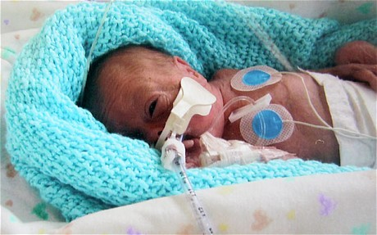
‘The only baby we had in Sheffield who survived at 22 weeks was a little chap called Nathan who was born in the late 1990s,’ Dr Smith says. ‘He weighed about 650g [1lb 7oz]. He was ventilated for three weeks. He also developed quite severe osteopenia of prematurity [low bone density – in the third trimester in the womb a foetus receives about 250mg of calcium to harden its skeleton] and had spontaneous rib fractures. ‘He had skin infections – pre-term babies quite often develop infections because they don’t have much immunity – but he was getting along quite nicely until he developed chronic lung disease. But we persevered and eventually he went home without oxygen. ‘I saw him until he was about two and a half and he was doing well; he was a happy, healthy toddler.’
According to a report last year by the National Institute for Health and Clinical Excellence, the three major problems are respiratory complications and lung disease, problems with bowel function and long-term neurological damage. While lung disease can in many Jacob McMahon in hospital in 2011 after he was born at just 21 weeks. PHOTO: Ross Parry
cases be managed, and, according to Dr Smith, ‘scores of children are going around with patched-up guts and doing all right’, brain injury is probably the risk most parents of premature babies fear. Cerebral palsy affects about 10 per cent of those born at 23 weeks (the risk falls to 1-2 per cent at 26 weeks). ‘There’s a small proportion of children who have severe cerebral palsy and that pains me more than anything else,’ Prof Marlow says. ‘In these children it’s really difficult to avoid producing a brain injury because you don’t quite know what has led to it in the first place.’
Since 2009 doctors have started giving pregnant women magnesium – ‘brain protection’ – before they go into pre-term labour, which, doctors have found, reduces the risk of cerebral palsy. ‘One of the problems they get is a condition called intraventricular haemorrhage, where the blood vessels bleed and blood accumulates in the ventricles of the brain,’ Dr Smith says. ‘It’s brain damage to the tissue around the ventricles – when you take a scan the brain looks like Swiss cheese and it is the main disabling phenomenon that babies have.’ He says it occurs in 5-10 per cent of short-gestation babies. If the brain injury is deemed too severe, doctors usually do not treat the baby.
One of the most important parts of his job, Dr Smith says, is knowing when to stop treatment. ‘If you had a child who had evident morphological brain injury and it was judged to be severe, and you were still ventilating at several weeks of age and they had bad lungs, infections, liver problems, then you’d say to the parents, “This is not a good situation.” ’
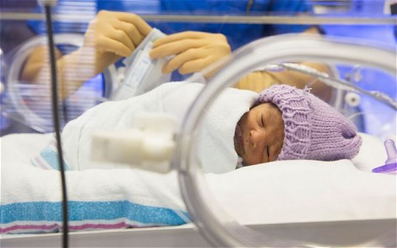
He remembers one occasion when the parents did not agree with his assessment. ‘We had this baby that was OK to start with, but gradually got into a real tangle with his chest. It was getting worse and worse. He was obviously as miserable as sin on the ventilator and he kept having crisis after crisis where we would have to resuscitate. We had to sedate him while we were ventilating his lungs at very high pressure.’ After two weeks the baby started to deteriorate further and Dr Smith told the parents he wanted to stop. ‘I told them he’s having an awful lot of treatment and I think it will be futile in the end.’ But even after ‘numerous discussions with the family’, the parents wanted to keep going. Dr Smith phoned his lawyer. ‘I wanted to know if we could get a declaration from the High Court,’ he says. ‘I didn’t think it was fair to keep doing this to the baby or to the nurses. And while I was on the phone the sister in charge of the room came in – he’d crashed again.
‘As we were working on him the sister said we should get the parents in. I thought it was too horrible for them to see, but she said it was important they knew what they were asking us to do. She brought them in. They looked at the kid and said, “You’ve got to stop.” And that was it, the poor little chap passed away.’
The emotional cost of caring for a premature baby is high – but so too is the financial cost. It costs about £1,500 a day to keep a baby in intensive care, £900 in a high-dependency cot and then a sliding scale of costs for special care, transitional care and normal care. The NHS has a £2.6 billion budget for maternity services in England, according to figures released last year. Some regions had had cuts of up to 15 per cent on the previous year.
All premature babies stay in hospital until they reach full term. ‘If you’re born at 24 weeks you do rack up quite a bill,’ Prof Marlow says. ‘You may need up to six weeks of intensive care, perhaps more, then another four or five weeks of high-dependency care. And that’s before they go home.’
On average, Prof Marlow estimates, it costs about £500,000 per child until the age of 18. ‘Then add to the costs those who need home ventilation or who, later on, attend school for special needs, then over a lifetime the cost can be astronomical,’ he says.
‘I don’t think any of us ever worried about costs,’ Dr Smith says. ‘Intensive care days were increasing all the time because instead of dying at day two they now survive to go home. But I always thought that in the context of health spending that was reasonable.’
Babies born at 24 weeks are, he says, capable of living independent lives. ‘The outcome is often more successful than neurosurgeon treatment for brain tumours in adults or stroke treatment, but somehow people weigh them up in a different way.’
The EPICure study in 2006 found that 34 per cent of those born before 27 weeks had mild disability (for example needing glasses) while 20 per cent had no problems. ‘Which is a miracle really, given than when you’re born in the middle of gestation your brain hasn’t finished developing,’ Prof Marlow says.
Until now the long-term effects of extreme prematurity have never been clinically studied. Prof Marlow and his team are in the middle of the latest update to the EPICure study, due to be finished next year. It will examine 160 children from the 1995 study, now aged 19, along with some ‘control’ teenagers who were born at full term. ‘It’s a really interesting study and it’s going to teach us a lot about how you can catch up your body development and mental development over adolescence,’ he says.
Some of the teenagers are babies that Prof Marlow treated; others are ones he has seen participate in the study over the years. They have been active in the EPICure study – not only by participating in tests, but also helping to set up EPICure on Facebook. ‘When they come down to London for the study now they’re proper young adults,’ Prof Marlow says, smiling. ‘Many of them are off to university, and that’s something no one thought they could achieve when they were born. These are children who in the 1990s would have had 50 per cent mortality and 50 per cent severe morbidity rate. Where they are now, it’s just fantastic; it’s getting better and better for these babies.’
The babies’ names have been changed. For more information visit epicure.ac.uk

