Together we can create a law that puts accessibility at the heart of a more inclusive Aotearoa
New Zealand

The Access Alliance
Access
Matters

Every New Zealander should be able to fully participate in society, have the opportunity to learn, to get a job, and to take part in community and social life.

Every New Zealander should be able to fully participate in society, have the opportunity to
learn, to get a job, and to take part in community and social life.
Without government action to ensure all businesses, buildings, and services are accessible, one in four
of us continue to be excluded from accessing or
fully participating in parts of life that other Kiwis take for granted.
It doesn’t need to be this way. We are sharing our personal stories with you and ask that you stand with us and support this government to introduce accessibility legislation that will put accessibility at the heart of a more inclusive Aotearoa New Zealand
Accessibility law will open the door so that EVERYONE, disabled and non-disabled, benefits
from the contributions of us all. Join us

Page 2
Access
Matters
The Access Alliance

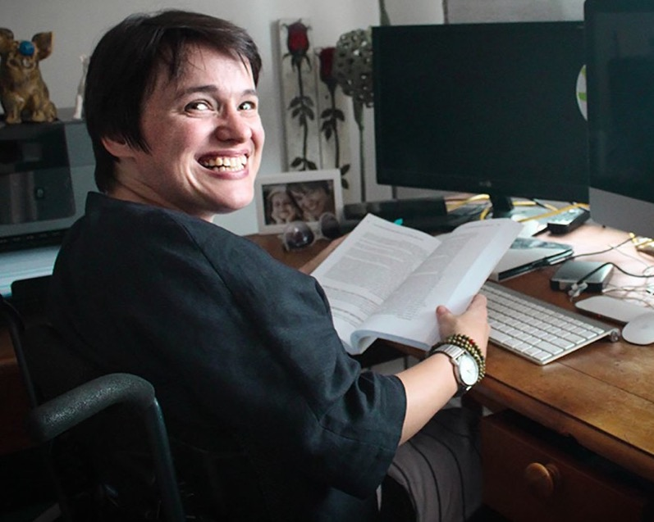

Amy’s Story
Portrait of Amy

I work as a researcher and writer in the field of health psychology, and with disability and chronic illness in general.
I also work as a guest lecturer and a teacher. One day I was asked to give a lecture on disability and social justice.
However, the university forgot there was no access to the teaching podium in the lecture theatre. In the end, I was forced to be carried down the stairs, in order to give that lecture. I was dependent on the fact that my supervisor was there. He

The Access Alliance
Access
Matters

Page 3

happens to be very strong and was able to carry me down the stairs. But what would I have done if he wasn’t there?
This served as an excellent teaching tool for the lecture I was giving – but it shouldn’t have to happen. Lecturing is a key part of my role as a professional, and so this barrier bars me from my own profession.
This was not a one off event. Often I am barred from places where I teach, because the podiums and lecterns are not accessible. I am limited in how much I can access a space, because people view accessibility as being able to enter the building rather than be able to use the building in its entirety. This automatically puts me on the back foot in my
professional setting. A great deal of emphasis is put on having a good first impression and how you convey yourself in a work- setting. Without the ability to access a space completely,
you automatically become problematised rather than being viewed as the professional that you are. It can erode your sense of confidence and your sense of self as a professional human being. You are no longer an individual with a purpose, you are an individual with a problem.
Access is the ability to enter and utilise a space independently with dignity and respect, and without reliance on others. I shouldn’t have to plead and negotiate with my employers
to make something accessible. We want to have consistent legislation which provides a clear standard for what access means in New Zealand for all New Zealanders. Having access will provide a fundamental gateway to the professional world for myself and other people with disabilities. A law will compel governments, businesses and organisations to make this happen.
Access
Matters

Page 4
The Access Alliance

Áine’s Story
Portrait of Áine

My name is Aine and I’m an accessibility and climate justice campaigner. I’m blind and I’d like to share a story about when I was trying to accept a job offer from an organisation last year.
I was excited about this job offer. The organisation, after I prompted them, sent me the forms that I needed to fill in electronically, so not just in hard-copy. Unfortunately, I soon discovered that a couple of them were not accessible with the screen-reader JAWS that I was using. JAWS is the synthesised speech software I need in order to hear what’s on the screen, and to fill in the forms electronically.
When I explained the issue to the organisation, and asked

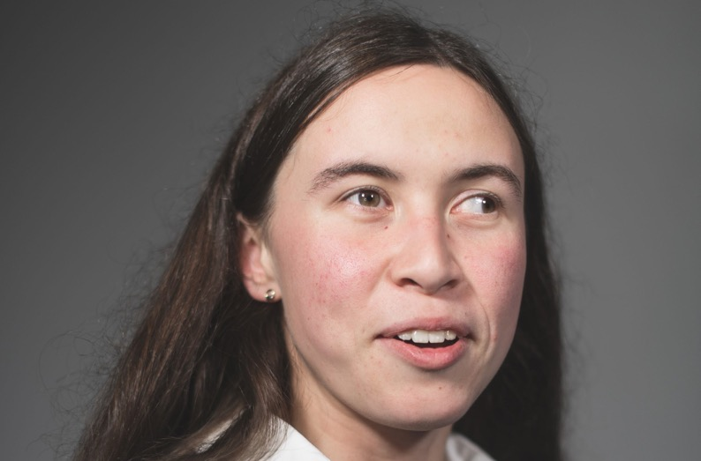
The Access Alliance
Access
Matters

Page 5

whether they could please send me a screen-reader friendly version of the forms, they said that they weren’t in control
of the form’s accessibility because those were actually government-issued forms. So it was the government who needed to make them more accessible.
As a result of this, I had to ask for help filling those forms in. In my particular situation, I was able to ask my mother for help. But I feel like my sense of dignity was trampled on there –
to have to ask somebody else to fill in my tax and other job acceptance paperwork for me. If sighted people don’t have to share that information with anyone else, neither should visually impaired and blind people.
The government should be taking responsibility here to enact a law which will make sure that all employment forms and documents are accessible with all the common screen readers and any other formats that people may need them to be accessible as well. That would involve consulting with
disability organisations around ensuring that that regulation is really robust.
There are a lot of barriers in the job process, from application stages through to accepting a job through to actually working. We need to have a solid conversation about prioritising accessibility in our laws, as well as really embodying what those laws mean: not just complying with them because they’re a thing on paper that you have to comply with, but doing that because it’s really important that we are giving all of our citizens equal opportunities to be able to contribute to their workplaces and to find work in the first place. I want to see the Government lead this process.
Access
Matters

Page 6

The Access Alliance

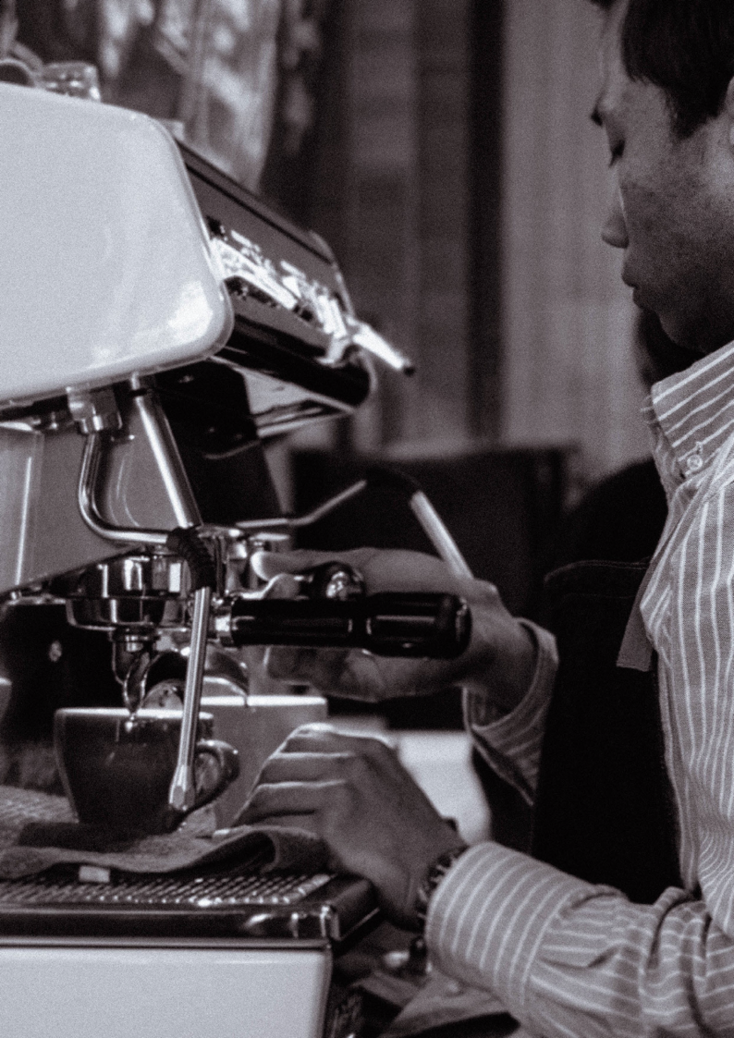

Man barista making coffee

Shannon’s story
I lost my job as a Barista because the owners of the business moved away and their café became a sushi shop. This was upsetting and frustrating, I became very angry. I could not decide what other types of work I would be able to do. It
is not easy for people with an intellectual disability to gain employment. I did some voluntary work at an opportunity shop for a while before I decided I would retrain and enrolled for a course called MSL. I have started my second year on this course which helps people to find a job. Unfortunately I have not been offered any interviews. I have realised that the biggest issues affecting disabled people are other people’s
attitudes and a failure to see that employing a disabled person would be a positive move for their business.
I would like to see an accessibility act introduced which ensures that disabled people are treated equally in the employment sector, that business owners are encouraged to employ people with a wide variety of disabilities, and we are helped to train for these positions.

Page 8
Access
Matters
The Access Alliance

Joanne’s story
Woman coding at desktop computer

My name is Joanne and I am autistic.
I have found often there is a lack of understanding and acceptance of what being autistic means, especially in the workplace.
I am open in my workplace about being autistic.
As an autistic I prefer to have clear instructions around what is expected of me, a clear job description, and clear deadlines.
I was once invited to a business meeting to discuss changes in our computer system and reporting outputs and processes.
Being autistic I had reviewed the documentation quite thoroughly and went into the meeting well prepared with information about changes I believed were required, not just for our organisation but other third parties we dealt with.

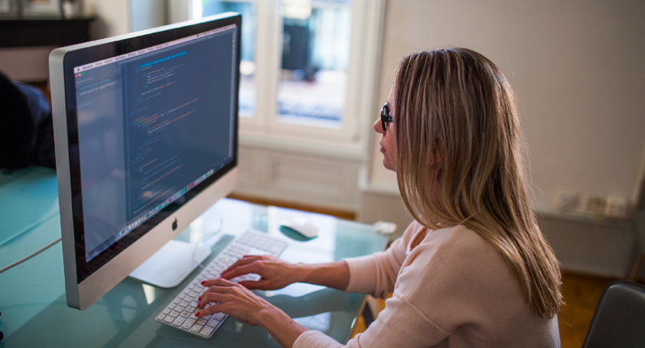
The Access Alliance
Access
Matters

Page 9

We went around the table all giving feedback – everyone was positive about all the reporting outputs however I had some constructive criticisms about some inaccuracies of the reports and some oversights.
This was not well received. To the point where one person verbally attacked me personally demanding to know why I was even there! No manager stood up for me so at this point I got up and left.
The next day I was expected to attend part 2 of the meeting.
I said to the manager “why would I attend a meeting where you allow me to ve verbally harassed and people don’t seem to want to listen to anything I have to say?” He was silent. I didn’t attend the meeting.
Another manager approached me later in the day though – asking me to explain in detail how the outputs were wrong as it was going to be his job to fix them.
I was left wondering why they hadn’t made expectations clearer because it was obvious they hadn’t wanted my genuine feedback.
Why could they not understand that I had simply done the task I was charged with? Why were they so upset that I had done exactly what I had been told to do? To add insult to injury I got a comment on my performance appraisal soon afterwards that I was “outspoken”.
There needs to be so much more understanding and acceptance of autism about our communication and working styles. Disability awareness training for employers and managers should be mandatory under an Accessibility Act.
Access
Matters

Page 10

The Access Alliance

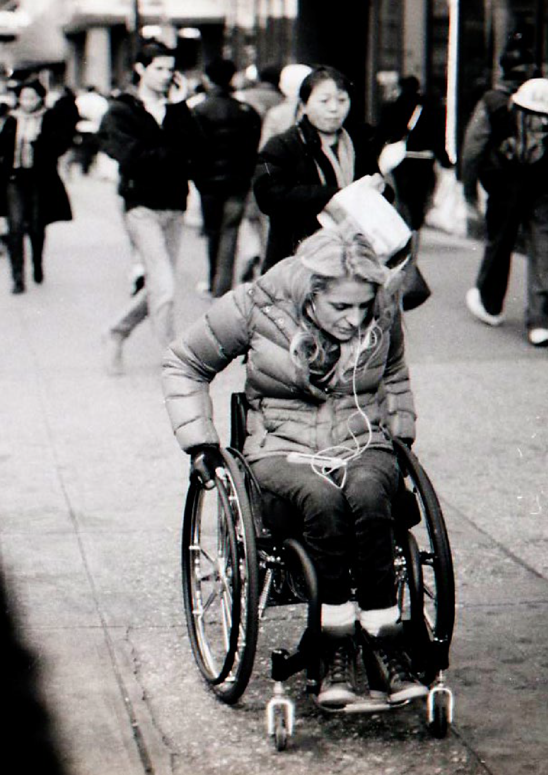

Woman using wheelchair on busy city footpath

Emma’s story*
I got my first proper job out of high school and was so excited. It was at a place where I really wanted to work - with a group of people who were super-accepting, and pushed me to
be my best. The only problem was that, the place had no bathroom that was accessible; my choices were either to quit that job. Or go to McDonalds to use the bathroom, so everyday that’s what I did, and I had to travel to get to the McDonalds in the first place.
It’s really hard when you want to work, and yet you have to face so many obstacles to work. Obstacles that are
unnecessary. My disability, my access need has challenges I expect, but in this day and age it is unnecessary for a place to not have accessible bathrooms.
I had to battle everyday to do something simple, I don’t think that’s fair. And I don’t think everyone is prepared to do that either - and they shouldn’t have to be.
It’s time for an Accessibility Act that ensures that all public buildings have accessible bathrooms, and it should go without saying but, accessible routes to get to those bathrooms. It shouldn’t be up to disabled people such as myself to have to fight for accessible bathrooms one building at a time.
*Name changed to protect identity

Page 12
Access
Matters
The Access Alliance

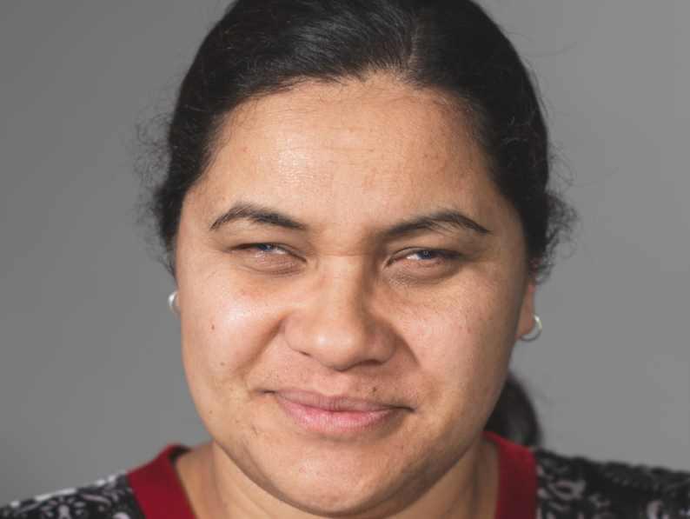
Portrait of Sharleen

Sharleen’s story
I am Sharleen Tonglaea, a Mum who has a vision impairment. I am always keen to access information on my child’s education and extra-curricular activities in the community.
One time, my son’s school was holding an open day which I was very excited to attend. No information was provided to me in advance other than a request to sign in at the school office when I arrived. I know where the office is but struggled with

The Access Alliance
Access
Matters

Page 13

the challenging process of signing in which required me to use a touchscreen on a tablet. Fortunately the staff understood my access needs and helped me.
Locating my son’s classroom was difficult. I tried to find it from memory but I was unable to read the tiny numbers on top of the classroom doors. With help, I located his classroom but there were no students or staff there to help me find my son’s artwork on the walls, although it was labelled with his name.
Visually I was unable to find any of his projects and that left me feeling a bit stink, isolated and embarrassed. I felt as a parent
I could not celebrate and enjoy the progress he has made at school. Eventually I received help from another parent, who is also on the Board of Trustees, to locate his artwork.
There are several things the school could have done to make this experience more accessible for me. They could have sent out a map of the school showing the location of classrooms with the invitation. Also, having students available to guide families around the school would have solved many issues.
I was not the only parent who got lost, I met several others trying to find their child’s classroom.
I think an accessibility law should require that information is provided automatically in many alternate formats such as sign language, large fonts, in other languages and electronically.
This would ensure that the education system in particular catered not just to children with access needs but to the wider community of friends and family who support the school. This would offer reassurance to the growing diverse community of people with access requirements.
Access
Matters

Page 14

The Access Alliance

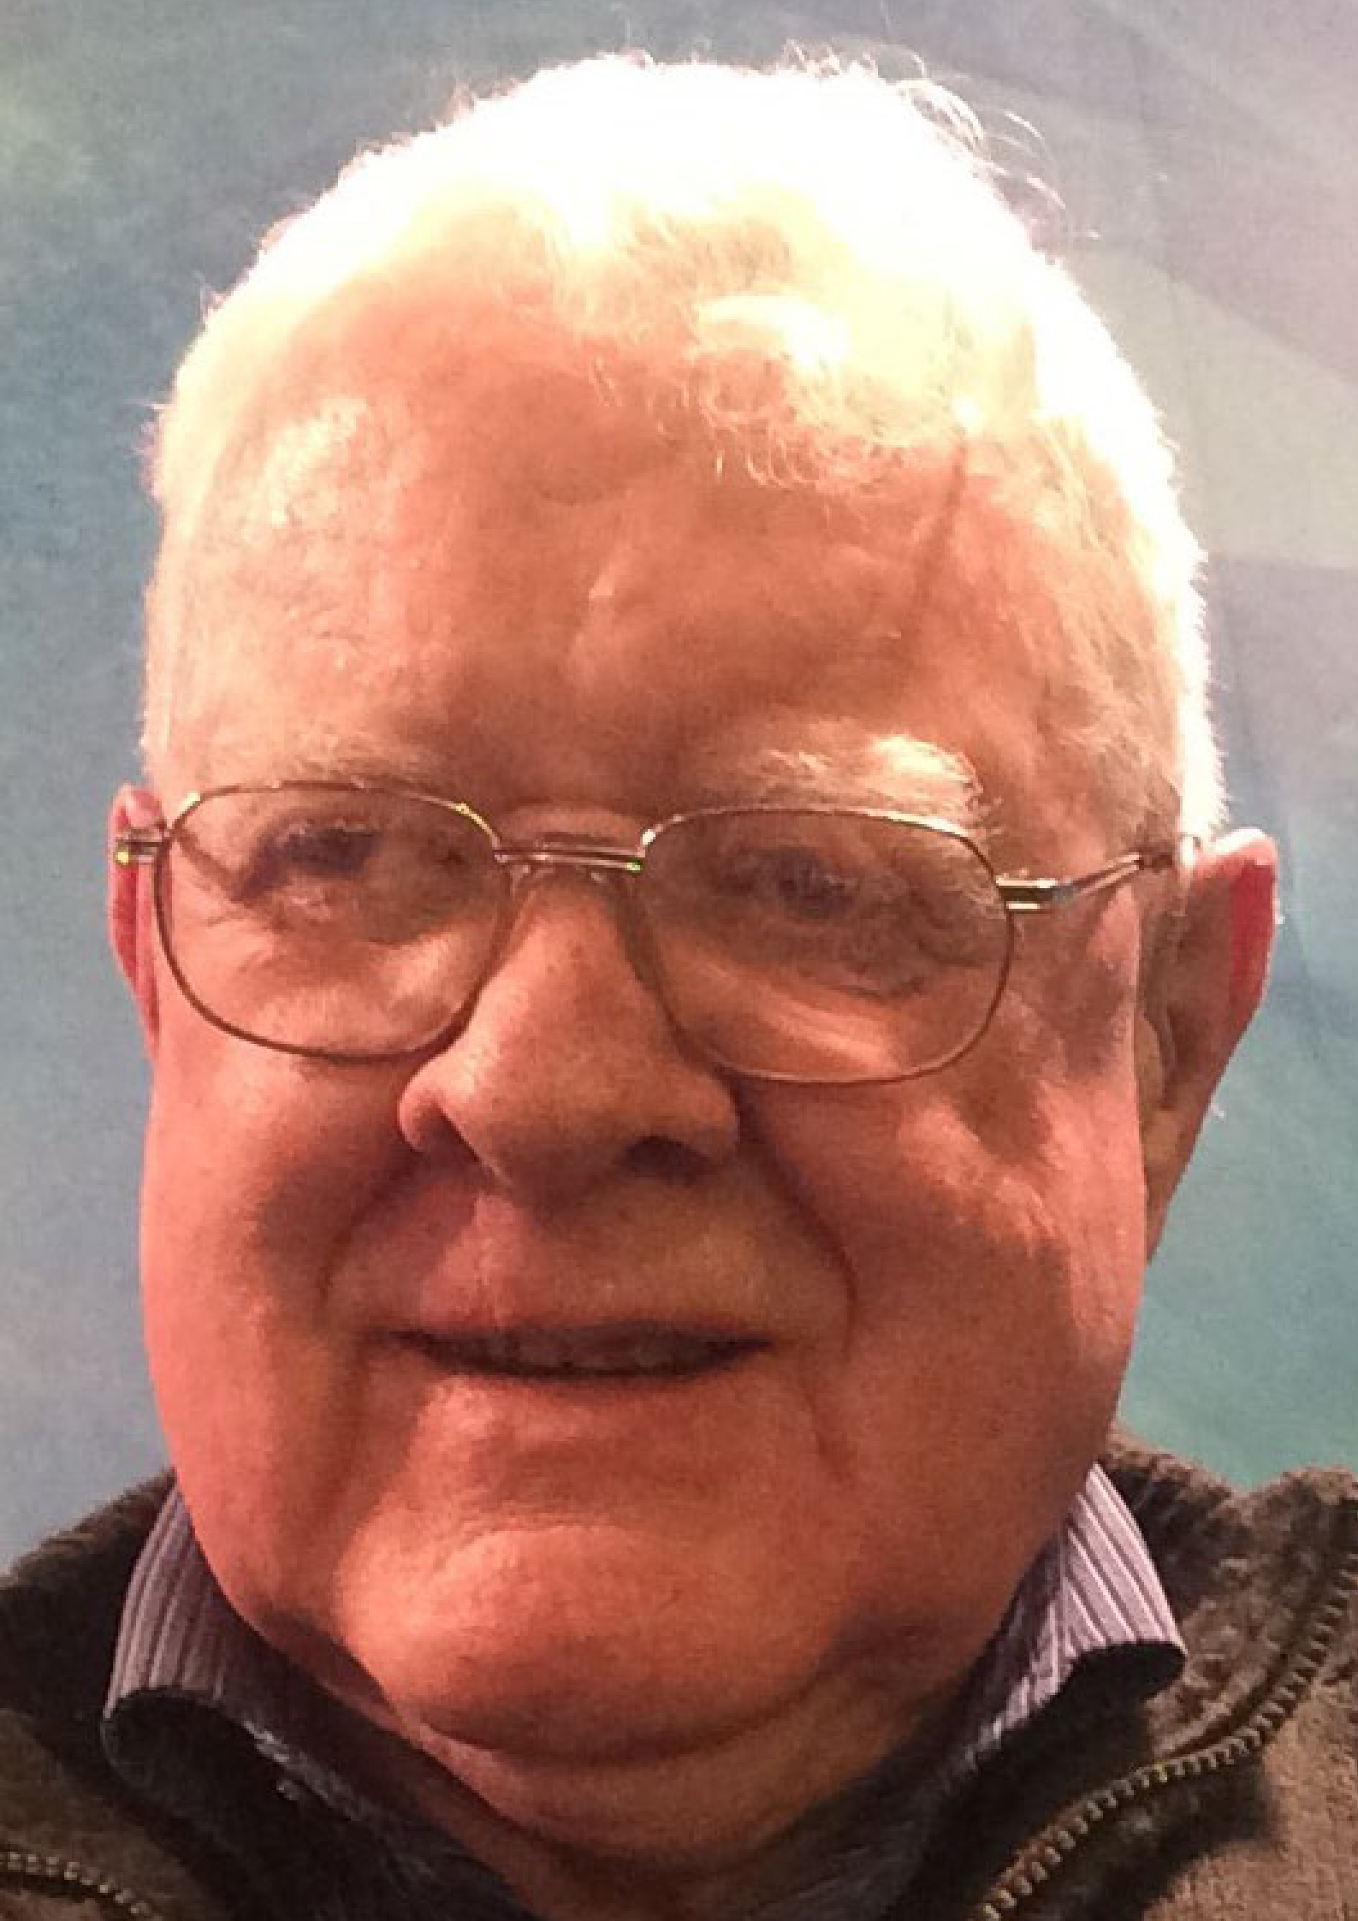

Portrait of Allen

Allen’s story
In older age, many Albinos such as myself suffer with skin damage of various kinds and our risk of skin cancer is high. This happens because we did not have the benefit of ‘anti sun burn’ remedies as children. In New Zealand’s harsh sun it’s important to ensure children are kept safe and comfortable as they play. Equal access to school and community play grounds is a basic right for every child. There needs to be
adequate sun shade built into all open space play areas where people with fair complexion can have refuge from the sun’s damaging rays.
Such protection was not available to me playing at school growing up in northern Southland 65 years ago. Despite some initial steps from the Ministry of Education to regulate it now,
it continues to be inexcusably lacking for this generation of children. Prevention of sun damage as children is a common sense measure. Myself and many of my friends are suffering the consequences now.
Access to safe play environments should be a prime consideration in facility planning and development. I would like it to become mandatory under an Accessibility Act for every school and early childhood facility to evidence ‘Sun Safe’ practices and ensure provision of adequate open space sun shaded play areas. Such regulation needs to be enforced without School Boards having the option to allocate funding for ;Sun Safe’ areas to other activities.
Access
Matters

Page 16
The Access Alliance

Carl’s story
Portrait of Carl

Come with me on a journey. I want to go to the city to do some shopping. I’m Deaf (I communicate in NZSL) and I’m Blind (I have a guide dog).
To save money, let’s take the bus. Oh no! I can’t go by bus because my local bus takes me to the bus hub where multiple buses stop and I can’t see the bus numbers or ask people for help.
Maybe change plans and go to the Mall instead. My local bus stops there. Oh no! I can’t get into the Mall because there is a free left turn at the traffic lights so there is no vibrating pad to let me know I can cross.
Try a communication card asking for help … Yay, 40 minutes later & finally someone helps me cross onto the footpath. Oh no, now I can’t cross through the Mall carpark to get into the Mall. Try a communication card again, another 30 minutes before someone stops to help.

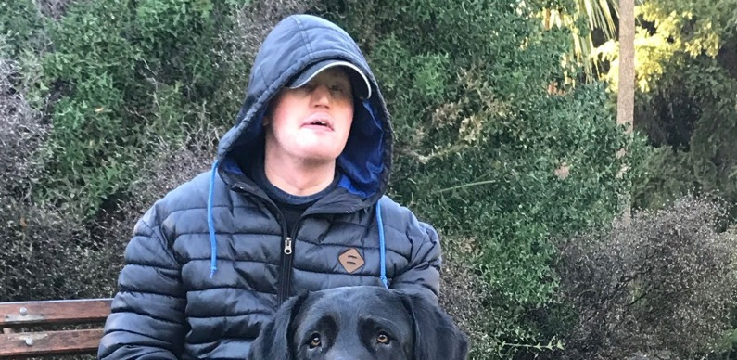
The Access Alliance
Access
Matters

Page 17

I try to get money from my banks ATM – oh no, it’s touch screen & touch screens don’t work with my skin condition, lucky I had a little cash with me. Finally shopping’s over, again it’s a waiting game, using communication cards to escape from the Mall. I can’t find my bus at the bus hub, and even if I could, I can’t access the timetable info so I’ll try walking home.
Oh, a gust of wind close to me, what was that? It made my guide dog stop suddenly and I got hit on my shoulder – Oh no, it’s a combined cycleway / footpath and that cyclist was going really fast.
By the time I get home, it’s been 6 hours and all I wanted was a tube of ointment from a chemist. I haven’t even had time for lunch.
Yes, Driving Miss Daisy could drop me at the Mall, but I can’t afford it when I have medical appointments to get to too. Yes I could rely on family, but I want to be independent.
Thank you for going shopping with me. Compared to a trip to my hospital appointments, this journey to the Mall has been easy.
In my journey, I faced a number of different barriers. Together they are stressful. Some are a matter of educating the public about the importance of stopping to check if someone with a communication card needs help. But in regarding the crossings, the number of zebra crossings that have lights could be majorly increased in transport regulations under an accessibility law. All ATMs should be required by law to have physical buttons, not just touch-screens, and also audio for blind people who aren’t Deafblind. Changing the law alone isn’t a silver bullet, but I would welcome an Accessibility Act.
It has the potential to make it easier for me to get around on a daily basis with greater independence and less stress.
Access
Matters

Page 18
The Access Alliance

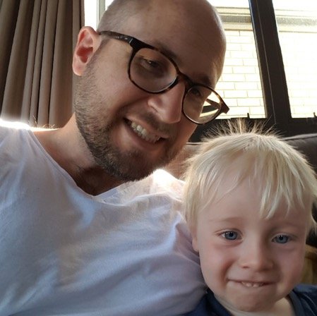

Dan and son Benji pose for photo on sofa

Dan’s story
I was 15 when I was told I was going blind. Now married and with a young family, my access needs and the accessibility of my environment has never been more at the forefront of my vision loss.
My son Benji is 2 and a half, and we have encouraged him to explore his world actively through play and sport. I increasingly need accessibility in his environment to engage in his active world and physical development.
A new playground is the heart of our community, a place for kids in the community to play and for parents to connect with each other and their families. But while accessibility of

The Access Alliance
Access
Matters

Page 19

the newly developed community has been considered, the accessibility of the playground has not.
This amazing new space for kids to play and learn, in a newly developed community, has been designed to fit as much play in a limited space as possible. As a parent with low vision wanting to engage with my son’s play and physical development, the playground equipment and park benches scattered through the space, with the exception of the bright red plastic slide, is all a natural wooden theme, leaving no colour contrast between the bark covering the floor of the playground and the play equipment. There is no colour contrast to assist me to map my path through the already busy space.
As a member of the low vision community I am not a cane user, but using my umbrella as a pseudo cane, I still manage to walk into the bench seats or poles holding playground equipment together. Canes would go right under these when they could be designed with a base that a cane would detect.
While other Dads participate in the process of play with their kids, I question whether I play with my son, but at my pace so I can safely navigate the inaccessible playground design, or remove myself from the opportunity to play with my boy, stand on the perimeter of the playground and let him play at his pace.
He wants his Dad to play, but I want him to reach his potential. I want to see an Accessibility Act that ensures the local disability community, is consulted at the design stage. We need to make public infrastructure, including playgrounds, accessible to the whole community.
Access
Matters

Page 20
The Access Alliance

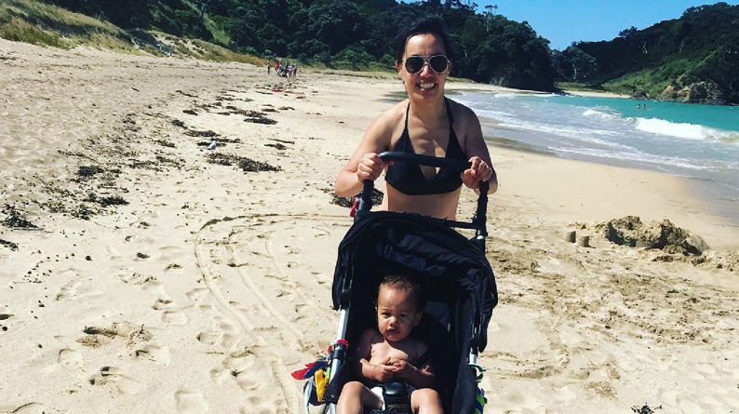
Renata walking on beach with daughter Te Akau in stroller

Renata’s story
I am Renata & this is my daughter Te Akau. She is my world and the dearest part of my life.
By sharing my experience of purchasing a stroller for my baby I hope to highlight the importance of listening and how attitudinal barriers impact on accessibility.
My intent is to challenge society about their attitude toward me as a mother with disability. I hope I can help to develop more understanding that having a physical impairment doesn’t mean you don’t have the desire or the capacity to be a good parent.
I have Cerebral Palsy, so for me it is crucial to try before buying. “Can this stroller be folded with one hand?, Is it lightweight?
Is the suspension good enough so my baby will sleep

The Access Alliance
Access
Matters

Page 21

despite my bouncy walking?” My process was to look online
– eliminate the “no go’s” & then go in store to try and find the best option.
Mostly staff ignored me. Sometimes they’d ask if I was OK or comment that whatever I was looking at was cute and would make a lovely baby shower gift. In contrast, I noticed other customers got all the ooh’s and aaah’s under the sun. “Oh your first baby! Congratulations! Boy or girl?”
When they finally spoke to me long enough to realise that I was an expectant first time mother, the reaction was very different. One assistant even went as far as saying “Wow I didn’t think you would be having a baby?!”
As I got further along and it was obvious I was pregnant the default reaction changed. Looks of shock or pity, sometimes fear. I would then almost unfailingly be led to the specials section.
Do you know how incredibly frustrating it is to try and buy something specific only to have someone disregard what you ask then proceed to demonstrate unsuitable, cheap products and try to sell you things in ugly bright colours?
It’s exhausting to constantly advocate for oneself, particularly when the other party seems incapable of listening. Many levels of discrimination were in evidence, particularly an assumption that I had no business having a baby. In addition, staff assumed that because I had a disability I couldn’t afford high quality baby products, and also that I had no taste in regards their colour or style.
Accessibility legislation should require education and training for the retail sector so disabled people are treated with equality and dignity.
Access
Matters

Page 22
The Access Alliance

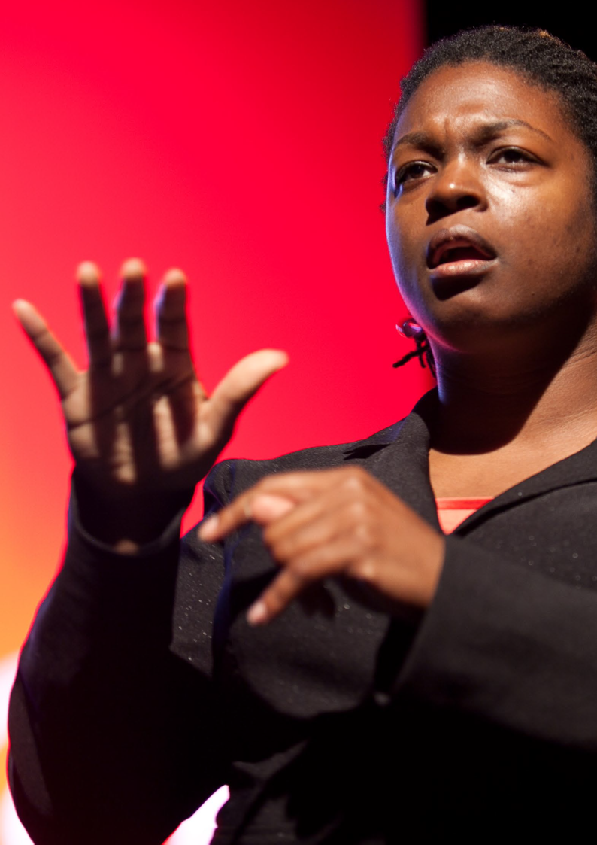

Woman using sign language

Ali’s story
I am a Deaf Somali refugee, I can communicate easily in my native sign language and I am learning NZSL (New Zealand Sign Language). I have difficulty in communicating to the staff in the café, supermarket, dairies, Settlement Centre and the Shopping Centre. The staff do not know how to communicate to me by sign language or through writing on paper. I have got a deaf support worker who is very good at communicating with people from the public and in businesses. When my deaf support worker is not with me, I am learning to communicate through sign language, but I give up easily because the staff do not communicate back in sign language or write down what they want to say on paper. I am not good at English like everyone else. My deaf support worker comes to see me twice a week on her paid job.
I want to become independent. Did you know that NZSL (New Zealand Sign Language is our official language in New Zealand? We deserve a better level of communication
through sign language – to all staff of premises and services of business, education providers, and transport operators
as much as every other New Zealander. Basic NZSL training should be required by law for these staff, under an Accessibility Act. We want the freedom to live our lives how we choose; we want to use our NZSL to contribute to our communities.

Page 24
Access
Matters
The Access Alliance

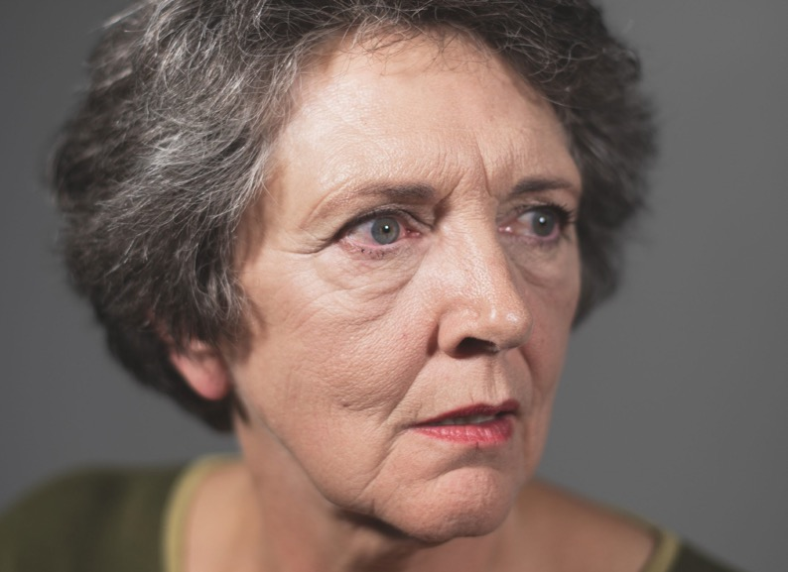

Christina’s Story
Portrait of Christina

My name’s Christina. I have a musco-skeletal disability, mostly caused through multiple injuries. I’ve had eleven orthopaedic surgeries in the past seven years so I’ve been variously abled and not so able. I’ve been in a wheelchair, used a walking frame and currently mobilise with a walking stick.
Because I don’t drive or have anyone to run me around, I depend upon public transport to get me out into the lived environment. This has become increasingly difficult because of preventable access barriers.

The Access Alliance
Access
Matters

Page 25

On the North Shore, our half hourly bus service recently became hourly. Compounding the problem, I’m regularly forced to catch the last accessible bus home at 4.15pm, which means I have no choice but to be confined to my house by 5.00pm. That absolutely enrages me.
The buses running after 4:15 on my route have steep steps, not only into the bus, but also into the seats. A guide or mobility dog would have no place to sit; I cannot imagine how a working dog could even safely board the bus with their handler.
All this has happened because the bus company who run the route I depend upon sold off fifteen accessible buses in order to put very, very old buses that are not accessible onto our route. They did this both on the North Shore and on the Hibiscus Coast where there are a lot of older adults.
I don’t think this is fair. I don’t think it’s reasonable for people like me, for the older adults I represent in my area’s Bus Group, or for people with wheelchairs, parents with push-chairs, nor persons on Walking frames or those using any other mobility aid including assistance dogs.
Anybody who needs an accessible bus should be able to travel at a time equivalent with other adults and shouldn’t be made to feel problematic, difficult, annoying or a nuisance.
We need to legislate to make accessible buses the only type of buses we use in New Zealand. This change is essential. It is an issue of parity and equity with other persons who simply don’t face these barriers.
Access
Matters

Page 26
The Access Alliance

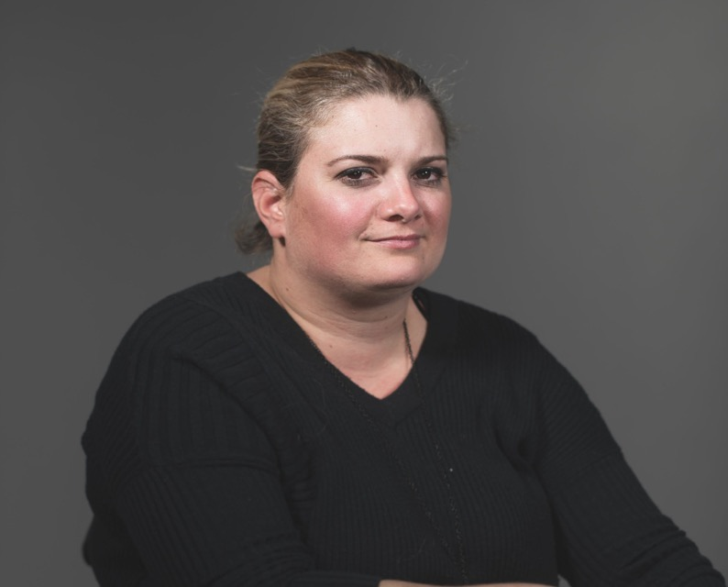

Juliana’s Story
Portrait of Juliana

My name is Juliana, I have a full-time job and a family, and I use a wheelchair to get around.
My story starts in July 2015. At that time, I had been taking the ferry to go to work for a little while. I live in east Auckland, so I would drive to Half Moon Bay and then I really enjoyed taking

The Access Alliance
Access
Matters

Page 27

the ferry because the alternative of driving through the traffic was terrible.
One day while I was at work, I got a call from Auckland Transport saying that I should try a different mode of transport because the ferry was not fully accessible. I had been relying on staff or even other passengers to help get my chair in to the ferry. When I got the call my jaw just dropped I couldn’t believe it. “Really?You guys are calling me to ask me to take
a different form of transport because your ferry service is not fully accessible?”
Since I ended up in a wheelchair, whenever I have a challenge I imagine that I’m a big strong rhino. I use anger to take action, because I don’t think it is fair. I cannot change my impairment but Auckland Transport can change the ferries and make them accessible.
I’m not the only person in a wheelchair that wants to take the ferry. There are heaps of other people that should be able to use the ferry to get around too.
I think we need an accessibility law so that public transport providers have to comply with it and make the ferries fully accessible to everyone.
I moved to NZ 5 years ago from Brazil. In Brazil we have legislation, we have our Accessibility Act, so when something goes wrong you have this back up from the law, and you can fight and have things happening the way they should. It’s much harder here. I would really like to see an Accessibility Act in New Zealand.
Access
Matters

Page 28
The Access Alliance

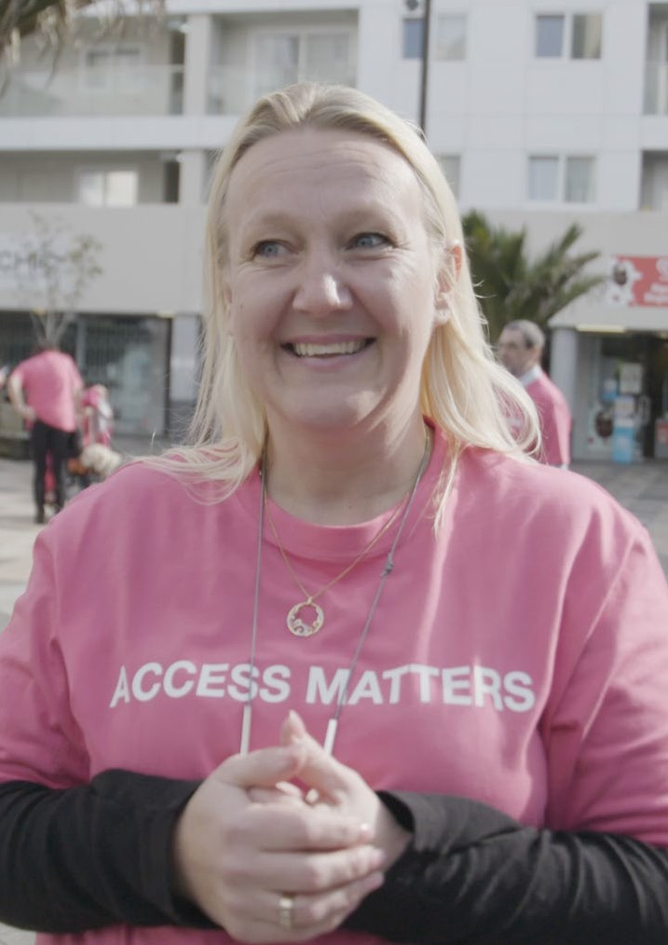

Portrait of Natasha

Natasha’s Story
I’m Natasha. Often when people see me, they don’t know that I can’t hear. I once had an experience on the train where it broke down. A few years ago my husband and I were going to the city. So we hopped on the train, but it stopped in Sylvia Park.
My husband and I looked at each other and thought “Hmmm, what’s going on, why has the train stopped?” We noticed a lot of people were getting off, but we still weren’t quite sure what was happening. We looked around once more and out the window, trying to figure out what was going on, but we still couldn’t. So we thought, we’ll just have to wait, we’re not there yet.
Suddenly, a conductor comes along and starts growling at us. I told her we were deaf, but she spoke so fast it wasn’t possible to hear what she was saying. Eventually, we understood we had to get off the train and go onto a bus - but we still had no idea why. In the end we found out that the train was broken.
But at the time, we couldn’t access that information. It’s really important for deaf people to be able to access that kind of information.
We really need to have much stronger legislation so that everybody can get to work, get to study, can get to school - wherever it is that they’re going. We want everyone to be able to go about their day-to-day business. And, everyone needs to have access to information at a much higher standard.
It’s really important that the government creates stronger accessibility legislation to make this a reality.
Access
Matters

Page 30
The Access Alliance

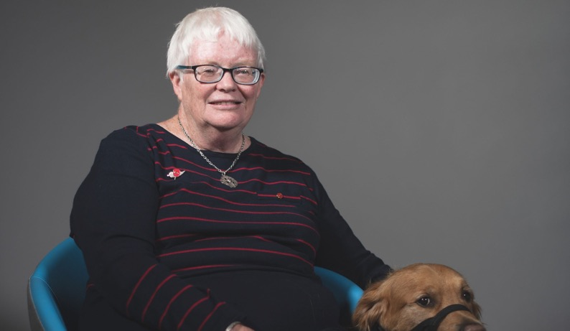

Susan’s Story
Portrait of Susan

My name is Susan. I live on my own in the Northern half of Hamilton with my guide dog. I need to be able to use the public transport system to get to appointments, meetings, and just to meet with friends for a coffee or attend a concert.
Recently, the bus company changed all the bus routes and added new ones in the northern suburbs. The bus I would usually take into town was changed from half hourly to hourly, and it also uses a slightly different route than it used to. This means I can seldom use this familiar route anymore and I find it harder to catch. When these changes happened in late January, I received one of those three way fold pamphlets with tiny maps and minuscule print in

The Access Alliance
Access
Matters

Page 31

the mail. I am vision impaired so there was no way I could read it. I did put it under my CCTV reader and discovered it only mentioned two of the routes that would affect me.
Since January, I have needed to plan every bus trip meticulously when taking a bus should be easy and not stressful. For instance, When I received an appointment at a medical centre in a suburb north of my place I was very anxious. I knew the bus route I normally took was quite different now. Ringing the help centre, hoping they could explain to me where the new buses went and what
direction they travelled in, I received incorrect information. Hardly any help was provided on-site at the bus stop.
When I finally managed to board what was apparently the correct bus, I discovered it went on a 35 minute trip around the suburbs when the old bus route normally took five minutes to get to the shopping centre.
Now well behind schedule, I had to run with my guide dog to the appointment in order to make it on time. This was quite distressing for me, particularly considering that the appointment was for a scan on a sore foot.
To be fair on the bus company, I was offered some help retrospectively after I complained about this incident. But when they were planning these changes they could have been more proactive advertising them in an accessible format. I think they should have made sure that all the local disability organisations were made totally aware
of these changes to the bus routes. Accessibility law reform could ensure that all information is available in an accessible format and is offered to those who require it in a timely manner so we can remain independent.
Access
Matters

Page 32

The Access Alliance

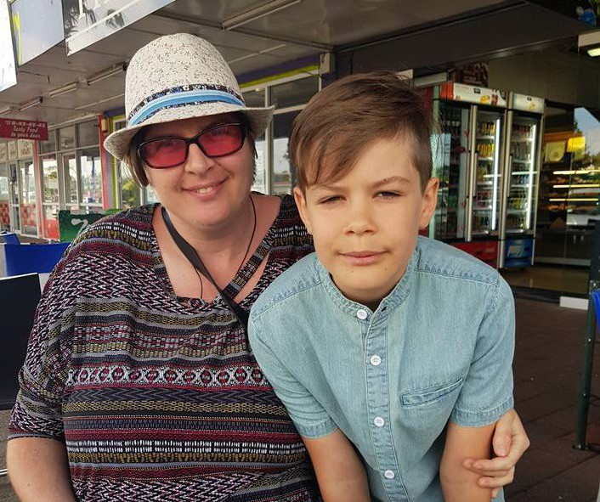

Gabby’s Story
Portrait of Gabby

I’m Gabby and I want to tell you what it is like going to the hospital for me and tens of thousands of other autistics and people with neurodiverse needs around the country. Going to the hospital and having surgery is traumatic enough – but imagine your diagnosis and treatment information isn’t presented to you in a format that is accessible, that hospital
staff don’t have adequate tools required to communicate with

The Access Alliance
Access
Matters

Page 33

you, and that the waiting rooms overload your senses.
Whenever I have appointments at the hospital, emergency department, with hospital staff, and my support workers I am faced with the same barriers.
Ahead of recent surgery, I was faced with inaccessible information about my upcoming surgery and staff that did not understand my Augmentative Alternative Communication needs. I was left waiting unsupported for ages in an environment that was not sensory-friendly causing me to head bang and self-bite while other members of the public could see me in distress.
I want an Accessibility for New Zealanders Act so we can have mandatory minimum standards for access to healthcare.
Hospitals could have sensory friendly rooms for patients waiting to be to be seen, where there is supervision from nurses. Staff should be trained in how to communicate with an individual who uses Augmentative Alternative Communication. The emergency department should have a basic visual symbols board available for AAC users to communicate what we need. Hospitals should develop easy read brochures on medical treatment and diagnosis and make this information accessible on a national website as well.
An accessibility for New Zealanders Act means safe and equal access to healthcare for everyone.

Page 34
Access
Matters
The Access Alliance

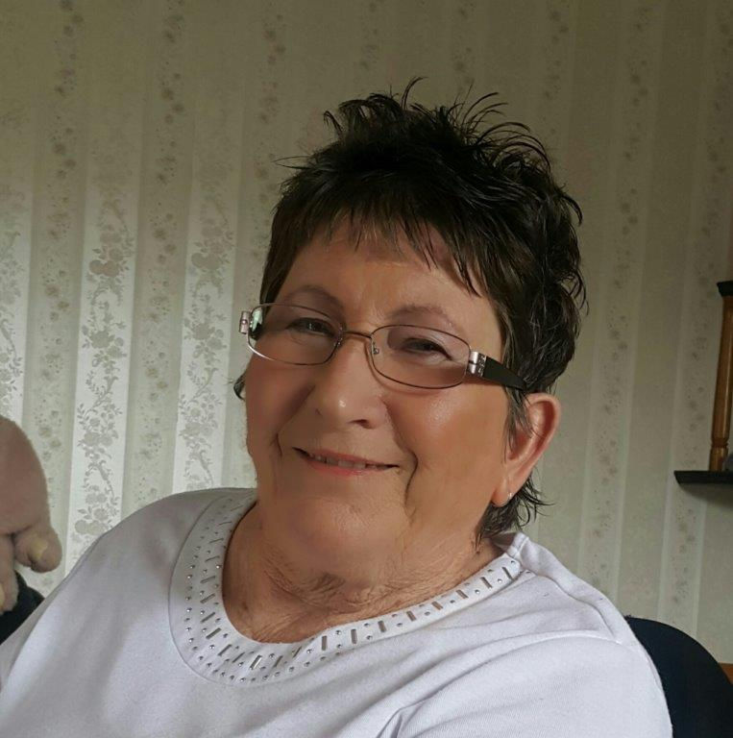

Portrait of Janette

Janette’s story
My name is Janette and I’m a wheelchair user.
It’s one of my ‘pet hates’ – the fact that my doctor has to come to my home to do a gynaecological examination – because medical centres often do not have a hoist to get me out of the wheelchair.
When that first happened, the doctors’ management team tried to charge me for a home visit, which I objected to, stating that it wasn’t my fault that they didn’t have a hoist. So now I pay for a normal medical centre visit when she comes to my home. However, I would like to see all medical centres supplied with hoists and trained to use them. This should be mandatory under an Accessibility Act or associated health regulations.
I am also no longer able to get chiropractic treatment, or get my back massaged, because neither of those groups have hoists either. The district nurses also don’t know how to use hoists, so when they come to do regular monthly procedures) they have to come first thing in the morning while I’m still in bed. This doesn’t always work for them and they get extremely annoyed when they want to come to me in an afternoon when they have spare time, but I have no support worker on hand to use the hoist for them.
I just want to be able to access available Healthcare services as those not requiring hoists already can. Thus mandatory hoist regulations should also cover massage and chiropractor facilities, as well as training for district nurses.
Access
Matters

Page 36
The Access Alliance

Sudima Hotels and Resorts and Hind Management support the Access Matters campaign. Here’s why.

Sudima Hotels & Resorts believe it is essential for all businesses to provide equal access for all customers regardless of whether or not they have permanent
or temporary access needs. It is important to us, and indeed the whole tourism industry, that our hotels and surroundings are accessible for all visitors to enjoy. Our hospitality and tourism industries cannot viably survive if certain Kiwis and tourists are denied the ability to fully experience what we and New Zealand have to offer.

Sudima Hotels & Resorts believes that all guests should be able to enjoy every aspect of its hotel’s facilities regardless of their individual needs. The team incorporates an ‘accessibility mindset’ in all facets of its business – from building design, procurement, human resources to guest experience. To this end, it became the only group of hotels in New Zealand to undergo accessibility assessments by social change organisation Be. Accessible, and each hotel has an accessibility rating of between Bronze and Gold.
The group is making continuous improvements to surpass expectations and set industry benchmarks. The cost of integrating better accessibility into our businesses has

The Access Alliance
Access
Matters

Page 37

been minimal and we are now able to better cater for the needs of all guests.

Sudima Hotels & Resorts has a number of ambitious goals for the future and strives to offer the best service it possibly can. Over and above the improvements made to its group of existing hotels to achieve accessibility ratings, the group has introduced a number of initiatives to improve its guests’ experiences. This includes offering special packs for assistance dogs with dog beds and treats; menus are available in Braille; evacuation chairs that are capable of travelling up and down stairs have been installed; and vibrating alarms are available which can be placed under a guests pillow to help ensure a fire alarm is not missed. It has an inclusive and diverse workforce and invests in educating staff on responding and adapting to social changes, which equips them
with the knowledge and ability to handle all manner of scenarios and customer needs. It is the culmination of all of these aspects which has resulted in growth of business, in the essentially untapped accessibility market.

With nearly one in four of our population living with an access need it is imperative that the government
introduces accessibility legislation. Such legislation will not only be a step towards an all inclusive society, but it will also grow our economy as we have found from our own experience.

Sudesh Jhunjhnuwala (Founder & CEO) & Les Morgan (Director of Hotels)
Access
Matters

Page 38
The Access Alliance

Businesses that stand with us

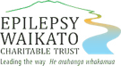

Aura
Enrich Plus Epilepsy Waikato
Charitable Trust

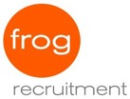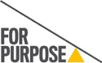

Frog Recruitment
For Purpose
Genesis Energy

Parent to Parent Salt YMCA

The Better Drinks Co.
Sudima Hotels & Resorts
NZ. View

Page 39

Member Organisations

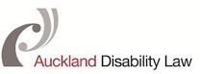

Auckland Disability Law

Deaf Aotearoa NZ

Disabled Persons Assembly NZ

The National Foundation for the Deaf Inc.

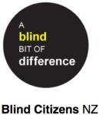
Blind Citizens NZ

Cerebral Palsy Society

Inclusive NZ

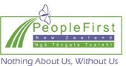
People First

Page 40

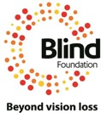
Blind Foundation

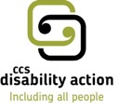
CCS Disability Action

Kapo Maori Aotearoa New Zealand Inc.

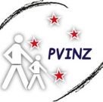
Parents of Vision Impaired (NZ) Inc.

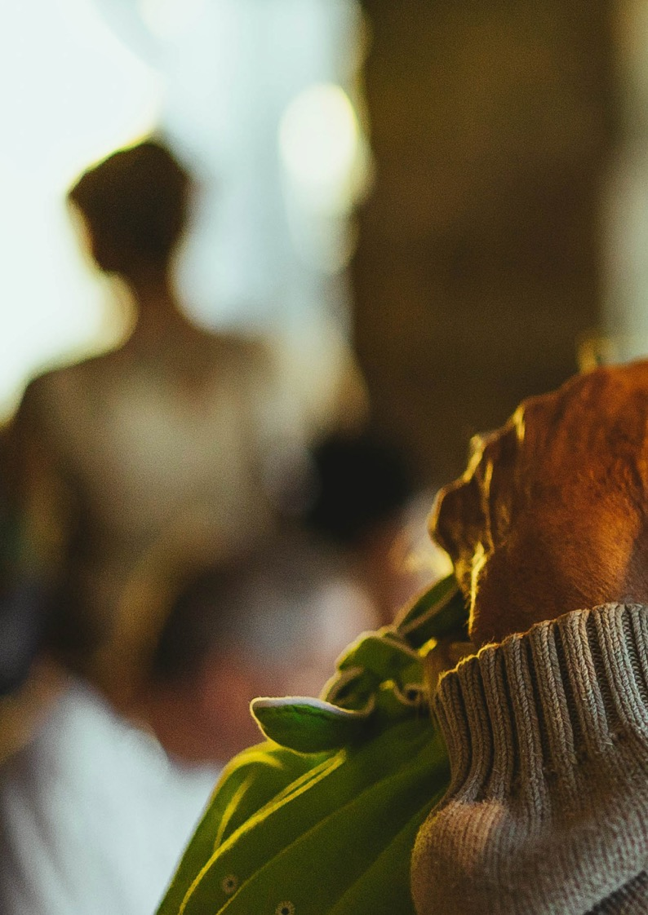
The Access Alliance
Access
Matters
The Access Alliance
website: accessalliance.org.nz
social media: @AccessForAllNZ

