#AccessLaw2020

Social Media Toolkit

It’s Time!

Thank you for your sustained efforts so far on the campaign for Accessibility Legislation. We share your vision for a fully accessible New Zealand, where everyone can learn, work and participate in every facet of life.

In 2018 the government committed to designing an approach to achieve a fully accessible New Zealand, including how legislation could help achieve this. - it’s now time for the government to make good its commitment.

In order to achieve Access Law in this term of government we need it to be seen as an urgent priority, from the Minister of Disability, across the government and the opposition. Now is the time to put Accessibility on the agenda for 2020.

Add your voice to the call for #AccessLaw2020. To save you precious time, we have prepared a few easy social media posts for you to share with your local MP.

Instagram

It’s Time! Show your support for an Accessibility Law in NZ! Please like, share, save and tag @csepuloni #AccessLaw2020

Can’t See Accessibility Legislation in NZ? Let @csepuloni Know It’s Time For #AccessLaw2020 Please like, share, and save this post

URGENT! Time is running out! Tell @csepuloni you support #AccessLaw2020 Please like, share, and save this post

Join the call for an Accessibility Act in 2020 @csepuloni Support #AccessLaw2020 Please like, share, and save this post

Instagram social media tiles

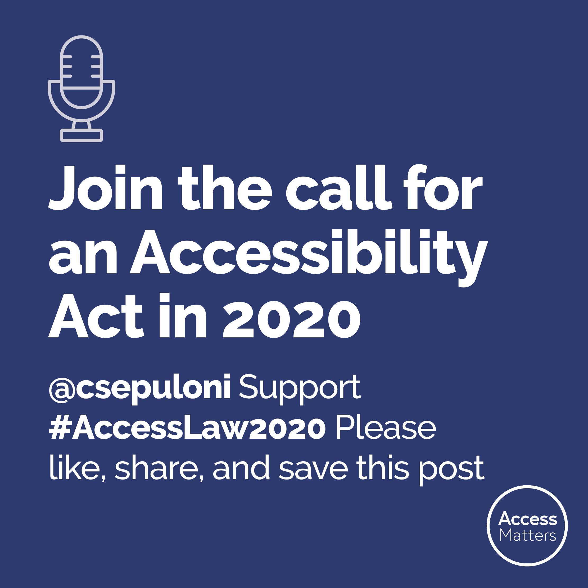
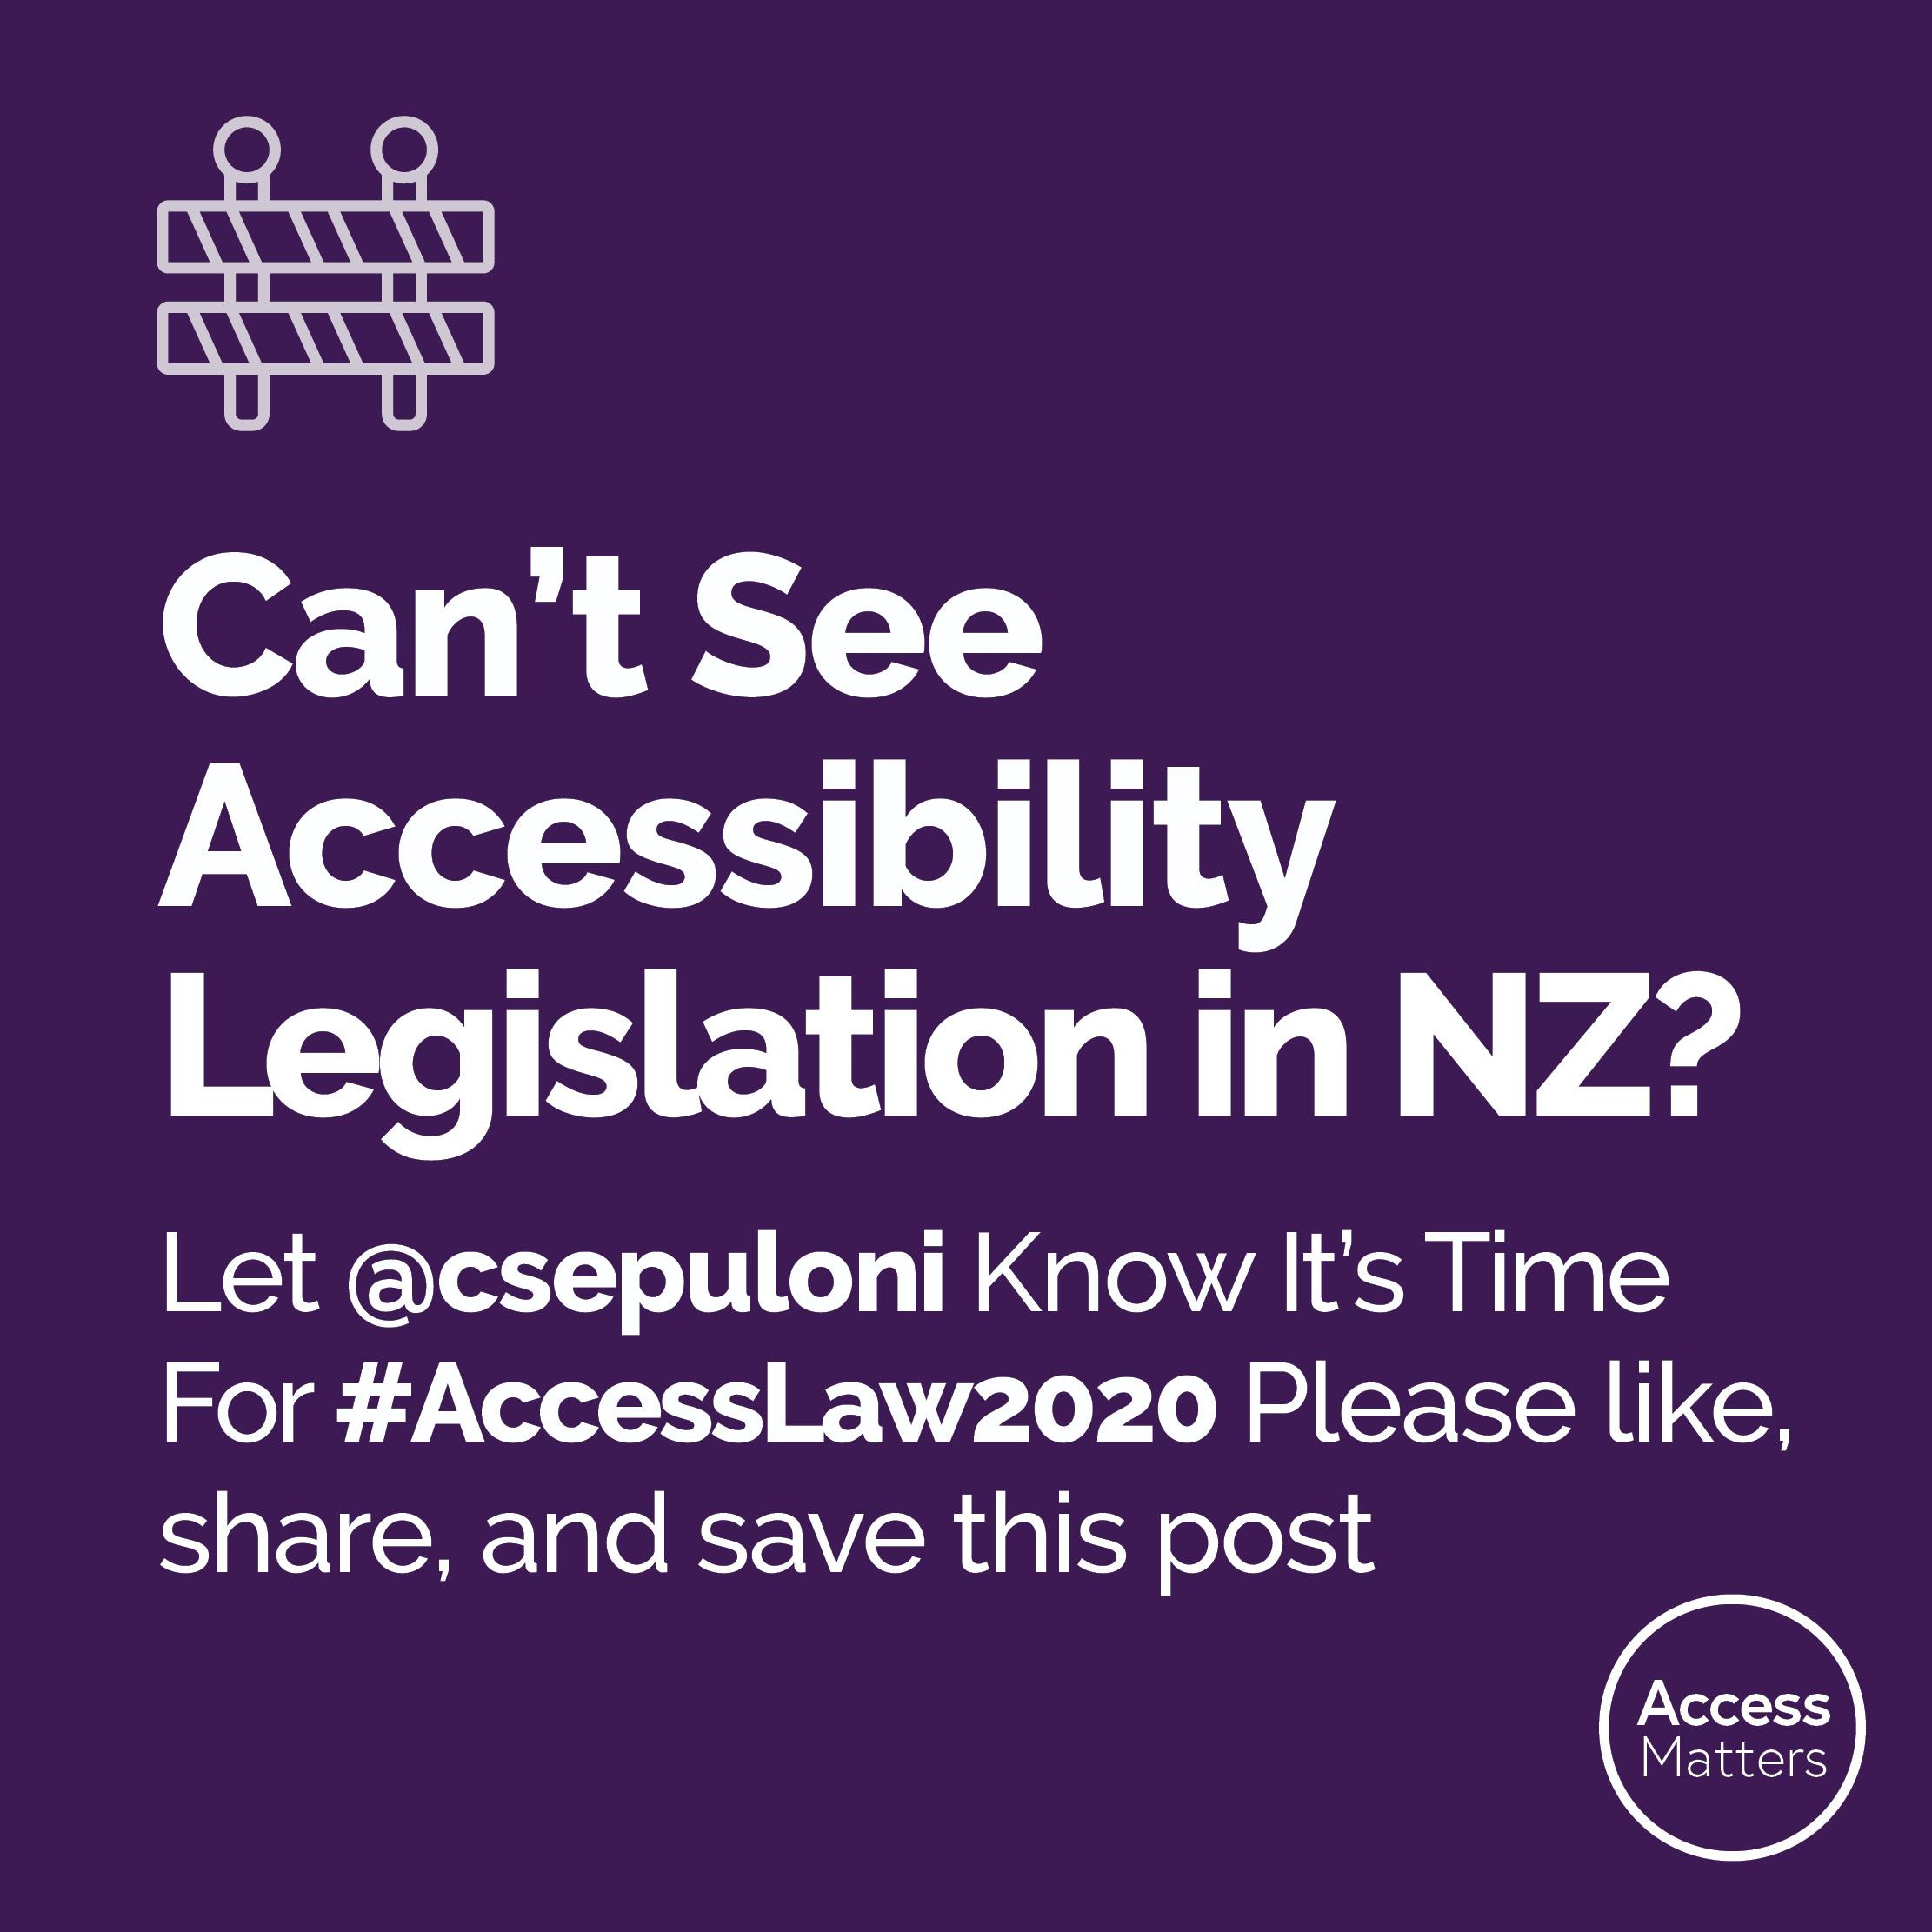
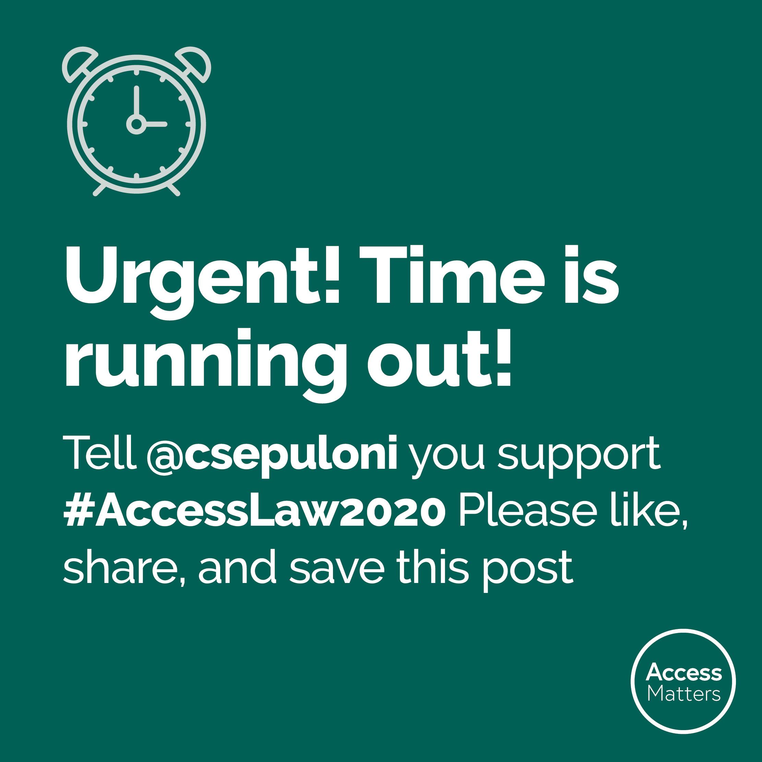
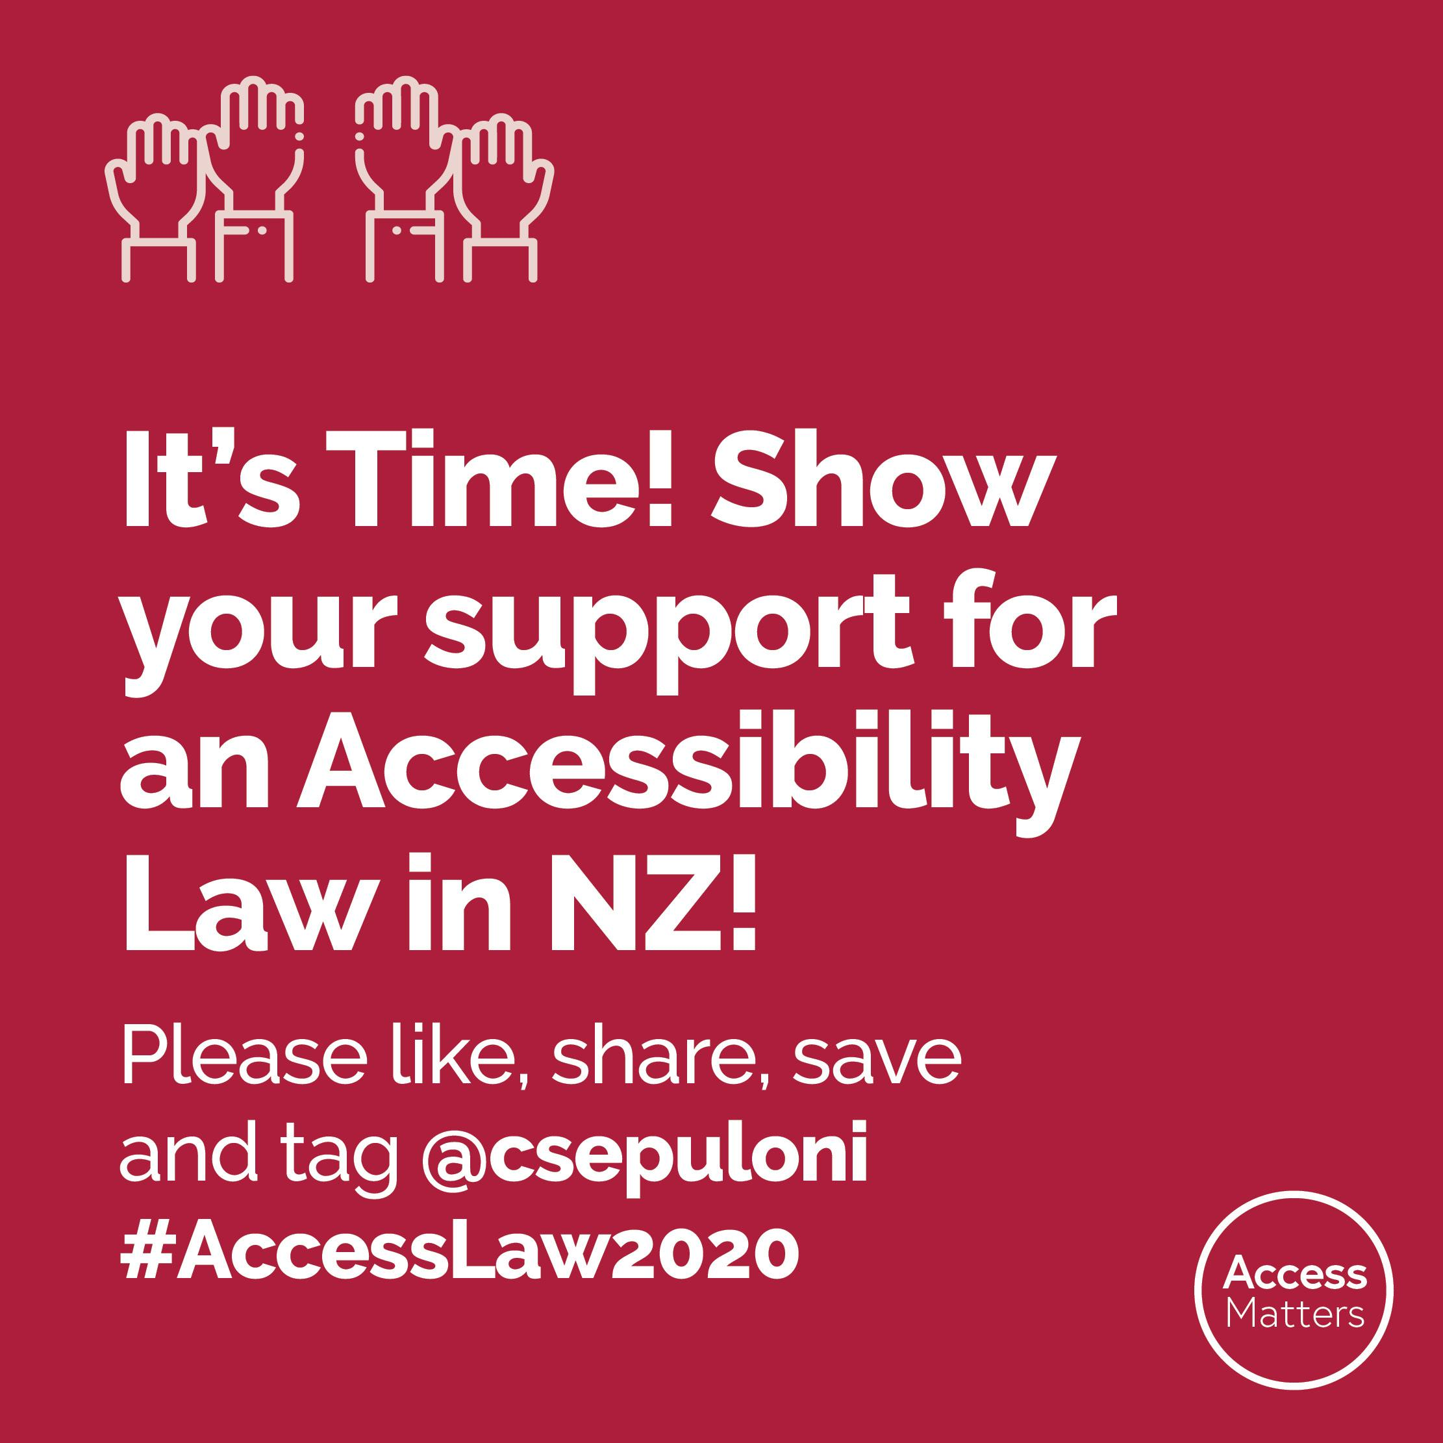
Link to download Instagram social media tiles

Facebook
It’s Time! Show your support for an Accessibility Law in NZ! Please like, share, save and tag @CarmelSepuloniLabour #AccessLaw2020

Can’t See Accessibility Legislation in NZ? Let @CarmelSepuloniLabour know it’s time for #AccessLaw2020 Please like, share, and save this post

URGENT! Time Is Running Out! Tell @CarmelSepuloniLabour You support #AccessLaw2020 Please like, share, and save this post

Join the call for an Accessibility Act in 2020! Ask @CarmelSepuloniLabour to support #AccessLaw2020 Please like, share, and save this post

Facebook social media tiles
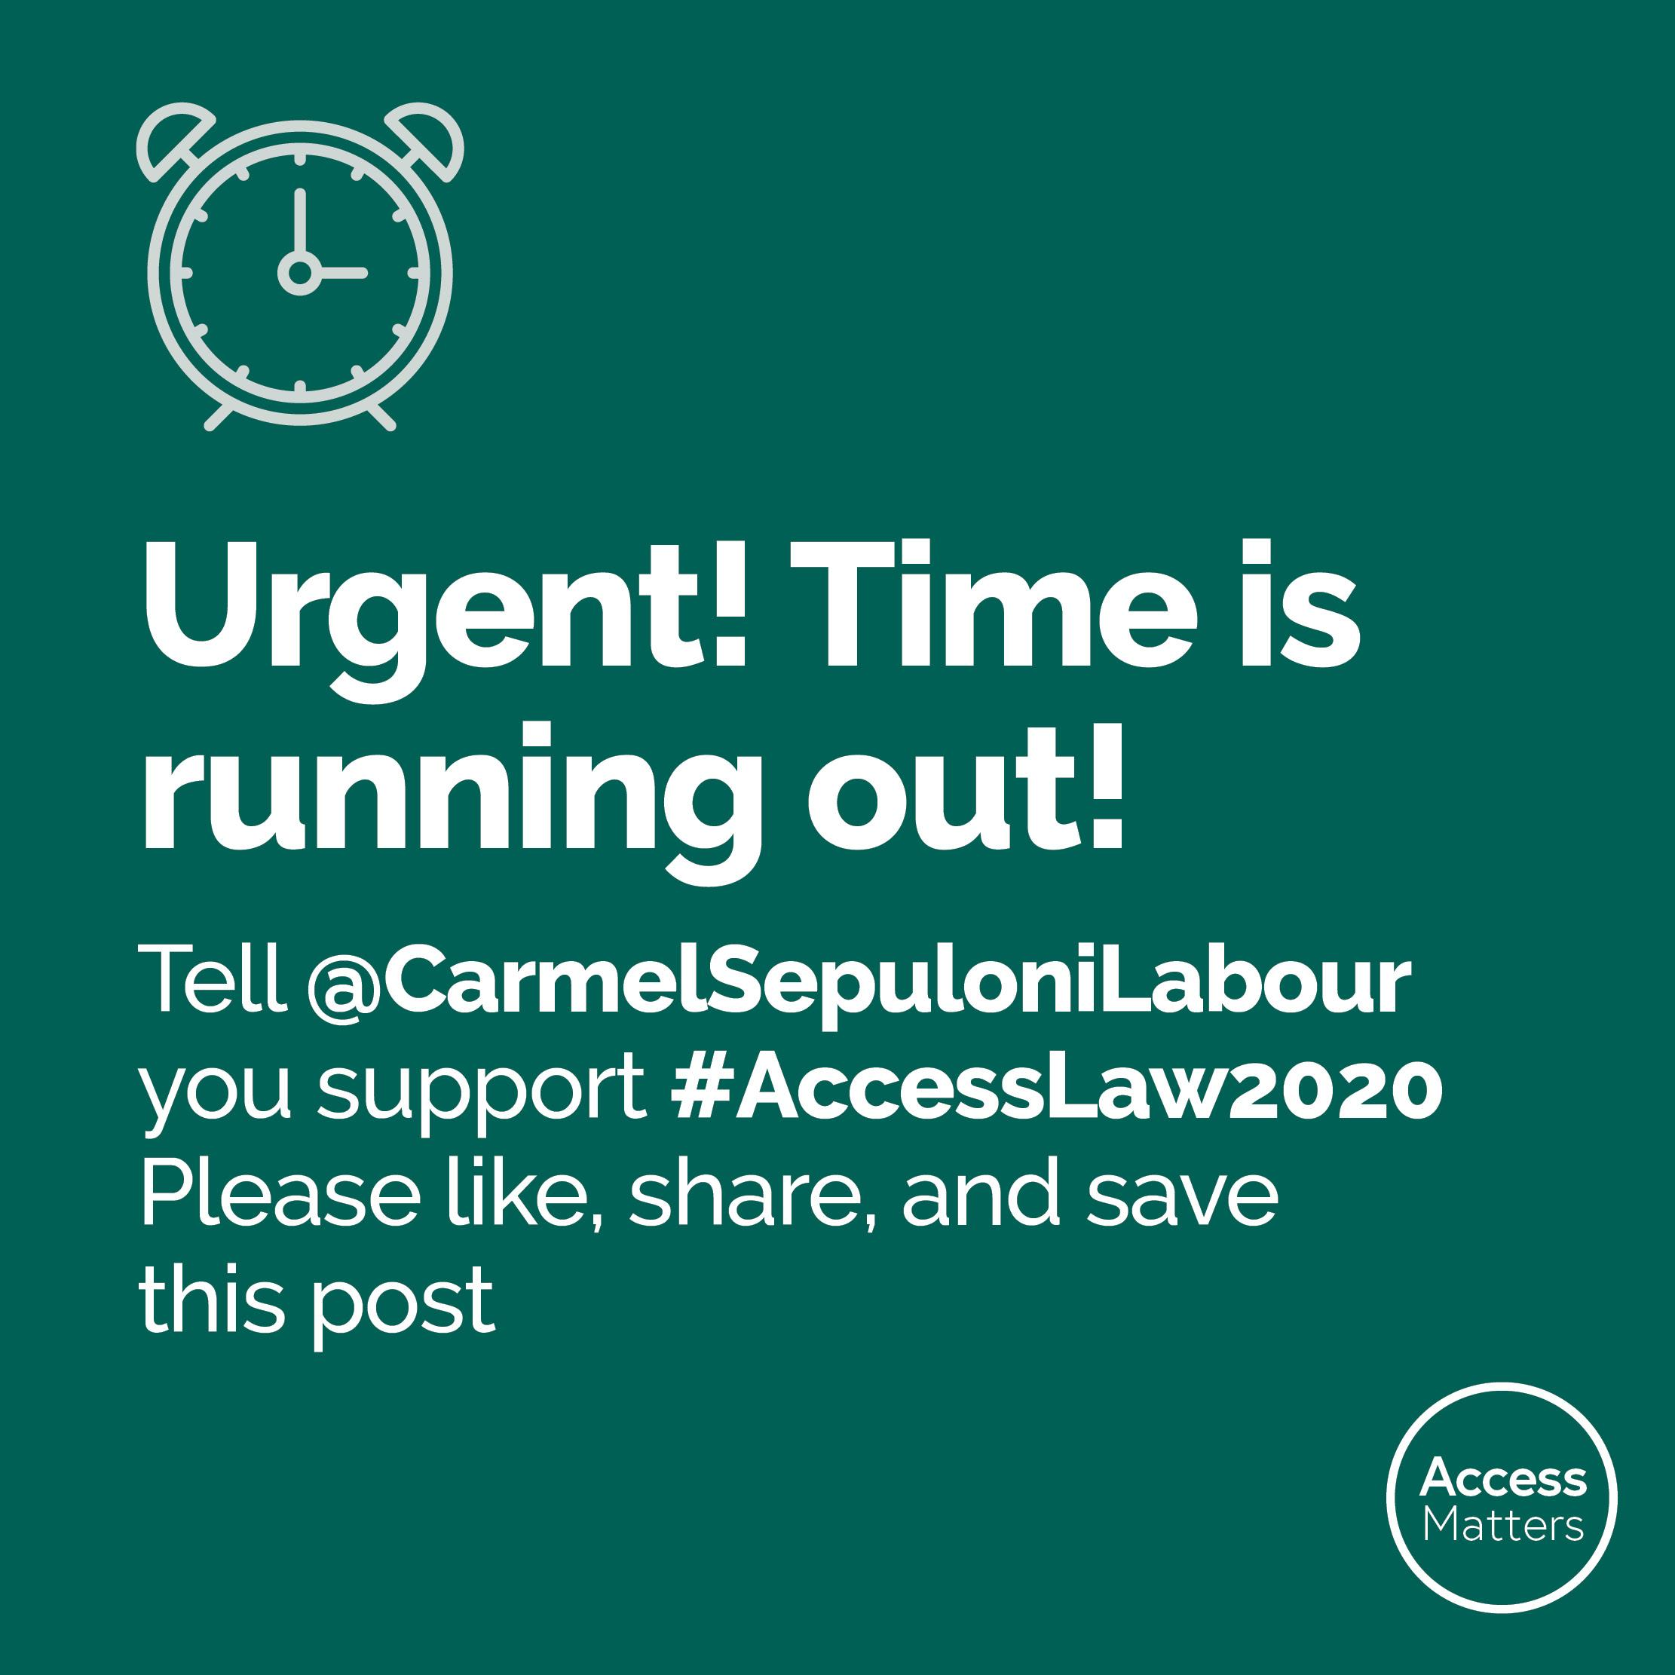
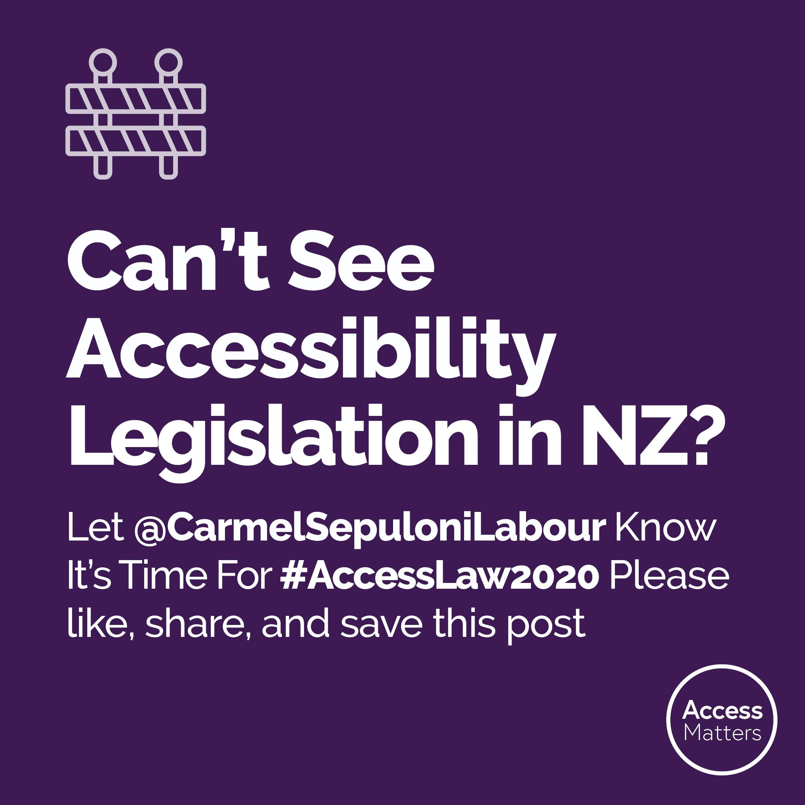
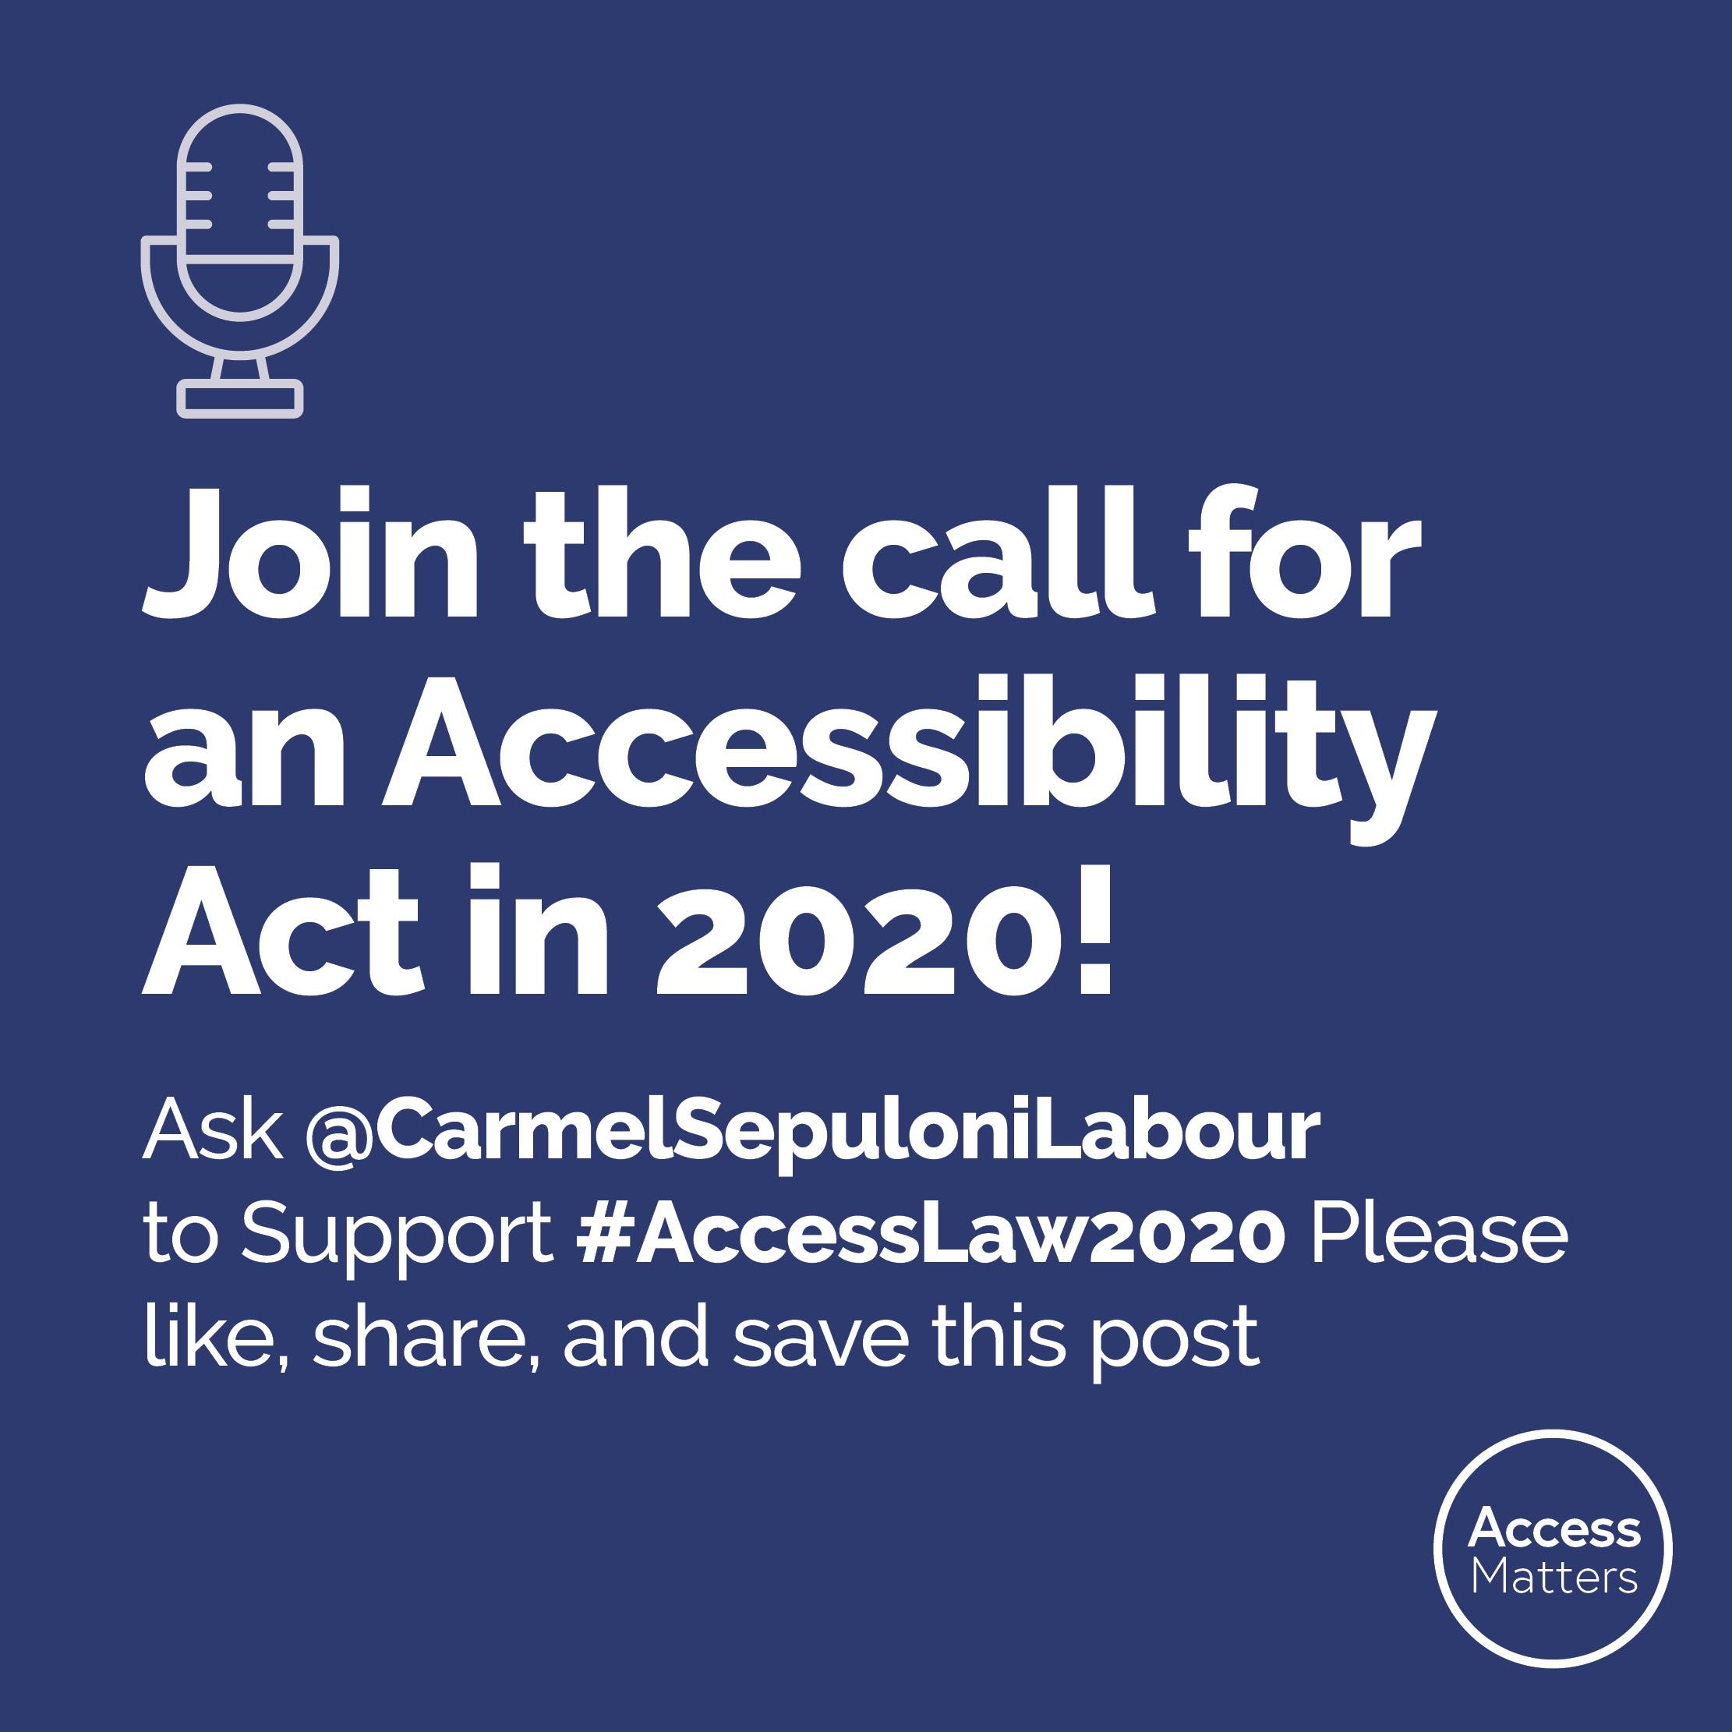
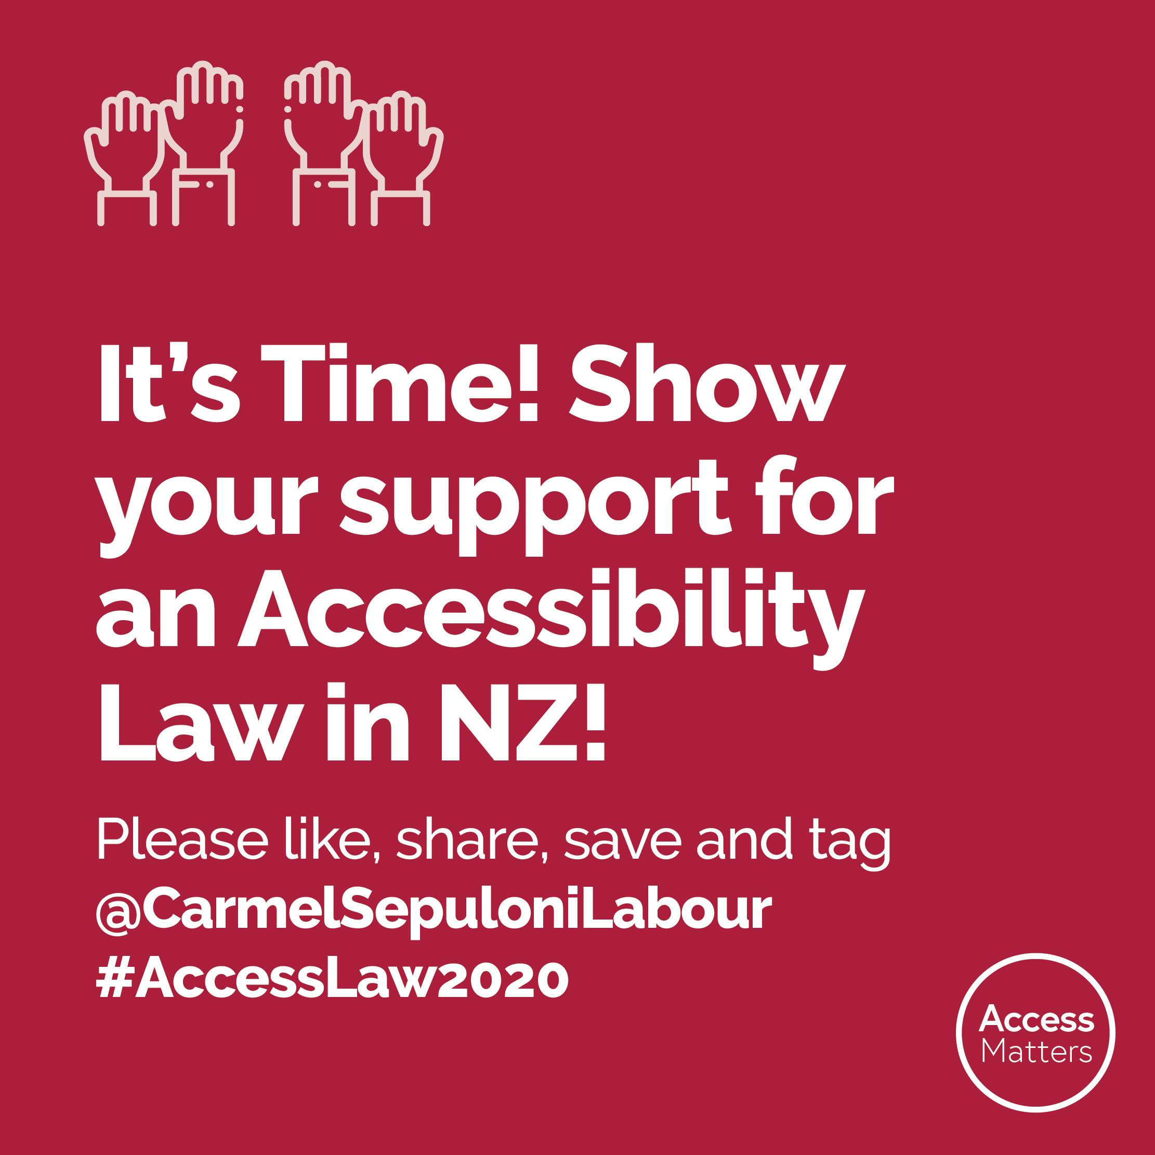
Link to download Facebook social medial tiles

Twitter

It’s Time! Show your support for Accessibility Law in NZ! Please like, retweet and tag @carmelsepuloni #AccessLaw2020

Can’t see Accessibility Legislation in NZ? Let @carmelsepuloni know it’s time for #AccessLaw2020 Please like, retweet & bookmark this post

URGENT! Time Is Running Out! Tell @carmelsepuloni you support #AccessLaw2020 Please like, retweet and bookmark this post

Join the call for an Accessibility Act in 2020! Ask @carmelsepuloni to support #AccessLaw2020 Please like, retweet and bookmark this post

Twitter social media tiles
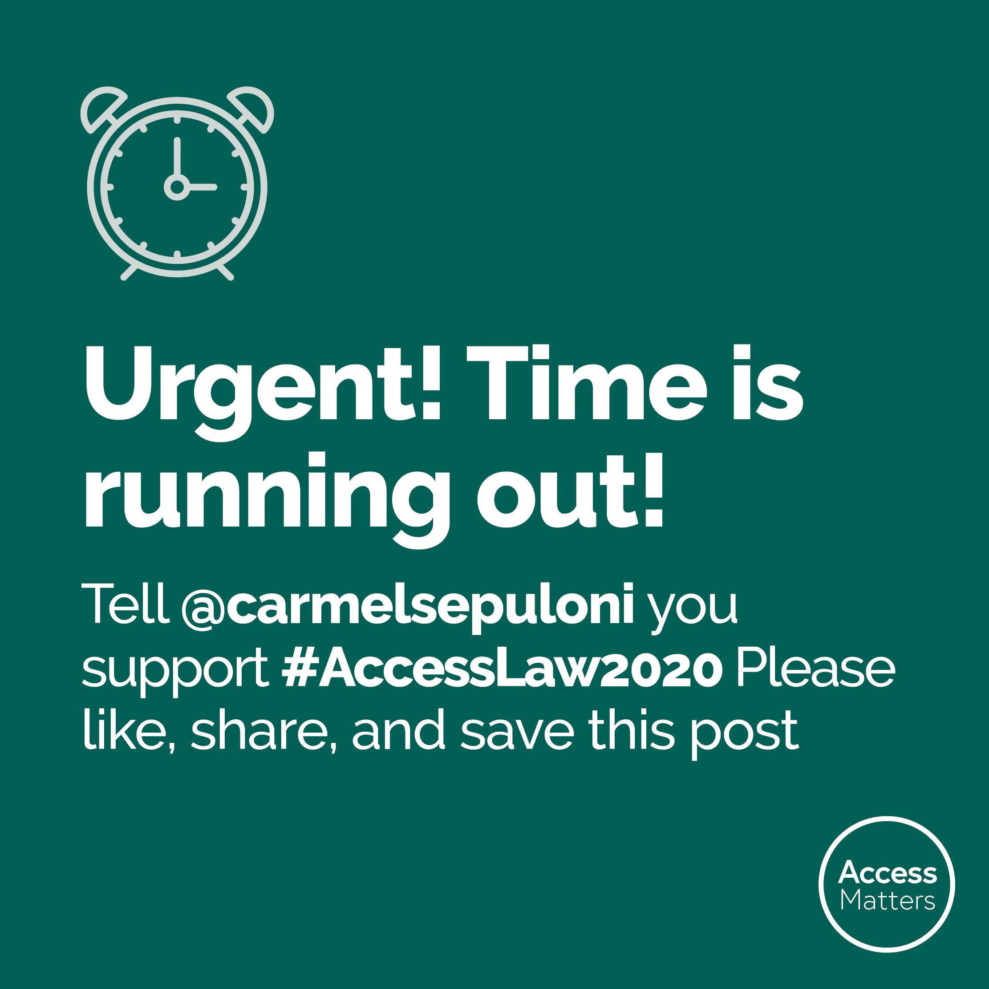
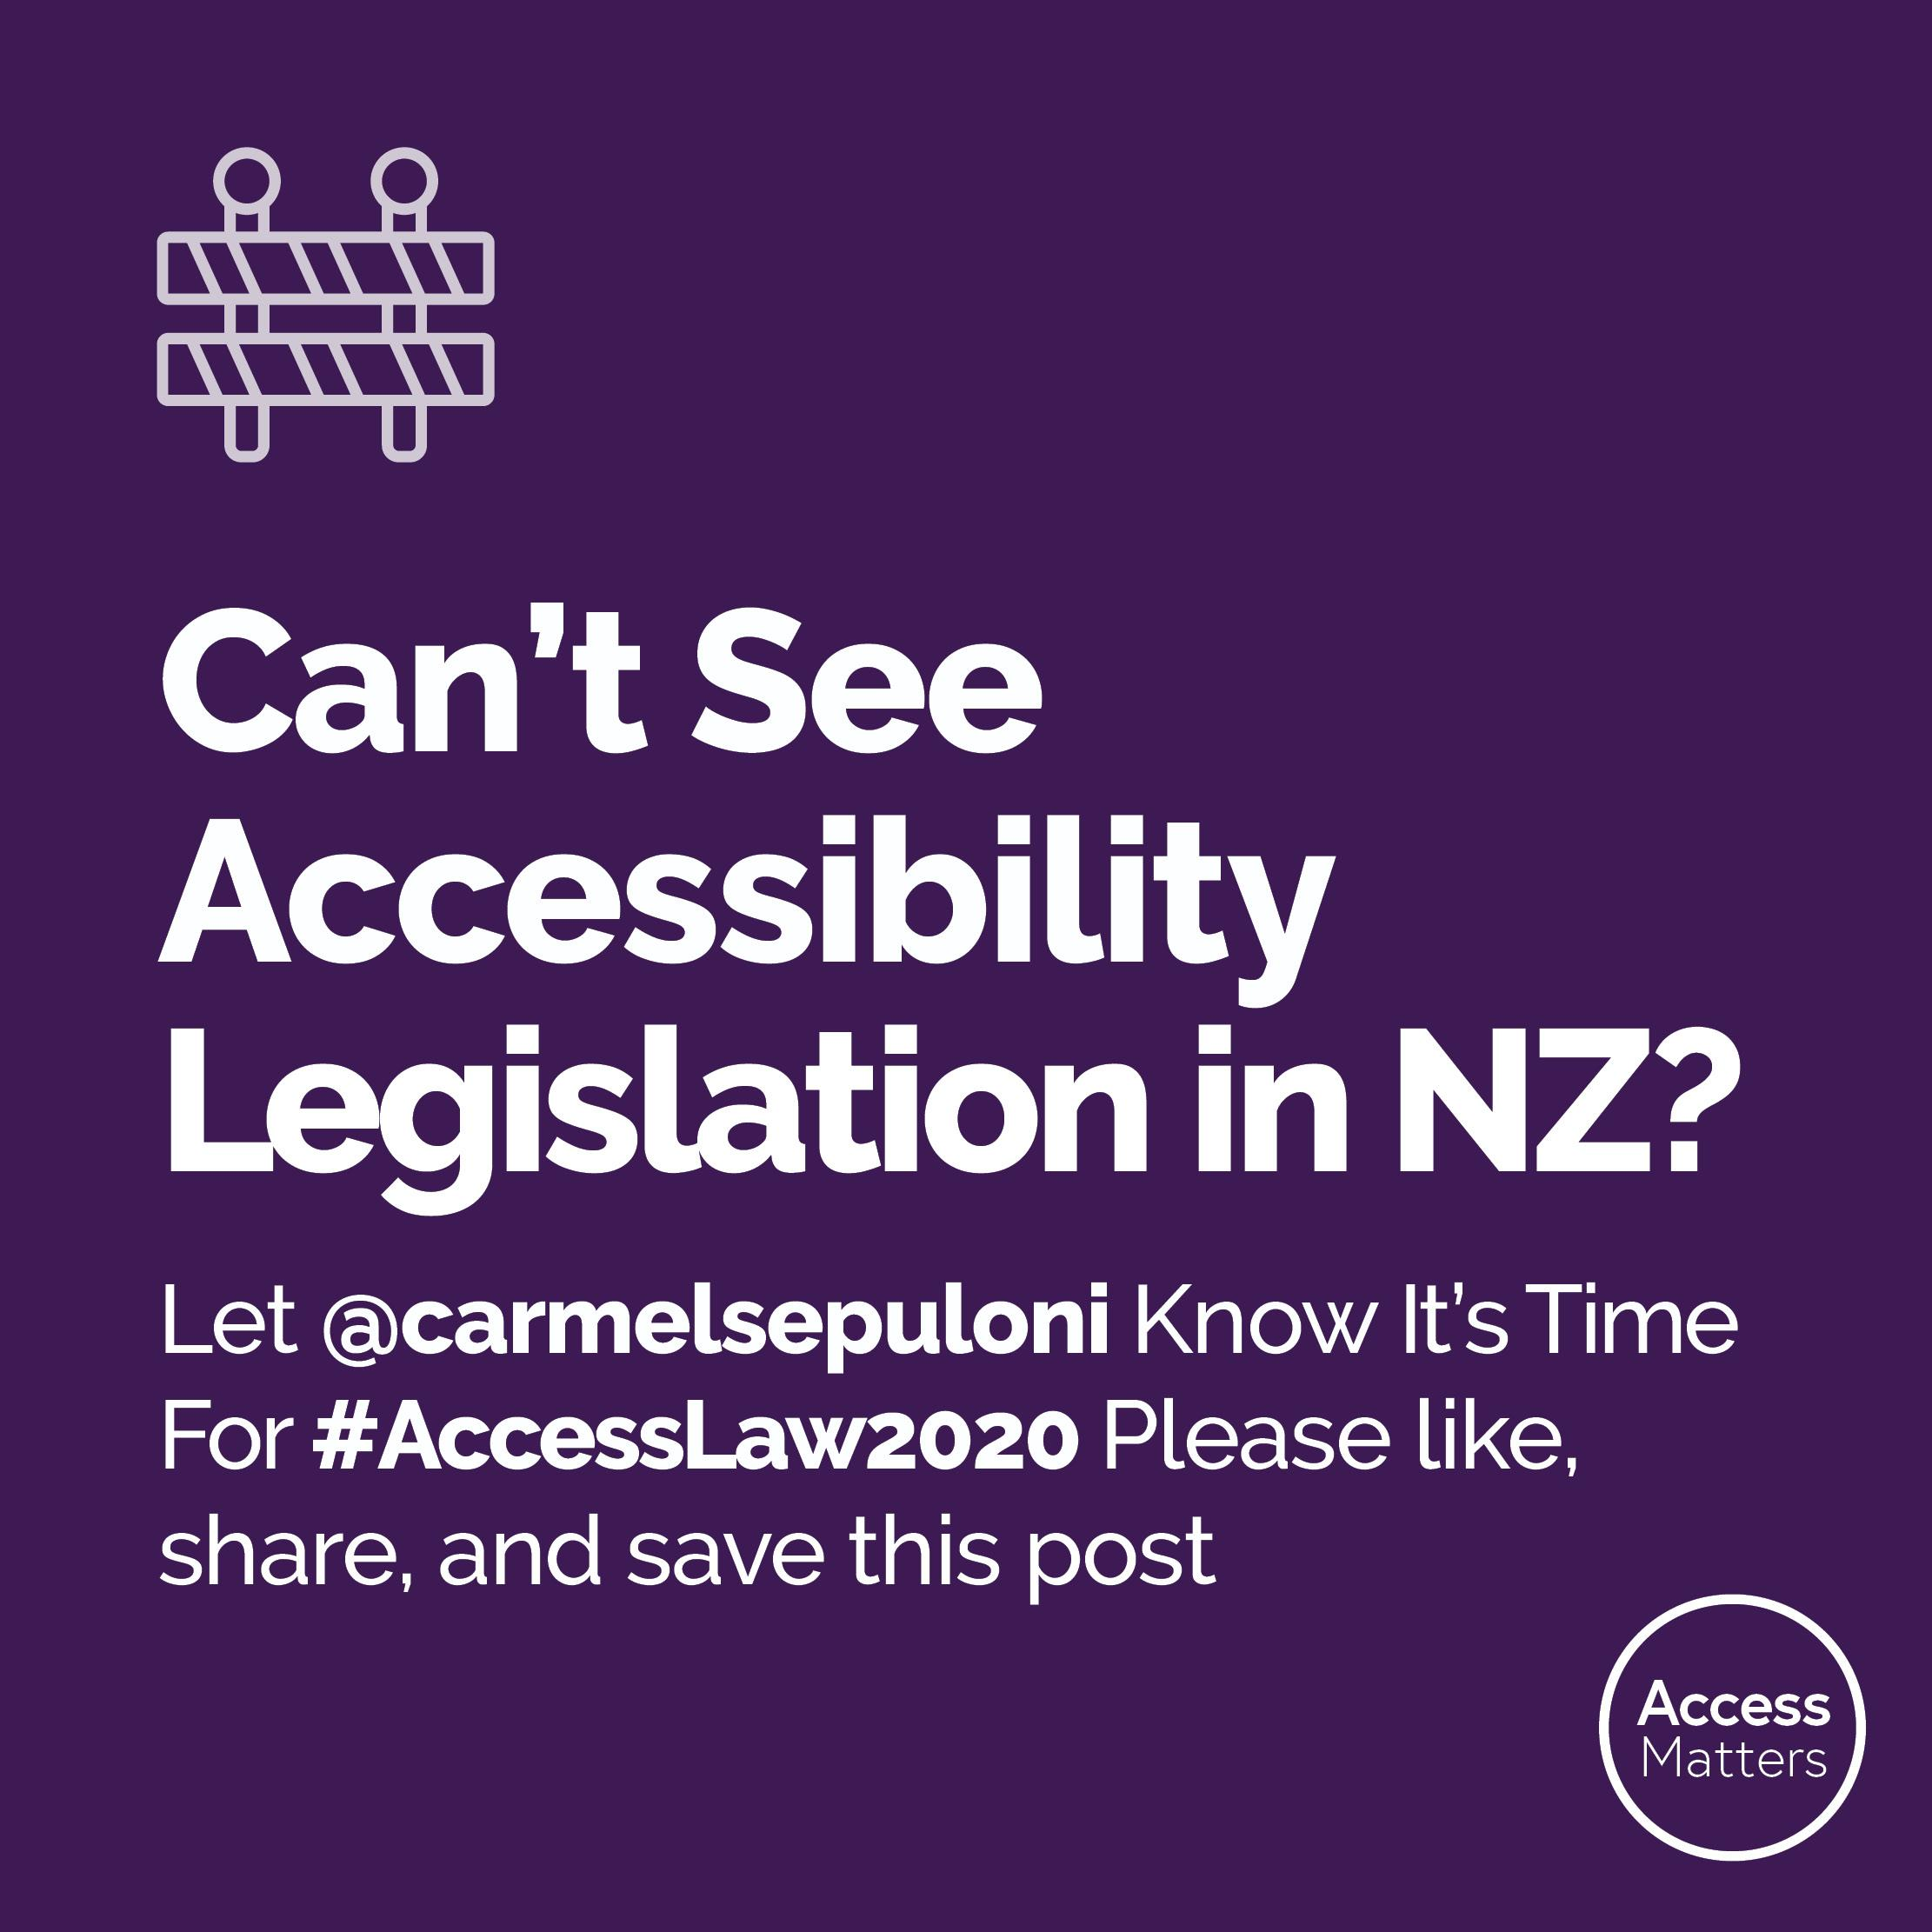
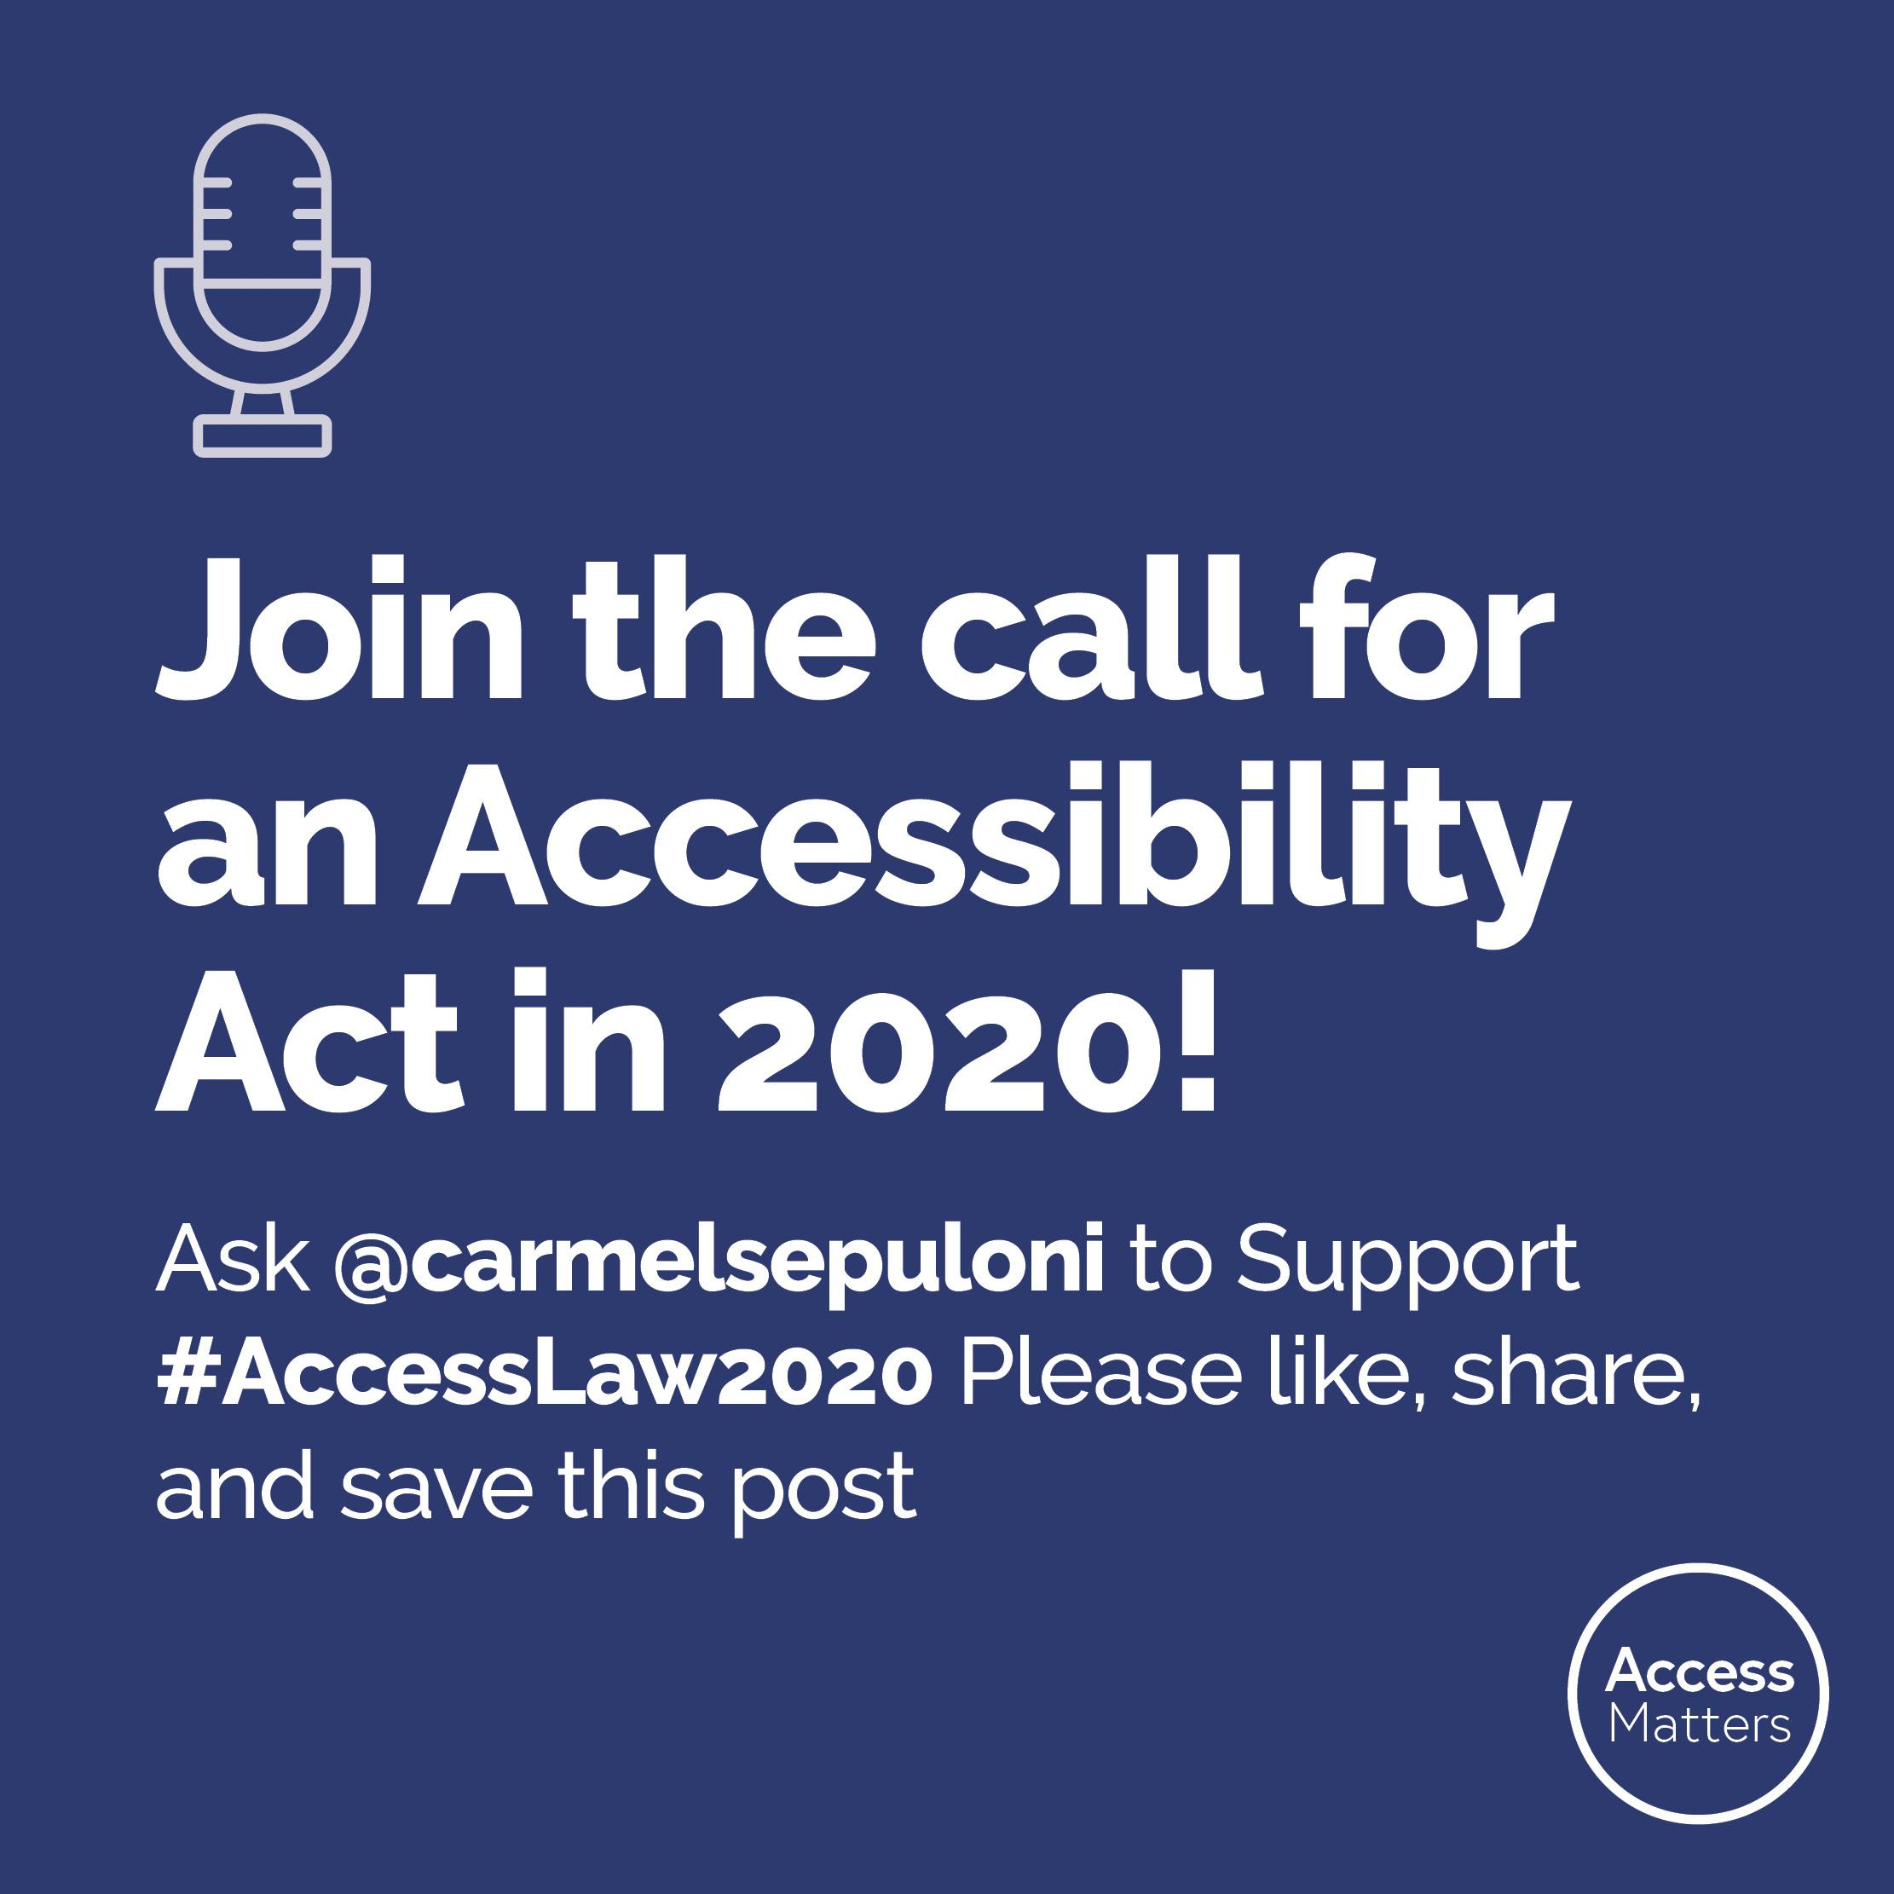
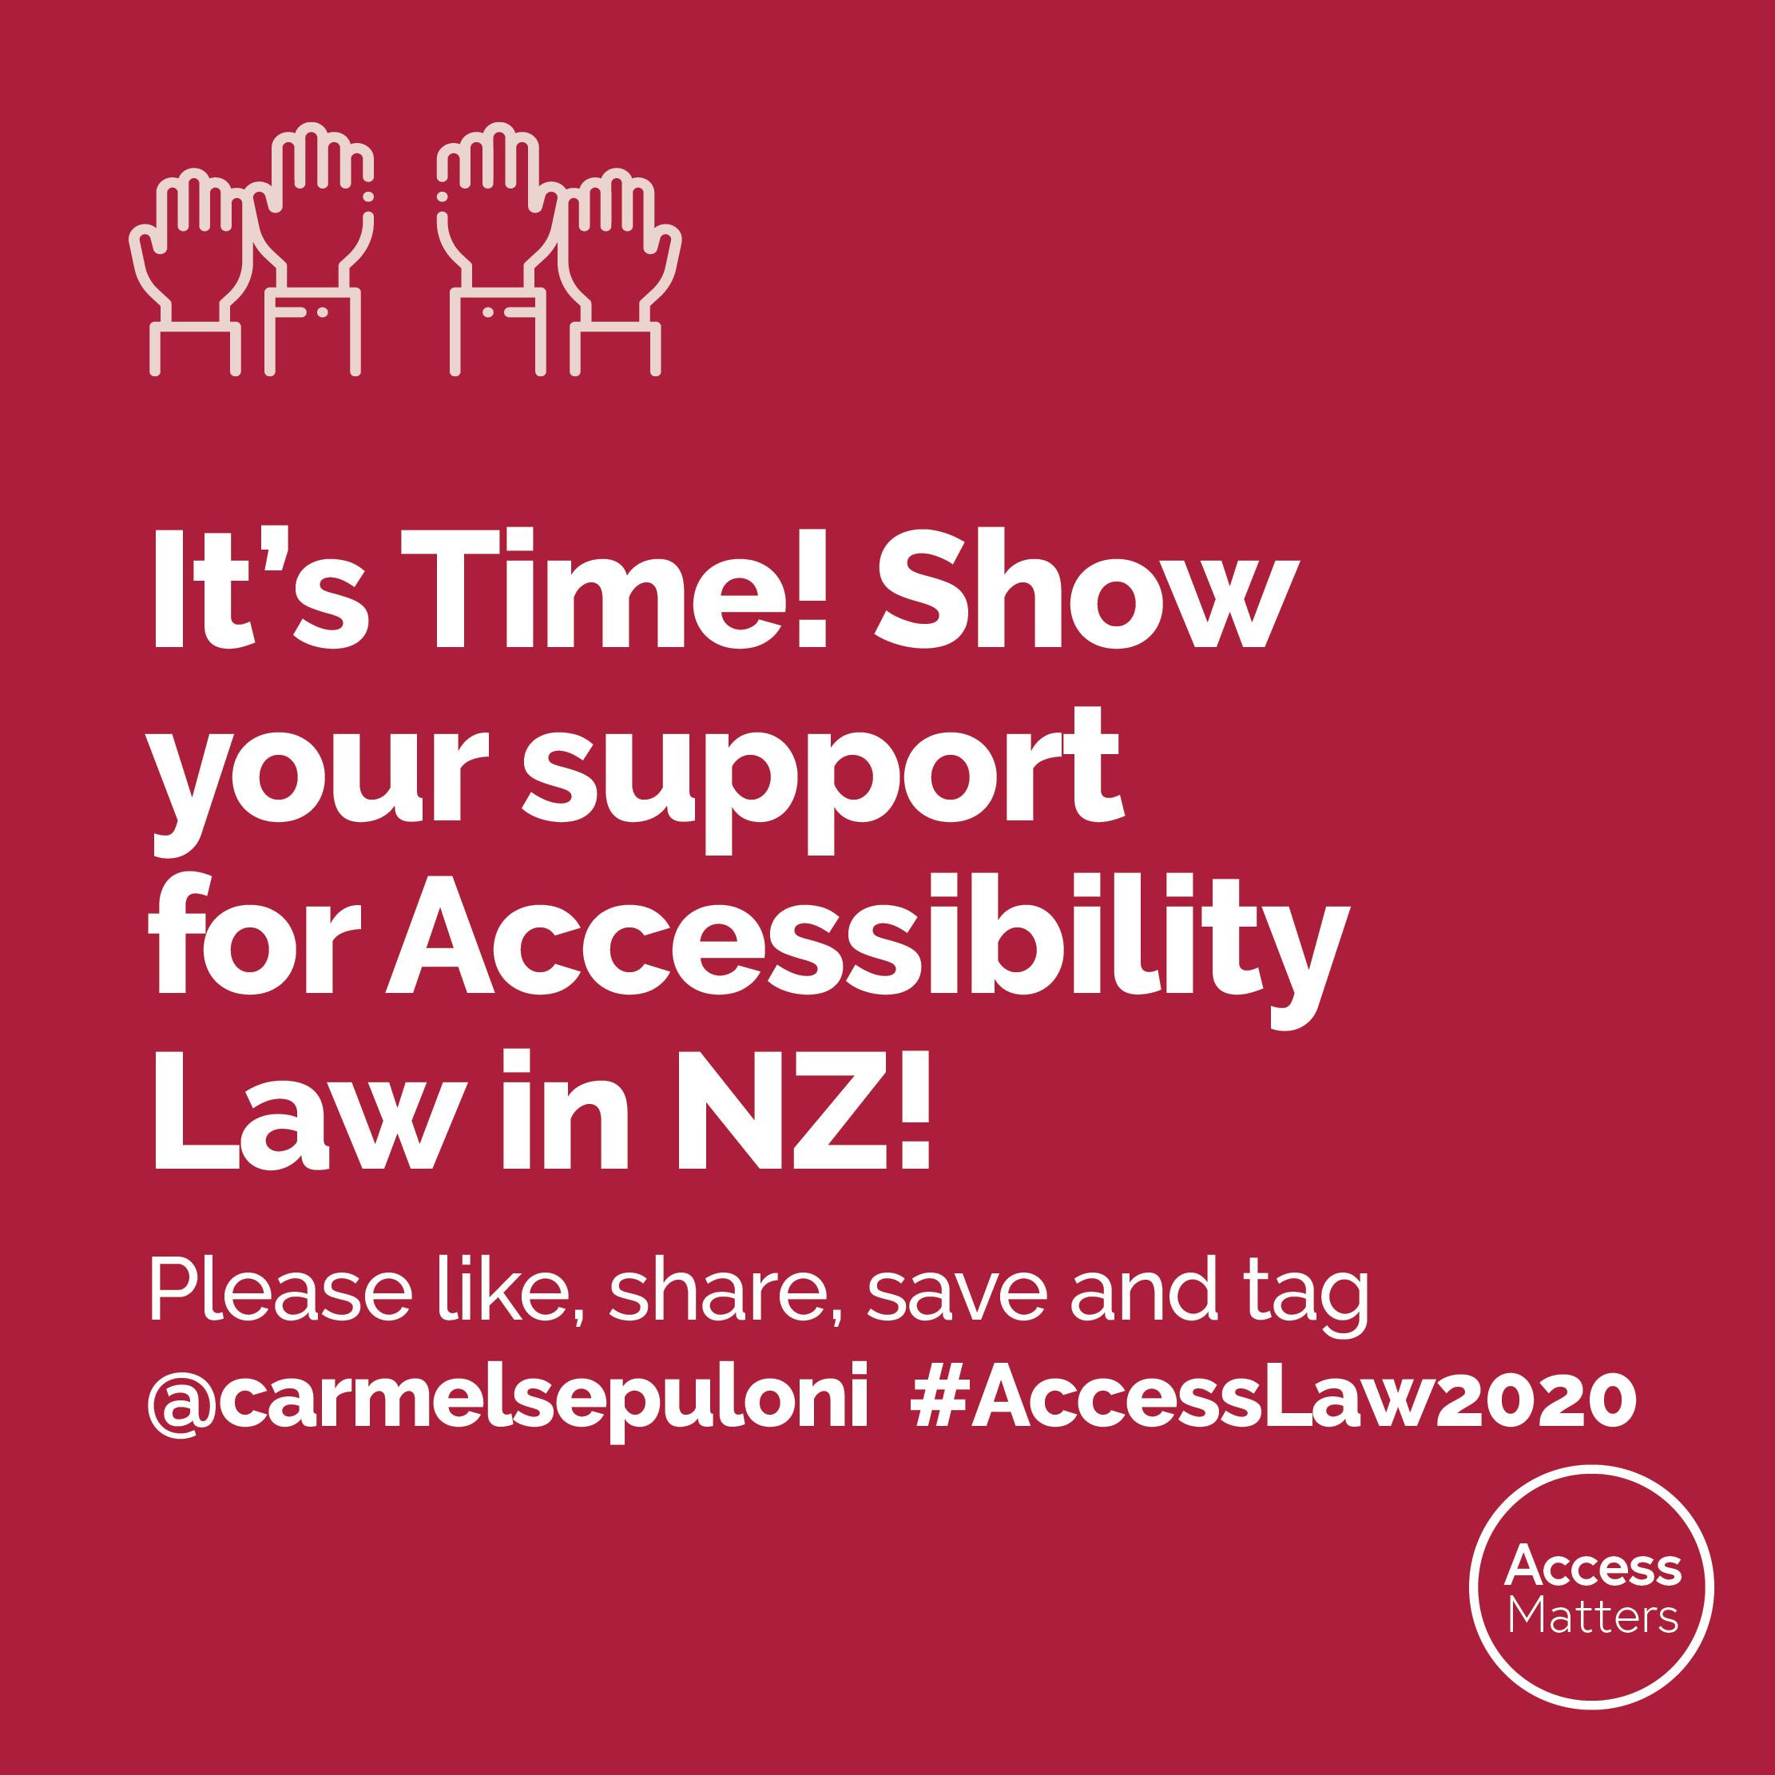
Link to download Twitter social media tiles

Email
Here is some draft text you can edit and send to your local MP (or any MP). It will be most effective if you personalise it. You can find links to MP’s email addresses and other contact details on our website: https://www.accessalliance.org.nz/ask_mps or on the Parliament website.

Subject: I urgently need your support on Accessibility Law

Kia Ora _________________ [insert MP name here]

In 2018 the government committed to designing an approach to create a fully accessible New Zealand. It’s now time for the government to make good its commitment.

Accessibility Legislation will help create a more inclusive Aotearoa New Zealand, lifting the economic and social outcomes for everyone by removing the barriers that people with disabilities, seniors, Māori, migrants, people with English as a second language, and those with temporary injuries face on a daily basis.

This directly affects me ___________________________ [insert personal experiences here]

I am asking you to show your support for #AccessLaw2020 by:
- Showing your support on social media using the hashtag #AccessLaw2020
- Telling your Disability Issues spokesperson why you support the introduction of Accessibility Legislation in this parliamentary term.

We have a chance to make history - please don’t let this opportunity pass by.

I would love to meet with you to discuss this further.

Thank you for your time.

______________________ [Insert your name and social media handles here]

