Price and Promotion
FACTSHEET ON EXCISE TAXES AND MINIMUM UNIT PRICE
- Excise Taxes
Like cigarettes, our Government puts a tax on alcohol which is sold in New Zealand. The tax is collected on all alcohol imported into or manufactured in our country.
In 2017, the Government collected over $980 million from alcohol excise taxes [1]. This compares to $1,710 million from tobacco excise taxes. Like smoking, it is important to note that this revenue does not match the excessive cost of alcohol harm in our society.
The amount of tax is mostly determined by how much alcohol is in the product which is being sold . The diagram in the next page shows the percentage of the retail price that is made up by excise tax. For example, excise tax makes up about 45% of the retail price of a popular vodka bought at an off-licence, but less than 20% of the retail price of off-licence beer and less than 13% of the retail price of off-licence wine. These figures are lower than the tax paid on cigarettes – whereby between 63% and 74% of the retail price of cigarettes is excise tax.
However, because it is alcohol companies that are required to pay excise taxes they may not always pass on any tax increase to the consumer. Rather, they may choose to absorb the increased costs themselves. This is important to realise when it comes to taking action to increase the amount of excise tax on alcohol. As an example, just because a 50% increase in excise tax should raise the retail price of alcohol by 10%, the real price paid at an outlet may not go up by 10%. For this reason, other approaches such as minimum unit pricing are useful.

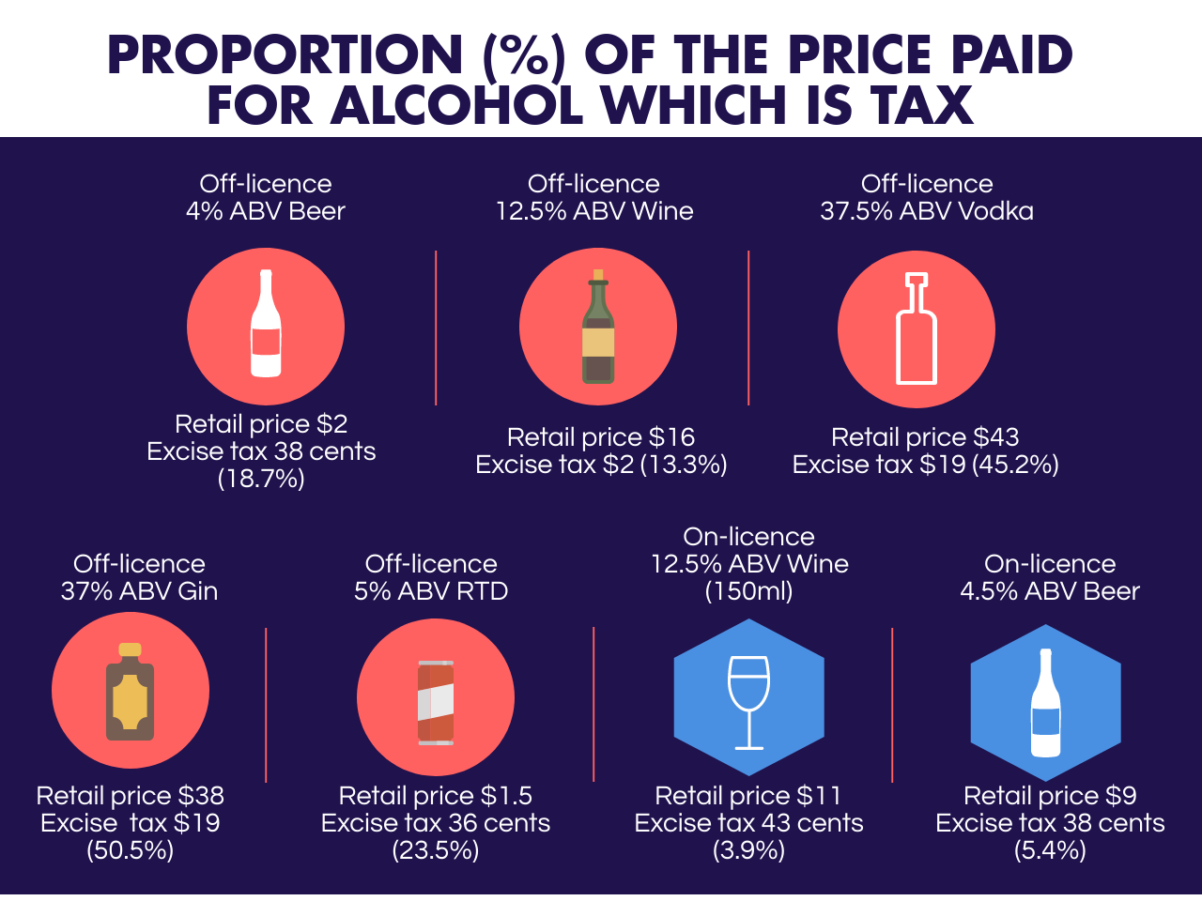
In 2010, the Law Commission recommended that excise taxes needed to increase by at least 50%, which would have the effect of raising the overall price of alcohol by around 10% [2]. This level of increase was estimated to reduce overall alcohol consumption in society by around 5%. In 2014, the Ministry of Justice estimated that an excise tax increase of 82% could reduce the amount of alcohol consumed in an occasion by 9% in the population (and by 11% in heavy drinkers) [3].
Many groups (including decision makers and community members) are necessarily cautious about the effects of tax increases on those with low incomes. However, those on low incomes may actually benefit the most - they are more sensitive to the price of alcohol [4] so may reduce their consumption the most when prices go up. They also experience more harms from their alcohol use so have the greatest potential to benefit. As shown in Canadian research [5], a minimum unit pricing strategy resulted in greater reductions in alcohol-related harm (acute and chronic hospital admissions relevant to alcohol use) amongst those with lower incomes.
Price increases may put some people under financial pressure and highlight issues concerning their alcohol use. Therefore, it is important that there are appropriate and accessible treatment and intervention options available.
There are also financial benefits to the whole of New Zealand from reducing alcohol-related harm. The Ministry of Justice estimated that raising the excise tax by 82% is expected to result in savings to New Zealand society of $339 million in the first year and $2,452 million over a ten-year period. All this from just raising the average price of a bottle of cheap wine from $7 to $8.90 and a 12 pack of beer from $10 to $14.88 (2014 prices).
To date, there has been no action taken by Government to substantially increase the price of alcohol. Although excise tax rates are adjusted annually for inflation, further increases are needed to reduce consumption and alcohol-related harm.
- Minimum Unit Pricing
A ‘Minimum Unit Price’ policy refers to the setting of a minimum or lowest price at which a standard drink of alcohol can be sold.
In New Zealand, many drinkers can purchase a single RTD bottle or can from an off-licence for approximately $1.50 (or half the price of a bottle of water). Because an RTD may contain approximately 1.4 standard drinks¸ this means the cost per standard drink in an RTD is about $1.07. In 2014, the Ministry of Justice [6] found that 72% of all spirits and 39% of all wine was sold in off-licences for $1.20 or less per standard drink. By having a minimum unit price, the lowest price of a standard drink could be specified which would affect many products for sale in New Zealand. For example, a minimum price of $1.20 would mean that the lowest an RTD containing 1.4 drinks could be sold is $1.68 and a $7.00 bottle of wine could not be sold below $8.60.
Although a minimum unit price per standard drink would apply equally to on- and off-licences, price increases would generally be seen at off-licences in New Zealand. This is because many of the prices of drinks at on-licences would already reach the minimum unit threshold.
However, on-licences may have special promotions whereby the prices of drinks are substantially reduced (e.g. happy hours). Research [7] has looked into whether a minimum unit price should also introduced at bars, pubs, etc. The study found that introducing minimum unit prices in on-licences as well as off-licences is estimated to be substantially more effective. Implementing minimum prices across all types of premises would also reduce the likelihood of switching from off-licence drinking to on-licence drinking.
Unlike excise taxes, minimum unit pricing does not create revenue for the Government. In fact, it is the alcohol industry which benefits and some people are concerned that this could result in greater profits or spend on marketing. However, if alcohol consumption is reduced then health gains and cost savings can be made. The Ministry of Justice review found that a minimum unit price of $1.00 per standard drink would result a net benefit to the society of $318 million over a ten-year period, and a minimum price of $1.20 per standard drink would result in savings to society of $624 million over ten years.
A number of countries around the world are looking at introducing a minimum price per standard drink. Scotland is set to become the first country in the world to implement minimum unit price in 2018. Ireland is currently considering legislation to MUP. Canada has had a minimum price for a number of years, showing positive results such as reduced alcohol consumption hospital admissions, fewer offences for impaired driving, and less alcohol-attributable mortality and morbidity [8-11]. Research published in 2017 [12] has further shown that minimum unit pricing reduces alcohol-related harm (acute and chronic hospital admissions relevant to alcohol use) the greatest among those with lower incomes, which aligns with a social justice goal of reducing inequities in harm. The New Zealand Ministry of Justice undertook an investigation into Minimum Unit Pricing following the Law Commission’s review. However, a policy has not been pursued at this stage.

References
- The Treasury of New Zealand Government. Government Revenue – Financial Statements of the Government of New Zealand (for the Year ended 30 June 2017) Retrieved from http://www.treasury.govt.nz/government/financialstatements/yearend/jun17 [Accessed 19 December 2017].
- New Zealand Law Commission. Alcohol in Our Lives: Curbing the Harm. Wellington: Author. 2010.
- White J, Lynn R, Ong SW, Whittington P, Condon C, Joy S. The Effectiveness of Alcohol Pricing Policies; Ministry of Justice. 2014. Retrieved from https://www.justice.govt.nz/assets/Documents/Publications/effectiveness-of-alcohol-pricing-policies.pdf [Accessed 21 August 2017].
- Babor T, Holder H, Caetano R, et al. Controlling affordability: pricing and taxation. In: Babor T, Caetano R, Casswell S, et al., eds. Alcohol: No Ordinary Commodity: Research and Public policy. Oxford: Oxford University Press; 2010.
- Zhao, J., & Stockwell, T. (2016). The impacts of minimum alcohol pricing on alcohol attributable morbidity in regions of British Colombia, Canada with low, medium and high mean household income. Addiction, early view June 2017.
- White J, Lynn R, Ong SW, Whittington P, Condon C, Joy S. The Effectiveness of Alcohol Pricing Policies; Ministry of Justice. 2014. Retrieved from https://www.justice.govt.nz/assets/Documents/Publications/effectiveness-of-alcohol-pricing-policies.pdf (Accessed 21 August 2017]
- Meier P, Brennan A, Purhouse R, et al. Modelling the potential impact of pricing and promotion policies for alcohol in England. Results from the Sheffield Alcohol Policy Model 2009. Independent Review of the Effects of Alcohol Pricing and Promotion: Part B. Univeristy of Sheffield. Retrieved from https://www.sheffield.ac.uk/polopoly_fs/1.95621!/file/PartB.pdf [Accessed 21 August 2017].
- Stockwell T, Zhao J, Giesbrecht N, Macdonald S, Thomas G, Wettlaufer A: The raising of minimum alcohol prices in Saskatchewan, Canada: impacts on consumption and implications for public health. Am J Public Health 2012, 102(12):e103-110.
- Stockwell T, Auld MC, Zhao JH, Martin G: Does minimum pricing reduce alcohol consumption? The experience of a Canadian province. Addiction 2012, 107(5):912-920.
- Stockwell T, Zhao JH, Marzell M, Gruenewald PJ, Macdonald S, Ponicki WR, Martin G: Relationships Between Minimum Alcohol Pricing and Crime During the Partial Privatization of a Canadian Government Alcohol Monopoly. J Stud Alcohol Drugs 2015, 76(4):628-634.
- Stockwell T, Zhao JH, Martin G, Macdonald S, Vallance K, Treno A, Ponicki W, Tu A, Buxton J: Minimum Alcohol Prices and Outlet Densities in British Columbia, Canada: Estimated Impacts on Alcohol-Attributable Hospital Admissions. Am J Public Health 2013, 103(11):2014-2020.
- Zhao, J., & Stockwell, T. (2016). The impacts of minimum alcohol pricing on alcohol attributable morbidity in regions of British Colombia, Canada with low, medium and high mean household income. Addiction, early view June 2017.

Please visit the Government Gazette for current excise rates on alcohol Beverages – Excise and Excise-equivalent Duties Table (Alcoholic Beverages Indexation) Amendment Order 2017 https://www.gazette.govt.nz/notice/id/2017-go2726

