Call for Proposals
AECEO Provincial Kindergarten Summit:
Framing our Future

Date: March 7, 2020
Location: George Brown College Waterfront Campus

Please submit your completed form to info@aeceo.ca by Friday, January 10, 2020
All submission will be responded to by Friday, January 17, 2020

The Association of Early Childhood Educators Ontario (AECEO), in partnership with Atkinson Centre for Society and Child Development and George Brown College School of Early Childhood welcomes you to submit a proposal to the Kindergarten Summit.

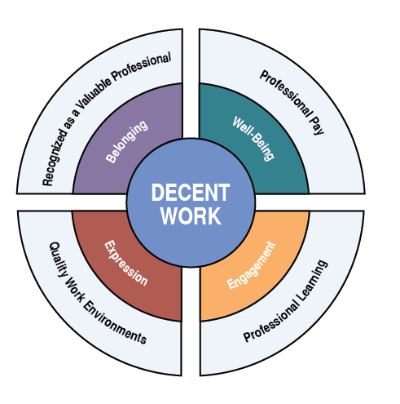
The Kindergarten Summit builds on the work of the AECEO’s Decent Work Taskforce, which has been advancing the effort to secure Decent Work across the early childhood sector through creation of the Ontario Early Childhood Sector Decent Work Charter.

This solutions-based summit seeks to convene diverse partners in the ECEC sector who are immersed in the Kindergarten Program to share best practices, innovative solutions, and new ideas relating to Decent Work in the Kindergarten Program. We are seeking proposals from all sector partners, including, but not limited to, RECEs, OCTs, Principals, Early Years Leads, union representatives, researchers and policy makers.

The Kindergarten Summit seeks to Frame our Future by exploring and advancing what is possible in achieving Decent Work in our current context. We are drawing on the four frames of How Does Learning Happen? as presented in our Decent Work Charter, and invite proposals that provide solutions oriented to (one or more of) the four frames:
BELONGING: Recognition of staff as valued professionals
WELL BEING: Professional Pay/Compensation
ENGAGEMENT: Professional Learning
EXPRESSION: Quality work environments

Name of Presenter(s)/Organization/Title:

Contact Information for corresponding presenter:

Topic of Presentation/Workshop:

General description of the Presentation/Workshop (90 minutes), including how it aligns with the solutions-based theme and Decent Work through the one or more of the four frames of Belonging, Well Being, Engagement, or Expression:

