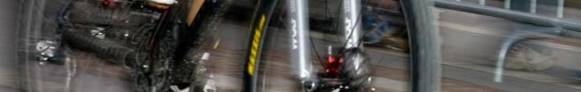
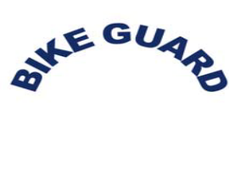
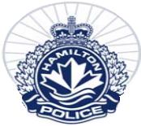
Hamilton Police Service BICYCLE IDENTIFICATION FORM
COMPLETE THE FOLLOWING FORM, INCLUDE A PHOTO OF YOUR BICYCLE AND ALL ORIGINAL RECEIPTS

BICYCLE OWNER
HPS OCCURRENCE # (COMPLETE ONLY IF REPORT IS FILED)

DATE OF PURCHASE LOCATION OF PURCHASE VALUE OF BICYCLE
$

BICYCLE DESCRIPTION
MAKE |  | MODEL |  |  | SERIAL # AND/OR PERSONAL IDENTIFYING MARKINGS |  |  | SUSPENSION SYSTEM  FRONT FORKS REAR
TYPE STYLE HANDLEBARS SEAT STYLE FENDER TYPE
BMX RECUMBENT COLLAPSABLE TANDEM HYBRID TOURING MOTOCROSS TRICYCLE  MOUNTAIN UNICYCLE  RACING OTHER |  |  | ADULT CHILD YOUTH OTHER | BMX  HIGH (MONKEY BARS) RACER  MOTOCROSS FLAT STANDARD-COMFORT OTHER |  | BANANA PERFORMANCE (NARROW) BMX (CHILD) OTHER  COMFORT (WIDE) |  |  | CLIP-ON MOUNTED NONE
 |  |  |  |  |  | BICYCLE COLOUR | FRAME SIZE |  | WHEEL SIZE
PARTS (ACCESSORIES)
AIR PUMP BASKET LOCK MIRROR LIGHT TOOL POUCH GEL SEAT COVER OTHER BELL SADDLEBAG CHILD SEAT WATER BOTTLE HOLDER STUNT PEGS TRAILER HANDLEBAR ENDS
CHAIN GUARD HORN KICKSTAND ODOMETER-COMPUTER RACK TRAIL-A-BIKE
ADDITIONAL COMMENTS
ATTACH YOUR BICYCLE PHOTO HERE.
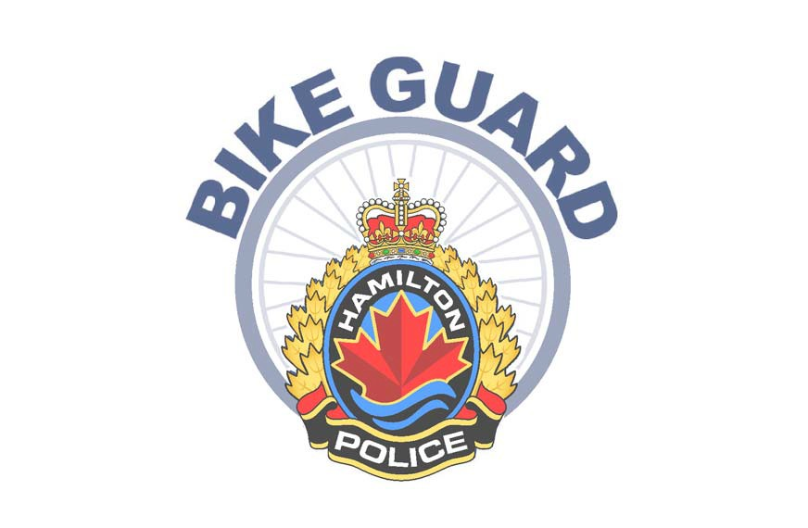
FOR ASSISTANCE COMPLETING THIS FORM OR TO HAVE A PHOTO TAKEN OF YOUR BICYCLE PLEASE VISIT ONE OF OUR COMMUNITY POLICING CENTRES. FOR LOCATIONS CALL 905 546-4900 OR VISIT WWW.HAMILTONPOLICE.ON.CA REMEMBER TO STORE THIS FORM IN A SAFE LOCATION
131136 NOV09

