Barrhead has a golden opportunity to shape its future and maximise the opportunity presented in the Local Development Plan for the planned 10-15 years capital investment development in Barrhead North and South with over 1000 homes and substantial commercial development.

As such there is a proposal to develop a Business Improvement District for Barrhead town centre. Business Improvement Districts (BID) are a business led initiative funded by the private sector to sustainably deliver a variety of agreed projects and services that will improve the local economy. It gives local businesses a unified voice and can include almost any project that the business agree would be of benefit over and above any statutory service provided by the local authority. There are currently 27 BIDs in operation around Scotland and another 19 in development. They range from town centre BID’s to tourism or business park BIDs. Projects BIDs can tackle can vary greatly but some examples are;
- Safety and security
- Marketing
- Events
- Improved asset management
- Independent business assistance
- Succession planning
- European funding

You will be invited to a public meeting to kick start the consultation process and provide and opportunity to share your views on what a Barrhead BID should focus on and the issues that you face. The meeting be held in the new Foundry building in front of the sports centre early in 2015.

A steering group will be established for the process and you will be invited to join at the meeting. A number of local business people have already expressed their interest, they are
- Paul Santi, New Yorker
- Bjorn Aaen Subway
- Brian MacMillan, F&M Hairdressing
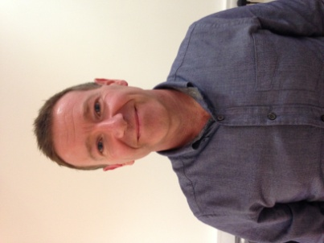
- Chris Waters, Card World

