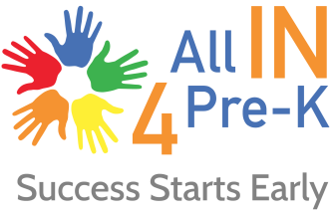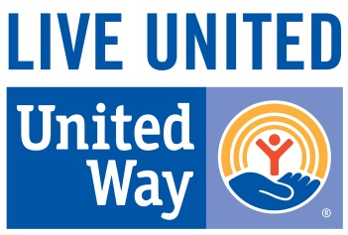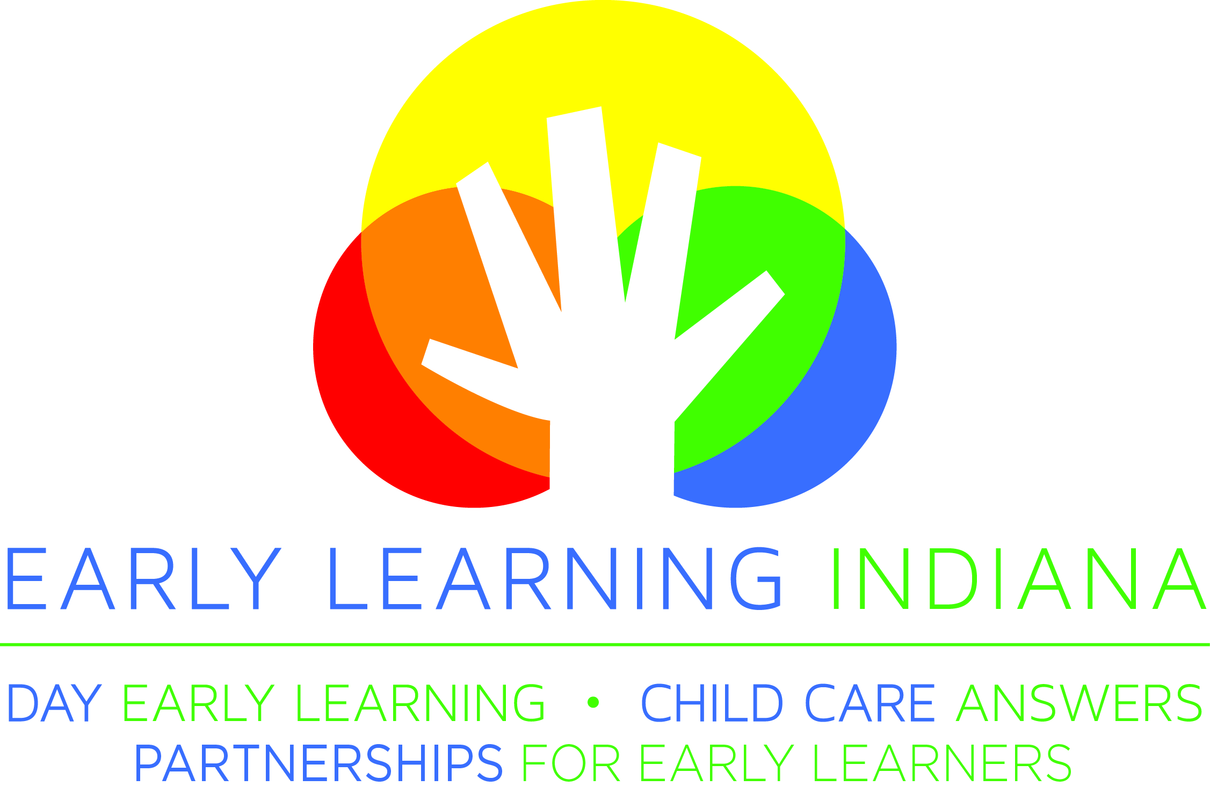

FOR IMMEDIATE RELEASE 10 a.m. (EDT) – August 12, 2016

BUSINESS AND CIVIC LEADERS JOIN FORCES WITH EDUCATORS AND GOVERNMENT OFFICIALS TO PROMOTE EXPANSION OF HIGH-QUALITY PRE-K IN 2017 LEGISLATIVE SESSION

Thousands of Indiana low-income children remain unserved by pre-k programs; 2017 presents rare window of opportunity for expansion
INDIANAPOLIS, AUGUST 12, 2016 – Key leaders in business, philanthropy, education and government announced today the Indianapolis business community has successfully reached its goal of raising $10 million for the city’s pre-k program. In addition, they announced the launch of a broad initiative to encourage Indiana lawmakers to fund the expansion of high-quality pre-k to benefit more students from low-income families across the state.

In a joint press conference, United Way of Central Indiana President and CEO Ann D. Murtlow, Eli Lilly and Company Chairman, President and CEO John C. Lechleiter, Ph.D., Early Learning Indiana President and CEO Ted Maple, and Indianapolis Mayor Joe Hogsett touted investments made by the private sector and government to expand access to high-quality pre-k for a limited number of Hoosier students. While those investments have increased the number of high-quality pre-k opportunities for low-income children, local leaders called on state policymakers to take the next step in expanding pre-k to help meet Indiana’s significant unmet demand.

“We need to ensure more Hoosier children – especially students from low-income families who stand to benefit most – can access high-quality pre-k so they start kindergarten ready to succeed,” Murtlow said. “Research shows us that dramatic brain development takes place in a child’s first five years of life, and the strong academic foundation provided by pre-k leads to positive academic and life outcomes. This has a ripple effect on communities and the state. That’s why we are advocating for expansion and see urgency to act.”

Today, Indiana’s signature pre-k efforts include a matching-grants program and a five-county pilot program funded by the state, and an Indianapolis-funded scholarship program, but demand for these programs far outpaces capacity. Thousands of students remain unserved statewide because adequate funding does not exist to meet demand, and nearly two-thirds of students who applied for the state’s five-county pilot program or Indianapolis’ program were denied a spot last year.

“We’ve seen the power of pre-k for Indianapolis students through our city’s scholarship program, yet we’ve also seen too many families turned away because there’s simply not enough money to build capacity and provide scholarships,” Mayor Hogsett said. “It is time to close this gap and help better meet the needs of families not just in our city, but across our state. It’s encouraging to see a broad group of parents, educators, business leaders and bipartisan elected officials joining to champion pre-k expansion in 2017.”

Advocates will pursue a two-pronged initiative to push for pre-k expansion. United Way of Central Indiana and a coalition of corporate partners, including Lilly, Cummins, PNC, the Indiana Chamber of Commerce, the Indy Chamber and others, will engage in a direct lobbying effort to expand pre-k in the 2017 legislative session. Meanwhile, All IN 4 Pre-K, an advocacy campaign led by Early Learning Indiana, is working with Hoosier families, education groups, community advocates and business leaders across the state to grow awareness of pre-k’s impact and highlight the need for expansion. United Way is funding All IN 4 Pre-K, along with Lilly Foundation, the Joyce Foundation and the Glick Fund.

“Lilly and other corporate leaders know that a thriving community depends on a high-quality education system, which starts with access to excellent early learning opportunities,” Lechleiter said. “Quality pre-k leads to stronger academic outcomes for students, which helps build a robust pipeline of talent to fuel the future workforce. That’s why we and other businesses stepped up to successfully raise $10 million for the Indianapolis pre-k program and why we’re advocating for pre-k expansion at the state level.”

Businesses that took a lead role in contributing toward the $10 million pre-k program include Lilly, Anthem, Cummins, Dow AgroSciences, PNC, IU Health and Pacers Sports and Entertainment.

A May 2016 Hart Research poll commissioned by Early Learning Indiana and United Way of Central Indiana demonstrates the strong bipartisan support for pre-k expansion. Seven in ten Indiana voters support expanded funding so that many more 4-year-olds can attend high-quality pre-k programs if their parents choose to send them. Some 63 percent of Republican voters and 82 percent of Democratic voters in Indiana favor this funding.

Though specific legislation has not yet been proposed, All IN 4 Pre-K has produced a roadmap, Success Starts Early, with a set of principles and recommendations to guide a successful expansion. They include: broadening income-eligibility requirements for families who can access pre-k; increasing pay and education requirements for pre-k teachers; aligning pre-k with early K-12 education to ensure continuity and long-term student success; expanding capacity for high-quality providers to serve students; and eliminating matching grant requirements that are burdensome and unsustainable, especially for rural providers and counties.

“Indiana has grown the number of high-quality pre-k providers in recent years, and as we expand pre-k, we will, first and foremost, focus on growing in a way that upholds high-quality for all students,” Maple said. “Indiana is ready for expansion. With our state on strong financial footing, we have a rare window of opportunity to make an investment in our children and an important statement about the future of our state in the upcoming budget session.”

All IN 4 Pre-K kicked off its public-facing efforts this week with a series of events engaging hundreds of participants in regions across the state, including Bloomington, South Bend, Goshen, Marion, Muncie, New Castle, and more. More than 600 pre-k champions have signed onto support the campaign, which will continue its public engagement and awareness-building efforts throughout the fall. To learn more about the campaign, including which partners are involved, or to find out how to participate, visit www.AllIn4PreK.com.

Media contact:
Francesca Jarosz Brady
For All IN 4 Pre-K
O: 317-454-8031
C: 317-450-2617
fjarosz@voxglobal.com
# # #
About All IN 4 Pre-K:
All IN 4 Pre-K is a campaign of Hoosier families, community advocates and business leaders working together to expand access to high-quality pre-k in Indiana. Led by Early Learning Indiana and powered by the United Way of Central Indiana, we showcase high-quality pre-k programs, support local champions and engage the voices of parents, business leaders, people of faith and others. To learn more, visit www.AllIN4PreK.com. Facebook and Twitter: @AllIN4PreK and #ALLIN4PreK

About United Way of Central Indiana:
United Way of Central Indiana fights for the education, financial stability, health and basic needs of all people in central Indiana by creating, managing, and investing resources in sustainable solutions to our communities' most stubborn barriers to self-sufficiency. UWCI invites all members of our community to LIVE UNITED by giving, advocating and volunteering to improve lives in central Indiana. Facebook: @unitedwayofcentralindiana. Twitter: @uwci

About Early Learning Indiana:
Early Learning Indiana provides the highest level of early childhood education to prepare children for success in school and build a foundation for life-long learning. We serve as an advocate and leading voice for children, families, and early childhood education providers across the state. Early Learning Indiana also is a direct provider of high quality early learning for children, as one of the oldest child care providers in Indiana and one of the few non-profit child care agencies in the Indianapolis area. We provide training, mentoring, and technical assistance to enhance and equip families, early learning providers and businesses with the skills and knowledge to provide high quality learning. Our mission every day is to assure the highest quality early childhood education for children in Indiana. To learn more, visit www.earlylearningin.org.

