|  |
| --- |
| [2017] ROCD 142 |
| **DECISION** |

*Fair Work (Registered Organisations) Act 2009*

s.189—Arrangement for conduct of an election

**"Automotive, Food, Metals, Engineering, Printing and Kindred Industries Union" known as the Australian Manufacturing Workers' Union (AMWU)**

(E2017/245)

|  |  |
| --- | --- |
| MR ENRIGHT | MELBOURNE, 11 DECEMBER 2017 |

*Arrangement for conduct of election.*

1. On 17 November 2017 the "Automotive, Food, Metals, Engineering, Printing and Kindred Industries Union" known as the Australian Manufacturing Workers' Union (AMWU) lodged with the Registered Organisations Commission prescribed information for an election to fill a casual vacancy in the following office for the remainder of the term:

**Vehicle Division New South Wales Region**

Delegate to National Conference (1)

1. I am satisfied that an election for the abovenamed office is required to be held under the rules of the organisation and, under subsection 189(3) of the *Fair Work (Registered Organisations) Act 2009*, I am making arrangements for the conduct of the election by the Australian Electoral Commission.

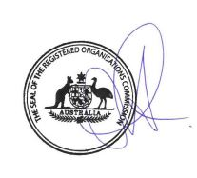

DELEGATE OF THE COMMISSIONER

Printed by authority of the Commonwealth Government Printer

<Price code A, PR350927>