|  |
| --- |
| [2018] ROCD 117 |
| **DECISION** |

*Fair Work (Registered Organisations) Act 2009*

s.189—Arrangement for conduct of an election

**"Automotive, Food, Metals, Engineering, Printing and Kindred Industries Union" known as the Australian Manufacturing Workers' Union (AMWU)**

(E2018/151)

|  |  |
| --- | --- |
| MR ENRIGHT | MELBOURNE, 21 JUNE 2018 |

*Arrangement for conduct of election.*

1. On 15 June 2018 the "Automotive, Food, Metals, Engineering, Printing and Kindred Industries Union" known as the Australian Manufacturing Workers' Union (AMWU) lodged with the Registered Organisations Commission prescribed information for an election to fill the following office, due to insufficient nominations received in a previous election (**E2017/245**):

**New South Wales**

Vehicle Division

Delegate to Vehicle Division National Conference (1)

1. I am satisfied that an election for the abovenamed office is required to be held under the rules of the organisation and, under subsection 189(3) of the *Fair Work (Registered Organisations) Act 2009*, I am making arrangements for the conduct of the election by the Australian Electoral Commission.

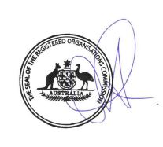

DELEGATE OF THE COMMISSIONER

Printed by authority of the Commonwealth Government Printer

<PR351098>