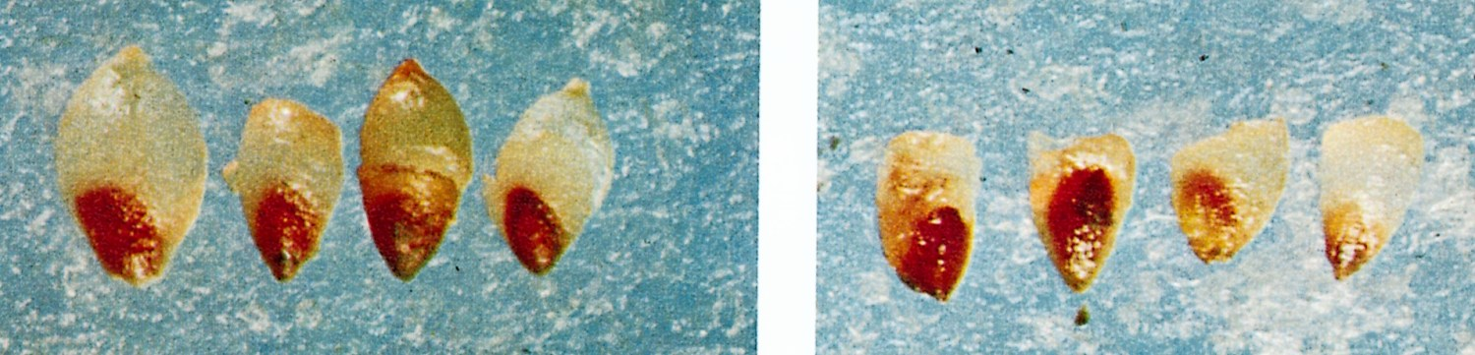
GRABE, D.F. (ed.) 1970. Tetrazolium Testing Handbook for Agricultural Seeds. Contribution No. 29
to the Handbook on Seed Testing, AOSA. Plate IV Timothy.
Photos: Frieda Wertman
Left: Right:
All seeds germinable. First seed: Germinable. Embryo completely stained
Embryos completely stained. Second seed: Non-germinable. Plumule dark stained.
Third seed: Non-germinable. Lower half of embryo unstained.
Fourth seed: Non-germinable. Upper half of embryo unstained.

