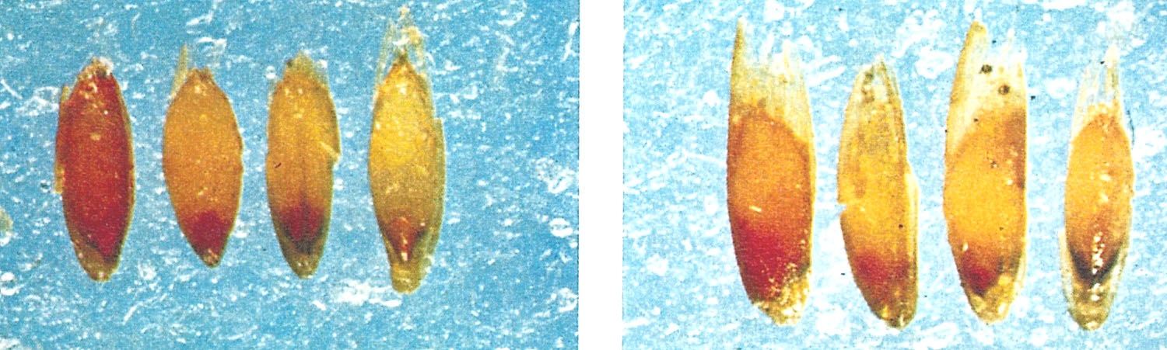
GRABE, D.F. (ed.) 1970. Tetrazolium Testing Handbook for Agricultural Seeds. Contribution No. 29
to the Handbook on Seed Testing, AOSA. Plate IV Bluegrass.
Photos: Frieda Wertman
Left:
First seed: Germinable. Embryo completely stained.
Second seed: Germinable. Embryo completely stained.
Third seed: Germinable. Embryo completely stained.
Fourth seed: Non-germinable. Embryo unstained.
Right:
First seed: Non-germinable. Embryo stained but with blurred outline.
Second seed: Germinable. Embryo poorly developed.
Third seed: Non-germinable. Embryo small and underdeveloped.
Fourth seed: Non-germinable. Embryo dark, not well stained.

