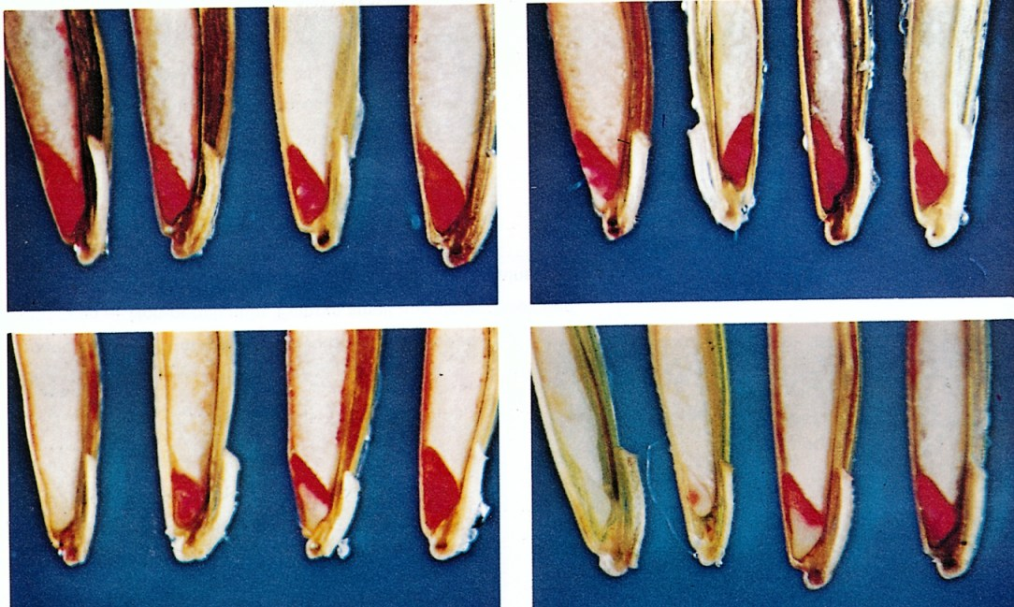
GRABE, D.F. (ed.) 1970. Tetrazolium Testing Handbook for Agricultural Seeds. Contribution No. 29
to the Handbook on Seed Testing, AOSA. Plate III Tall Fescue
Photos: R. P. Moore
Upper left:
First seed - Germinable. Embryo entirely stained.
Second seed - Germinable. Slight deterioration in embryo axis.
Third seed - Germinable. Slight deterioration in embryo axis.
Fourth seed - Germinable. Embryo entirely stained.
Upper right:
First seed - Non-germinable. Radicle and plumule unstained.
Second seed - Germinable. Embryo completely stained. Seed is slightly immature.
Third seed - Germinable. Embryo completely stained.
Fourth seed - Germinable. Embryo completely stained.
Lower left:
First seed - Non germinable. Embryo completely unstained.
Second seed - Non-germinable. Embryo poorly developed.
Third seed - Non-germinable. Embryonic axis and lower part of scutellum unstained.
Fourth seed - Germinable. Embryo completely stained.
Lower right:
First seed - Non-germinable. Embryo completely unstained, immature.
Second seed - Non-germinable. Embryo poorly developed, unstained.
Third seed - Non-germinable. Plumule and lower half of embryo unstained.
Fourth seed - Germinable.

