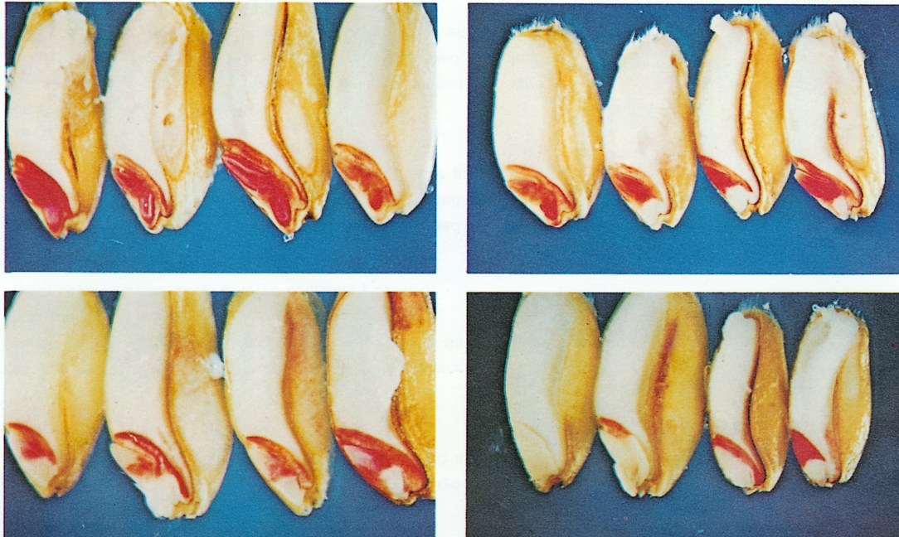
GRABE, D.F. (ed.) 1970. Tetrazolium Testing Handbook for Agricultural Seeds. Contribution No. 29
to the Handbook on Seed Testing, AOSA. Plate II Wheat.
Photos: R. P. Moore
Upper left:
All seeds germinable. Embryos completely stained.
Upper right:
First seed: Germinable. Embryo completely stained.
Second seed: Germinable. Radicle and lower part of scutellum unstained.
Third seed: Non-germinable. Radicle, lower part of scutellum and seminal root area unstained.
Fourth seed: Germinable. Radicle unstained.
Lower left:
All seeds non-germinable. Radicles and plumules unstained.
Lower right:
First seed: Non-germinable. Embryo entirely unstained.
Second seed: Non-germinable. Embryo nearly all unstained.
Third seed: Non-germinable. Embryonic axis unstained.
Fourth seed: Non-germinable. Radicle and seminal root area unstained.

