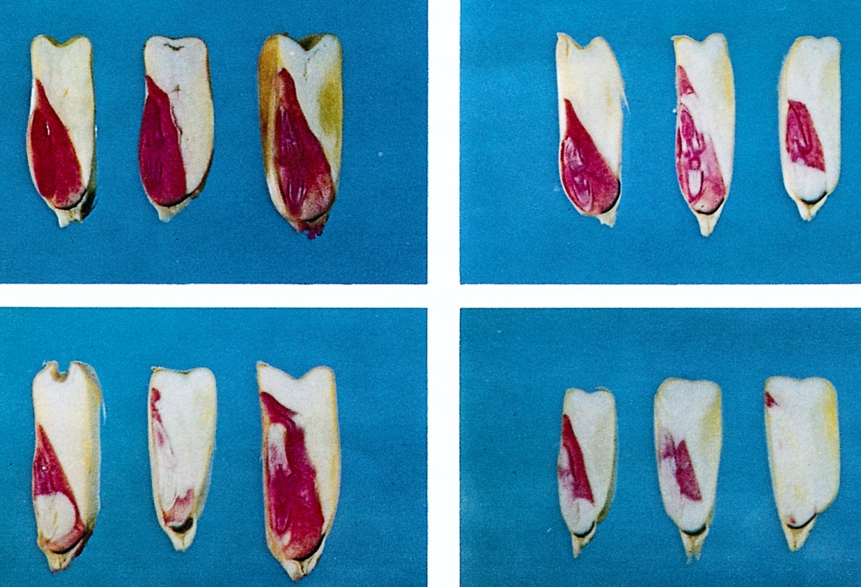
GRABE, D.F. (ed.) 1970. Tetrazolium Testing Handbook for Agricultural Seeds. Contribution No. 29
to the Handbook on Seed Testing, AOSA. Plate I Corn.
Photos: R. P. Moore
Upper left:
First seed - Germinable. Embryo completeley stained. Note dotted appearance of scutellum
Second seed - Germinable. Embryo completely stained.
Third seed - Germinable. Slight deterioration of embryonic axis.
Upper right:
First seed - Germinable. Moderate deterioration of embryonic axis
Second seed - Germinable. Radicle unstained. Unstained areas in scutellum and mesocotyl. Plumule and seminal roots are stained.
Third seed - Germinable. Radicle and upper and lower parts of scutellum unstained. The stained areas represent the minimum area of the embryo required for normal germination.
Lower left:
First seed - Non-germinable. Radicle and seminal root area unstained.
Second seed - Non-germinable. Majority of embyro unstained.
Third seed - Non-germinable. Shoot unstained.
Lower right:
First seed - Non-germinable. Embryonic axis unstained.
Second seed - Non-germinable. Embryonic axis and upper and lower parts of scutellum unstained.
Third seed - Non-germinable. Embryo almost completely unstained.

