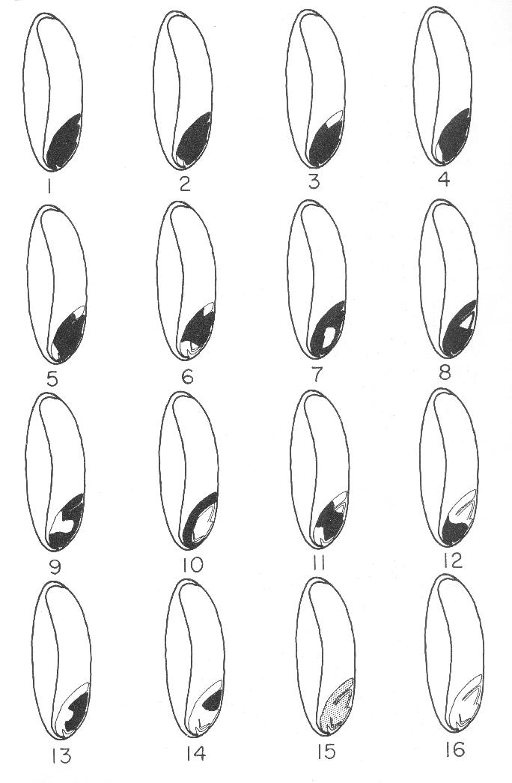
GRABE, D.F. (ed.) 1970. Tetrazolium Testing Handbook for Agricultural Seeds. Contribution No. 29
to the Handbook on Seed Testing, AOSA. Figure 6 wheat.
originally appeared in:
Delouche, J.C., T. W. Still, M. Raspet, and M. Lienhard. 1962. The tetrazolium test for seed viability.
Miss. Agric. Exp. Sta. Tech. Bull. 51.
Criteria for interpreting tetrazolium test results on wheat seed. Black areas indicate stained , living tissue; white areas represent unstained and dead tissue.
1. Germinable. Entire embryo stained bright red.
2.-5. Germinable. Extremities of scutellum unstained.
6. Germinable. Extremities of scutellum, radicle tip, and coleorhiza
unstained.
7. Non-germinable. More than three-fourths of radicle unstained.
8. Non-germinable. Plumule unstained.
9. Non-germinable. Central portion of scutellum and scutellar node unstained.
10. Non-germinable. Embryonic axis unstained.
11. Non-germinable. Extremities of scutellum and plumule tip unstained.
12. Non-germinable. Entire upper half of embryo unstained.
13. Non-germinable. Scutellum unstained.
14. Non-germinable. Scutellum, radicle, and coleorhiza unstained.
15. Non-germinable. Stain very faint pink.
16. Non-germinable. Entire embryo unstained.

