In Partnership with Alvarez HS

ARISE Revolutionary Thinkers and Doers
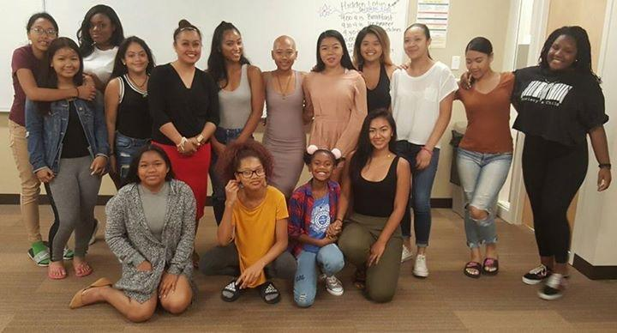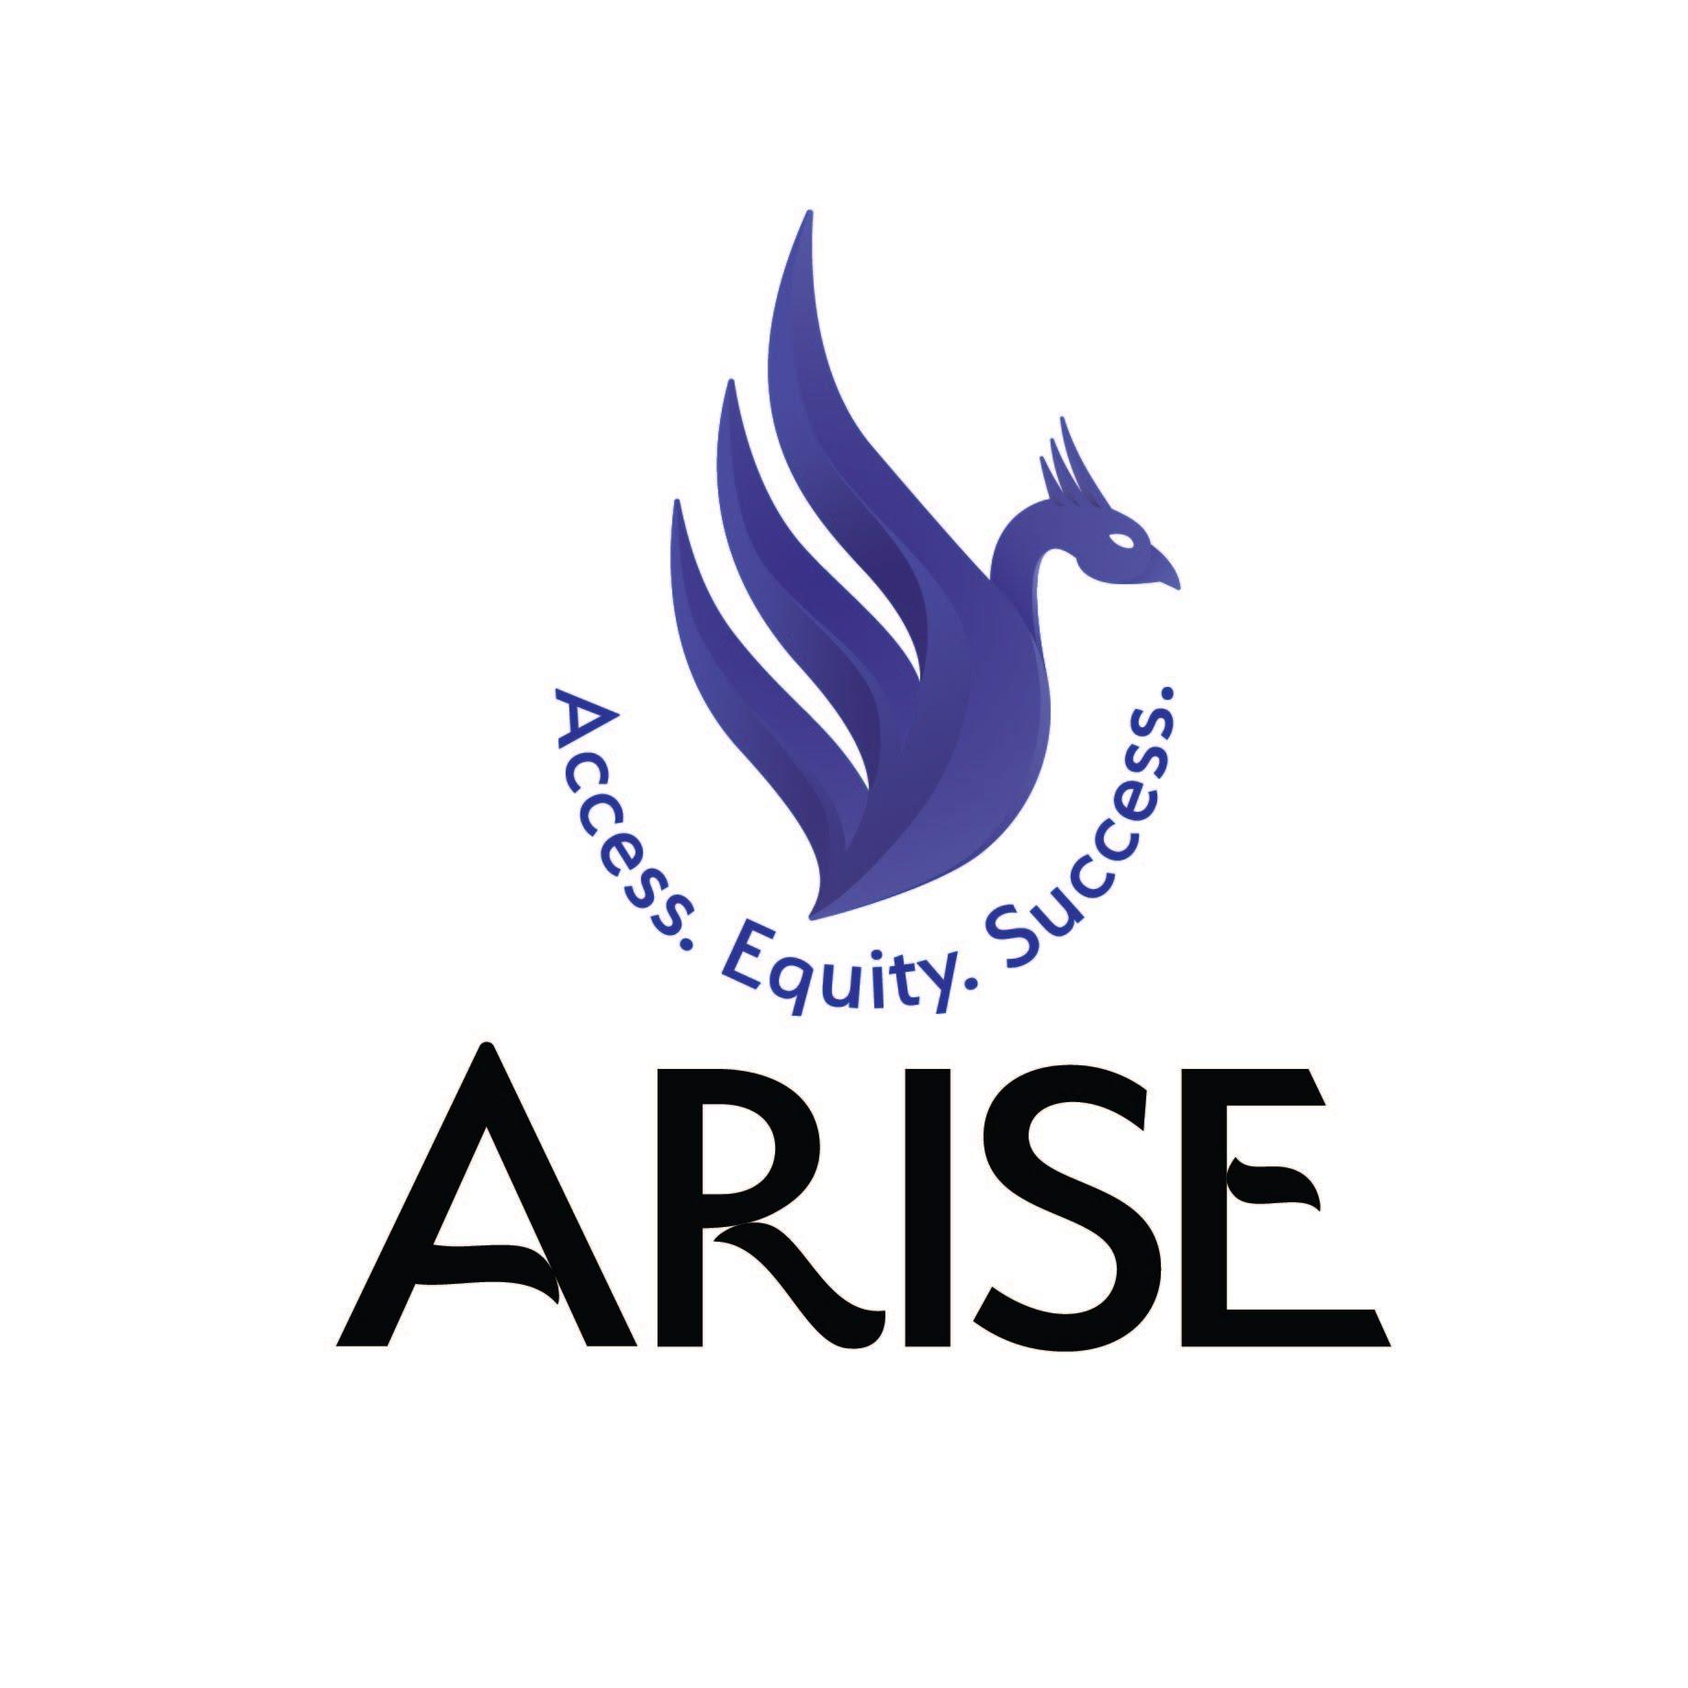
For more info, check us out at www.ariseducation.org

21st CCLC 2018
ARISE is offering after school program for students to have opportunities to engage in interactive, student centered learning activities exploring the following themes below

Students will meet Tuesdays and Thursdays
Contact Rosey Ok at Rosey@ariseducation.org
WORKSHOP THEMES
- Healthy Relationships
- Diversity, Cultural Sensitivity & Inclusion
- Developing a Culturally Responsive Support System
- Intergenerational Conflict & Conflict Resolution
- Values and Goal setting
- Surviving and Thriving in High School
- Activism/Strategic Advocacy
- Post-Secondary Prep and Career Exploration
- Leadership Intergenerational Leadership
- Intergenerational Trauma
