Bible and ecology:
Reading scripture through ecological eyes

Monday 19th September
10:30am to 5:30pm (Australian Eastern Time)
10:00am to 5:00pm (Australian Central Time)
8:30am to 3:30pm (Australian Western Time)

Venues:

United Theological College:
16 Masons Dr, North Parramatta, NSW 2015

Centre for Theology and Ministry:
29 College Cres, Parkville, Vic 3052

St Mark’s National Theological Centre:
10-12 Brisbane Ave, Barton, ACT 2600

Uniting College for Leadership and Theology: 34 Lipsett Tce, Brooklyn Park, SA 5032

Trinity College Queensland:
60 Bayliss St, Auchenflower, Qld 4066

Perth Theological Hall:
Worship Centre, Murdoch University, WA 6150

In recent years, in the context of growing ecological awareness, biblical scholars have been working to move beyond human-focused perspectives and read the Bible with a deliberate sympathy for the wider Earth community. In this full-day webinar, we will hear from scholars around the country about reading the Bible through “ecological eyes”, and will practise applying such lenses to scripture. With speakers: Rev. Dr Jason John, Dr Anthony Rees, Bishop Dr George Browning, Rev. Assoc. Prof. Monica Melanchthon, Dr Anne Elvey, Rev. Prof. William Loader, Rev. Dr Vicky Balabanski and Rev. Dr Clive Pearson.

Join a hub in each state, or organise a small group in your local area. It will also be possible to connect in as an individual, but we recommend coming along to enjoy the benefits of face-to-face interaction.

Cost: Donation. Morning tea and afternoon tea provided. BYO lunch.

Registrations:
More information and register your attendance via http://unitingearthweb.org.au/events

Brought to you by Uniting Earth Ministry, in collaboration with theological colleges across the country.

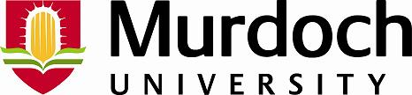
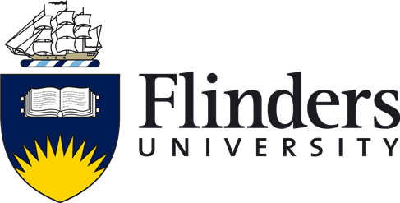
Perth
Theological
Hall

