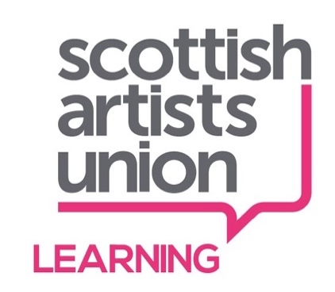
Equality & Diversity Monitoring Form

The Scottish Artists Union is committed to equal opportunities in all of its recruitment processes. This includes not discriminating under the Equality Act 2010, building an accurate picture of the make-up of the workforce and encouraging equality and diversity in the workplace. This monitoring form is voluntary but the information we collect helps to ensure that we are an inclusive employer and that our workforce is diverse. The information you supply on this form will be confidential and will not be held with any of your personal details. The monitoring form is not sent to the recruitment panel and plays no part in the shortlisting process.
In this form we have given you the option of describing yourself within the different categories by using your own terms. The phrases, wording, and make up of this form have been compiled with guidance from The Equality Network, Stonewall UK, Scottish Trans Alliance, ACAS, Information Commissioner’s Office and the Equality and Human Rights Commission.

Revised 2021
Which vacancy are you applying for?

What is your Country of Birth?

Prefer not to say
Please state what you feel to be your National Identity.
Prefer not to say
Please state your ethnic group.
Ethnic origin is different from nationality, place of birth or citizenship. It is about the group to which you perceive you belong. If you have dual nationality, or a combined/compound National Identity, you could indicate this if you wish.
Prefer not to say
How would you describe your gender?
Prefer not to say

If you would like to indicate the pronouns that you go by, please do so in the text box here:

Do you consider yourself to be a Trans person?
Yes
No
Prefer not to say

Please tell us your age.
16-17 18-21 22-30 31-40 51-60 61-65
66-70 71+ Prefer not to say

How would you describe your sexual orientation?

Prefer not to say
What is your relationship status?
Prefer not to say
Do you have a religion or belief?
Yes
No
Prefer not to say
If yes, please specify:

Do you consider yourself to have a disability according to the terms given in the Equality Act?
The Equality Act 2010 defines a disabled person as someone who has a physical or mental impairment which has a substantial, long-term and adverse effect on their ability to carry out normal day-to-day activities.

Yes
No

Prefer not to say
If yes, please specify:
What is your current working pattern?
Full time
Part time
Prefer not to say
Other
If other, please specify:

What is your ideal flexible working arrangement?
None
Flexi-time
Staggered hours
Term-time hours
Annualised hours
Job share
Flexible shifts
Compressed hours
Working from home
Prefer not to say
Other
Please specify:

Do you have caring responsibilities? If yes, please tick all that apply.
None
Primary carer of a child/children under 18
Primary carer of a disabled child/children
Primary carer of a disabled adult 18 and over
Primary carer of older person
Secondary carer (another person carries out the main caring role)
Prefer not to say
Other
If other, please specify:

Thank you for taking the time to complete this form.
Please email a completed copy to office@artistsunion.scot.

