How to set up your new email signature
Step 1
- Enter your details in the template

Name Surname
Job Title
Group
Sydney Water, Level X, 1 Smith Street, Parramatta NSW 2150


Phone: XXXX XXXX
Mobile: 0400 000 000
name@sydneywater.com.au
- 
- 





Step 2
- In Microsoft Outlook, select File > Options > Mail > Signature
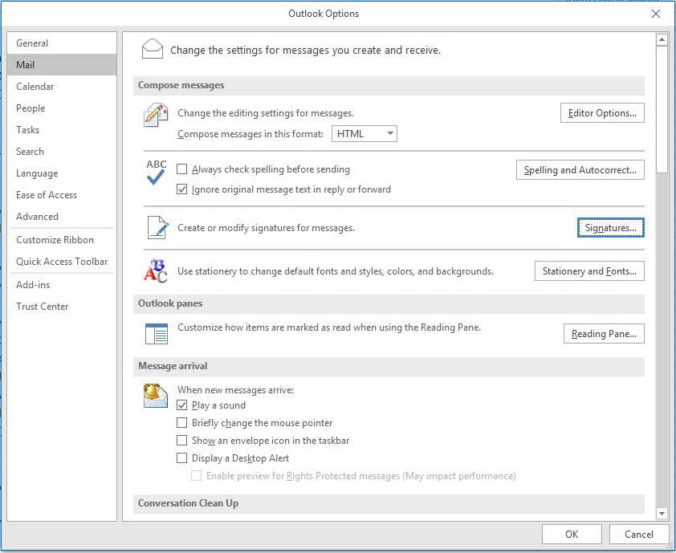

Step 3
- When you click on ‘Signatures…’ the below box will appear. Select ‘New’
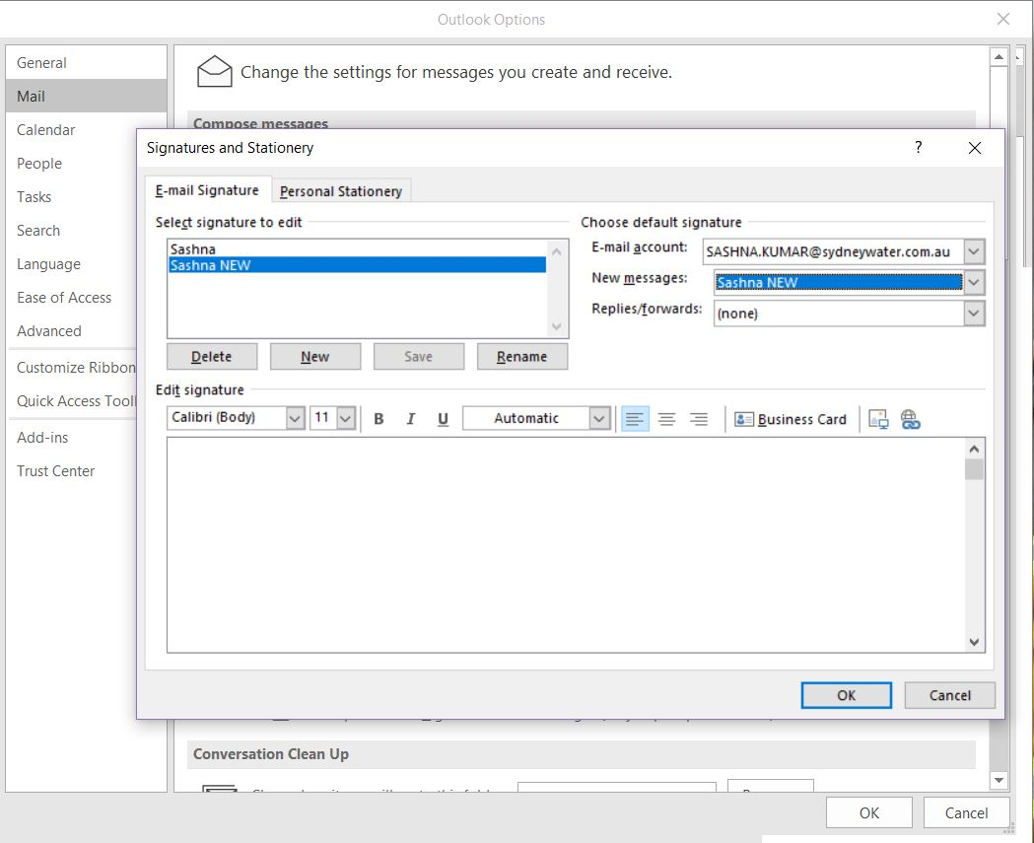

Step 4

- Copy the signature template you completed in step 1 and paste it into the window shown in step 3.
- After pasting, press enter twice at the bottom of the box (this will be under where the social media icons will be)
- Under Choose default signature in the top right corner, make sure you select the name of your new signature next to New messages.

