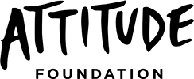

1 July 2015 to 30 June 2016
ANNUAL REPORT

The Attitude Foundation Limited

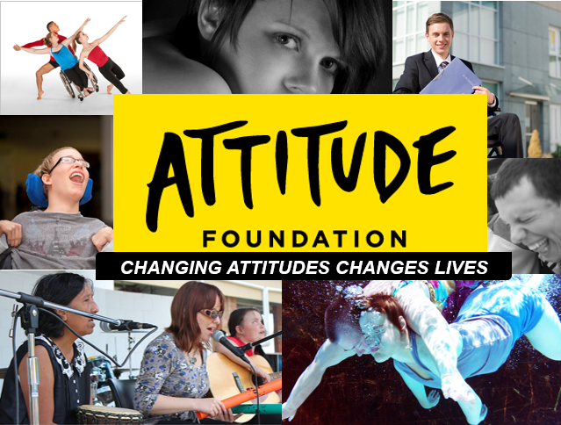

Our mission
We will give a voice to the 4 million Australians with disabilities by sharing powerful stories. Stories that are life-changing.

The Foundation has been created with the purpose of relieving the discrimination experienced by people with disabilities in Australia by increasing the inclusion and integration of people with disability into every aspect of political, social, economic and cultural life and by empowering and building capacity of people with disability. The discrimination experience is a distressing consequence of the lack of disability understanding and the emotional stress caused by prevailing negative stereotypes and life-limiting assumptions.

We must nationally challenge and change people’s thinking, attitudes and behaviour to stop this cycle of abuse, distress and poverty experienced by people with disabilities.

The content and targeted focus we propose is essential to spark conversations, deliver subtle messaging, and position people with disabilities as role models and leaders and to open the door to allow people with disabilities to be successful in life.

Through the development and promotion of media content, we aim to shape a new understanding of disability throughout Australia.

We plan to take advantage of the emerging shift in the media landscape and the arrival of new highly accessible platforms which provide innovative opportunities for us to connect individuals and communities throughout Australia. We seek to capture this opportunity to reach the broadest audiences as early adopters of new media; we will utilise the growing role of social media to channel social messages around disability, to reshape the views and opinions of mainstream Australians.

Our vision
Attitude Foundation’s vision is:

To live in an Australia in which people with disability are welcomed and fully included on an equal basis in every aspect of life.

The Foundation’s goal is to drive a material change in attitudes and lives through the creation of a television documentary series with real stories of people with disability told in their own voices.

The documentaries will help change people’s attitudes by delivering insight and shaping a new understanding of disability in Australia, framed in terms of possibilities and positivity. They will not focus on a victim or hero mentality but show people with disability as agents of their own destiny and positivity to drive a fundamental attitudinal shift in our community.

Our History
Attitude Foundation Limited was established in 2014 by people who are passionate about the inclusion of people with disabilities in society and sharing their stories. Our Board holds extensive experience in human rights, not-for-profit organisations and the media.

CONTENTS

Section 1 – An overview of The Attitude Foundation
About us | 3
Our people | 3
Our supporters | 4
Section 2 – Governance
Structure & management | 5
Chairperson’s report | 6
Our Objectives and Activities | 7
Section 3 – Our Finances
Treasurer’s report | 8
Section 4 – Our other important information
Acknowledgements | 10
How you can help | 11
Contact us | 11

SECTION 1 | AN OVERVIEW OF THE ATTITUDE FOUNDATION LIMITED

ABOUT US

OUR PEOPLE

Founder & Chair
Graeme Innes AM, LLB, FAICD

Board members/Trustees
Name | Position | Dates acted  (if not for whole year)
Dominique Antarakis BA (HONS), MFIA | Director and Public Officer | May 2014 to date
Jane Seeber BA (HONS), M ACCOUNT, CA | Director and Treasurer | May 2014 to date
Lesley Branagan BA, GRADDIP JOURN, M APL ANTH | Director | May 2014 to date
Catia Malaquias LLB/BA | Director | September 2015 to date
Sue Jeffery BACHELOR SCIENCE (HONOURS), MBA | Director | October 2015 to date
Christine Linden GENERAL MANAGER – REGIONAL BUSINESS BANKING, ANZ | Director | April 2016 to date

Volunteers
Name | Position | Dates acted  (if not for whole year)
Michelle Butterly | ANZ Secondee | May 2016 to date

OUR SUPPORTERS

Sponsor
ANZ Banking Group

Major Supporters
The Copy Collective
Gilbert + Tobin Lawyers

SECTION 2 | GOVERNANCE

STRUCTURE & MANAGEMENT

The Attitude Foundation Limited is registered with the Australian Charities and Not-for-profits Commission (ACNC) and endorsed by the Australian Tax Office (ATO) as an Item 1 Deductible Gift Recipient (DGR) – the foundation is eligible to receive funds from Item 2 DGR entities such as philanthropic trusts, foundations and prescribed private funds.

The Attitude Foundation holds Tax Charity Concession status. Therefore, all donations of $2 and over are fully tax-deductible.
ABN: 67 600 518 223.

CHAIRPERSON’S REPORT

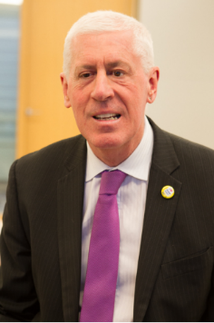

Graeme Innes AM, LLB, FAICD

It has been a busy year for the Foundation as we consolidate our first year's work, and build to the successful airing of a television programme in which people with disabilities will tell our stories to change community attitudes towards people with disabilities.
We have continued to receive outstanding support from the ANZ Bank, our founding sponsor. Not only have they made a very significant financial contribution to our work, but they continue to provide us with talented and committed secondees who have significantly progressed the day-to-day work of the Foundation. Their wise advice, both on the board and from various sections of their organisation, has also provided us with enormous benefit and knowledge.
Our business case was developed with input from the ANZ, and they critiqued our first pitch. We have since honed the pitch and the business case, and presented it to numerous other sponsors from the government, commercial and pro bono sectors. I am confident that one or more of these organisations will soon join the ANZ in financially backing our initiatives.
Cain Beckett resigned from our board during the year to pursue his career with the National Disability Insurance Agency. His sector knowledge, market appreciation and strong commitment have been sorely missed.
Catia Malaquias joined the board in September 2015. Catia’s contribution to the board in relation to the full inclusion of people with intellectual disability and her perspective of people with disability portrayed in media is invaluable.
Christine Linden joined the board in April 2016 as the ANZ’s representative. Christine brings essential governance and business acumen to the foundation. Further, the promotion of the foundation within the ANZ organisation is much appreciated.

Thank you to all board members for your continued passion and commitment.
I am confident that in the year to come we will succeed in our aim of developing television content which will change attitudes towards people with disabilities in Australia.

Graeme Innes AM, LLB, FAICD
Chair, Attitude Foundation

OUR OBJECTIVES AND ACTIVITIES

The Attitude Foundation’s objectives are to produce a TV Series, online portal/hub to host streaming video and social media as well as commission a research program to measure attitudinal change before, during and after the broadcast of the TV Series.

The foundation has sought monetary and in-kind support from a number of organisations, including:

ANZ Banking Group
The Copy Collective
State and Federal Government Departments & Agencies

Individual donors have also made contributions to our worthy cause via the foundation’s website donation facility.

The foundation has built a comprehensive business case which outlines the case for change, the media chosen and why as well order of magnitude costs for the project.

In addition, the foundation has kept a social media presence on the foundation’s website blog, Twitter and Facebook.

The foundation plans to increase investment in the foundation from industry, benevolent societies and will continue to engage government agencies.

SECTION 3 | OUR FINANCES

TREASURER’S REPORT

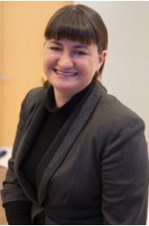

Jane Seeber BA (HONS), M ACCOUNT, CA

Donors
Since our foundation in July 2014, the Attitude Foundation has had support from donors who recognise that changing attitudes will change lives. We would like to thank the 63 individual donors who contributed more than $15,000 to Attitude over the last two years and in particular our Chair Graeme Innes whose seed contribution started things off. We would also like to recognise our initial ongoing contributor, Maureen Shelley, who has made monthly donations since July 2014. If you would like to join Graeme, Maureen in supporting Attitude, visit our website for information.

Partners
ANZ Bank: The genuine and generous support of ANZ has provided Attitude with a firm foundation for our work. Besides a generous financial commitment, ANZ’s secondee program has enabled us to tap into their pool of talented people to work with the Board and start changing attitudes.

We would also like to thank the following organisations who have assisted us with pro-bono work and in-kind support in our first two years:
- PwC
- Gilbert + Tobin
- The Copy Collective

Achievements
With the support of our donors and partners, in our first two years Attitude’s resources have gone towards the following priorities:

- Content Guidelines: Create and publish a guide for accessible and inclusive content for all of the Foundation's media content

- Deductible Gift Recipient Status: ATO recognition of Attitude’s status as a charity

- ANZ Partnership: in September 2015 Attitude announced our partnership with ANZ

- Business planning: the budget and planning for our key goal of producing a product for television are in place, created with and by people with disabilities, and with feedback from industry professionals

The first two years of Attitude Foundation Limited have been exciting, and with financial resources and key relationships in place we ready to take the next step.

Thanks again to our many donors, and to our founding Treasurer, Cain Beckett, on whose work we build.

Jane Seeber BA (HONS), M ACCOUNT, CA
Treasurer, Attitude Foundation

SECTION 4 | OUR OTHER IMPORTANT INFORMATION

ACKNOWLEDGMENTS & THANK YOU

Donors
Graeme Innes
Maureen Shelley
Karen Lindley
Jon Isaacs
Dominique Antarakis
Lorraine van der Weide
Michelle Butterly
Martin Petersons
Diane Utatao
Iman Aboucham
Daisy Edwards
Jeannine Bayne
Arahni Sont

Corporate & community partners
ANZ Banking Group
Gilbert + Tobin
The Copy Collective

HOW YOU CAN HELP

Spread the word
http://www.attitude.org.au/spread_the_word

Make a donation
https://attitude.nationbuilder.com/donate

Become a corporate partner
Contact us on +61 2 8005 7605 or email us at attitude@ausattitude.com

CONTACT US

317/185 Elizabeth St. Sydney NSW 2000
+61 2 8005 7605
http://www.attitude.org.au/
attitude@ausattitude.com
Twitter @ausattitude
Facebook Attitude Foundation Limited

