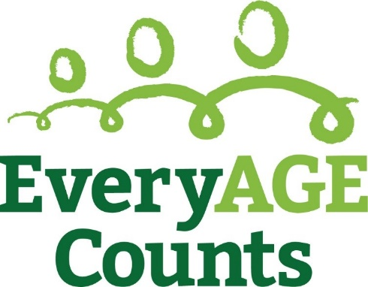

Membership Agreement – EveryAGE Counts Coalition

The EveryAGE Counts Coalition [the Coalition] is the formal alliance of organisations and individuals who have agreed to actively support and participate in the EveryAGE Counts Campaign.

As a member of the Coalition, you understand the goals and values of the campaign and accept, and agree to act upon, the campaign pledge:

“I/we stand for a world without ageism where all people of all ages are valued and respected and their contributions are acknowledged. I/we commit to speak out and take action to ensure older people can participate on equal terms with others in all aspects of life."

Please complete the details below and return by email to info@everyagecounts.org.au

Name of organisation

Registered postal address

Senior Signatory
Name:
Title/role:
Phone:
Email:

Communications Representative
Name:
Title/role:
Phone:
Email:

Signed by [name]: ____________________________________________________________

Title: _____________________________________ Date: ___________________________

Signature:___________________________________

