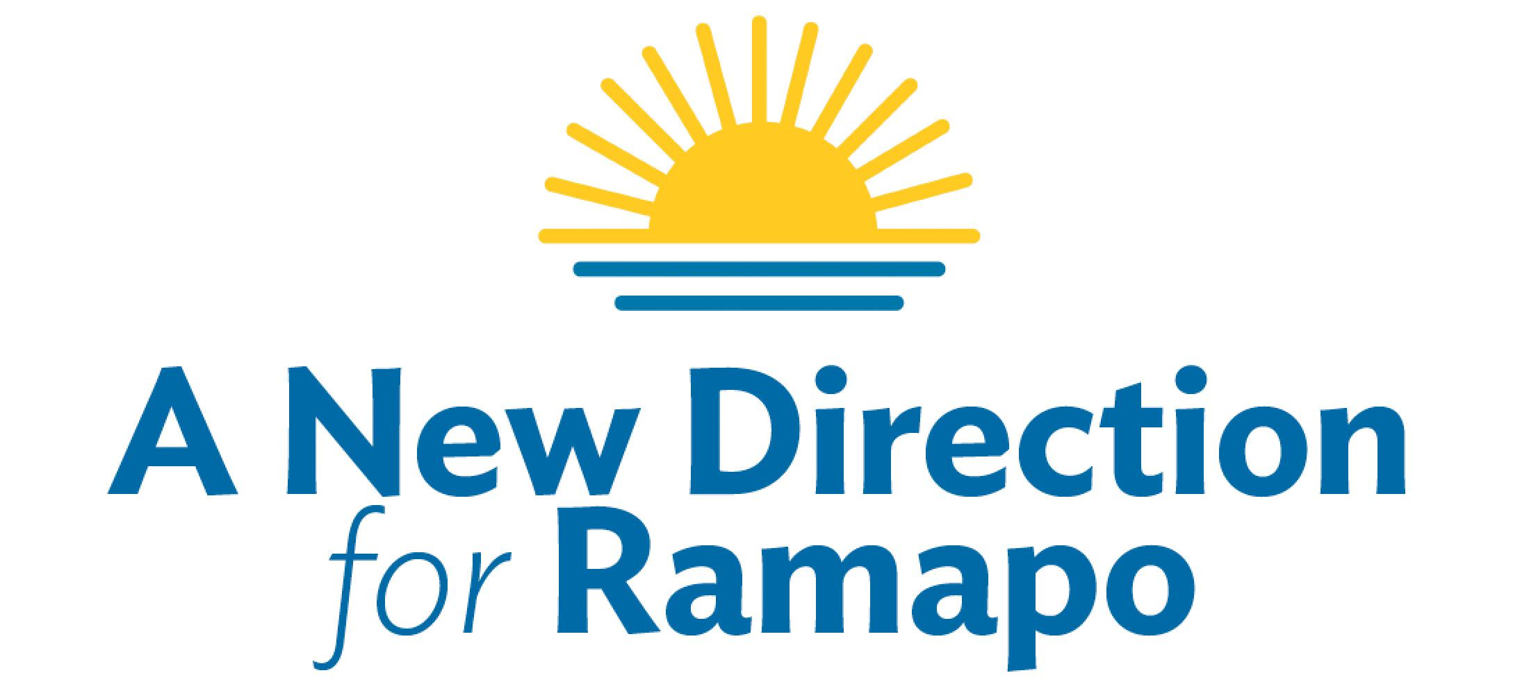
Elect
William Weber (REP) Supervisor
Shani Bechhofer (IND) Council
Grant Valentine (DEM)Council
Nov. 7th

Thank you for helping gather petition signatures for Bill, Shani and Grant to establish a separate independent ballot line for the New Direction for Ramapo party for the fall election.

Gathering signatures is not hard and can actually be fun! It is a great way to reconnect with friends and meet new neighbors. More importantly, this is the work that needs to be done to help win the Town of Ramapo election on November 7th, 2017.

Who can sign?
Anyone who has not signed already the republican petition for Bill Weber et. al. or a democratic petition for Michael Specht et al. and is a registered voter in the Town of Ramapo.

Five steps to get an accurate signature
1. Be certain that the person signing is registered to vote in the Town of Ramapo
2. Put the date in the first column
3. Have them sign their name in the appropriate box.
4. Have them print their name on the line below their signature
5. Have them print their street address in the column labeled “Residence”, this must be the address at which they are registered to vote, i.e. No P.O. Boxes

You can help them fill in the entries but they must be the one who signs it.
Note: you cannot witness your own signature. Meaning if you are the circulator you may not sign your own petition.

When you are done gathering signatures, fill out the witness area at the bottom (you must be a registered voter in the state of NY and not have signed anyone else’s petition William Weber for republican or Michael Specht for democrat). If you have any doubts as to how to fill this in, just call and ask. 845-535-9185. If you make a mistake, just correct it and INITIAL the correction.

Send/drop off completed forms to Sam Molik, 5 Rose Hill Road, Suffern NY each Monday before Aug 20th at the latest. This will give us enough time to review the petition sheets and contact you back in case something needs to be corrected.

Please carry blank copies of these instructions and the forms in case you run into anyone willing to also help collect signatures. During the summer months you never know when you will go to a sporting event, a social event, run into people you know in restaurants or the supermarket. And yes, you can walk up to a stranger and simply ask “Are you registered to vote in the Town of Ramapo?, Great! Will you help me get my friends on the ballot for the upcoming town election?”

This is our year to finally make a difference! People are more excited than you might realize and many want to participate in finally getting change to happen. Please tell everyone who signs to please go to NewDirectionForRamapo.org to sign up for event announcements, make donations and sign up to volunteer.

Remember many drops of water can add up to a Hurricane. Let’s make it a category 5!!

