Renting in Queensland
Strategic Policy and Legislation
Housing, Homelessness and Sport
Department of Housing and Public Works
GPO Box 690
Brisbane Qld 4001
To whom it may concern
Re: A Better Renting Future
Thank you for the opportunity to provide our feedback on proposed changes to Queensland rental laws. As a community of renters working together for stable, affordable, and healthy homes, Better Renting welcomes the chance to advocate for the interests of the growing number of Queenslanders who rent their homes.
Below, we respond to the five areas covered in Stage 1 of the reforms. We welcome the Queensland Government’s commitment to action in this area, and we hope to remain in contact in order to further the development of modern renting laws that allow people who rent to benefit from stable, affordable, and healthy homes.
Regards,

Joel Dignam
Executive Director
Better Renting

Minimum Housing Standards
Of the available options in the RIS, our preferred option is Option 5. However, we believe that this option falls short of the stated objective of ensuring that rental accommodation is “safe, secure and functional.” As proposed, Option 5 would leave many renters living in unsafe homes.
Housing that is too cold in winter or too hot in summer poses a risk to human health. Despite Queensland’s warm climate, about one in twenty deaths in Brisbane is attributable to cold weather. Inefficient housing fails to provide healthy indoor temperatures: this leads to respiratory and cardiovascular diseases, such as asthma or strokes. People who rent are more likely to be living in inefficient homes without, for example, ceiling insulation or window treatments. This means that they are more at risk.
It’s also noteworthy that landlords and renters are engaged in a commercial relationship. Landlords are conducting an enterprise and should be treated as professionals with concomitant responsibilities to their customers. As AHURI noted in their report, Private rental in transition : institutional change , technology and innovation in Australia, the reality of landlords as for-profit service providers is obscured by cultural representations of so-called “mums and dads”. Landlords are in the business of renting out properties, this involves responsibilities, and landlords that do not, cannot, or will not meet these responsibilities have no place in the private rental sector.
If the Queensland Government is committed to safe rental homes, it must do more to ensure that landlords provide healthy indoor environments for people who rent. This could include a “healthy temperatures” component of prescribed standards that may include such features as:
- Energy efficient building shell,
- Ceiling fans,
- Flyscreens for windows,
- Draught-proofing,
- A requirement for heating and/or cooling, &
- Window treatments that reduce heat transfer through windows.

Renting with pets
Better Renting is broadly supportive of the direction indicated in the RIS. We agree that the status quo is not working well and means that many renters are unfairly missing out on the benefits of pet ownership. Landlords should not be able to enforce a blanket ban against pets without a valid reason.
However, there are various problems with what is recommended.
Firstly, people who have pets would still experience discrimination when applying for rental properties. As long as lessors are able ask about pet ownership at the point of application, people who rent with pets will be at a disadvantage. Discrimination on the basis of pet ownership is the most common form of discrimination experienced by people who rent. In 2012, 30% of pets surrendered to the RSPCA were from owners who could not find a suitable property. To prevent this, we support standard application forms that prevent questions that could facilitate discrimination.
Secondly, if a landlord wishes to refuse consent for a pet, they should be the party responsible for going to the Tribunal. We support a process by which landlords and incumbent tenants can discuss the suitability of a potential pet for any given dwelling. In some cases, this could lead to mutual agreement that a pet isn’t suitable. However, where mutual agreement isn’t reached, the onus should be on the lessor. Under Option 4, we believe that many renters would avoid going to the Tribunal, possibly due to time or cost concerns, or because of fear of retaliation from their landlord. In the tenant/landlord relationship, the landlord has much greater resources and less vulnerability. If they seek to limit the tenants rights by preventing pet ownership, they should be responsible for demonstrating why this is justified.
Finally, we are strongly opposed to pet bonds. The effect of pet bonds is to legitimise and perpetuate discrimination against pet owners. It will send a message that pets create additional damage and wear. This will be to the disadvantage of existing and potential pet owners in the rental sector, and will also create cost barriers for low-income renters. Landlords can already require a bond to cover potential damage to the property. No additional bond should be required simply because renters choose to have a pet.

Ending tenancies fairly
We agree with the proposed option, Option 5. We believe this is an appropriate step at this point towards a fairer system. Abolishing no grounds terminations will improve stability for people who rent and make it easier for them to make a home. It will also improve tenants’ capacity to exercise other rights, as there will be less risk of retaliation.
We believe the proposed additional grounds are sufficient to cover situations in which a property owner may be entitled to terminate a lease. We are supportive of requirements for evidence, as there is otherwise a risk of ‘with grounds’ terminations being used in a fraudulent or retaliatory fashion.
We do, however, believe that the notice period for ‘with grounds’ terminations should be extended to a minimum of twelve weeks. With changes in the demographics of the renter population, a growing number of renters would face difficulties with a short notice period, due to work or school obligations. A longer notice period would assist with this. Within the notice period, tenants should be allowed to terminate with one week’s notice, or three days’ notice within the final fourteen days. This would ensure that a longer notice period is useful for the renters.

Minor modifications
We support the move towards making it easier for renters to make minor modifications to help adapt their home to their living situation. However:
- Renters should be able to make health and safety modifications and/or “amenity or personalisation modifications” without owner consent, only with a requirement for notification;
- If the owner wishes to oppose a modification, it should be their responsibility to pursue dispute resolution; &
- The government should provide financial support to cover restoration costs for low-income renters who require health and safety modifications.

Domestic and Family Violence
We support Option 3. It is important that a tenant or co-tenant experiencing domestic and family violence has the option to easily terminate their tenancy, to access their bond funds, and to make necessary modifications to ensure their safety and security.

Potential impacts on rents
Reforms that make it easier for renters to have stable, affordable, and healthy homes are unlikely to materially affect rents. If anything, they would reduce rents. However, given some of the claims being made, we would like to take this opportunity to discuss why we reforms wouldn’t have a material impact on rents.

Rent increases reflect the balance between supply and demand
Generally, the level of rents in the rental market is determined by the balance of supply and demand. When supply increases (or demand decreases), landlords must compete more for tenants, and this can result in lower asking rents. Conversely, when supply decreases (or demand increases), landlords face less pressure to compete. Rather, tenants compete for the limited supply of rental dwellings, and this puts upward pressure on rents. A fair indication of the amount of supply in the rental market is the vacancy rate, and we can observe a relationship between rent growth and the rental vacancy rate, as depicted in the graph below.
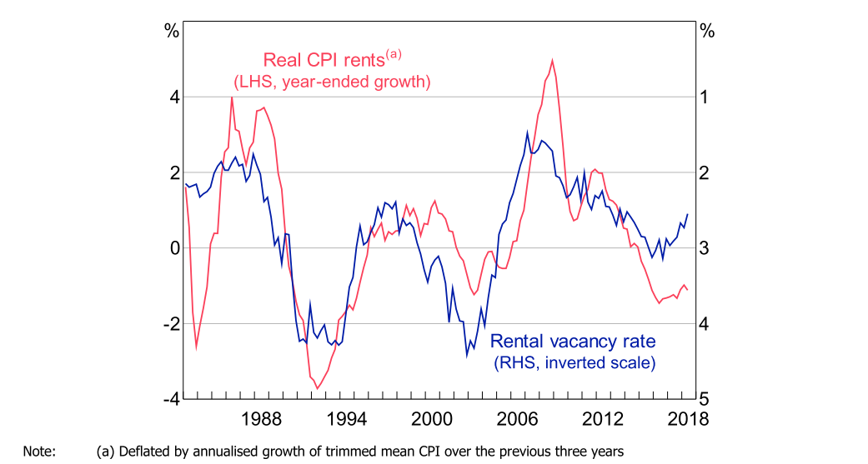
Figure 1: Real CPI Rent Growth and the Rental Vacancy Rate

As such, we need not concern ourselves with the bogeyman of ‘pass through costs’. Landlords already set rents to maximise their returns and they cannot arbitrarily increase them because their own costs have increased. Nor, of course, do landlords arbitrarily decrease rents because their own costs have decreased. However, it is fair to consider whether changes to rental laws could result in a reduction in supply relative to demand, thus putting upward pressure on rents. But this is unlikely to be the case.

Supply relative to demand remains constant despite reform
Firstly, rental reform is unlikely to affect the supply/demand ratio as it is unlikely to have a big impact on investor decisions. When AHURI studied the motivations of investors in the private rental market, they reported that investors “come in and out of the market all the time”, responding to a variety of differing incentives, chiefly the potential for long-term gains. They found that tenancy law had negligible impact on investment decisions: “...in this study it was almost impossible to get investors to engage on tenancy law as an issue, let alone an important factor connected to investment decisions.” Simply, the investment decisions of landlords are influenced by bigger things than tenancy laws. In other countries, there is no evidence of increased tenancy regulation causing a reduction in the size of the private rental sector.
Even if rental reform does result in landlord disinvestment, this would not affect the supply/demand ratio. A property might be bought by another investor, with no impact on supply. Or it might be bought by owner-occupiers which then creates another vacancy. If a former investment property is bought by former renters, this will marginally reduce the supply of rental properties, but it will also reduce demand by an equivalent amount (ie, one household). If anything, the disinvestment argument implies an improvement in housing affordability which is, many would argue, a good thing.

Sources Sources Gasparrini, A, Y Guo, M Hashizume, E Lavigne, A Zanobetti, J Schwartz, et al., ‘Mortality risk attributable to high and low ambient temperature: a multicountry observational study’.in The Lancet, 386, 2015, 369–375.
Rudge, J, Indoor cold and mortality.in WHO Environmental Burden of Disease Associated with Inadequate Housing, Copenhagen, 2011.
Fitzgerald, T, ‘Home energy affordability: Accommodating the case for energy efficiency’. 2017, <https://www.energycouncil.com.au/analysis/home-energy-affordability-accommodating-the-case-for-energy-efficiency/#_edn2> [accessed 12 December 2019].
Hulse, K, W Stone, K Hulse, & W Stone, Private rental in transition : institutional change , technology and innovation in Australia.Melbourne, 2018.
CHOICE, National Shelter, & NATO, Unsettled: Life in Australia’s private rental market. 2017.
Nancarrow, D, ‘Vet pleads for landlords to welcome pets’.in Brisbane Times, , 2012, <https://www.smh.com.au/business/companies/vet-pleads-for-landlords-to-welcome-pets-20120111-1puxl.html> [accessed 12 December 2019].
Productivity Commission, Vulnerable Private Renters : Evidence and Options Productivity Commission Research Paper. 2019.
Saunders, T, & P Tulip, A Model of the Australian Housing Market. 2019.
Seelig, T, A Thompson, T Burke, S Pinnegar, S McNelis, & A Morris, Understanding what motivates households to become and remain investors in the private rental market.in AHURI Final Report No. 130, Melbourne, 2009.
See Martin, C, K Hulse, & H Pawson, The changing institutions of private rental housing : an international review. Melbourne, 2017; also Department for Business Energy and Industrial Strategy, Green Deal: Energy saving Information. 2018.

