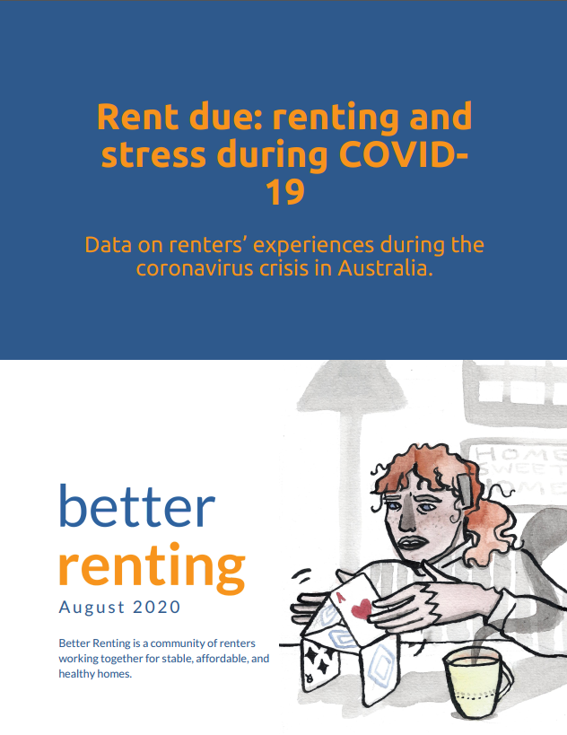

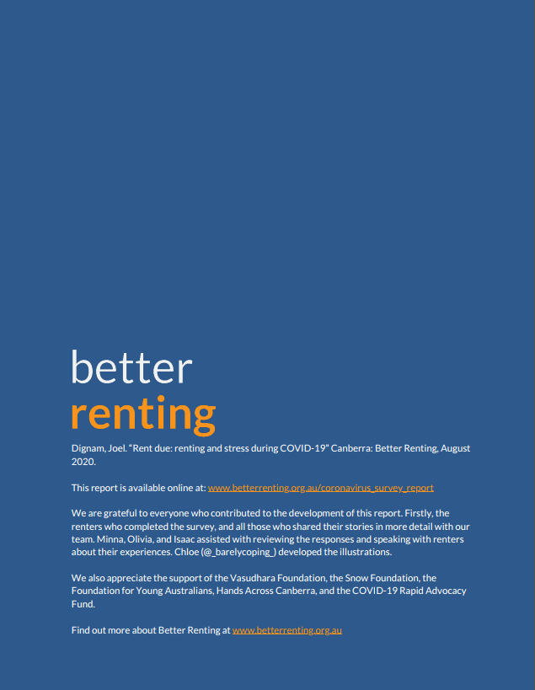

Table of contents

Executive summary 4
Methodology 5
Rock and a hard place: COVID-19 compounded existing vulnerability for renters 6
What worked 8
Expanded income support helped renters to avoid debt 8
Recommendation: Keep the rate of JobSeeker 8
A small minority of renters got rent reductions 10
What went wrong 11
Renters were afraid to ask for reductions 11
Renters who asked for rent reductions received little support 14
Negotiating reductions was a quagmire 14
Lessors offered deferrals to avoid genuine reductions 16
Lessors refused rent reductions with little accountability 17
Recommendation: Implement the measures in the National Statement on Renting and Coronavirus 18
The power imbalance between renters and lessors makes an unfair playing field 19
Recommendation: Abolish unfair evictions 21
Recommendation: Invest in social housing 21
Conclusion 22
Bibliography 23
Appendix A: Survey questions 26

Executive summary
At the start of 2020, Australian renters faced competing cost of living pressures and were already particularly vulnerable to an economic shock. Making matters worse, coronavirus had a greater impact on industries like hospitality and service sectors where renters were more likely to work.

Facing this double-whammy, many renters were helped by expanded income support, but very few were lucky enough to secure a rent reduction. Most renters ended up bearing a significant burden to keep a roof over their head.

Coronavirus has exposed ongoing inequity in the private rental sector. The results in this report demonstrate the need for short and long-term reforms to ensure that the growing number of people who rent their homes can have secure, affordable housing.

Better Renting surveyed almost 1000 renters from across Australia, asking about their experiences of renting during the coronavirus pandemic and associated lockdown. From this survey and other inputs, key findings emerged:
- Over three in five renters (63%) reported losing household income due to the coronavirus crisis.
- Of renters who lost income, only one in two (50%) asked for a rent reduction.
- Of renters who lost income, less than one in ten (9%) got a satisfactory rent reduction.

People who rent were more affected by the economic downturn, with significant personal impacts. This led to deprivation, anxiety, and stress.

The expanded JobSeeker was critical in keeping renters secure. In the absence of rent reductions, the Coronavirus Supplement helped renters to keep their head above water.

Power imbalances prevented tenants from getting the support they needed. Renters did not have the security to ask for rent reductions. Until this is addressed, the system will remain unfair.

In response to these findings, we offer the following recommendations:
- Keep the rate of JobSeeker,
- Implement the measures in the National Statement on Renting and Coronavirus,
- Abolish unfair evictions, and
- Invest in social housing.

With these changes, we can enable more renters to occupy homes that are stable, affordable, and healthy. In times of crisis - and in normal times as well - this will make the Australian community safer and more resilient. We can and must improve conditions for people who rent their homes. As we build back, we can build back better.

Methodology
Between 29 April and 15 June, Better Renting researchers conducted an online survey of renters to ask about their experiences of renting during coronavirus. The survey received 967 responses. The survey gathered some quantitative data, but focused on hearing qualitatively from renters about their experiences. These quantitative responses were later coded for analysis. Survey questions are listed at Appendix A.

The researchers also conducted fifty-two qualitative interviews by phone to learn more about renters’ situations.

In total, the survey had a strong representation from renters in Eastern Australia, with smaller rates of participation from other states and the Northern Territory. Eighty-five percent of respondents said they came from an urban area.

Jurisdiction | Responses | Phone interviews
Victoria | 283 | 17
NSW | 222 | 13
Queensland | 187 | 9
ACT | 139 | 7
SA | 59 | 3
WA | 38 | 2
Tasmania | 28 | 1
NT | 11 | 0
Total | 967 | 52

Qualitative responses are generally reproduced verbatim, but in some cases are lightly copy-edited for clarity. Some names have been changed.

Rock and a hard place: COVID-19 compounded existing vulnerability for renters
- Renters were already more vulnerable.
- COVID-19 hit renters harder than others.
- This resulted in hardship, stress, and anxiety.

Even before COVID-19, rental households were in a worse economic position than other households. Private rental households tend to have lower incomes than owner-occupier households, earning roughly 20% less per week.¹ This makes it hard for renters to save, so they end up with less of a “liquidity buffer”: renters have less in savings to cover their living expenses and are more dependent upon week-to-week income.² Low-income renters are also more likely to be “materially deprived”: for example, skipping necessary dental treatment to keep paying high rents with less income.¹

This inferior economic position is a cause and an effect of being a renter: people who are worse off are more likely to be renters, but renting then perpetuates this disadvantage, making it harder for someone to improve their situation. The Productivity Commission recently found an increased persistence of rental stress in the private rental market, with almost one in two renters who entered rental stress remaining in a state of rental stress four years later.¹

Renters were already more vulnerable to an economic downturn. Making matters worse, the public health measures taken in response to COVID-19 had a disproportionate economic impact on the people who tend to be renters.

Shutdown measures affected different industries in different ways. Some of the worst-hit sectors were hospitality, arts and recreation, and retail. Workers in these industries have an above-average likelihood of living in rental households.² In addition, they are more likely to be “liquidity constrained”: lacking sufficient liquid assets to cover living expenses for one month. Renters were also more likely to be in casual work: more at risk of losing work, and potentially ineligible for JobKeeper.³

This is consistent with our survey results and other survey findings. 18% of respondents reported losing “all my income” and 45% of all respondents reported losing “some income”. Over three in five renters faced a negative financial impact. Another survey arrived at a similar result.⁴

What impact does it have when a group of people, already on lower incomes and with less in savings, is hardest hit by an economic crisis?

Our survey found that renters endured hardship and scarcity as they struggled with reduced incomes and unsupportive landlords. Of those renters who faced a reduction in income, almost one in two (44%) struggled to make ends meet with rent and bills. About 15%, or one in seven renters, had to skip meals to reduce their living costs. Renters also experienced a mental health burden, describing experiences of anxiety and stress as they worried about how they would keep their head above water and avoid losing their home.

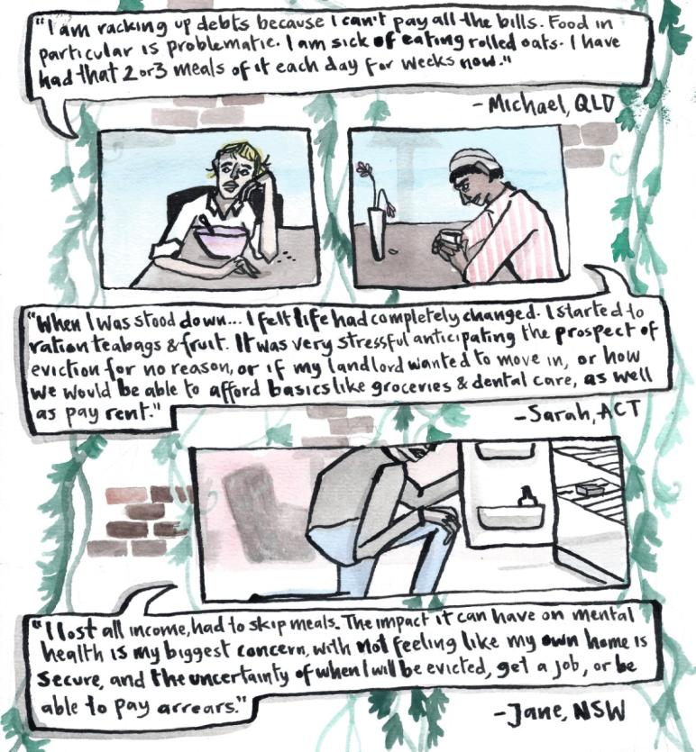

The economic crisis of COVID-19 compounded the existing disadvantage of people who rent. Renters were already worse off: now they experienced a disproportionate burden of the economic shutdown. As renters struggled to manage their expenses on drastically reduced incomes, many confronted hardship and worse mental health.

In this context, the National Cabinet acted with welcome speed. The Federal Government expanded income support and called on landlords to negotiate rent reductions with their tenants. In parallel, most state and territory governments acted to limit evictions for rental arrears. Our survey finds that these steps made a positive difference for people who rent, as we discuss in the next section of this report.

What worked
- The expanded JobSeeker meant people could afford to eat.
- A small proportion of renters negotiated meaningful rent reductions.
- We recommend keeping the rate of JobSeeker to keep renters out of homelessness and debt.

Our findings strongly affirm the value of the Federal Government’s decision to increase income support, in particular through increasing the JobSeeker rate (with the Coronavirus Supplement). We also find that rent reductions helped the minority of renters who were able to negotiate a reduction successfully.

Expanded income support helped renters to avoid debt
As the public health crisis of coronavirus became an economic crisis, a vast number of Australians lost their jobs. Young people, disproportionately renters, were some of the worst affected.⁵ On the old JobSeeker rate, it would have been an immense challenge to keep paying rent.⁶ The doubling of JobSeeker, through the Coronavirus Supplement, made a huge positive difference for these unemployed renters.

In their survey responses, renters described an initial period of fear and anxiety when they imagined paying full rent after a significant loss of income. For these renters the Coronavirus Supplement meant they could keep paying rent while also affording essentials such as food and dental care. However, this relief has been relatively short-lived. Although the economic crisis continues to deepen, people who rent now anticipate a cut to income support come September.⁷ These people are frightened by the prospect of paying unaffordable rents on reduced incomes without the protection of eviction moratoria.

Recommendation: Keep the rate of JobSeeker
The increase in JobSeeker made a profound positive difference for both long-term and newly-unemployed people, including people who rent. Keeping JobSeeker at the current rate with the full Coronavirus Supplement will support unemployed renters to remain above the poverty line, keep paying rent and, crucially, remain in their homes.

JobSeeker should be enough so that people who are looking for work can afford the basics that they need. The current payment of $557.85 per week for a single person without children is only barely above the Henderson poverty line of $542.92.⁸ Any cut from the current level will push families and children into poverty.⁹

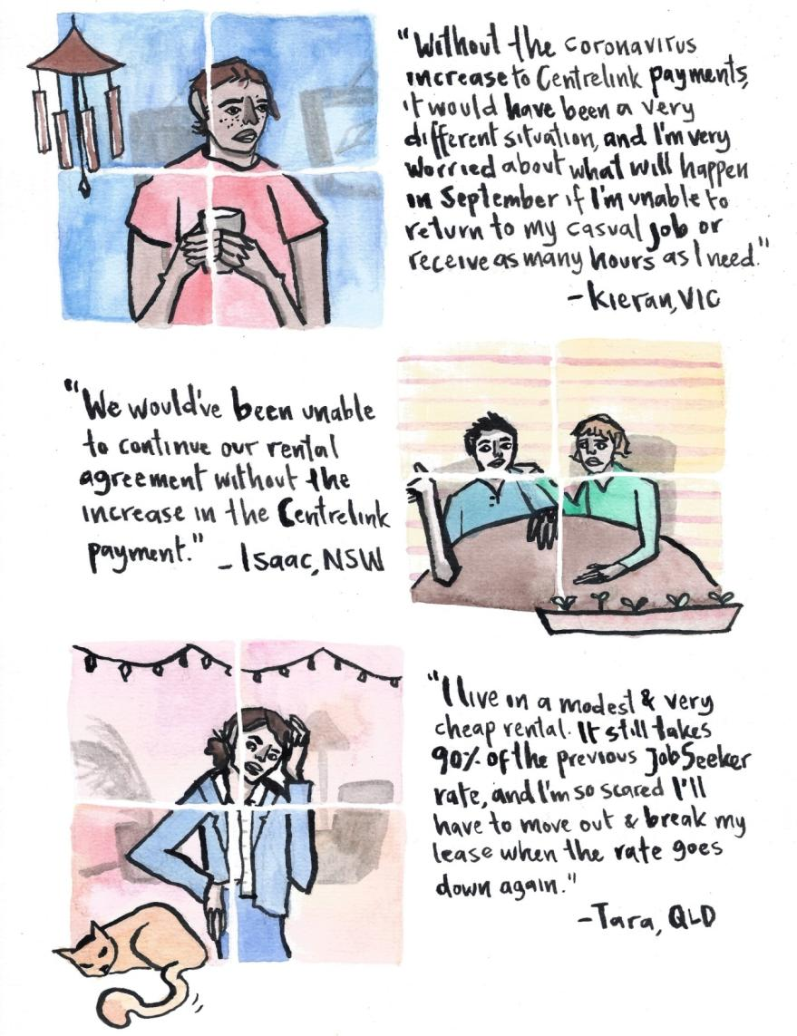
Further, the expanded JobSeeker rate has dramatically improved housing affordability and any cut will severely reduce housing options. The 2020 Rental Affordability Snapshot shows that, for a family with two children and two adults earning JobSeeker, the Coronavirus Supplement of $550 per fortnight means that 11.6% of rental properties are affordable, compared with 0.8% previously.¹⁰ For a single person on JobSeeker the increase is also impressive, although they are still left with very few options. The Snapshot shows that any reduction in JobSeeker will have a negative effect on rental affordability, putting many at risk of rental debt or homelessness.

A small minority of renters got rent reductions
A minority of renters asked for and secured rent reductions. This meant they could pay their rent without having to cut back on essentials, especially when they also had access to JobKeeper or the Coronavirus Supplement.

Of tenants who experienced a reduction in income (63% of all respondents), about one in ten (9%) asked for a rent reduction and received an outcome they were happy with. For comparison, an ANU survey found that 10.5% of renters negotiated a lower rent.¹¹ These proportions are disappointingly low, but the rent reductions did make a significant difference for the lucky renters.

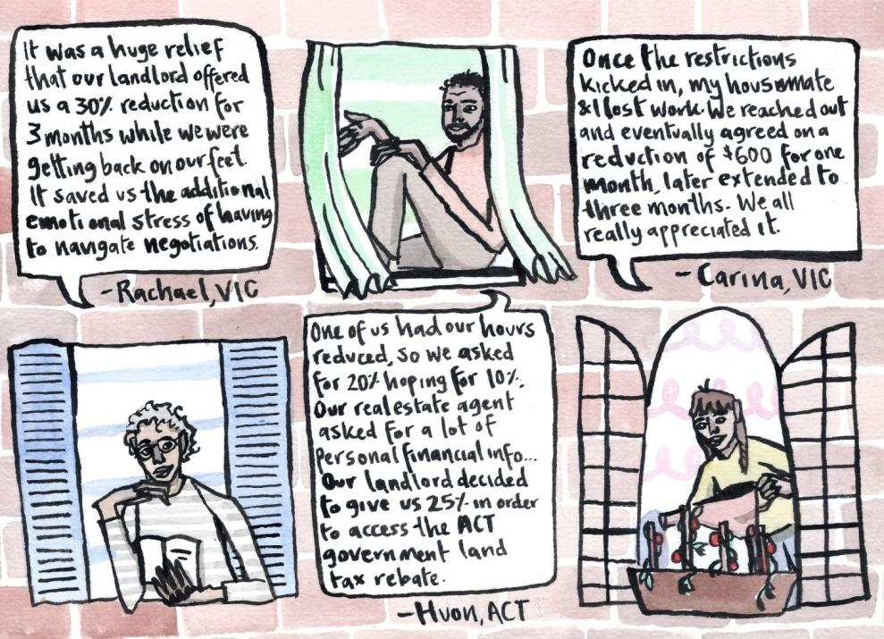

Unfortunately, success stories are the exception, not the rule. The most common experience for a renter was losing some income but being reluctant to ask for a rent reduction, usually due to a fear of retribution. The power imbalance between people who rent and their landlords meant that voluntary rent reductions were not an option for most renters. In the next section of this report, we discuss the challenges for impacted renters who were unable to reduce their housing costs during the COVID-19 pandemic.

What went wrong
- Despite widespread loss of income, most renters did not ask for a rent reduction.
- This was due to a fear of retaliation or a sense of hopelessness.
- Most renters who did ask for a reduction missed out.

Although many renters benefitted from increases income support, and some secured rent reductions, most renters were left trying to pay their original rent, often on a reduced income. Our survey finds one in two renters (50%) that experienced a loss of income did not ask for a rent reduction, typically due to a fear of retaliation. The most common outcome when renters did ask for a rent reduction was a frustrating, protracted process, leading to a refusal or a mere deferral. As a consequence, renters were left isolated in shouldering the burden of an economic crisis.

Renters were afraid to ask for reductions
Our survey found that one in two renters that experienced a loss of income did not ask for a rent reduction. This is due to two key factors. Firstly, renters feared retaliation from their lessor. Secondly, renters felt powerless and sensed that asking for a reduction would be futile.

Lessors have significant power over people who rent and can use this power, often implicitly, to sanction tenants who are too assertive. Such sanctions may include rent increases, delays in effecting repairs, or the termination of a tenancy. Whether or not landlords exercise such powers, tenants are aware that the power exists, and this limits their willingness to self-advocate.

For example, a 2018 survey of renters found that seven in ten renters were worried that a request for repairs could mean a rent rise.¹² Another survey found a positive relationship between length of time renting and the likelihood that tenants would hold off making a complaint¹³, suggesting that tenants with more experience of the rental market had a learned reluctance to get their landlord offside. The Productivity Commission has also noted that the potential for landlord retaliation prevents tenants from exercising their rights.¹

The responses we heard from renters bear this out. Renters described a fear of eviction, rent increases, or just the creation of ill-will that could come back to haunt them later. For renters who lost income and didn’t ask for a rent reduction, one in four described concerns about retribution.

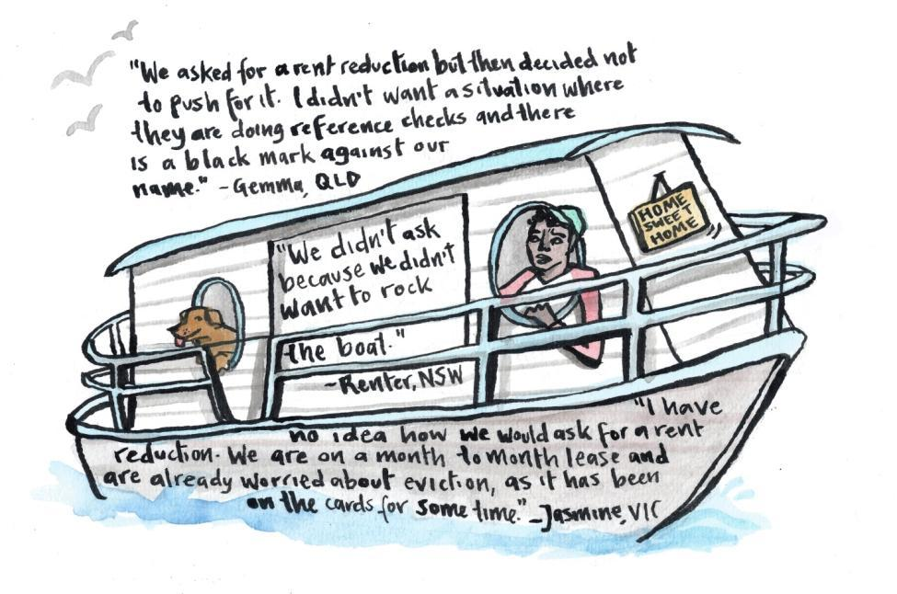
One irony worth noting is that tenants, especially those reliant on income support, had a dread of losing their tenancy and having to apply for a new place. Consequently, some of those most in need of a rent reduction were particularly unwilling to ask for one because of the risk of an eviction.

In addition to the fear of retaliation, a sense of hopelessness prevented a number of people from asking for a rent reduction. This was more common than an explicit fear of retaliation, with about one in two renters who didn’t approach their lessor describing this sense of futility.

Many renters have learnt over time that it is worthless trying to get their landlord to do anything. If your landlord took six weeks to repair a broken tap, it’s hard to believe that they will respond promptly and positively to a request for a rent reduction. In effect, many people who rent experience a learned helplessness that made them unwilling to ask for a rent reduction. In this case, renters not only anticipated negative consequences, they were also sceptical about the likelihood of a positive outcome.

Unfortunately, the renters who doubted the value of asking for a rent reduction were mostly spot on. In the next section we consider the outcome for those who did ask for a rent reduction.

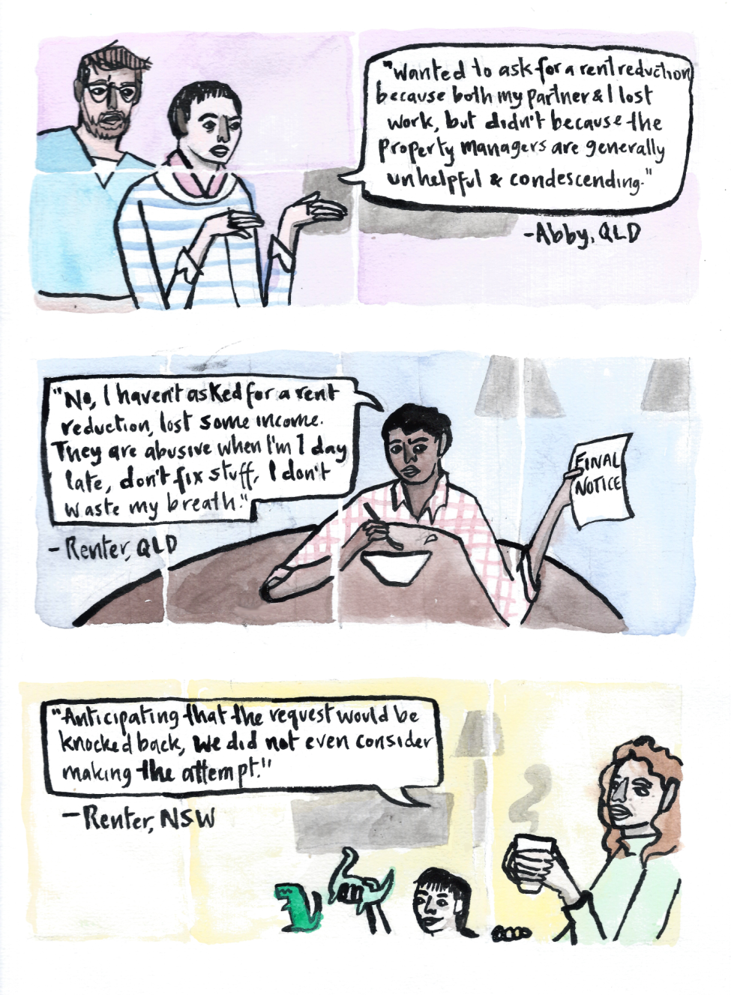

Renters who asked for rent reductions received little support
Of renters who experienced a loss of income, one in two asked for a rent reduction. However, the majority of these renters received an underwhelming outcome. About half received no reduction, or a trivial amount, and about one in five was offered a rent deferral. Others experienced a bureaucratic, even Kafkaesque process, which caused many renters to give up in frustration. A separate survey, specifically of older renters, arrived at similar conclusions.¹⁴ Overall, less than one in ten renters who lost income was able to negotiate a satisfactory outcome.
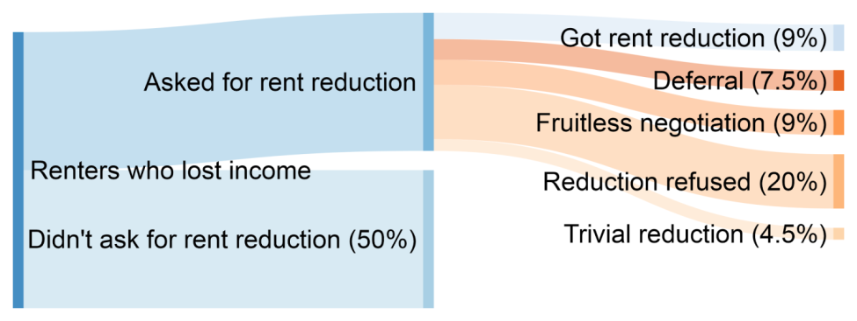
Figure 1 Rental cost outcomes for renters who lost income.

Negotiating reductions was a quagmire
Some renters began negotiations for a rent reduction only to be thwarted by an alienating process. Agents or landlords would take weeks to reply, would have to be followed up, and would demand private information and reams of documentation. Renters would be asked if they had accessed their super, what they had in savings, or what other expenses they had cut back. Weeks later they might be told to provide more information, or that they had filled out the wrong form. It’s no surprise that many gave up.

Property management income is proportional to rent paid, so agencies have a disincentive to facilitate rent reductions. They are aware of this.¹⁵ We heard from many renters who described agents as “gatekeepers” who would not pass on requests to lessors. Regardless of the intent of agents or lessors through this process, the effect has been to discourage renters from pursuing rent reductions and to resign themselves to trying to pay unaffordable rents.

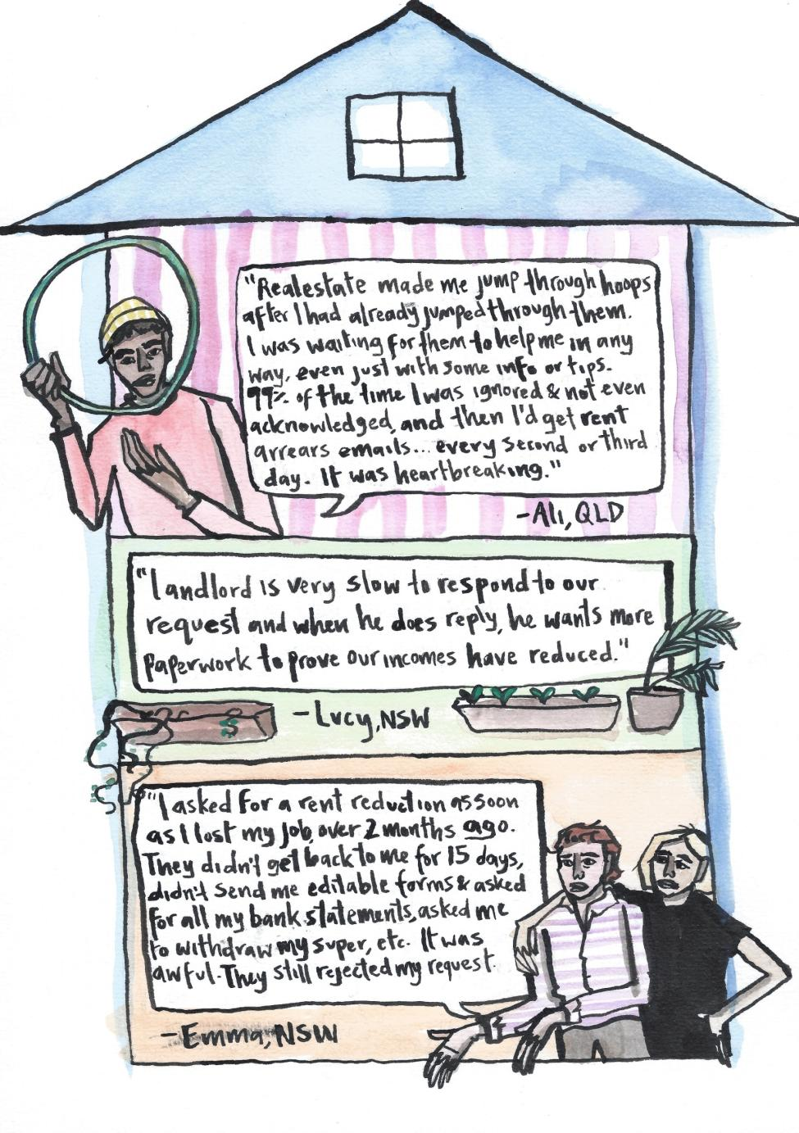

Lessors offered deferrals to avoid genuine reductions
Most renters who sought a reduction eventually got a response. However, this was sometimes a mere rent deferral: the tenant would pay less rent temporarily, accruing a debt they would have to pay back in the future. Eviction bans meant renters could already accrue rental debt without the threat of legal eviction, so a rent deferral seems worthless. It also meant that renters would later have to pay even more rent than usual in order to clear their debt. For most renters, particularly in the given economic climate, this was entirely unrealistic.

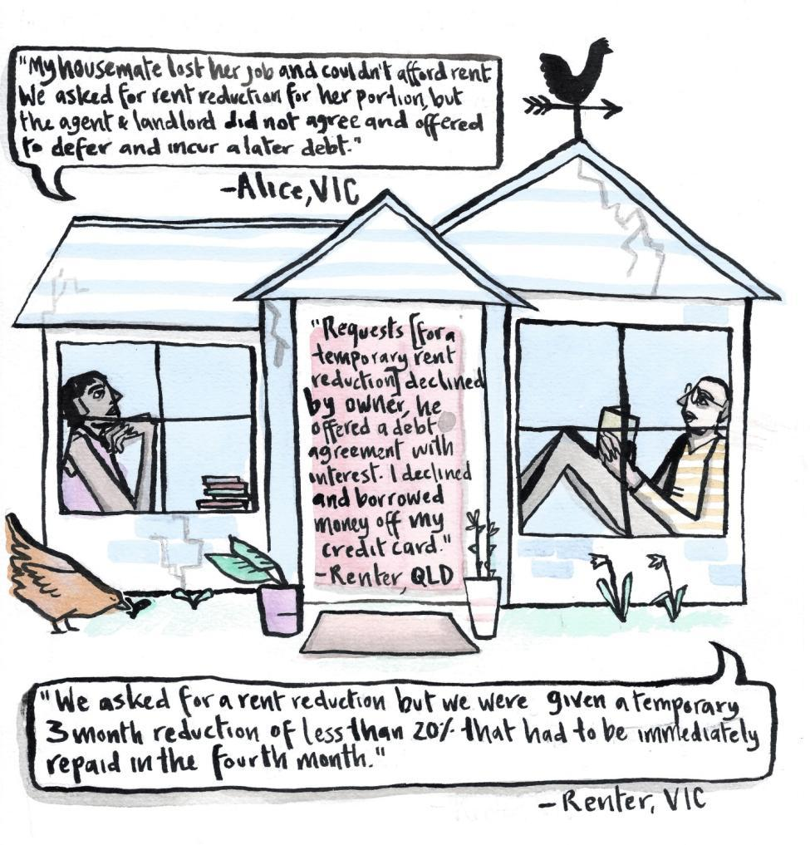

Lessors refused rent reductions with little accountability
The most common outcome for a rent reduction request was that an agent or landlord would say no. In some cases, landlords would offer a trivial rent reduction that was barely better than nothing and did little to assist tenants with their financial situation.

This is disappointing but unsurprising. Most renters have no leverage in negotiating a rent reduction and are entirely dependent on the benevolence of their lessor. As noted previously, real estate agencies have an economic incentive to prevent rent reductions. In Victoria and Queensland, renters had the option to seek arbitration and some used this to secure rent reductions.^{16,17} In most jurisdictions, however, renters had no option but to accept their landlord’s decision.

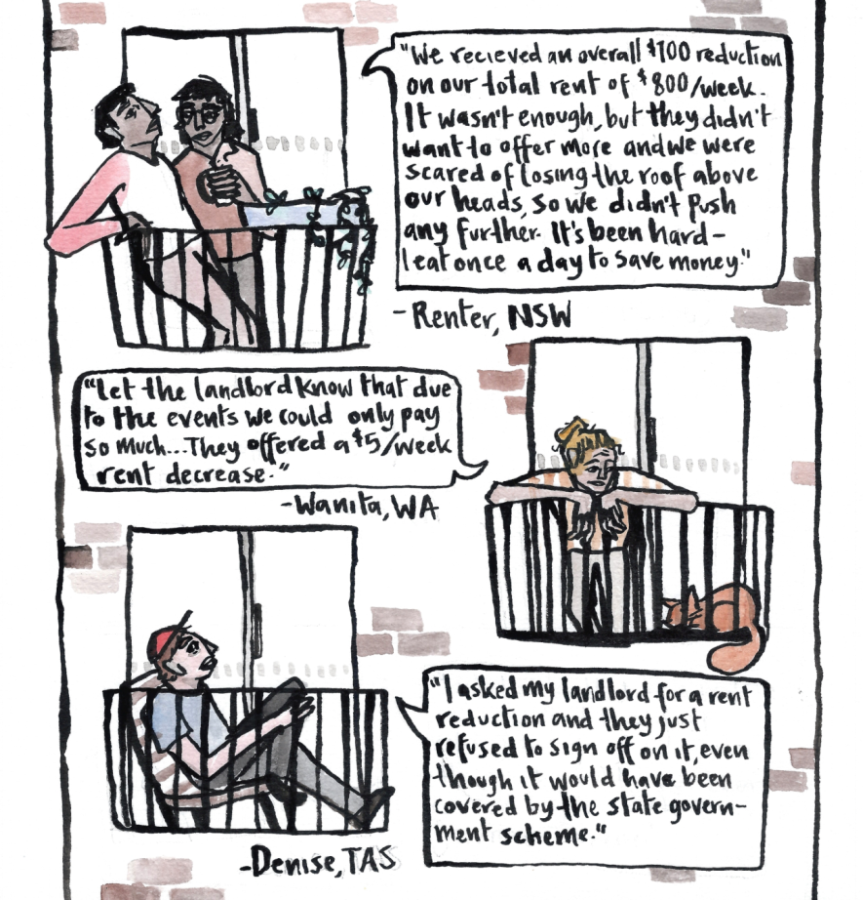

Recommendation: Implement the measures in the National Statement on Renting and Coronavirus
Many renters have lost income yet been unable to obtain relief from their landlord. These renters are at risk of eviction in the future, either due to rental arrears or in retaliation. This indicates the need for stronger protections for people who rent. These protections should strengthen the capacity of renters to negotiate rent reductions, while also ensuring that all renters are able to stay in their homes and out of debt.

On 18 June 2020, an open letter was sent to members of the National Cabinet calling for more support for renters. The statement has now been signed by over 70 organisations.¹⁸ It calls for measures to:
- Stop evictions for rental arrears or where the tenant is not at fault,
- Support renters to terminate an unaffordable rental contract,
- Require binding arbitration where a landlord and tenant cannot agree on a rent reduction,
- A temporary freeze on rent increases,
- Direct financial support for renters who would struggle to afford even reduced rent, and
- A requirement for banks and insurers to offer genuine relief to those landlords who have reduced rent.

Tenants in need are struggling to secure rent reductions because they have no leverage. These measures above would support renters to negotiate rent reductions. Enabling tenants to terminate an unaffordable contract would assist with avoiding debt, and also give landlords an incentive to negotiate; binding arbitration would have a similar effect. In all, these steps form a package that would support renters to be able to stay in their homes and out of debt. Such a package would ensure that renters are not left to shoulder the burden alone.

Binding arbitration should be introduced across Australia, and should also include the possibility of a retroactive rent reduction. This would ensure that relief is aligned with when the need began, not just when an outcome was eventually achieved. Without this measure, Scrooge-like landlords stand to benefit by denying a rent reduction for as long as possible. Retroactivity is necessary here to provide a strong incentive for landlords to negotiate in faith, and genuine consequences if they refuse.

The power imbalance between renters and lessors makes an unfair playing field
- COVID-19 has highlighted pre-existing power imbalances in the private rental sector.
- These power imbalances prevent the law from functioning as intended.
- Structural changes are needed to ensure the private rental sector can offer adequate housing.

"As someone who works abroad often and regularly rents housing internationally... This current situation is yet another example of the complete lack of renters rights in Australia."
-Renter, ACT

COVID-19 has revealed the flaws of taking housing, an essential service, and putting it in the hands of an atomised sector of amateur individuals whose first priority is their own financial security. When the lockdown began, too many renters were left dependent on the sympathies of their agents and landlords. Sadly, these actors let renters down. Governments across Australia, perhaps naive about the realities of life as a renter, failed to take adequate steps.

The power imbalance between renters and landlords is not inevitable. It exists in Australia because of a rental system that prioritises the economic interests of property investors over the basic needs of the people who inhabit their properties. In addition, low vacancy rates are a recurring feature of the rental market, so there is negligible market pressure on landlords to offer better service. Tenants are easily replaceable; landlords and tenants know this.

The outcomes of this have been on display these last months. Renters, aware of their own vulnerability, were reluctant to request rent reductions for fear of souring a relationship with someone who controls their access to housing. Property investors, accustomed to treating their assets as a source of passive income, balked at the prospect of reducing their own profits to support tenants. For a moment, it seemed like COVID-19 might be a watershed leading to greater security and affordability for people who rent. For the time being, that promise has been unfulfilled.

Governments need to reform the rental sector. This need for reform grows out of COVID-19, but not only that. It is a long-dormant need, newly brought to light. It is a need that anticipates and builds resilience for future health, environmental, or economic shocks.

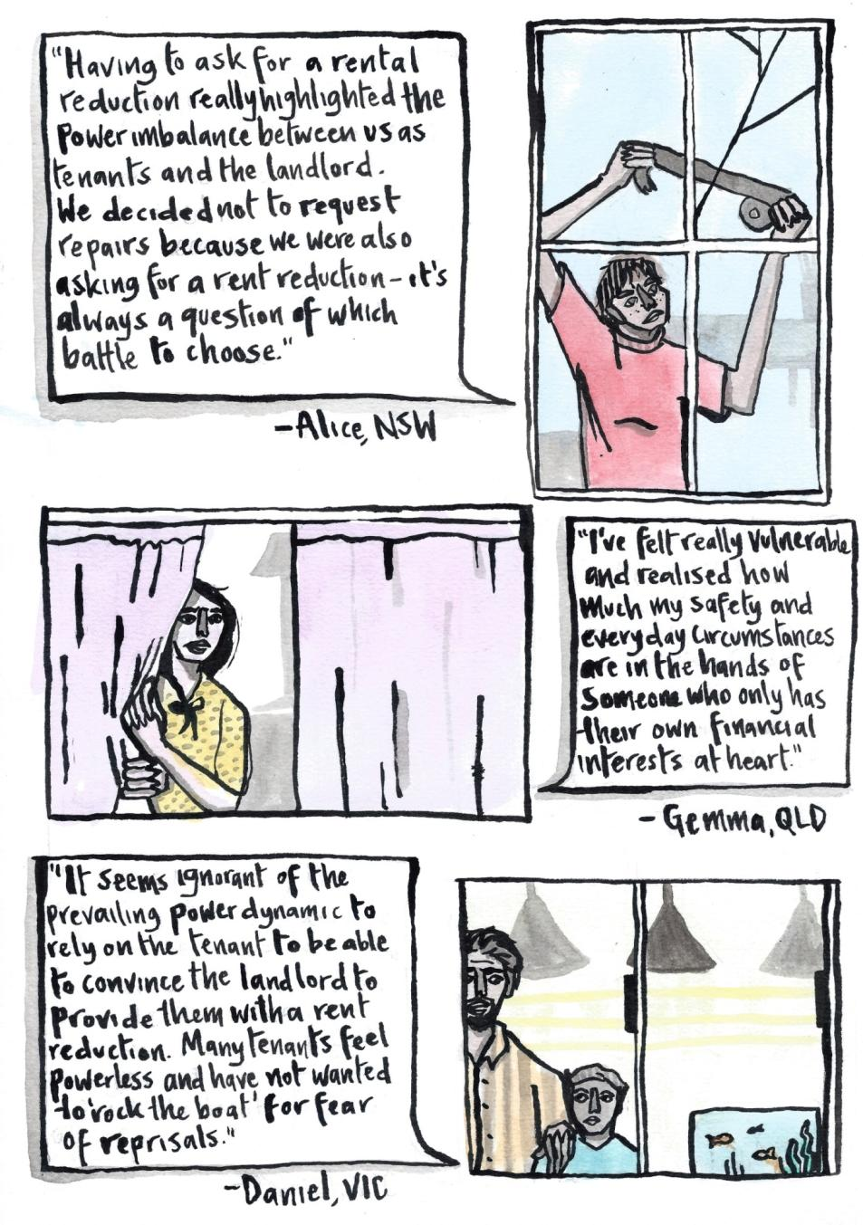

Recommendation: Abolish unfair evictions
One long-overdue change is the abolition of unfair, “no grounds” terminations. These laws allow property investors in most states and territories to terminate a tenancy without having to provide any reason. In practice, they enable property investors to kick out assertive tenants. Correspondingly, they have a chilling effect on people who rent, making them unwilling to assert their legal rights.

This phenomenon has been documented by tenant organisations¹⁹, academics²⁰, and the Productivity Commission of Australia¹, among others. It was on display again these last few months, with tenants unwilling to request rent reductions for fear of a retaliatory eviction down the track.

Instead of “no grounds” terminations, tenancy law can prescribe particular legal grounds for terminating a tenancy. This would allow landlords to terminate a tenancy only when there is a fair reason to do so.

Recommendation: Invest in social housing
In recent history, the public rental sector has shrunk, pushing more renters into the private rental sector. This makes housing less affordable.¹ It also leaves disadvantaged renters subject to the whims of an atomised industry of amateur property investors, who may not know their responsibilities or have the financial resources to provide adequate housing. How does this affect renters? In our survey, we heard from many renters whose landlords illegally attempted to evict them. In another newsworthy incident, a landlord was charged for allegedly assaulting a tenant in financial hardship.²¹

Investment in social housing is an economic stimulus measure that also brings about lasting improvements in housing affordability and reductions in homelessness. It has attracted support recently from stakeholders such as the Grattan Institute, the OECD, and the CFMEU and MBA.^{8,22,23}

Some renters would benefit directly from having improved access to housing which is more affordable than that in the private rental sector and also offers greater stability and security of tenure. Other renters would benefit indirectly: increased supply overall would mean reduced competition between renters in the private rental sector. We expect this would reduce upward pressure on rents. In addition, private renters would also be in a stronger position to assert their legal rights and to negotiate with landlords.

Conclusion
A recent report on mortgage and rental stress concluded with the ominous words:

“What started as a public health crisis and is turning into an economic crisis may eventually lead to a housing crisis, particularly for young Australians and those on low incomes.”¹¹

We echo this sentiment with one clarification: young or poor Australians already faced a housing crisis. COVID-19 just made us start paying attention. It was routine for low-income renters to be in rental stress, having to live a life of want to afford their rent and keep a roof over their head.

Thus, when COVID-19 struck, renters had a particularly hard time. Many lost work and had minimal financial buffer to see them through. Renters found themselves going without and experiencing mental health impacts, skipping meals to get by or going to bed each night in tears.

The expansion of JobSeeker was an overwhelming positive in this time. Some renters also succeeded in negotiating rent reductions: a vindication of some landlords and of the incentive systems that some state or territory governments introduced.

However, most renters struggled. Many were on reduced incomes, yet a fear of landlord persecution made them unwilling to even reach out for support. Those renters who did take the risk and reach out were stymied by heartless processes and unsympathetic responses from both agents and lessors.

These experiences reveal a fundamental problem: renters are not on an even playing field with their landlords. If a renter gets their lessor offside, they risk rent evictions, delayed maintenance, even eviction. Conversely, a landlord risks a temporary disruption to their investment income, if that. Unless this power imbalance is addressed, tenants will continue to be left worse-off, and legalistic interventions will fall short of achieving fair outcomes for tenants.

Given this, we call for the abolition of ‘no grounds’ termination to reduce the potential for retaliation and empower tenants to exercise their rights. In addition, an increased supply of social housing would benefit all tenants, directly or indirectly, improving affordability across the board and helping to address the power imbalance.

What started as a public health crisis is now also an economic crisis. It may yet make Australia’s housing crisis even worse. But it need not. It’s now clear that the current configuration of Australia’s rental sector is not fit for purpose: it fails to provide decent homes for the growing number of Australians who rent. This was true before COVID-19; it is especially evident now. As we build back, we can build back better. This can mean more affordable housing. It can also mean constructing stronger systems to protect the needs of people who rent their homes.

Bibliography
1. Productivity Commission. Vulnerable Private Renters: Evidence and Options Productivity Commission Research Paper. https://www.pc.gov.au/research/completed/renters (2019).
2. Reserve Bank of Australia. Financial Stability Review. https://www.rba.gov.au/publications/fsr/2020/apr/ (2020).
3. Ong Viforj, R. As coronavirus widens the renter-owner divide, housing policies will have to change. The Conversation https://theconversation.com/as-coronavirus-widens-the-renter-owner-divide-housing-policies-will-have-to-change-135808 (2020).
4. Nearly 60% of Australian renters adversely affected by COVID-19. rent.com.au https://www.rent.com.au/blog/renter-survey-covid-19-affordability-issues (2020).
5. Janda, M. Coronavirus risks widening intergenerational wealth divide. ABC News https://www.abc.net.au/news/2020-04-24/coronavirus-risks-widening-intergenerational-economic-divide/12178410 (2020).
6. Anglicare Australia. Rental Affordability Snapshot: National Report April 2019. https://www.anglicare.asn.au/research-advocacy/the-rental-affordability-snapshot (2019).
7. Hitch, G. What are the changes to JobKeeper and JobSeeker? Government announces tweaks to coronavirus programs. ABC News https://www.abc.net.au/news/2020-07-21/changes-jobkeeper-and-jobseeker-coronavirus-payments-explained/12476174 (2020).
8. Daley, J. et al. The Recovery Book: What Australian governments should do now. (2020).
9. Grudnoff, M. Poverty in the age of coronavirus: The impact of the JobSeeker coronavirus supplement on poverty. https://www.tai.org.au/content/poverty-age-coronavirus-impact-jobseeker-coronavirus-supplement-poverty (2020).
10. Anglicare Australia. Rental Affordability Snapshot. 24 https://www.anglicare.asn.au/research-advocacy/the-rental-affordability-snapshot (2020).
11. Biddle, N., Edwards, B., Gray, M. & Sollis, Kate. COVID-19 and mortgage and rental payments: May 2020. 22 https://csrm.cass.anu.edu.au/research/publications/covid-19-and-mortgage-and-rental-payments-may-2020 (2020).
12. CHOICE, National Shelter & National Association of Tenant Organisations. Disrupted: The consumer experience of renting in Australia. https://www.choice.com.au/disrupted (2018).
13. CHOICE, National Shelter & National Association of Tenant Organisations. Unsettled: Life in Australia’s Private Rental Market. https://www.choice.com.au/money/property/renting/articles/choice-rental-market-report (2017).
14. York, F. Covid-19 and older people in housing stress. 6 https://www.oldertenants.org.au/sites/default/files/covid19-policy-note.pdf (2020).
15. Nolan, D. Real estate agent mistakenly sends tenant embarrassing internal document in response to COVID-19 rent reduction request. A Current Affair https://9now.nine.com.au/a-current-affair/real-estate-agent-coronis-mistakenly-sends-tenant-internal-document-on-covid19-pandemic-rent-reductions/3284a971-e1b5-4e2d-97a3-c61a18ec1178 (2020).
16. Heagney, M. Sunshine Coast landlord forced to discount rent after QCAT ruling. Domain https://www.domain.com.au/news/sunshine-coast-landlord-forced-to-discount-rent-after-qcat-ruling-958481/ (2020).
17. Tenants Queensland. COVID-19 affected family wins genuine rent reduction in QCAT! Tenants Queensland https://tenantsqld.org.au/covid-19-affected-family-wins-genuine-rent-reduction-in-qcat/.
18. Renting and Coronavirus. Renting and Coronavirus www.rentingandcoronavirus.com.au.
19. Tenants’ Union of NSW & Marrickville Legal Centre. Lives Turned Upside Down. 25 http://files.tenants.org.au/policy/2019-Lives-turned-upside-down.pdf (2019).
20. Domain. No more no-grounds terminations: Experts unite in open letter on rental housing reform in NSW. Domain https://www.domain.com.au/news/time-evict-no-grounds-termination-open-letter-rental-housing-reform-nsw-766696/ (2018).
21. Ward, M. Two charged after man allegedly detained, assaulted in Surry Hills for failing to pay rent. The Sydney Morning Herald (2020).
22. Organisation for Economic Co-operation and Development. OECD Economic Outlook - June 2020: The world economy on a tightrope. https://www.oecd-ilibrary.org/economics/oecd-economic-outlook/volume-2020/issue-1_0d1d1e2e-en (2020).
23. CFMEU and MBA call for $10b social housing stimulus package. medianet https://www.medianet.com.au/releases/186835/ (2020).

Appendix A: Survey questions
The first seven questions of the survey related to the respondent’s renting experiences. The final questions were to identify renters who were happy to share their stories publicly.

- Where do you live?
  - NSW
  - Victoria
  - ACT
  - Queensland
  - SA
  - Tasmania
  - NT
  - WA
- In your state/territory, do you live in an
  - Urban area
  - Regional or rural area
- Have you asked your landlord/agent for a rent reduction?
  - Yes, we got what we wanted
  - Yes, but we didn’t get what we wanted
  - Yes, and negotiations are ongoing
  - No
- Can you let us know more about asking for a rent reduction?
- Has your household income been affected by coronavirus?
  - Yes, lost all my income
  - Yes, lost some income
  - No, income is the same or higher
- Has coronavirus impacted your living situation?
  - I've moved house, still renting
  - I've moved in with family
  - I've moved out, currently couchsurfing/crashing with friends
  - I've had to skip meals to save money
  - I've struggled to make ends meet with rent and bills
  - I haven't had any big changes
- Would you like to share anything else about your experience as a renter during the pandemic?

