Pet peeves: how landlords are denying renters the benefits of pets
Better Renting, November 2020

As the numbers of renters in Australia has grown, so too has the push for changes to rental laws, including around pets. This report considers the current situation for renters in Australia, reviewing data on the situation facing renters with or without pets, and the possible implications for renters and lessors. We find that 44% of renter households have pets but only 8% of SA rental properties explicitly welcome pets. In addition, we identify significant variation across different agencies, suggesting that landlord preferences are not a determining factor.

Introduction
Over the last two years, Victoria, NT, and the ACT have changed laws around renting with pets.^{1–3} The Queensland Government has proposed changes to the same effect.⁴ These changes reduce the ability of a landlord to veto a pet without grounds, instead establishing a system in which a lessor may require consent, which may not be unreasonably refused.

A bill to allow South Australian renters to keep pets is currently before the South Australian parliament.⁵ But what is the need for legislation like this? This report analyses the current situation facing people who rent in South Australia, outlining the challenges facing renters and the potential policy options to address these challenges.

Renting with pets
Australia is a nation of pet owners. But pet ownership is not evenly distributed. About seven in ten non-rental households include pets. But when we consider rental households, only 44% include pets. There are more owner-occupier households with pets than there are renters with or without pets.⁶

This gap is most likely because Australia’s rental market makes it impractical for renters to keep pets. According to a 2019 survey, amongst renters who would like to have a pet, over one in two faced barriers posed by landlords or body corporates, compared to just one in ten owners interested in having a pet.⁶ Renters with pets also face discrimination when applying for rental properties^{7,8}, which is likely to suppress pet ownership. The disproportionately low rate of pet ownership amongst renters is a consequence of Australia’s rental market, not the wishes of renters themselves.

Because they are less likely to have pets, people who rent are denied the potential health benefits of companion animals. Pets have been demonstrated to improve physical, psychological, and social health.⁹ For example, pet owners are more likely to have healthy blood pressure and less likely to experience depression.¹⁰ By compelling renters to avoid pet ownership, landlords make it harder for people who rent to experience the health benefits of companion animals.

Alternatively, some renters do obtain a pet, but they are then forced to abandon their pet when they next search for rental accommodation. In the 2018-19 financial year, renters were forced to surrender 259 pets to the RSPCA SA. This is roughly one in ten of the surrenders processed by the RSPCA SA.¹¹ Although animal welfare organisations strive to rehome surrendered pets, this process is an emotional ordeal for the people and the animals involved. Across Australia, in the 2019 fiscal year 12.72% of received dogs and 22.94% of received cats had to be euthanased by the RSPCA.¹²

In some cases, renters cannot bear to give up their pet. These people may end up homeless, for example sleeping in their car in order to remain with a pet dog.¹³ A reluctance to leave a pet behind can mean that people hesitate to leave a violent home, as they cannot be confident of taking their pet with them to a new rental property.¹⁴ For renters with pets, an unwillingness to sacrifice a pet to secure a new rental home can lead to dangerous living situations.

This discrimination against pet owners harms both current and potential renters with pets. But there is no evidence that these harms are justified by the benefit to lessors. People who rent with pets remain liable for any damage caused by their pet: a lessor would always have legal recourse to cover any damages. In addition, evidence suggests that lessors who allow pets receive increased income that more than offsets any additional wear.¹⁵ Overall, lessors are better off allowing pets. Lessors or agents who refuse are acting arbitrarily without evidence to support their position.

But what is it like for a pet-owner looking for rental accommodation in South Australia? In our analysis below, we aim to begin answering this question.

Method
We analysed a dataset of 4053 unique South Australian rental advertisements from AllHomes, recorded over three months between November 2019 and January 2020. For each advertisement, the property description was analysed for the word “pet” or “pets”. The context of the term was then used to classify the sentiment towards pets as negative, positive, or neutral.

Sentiment was classified as negative when it was clear from the advertisement that pets would be a liability for a potential applicant. For example, many ads described pets as “not permitted”. Sentiment was positive when pets were explicitly welcomed, or if the ad highlighted that pets were allowed. Some ads would identify this as a positive feature of the property. Finally, sentiment was neutral when pets were mentioned in an ambiguous or conditional way. Commonly, an ad would say that pets were “negotiable”. Alternatively, an ad might stipulate conditions: “small pet only”. A sample of phrases is included in the Appendix.

We then selected the real estate agencies (REAs) with the greatest representation, each of which had forty or more ads in our sample. This left 23 REAs. No private lessors were included.

Findings and discussion
Across all ads, we found the following results:
- No position: 40%
- Negative sentiment: 34%
- Positive sentiment: 8%
- Neutral sentiment: 17%

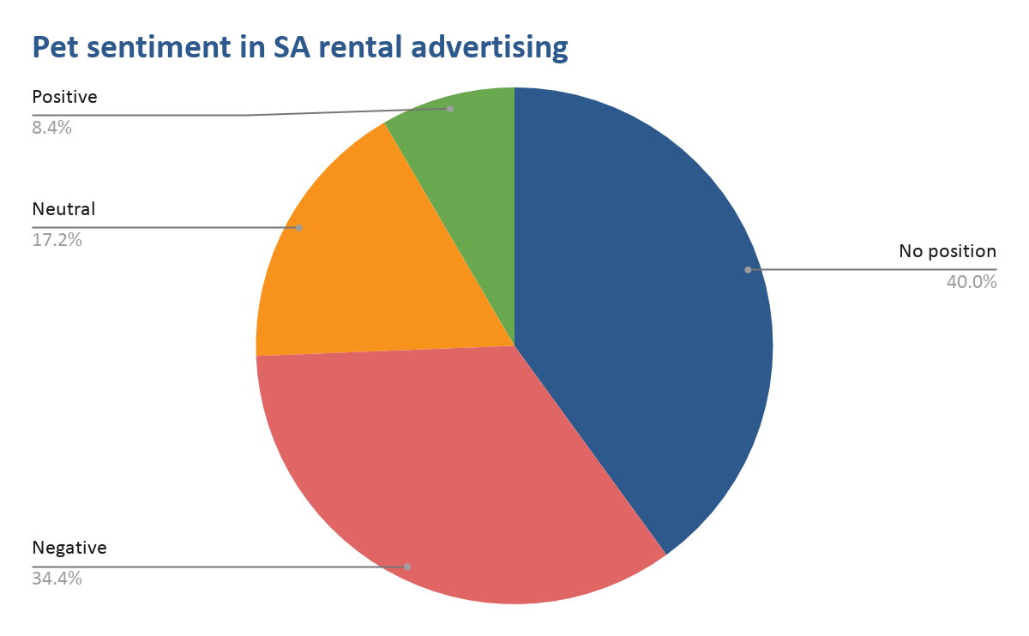
Figure 1: proportion of rental ads with different sentiment towards pets: positive, neutral, negative, or no position expressed.

Disclosure rates
Across the ads we analysed, three in five disclosed a position on pets. This disclosure rate is higher than the rate we previously found in the ACT.¹⁶ A high-disclosure rate is positive, as it is in the interests of both renters and lessors to efficiently match pet-owning renters with pet-accepting lessors. A lack of disclosure reduces transparency, meaning that renters may waste time on fruitless applications, and lessors may have to deal with applications with no chance of success.

Positive sentiment
8% of ads, or about one in twelve, was positive about pets. These are ads where a renter with a pet would be encouraged when applying. However, renters may still face significant competition when applying for these properties. With around 44% of renter households including pets, the rate of positive sentiment would need to be much higher to correspond to the needs of people who rent.

Variation between agencies
Individual real estate agencies show highly-varied sentiment. If the views of lessors determined the sentiment expressed in rental advertising, we would expect greater consistency. In contrast, what we observe suggests strong input from real estate agencies.

Specifically, negative sentiment towards pets varies from 20% to as high as 46%. Positive sentiment varies from as high as 33% to as low as 0%. Each real estate agency acts as a gatekeeper to rental properties, and their attitude towards pets — unregulated, and not necessarily reflective of lessor preferences — has a significant impact on the ability of potential tenants to obtain shelter.

Conclusion
In this report, we review evidence that renters are disproportionately likely to face barriers to pet ownership, and this shows up in lower rates of pet ownership. This finding is complemented by our own research, which highlights the difficulties facing renters with pets when looking for rental accommodation: less than 10% of ads welcomes pets, while about three in four ads either give no indication or prohibit pets explicitly. We also find variation between real estate agencies, suggesting that the ability of a renter to obtain shelter is contingent upon the arbitrary inclination of individual agencies.

Recent reform in some jurisdictions, similar to what is proposed in SA, makes it easier for renters who already have secured a tenancy to then obtain a pet. While this doesn’t address discrimination at the point of application, it is a positive step. Such legislation may help to normalise pets in rental properties, changing the culture and reducing discrimination by lessors or real estate agents.

Our analysis reinforces the need for renters to have a recognised right to keep a pet. But it also highlights the limitations of current approaches. Some jurisdictions have made it easier for current renters to obtain a pet. However, when it comes to applying for properties, potential renters are still at the mercy of a rental market which discourages and penalises renters with pets. For as long as this remains the case, renters and their pets will continue to miss out.

Bibliography
1. Hair, J. & Arrow, B. All Victorian renters given right to have a pet under sweeping new rules. ABC News https://www.abc.net.au/news/2017-10-08/victorian-tenants-allowed-pets-in-rental-properties/9027000 (2017).
2. Alvaro, A. If you rent in Canberra, from today you’ll have more rights ... sort of. ABC News https://www.abc.net.au/news/2019-11-01/how-will-the-acts-new-renting-laws-affect-the-property-market/11659206 (2019).
3. Thrive Property NT. NT Government Passes Bill to Allow Pets in Rentals. Thrive Property NT https://thrivepropertynt.com.au/nt-government-passes-bill-to-allow-pets-in-rentals/ (2020).
4. Gartry, L. Queensland property owners could be forced to take tenants with pets. ABC News https://www.abc.net.au/news/2018-09-30/queensland-landlords-could-be-forced-to-accept-tenant-with-pets/10322618 (2018).
5. Henson, E. Push for pets in rentals. The Advertiser (2020).
6. Animal Medicines Australia. Pets in Australia: A national survey of pets and people. https://animalmedicinesaustralia.org.au/wp-content/uploads/2019/10/ANIM001-Pet-Survey-Report19_v1.7_WEB_high-res.pdf (2019).
7. Power, E. R. As pet owners suffer rental insecurity, perhaps landlords should think again. The Conversation https://theconversation.com/as-pet-owners-suffer-rental-insecurity-perhaps-landlords-should-think-again-63275 (2016).
8. CHOICE, National Shelter & National Association of Tenant Organisations. Unsettled: Life in Australia’s Private Rental Market. https://www.choice.com.au/money/property/renting/articles/choice-rental-market-report (2017).
9. Walsh, F. Human-Animal Bonds I: The Relational Significance of Companion Animals. Fam. Process 48, 462–80 (2009).
10. Smith, B. The ‘pet effect’: health related aspects of companion animal ownership. Aust. Fam. Physician 41, 353–448 (2012).
11. Parnell MLC, Mark. Greens Bill: Renting with Pets. Greens Bill: Renting with Pets https://www.markparnell.org.au/20191016_1 (2019).
12. RSPCA. RSPCA Australia National Statistics 2018-2019. https://www.rspca.org.au/what-we-do/our-role-caring-animals/annual-statistics (2019).
13. Branley, A. Four wheels, two dogs and one back seat: homeless and staying on the streets. ABC https://www.abc.net.au/news/2018-12-22/homeless-kristina-forced-to-live-in-a-volkswagen/10632224 (2019).
14. Novak, L. SA Government releases new proposed measures for escaping domestic violence, allowing victims to take pets or move abusers out. The Advertiser https://www.adelaidenow.com.au/news/south-australia/sa-government-releases-new-proposed-measures-for-escaping-domestic-violence-allowing-victims-to-take-pets-or-move-abusers-out/news-story/37e9d5c051bf1e65cb9ae60f663d1235 (2019).
15. Carlisle-Frank, P., Frank, J. M. & Nielsen, L. Companion animal renters and pet-friendly housing in the US. Anthrozoos 18, 59–77 (2005).
16. Better Renting. Pet Hates: Lessor Pet Sentiment and the ‘Agent Effect’. 6 https://www.betterrenting.org.au/pet_hates_report (2019).

Appendix: sample phrases of different sentiment
Negative | Neutral | Positive
does not accept pets | A pet may be considered | Great for pets
no couples or sharing, or pets | Outdoor pet considered | Happy to consider most pets
NO groups or pets | Pet considered on application | Ideal for small pets
no pets | Pets will be considered | Perfect for kids and pets
not permit any pets | Pets by application | Perfect for pets
not suitable for pets | Small pets only considered | Pet are allowed
not suited for pets | Pets are negotiable | pet-friendly
Pet will not be considered | Pets via negotiation | Pets Accepted
Pets not accepted | Cat by negotiation | Pets are also welcome
Pets not allowed | Pet will be negotiable | Pets ok
Will not consider pets | No indoor pets | Pets will be allowed
Pets not permitted | Outside pets only | Pets: Yes

(These numbers do not sum to 100% due to rounding).

