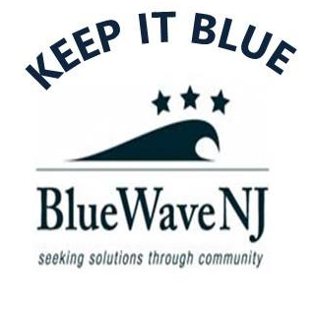

Dear:

I appreciate your stand last month against the American Health Care Act, the ACA repeal bill that would swell the ranks of the uninsured by 24 million in ten years, according to analysis by the Congressional Budget Office.

The newly amended AHCA would enable states to strip away essential consumer protections in the individual market for health insurance -- and so potentially render coverage unaffordable to millions more. The amendments would enable states to restore medical underwriting, potentially making insurance unaffordable for a quarter or more of those who look to the individual market for coverage. By allowing repeal of the ACA's Essential Health Benefits, the amendments could also make coverage for needed treatment unavailable to millions more.

Equally vital reasons that led you to reject the AHCA last month remain in place.

The AHCA repeals enhanced federal funding for almost 500,000 New Jerseyans rendered eligible for Medicaid through the ACA Medicaid expansion. If the enhanced federal match is repealed, there is no way New Jersey can make up the shortfall and maintain the ACA's expanded eligibility criteria. The AHCA also subjects federal Medicaid funding to per-capita caps that will not keep up with costs. Finally, the bill provides inadequate subsidies to low income and older prospective enrollees in the individual market and will cause millions of current enrollees to drop coverage.

In New Jersey, the AHCA will lead to an increase in the uninsured of over 475,000 by 2020, according to an analysis by New Jersey Public Policy.

As your constituent, I urge you to maintain your principled opposition to any bill that allows insurers to offer non-comprehensive coverage or to discriminate against prospective enrollees with pre-existing conditions, or that reduces access to Medicaid. I will be watching to see whether you stand up to protect our access to health insurance. I will work through 2018 and beyond to educate citizens in our district of your choice. Please honor your pledge to protect our care.

Sincerely,

