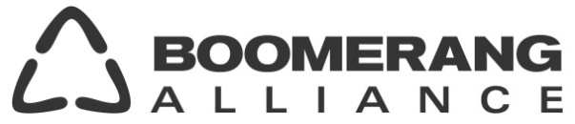

media release
Thursday 18th February, 2016

GOVERNMENTS ALL AT SEA
ON MARINE PLASTIC

The Commonwealth government is a major obstacle to action on plastic pollution, two major environment groups will be telling the Senate Inquiry Into the Threat of Marine Plastic Pollution, today.*

With a Senate report on the science, sources and impacts of plastics on Australia’s waterways due in April, representatives of the Boomerang Alliance and Total Environment Centre will reveal that levels of plastic pollution in Australia are 3-5 times greater than estimated by government.

“Australia is losing the race to stem the plastic tide even as it decimates wildlife and contaminates the food chain with increasing speed and toxicity. Scientists are now reporting an average seafood diet contains 11,000 pieces of plastic a year,” said Dave West, National Policy Director of the Boomerang Alliance.

Jeff Angel, Director of TEC & Boomerang Alliance said, “Commonwealth departments have spent years getting the data wrong, commissioning cost benefit studies that came to erroneous conclusions, and fiddling about. We believe only concerted action by the states more in touch with the community and environmental problems can make an impact.”

“The Government continues to reference the Annual Plastics Industry Survey even though its figures suggest we are producing 50% more waste plastic than we are consuming. Go figure,” said Mr West. “The Australian Packaging Covenant of industry and government representatives has finally admitted that their reported plastic recycling rate was wrong by almost 100% and is now down to 28% - something we have been telling them for years.”

Jeff Angel criticised recent endorsement of voluntary action on microbeads by the Commonwealth. “The US Congress has acted decisively on microbeads, passing a law to ban them and so-called biodegradeable plastic alternatives, yet Australia is still relying on voluntary industry actions which invariably have loopholes.”

“With an all-state stakeholder meeting on plastic bags on 29 February, we hope the Commonwealth won’t stuff up a ban policy.”

Both groups are seeking quick action by the states to attack 50% of the problem with:
- Container deposit systems
- A ban on free plastic shopping bags
- An end to microbeads in cosmetic and cleansers, replaced by safe alternatives

*Jeff Angel and Dave West are appearing at the Senate hearing in Sydney on Thursday, 18 February at 1.45pm, at the Portside Centre, 207 Kent Street, Sydney.

Further information: Jeff Angel 0418 273773, Dave West 0404 093718

