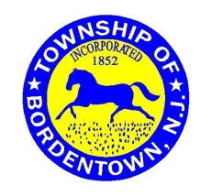
CITIZEN ADVISORY RECORD
Residents of Bordentown Township interested in volunteering to serve the community are invited to completed this form to express their interest. The information provided will be forwarded to the Township Committee and others strictly on a need-to-know basis. Volunteers may be subject to filing an Annual Financial Disclosure Statement in accordance with the Local Government Ethics Law.
NAME:
STREET ADDRESS: | CITY: |  |  | ZIP:
TELEPHONE: | EMAIL:
PROFESSION / OCCUPATION / TYPE OF WORK:
EDUCATION / TRAINING:
RELEVANT QUALIFICATIONS OR INTERESTS:
PRIOR SERVICE TO TOWNSHIP OR OTHER GOVERNMENTAL ENTITY:
VOLUNTEER INTEREST:
☐ Bordentown Sewerage Authority | ☐ Emergency Management Council
☐ Environmental Commission | ☐ Planning Board
☐ Veterans Advisory Committee | ☐ Other:
HAVE YOU EVER BEEN CONVICTED OF A CRIME?
☐ YES ☐ NO
Your signature below is an acknowledgement that you consent to the Township’s sharing of the information provided and that you understand that submittal and receipt of the information constitutes no assurance that you will be offered a service opportunity.

SIGNATURE |  | DATE
OPTIONAL: Attach resume or other pertinent information
Email to the Township Clerk at m.carrington@bordentowntwp.org or mail to: Township Clerk Maria Carrington
Township of Bordentown
1 Municipal Drive
Bordentown, NJ 08505

