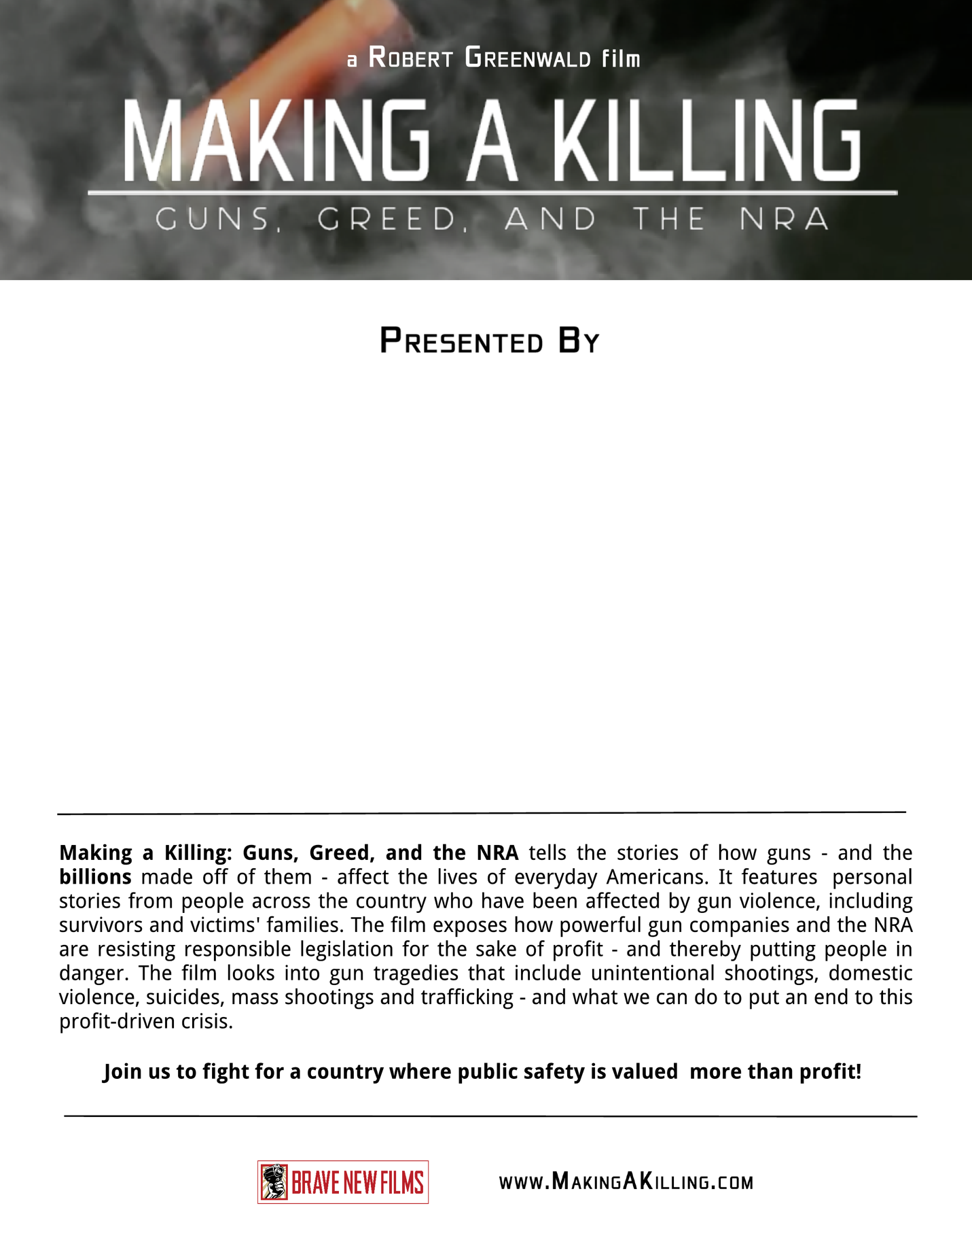

Question, contact:

Venue Name  
Address

Ticket/Parking Details

Date/Time

List of Partner Organizations