ORGANIZING TO WIN WEBINAR #1 WORKSHEET
Creating a grassroots campaign plan: Mission, goal, targets, strategies, and tactics

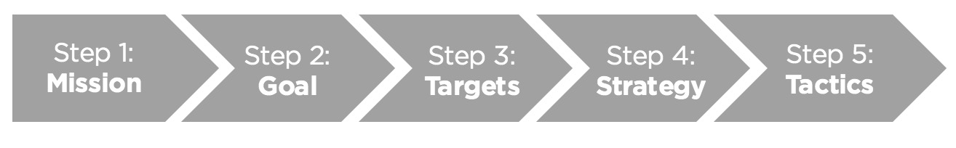

Step 1: Define your campaign’s mission

- What change do you want to see in the world? What is the end result you’re working toward? (Consider: Win a majority government, drive positive outcomes for specific constituencies)

Pro-tip: Your mission should be one concise, specific statement about the change you seek to make.

Step 2: Define your campaign’s goal

- What needs to happen to achieve your mission? When do you need this to happen? (Consider: Retain or pick up a specific # of seats in Parliament, pass specific legislation by a certain date)

Pro-tip: Your campaign goal should be SMART (Specific, Measurable, Actionable, Realistic, and Time-Bound).

Step 3: Identify your targets

Who has the resources to create that change you want? What does that person (or group) need, want and care about? Fill out the table below. Be specific!

We have broken this into three pieces: elected officials, organizations and the public for you. You may need all three, just one, or more.

 | Elected Officials | Organizations & Government | Public
Targets | Ex. A specific MP
Target’s needs & wants | Ex. Votes

Step 4: Outline your strategies and tactics

Now that you have your goal, target, and resources thought through, what strategies (or approaches) will you use to achieve your goals? Which tactics fall under those strategies?

When you think about your tactics, be very specific and have measurable metrics and a date (or dates) assigned to them. Here’s an example:

STRATEGY  Raise awareness of the effects of poverty on children through neighbor-to-neighbor contact | TACTICS  Phone calls  Canvassing  House Parties  Community events  Church service messages | METRICS  # of calls made per week  # of Commit Cards signed per week  # of unique attendees per month  # of pastor sermons on poverty and poverty reduction
Strategy | Tactics | Metrics

