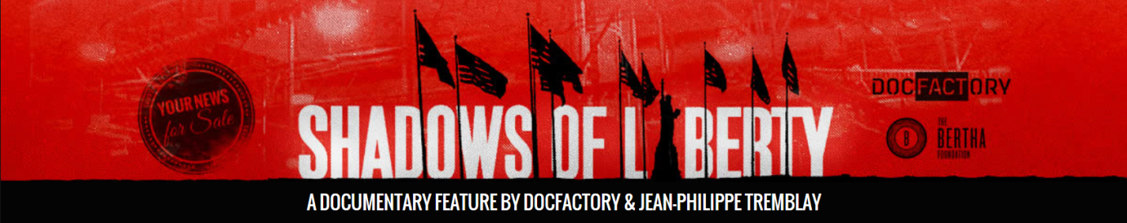
Sample Thank You Notes

-----------------------------------------------------------------------------------------------------

Template for screening co-sponsors:

Dear

On behalf of __________________ we would like to thank you for partnering with us on the ___name of venue_____ screening of Shadows of Liberty.

The event was an incredible success, largely in part of your participation. One of the most memorable moments of the evening was _____________________.

**If sharing the income was part of the co-sponsorship, be sure to include the relevant information such as:

Overall the event brought in $____, and after expenses (which are outlined in the attach budget and/or copies of all receipts are attached to this letter) the net income was $____, of which your portion is $____. Accordingly, we have included a check for $____.

We truly appreciated working with you, and hope for opportunities to collaborate again in the future.

** If contributing money was part of the co-sponsorship include something like:

Without your sponsorship of $____ this screening would not have been possible or your sponsorship of $____ contributed significantly to the overall success of the event.

We greatly appreciated working with you, and hope for the opportunity to collaborate in the future.

Sincerely,

Name
Title
Email
Phone

-------------------------------------------------------------------------------------------------------------------------------
Template for screening attendees:

Dear _______,

On behalf of __________________ we would like to thank you for attending our screening of Shadows of Liberty at ___________ last ___night/week__ or on __date____.

We are grateful for your support of our efforts to shed light on our broken media system, and hope for the opportunity to work with you in the fight for media reform.

If you would like to learn more about what our organization is doing to address the issues highlighted in the Shadows of Liberty film, please visit our website at _________________

And if you want to stay connected with the filmmaker and cast of the film, purchase a DVD, or host your own screening, you can visit their website at: www.shadowsofliberty.org

Thank again for your attendance, and your involvement in the fight for media justice!

Name
Title
Email
Phone

-------------------------------------------------------------------------------------------------------------------------------
Template for screening participants:

Dear _______,

On behalf of __________________ we would like to thank you for participating in our screening of Shadows of Liberty at __________ last ___night/week__ or on __date____.

The event was an incredible success, largely in part of your participation. Overall we ________include a statement or two about what you think made the event successful. It could be the number of people that attended the event, the amount of money raised, or the group’s commitment to take an action as a result of viewing the film…_____________

One of the most memorable moments of the evening was _____________________.

We are grateful for your support of our efforts to shed light on our broken media system, and hope for the opportunity to work with you in the fight for media reform.

Thanks again for helping make our screening a success!

Name
Title
Email
Phone

