The Mayors Campaign to End Bullying Social Media Kit

Below we have provided sample language and graphics to begin to promote your involvement in #MayorsEndBullying Campaign, as well as the event you will be hosting from various digital platforms. We encourage you to customize this language to fit your specific needs and message. Can’t wait to see what you come up with!

Facebook/Instagram:

For Mayors office-

We’re thrilled to announce that [Mayor XXX] of [City Name] is standing with hundreds of mayors across the country during National Bullying Prevention Month as #MayorsEndBullying! As part of this movement, we’ll be hosting a screening of the documentary BULLY at [place] on [date]. Show your support by standing with us on [date]!

For Constituents-

I support [mayor’s name] of [city name] for standing up to bullying this October during National Bullying Prevention Month! I’m joining him/her at [place] on [date] for a screening of the film Bully in solidarity as #MayorsEndBullying across the country.

Sample Graphic to Post-

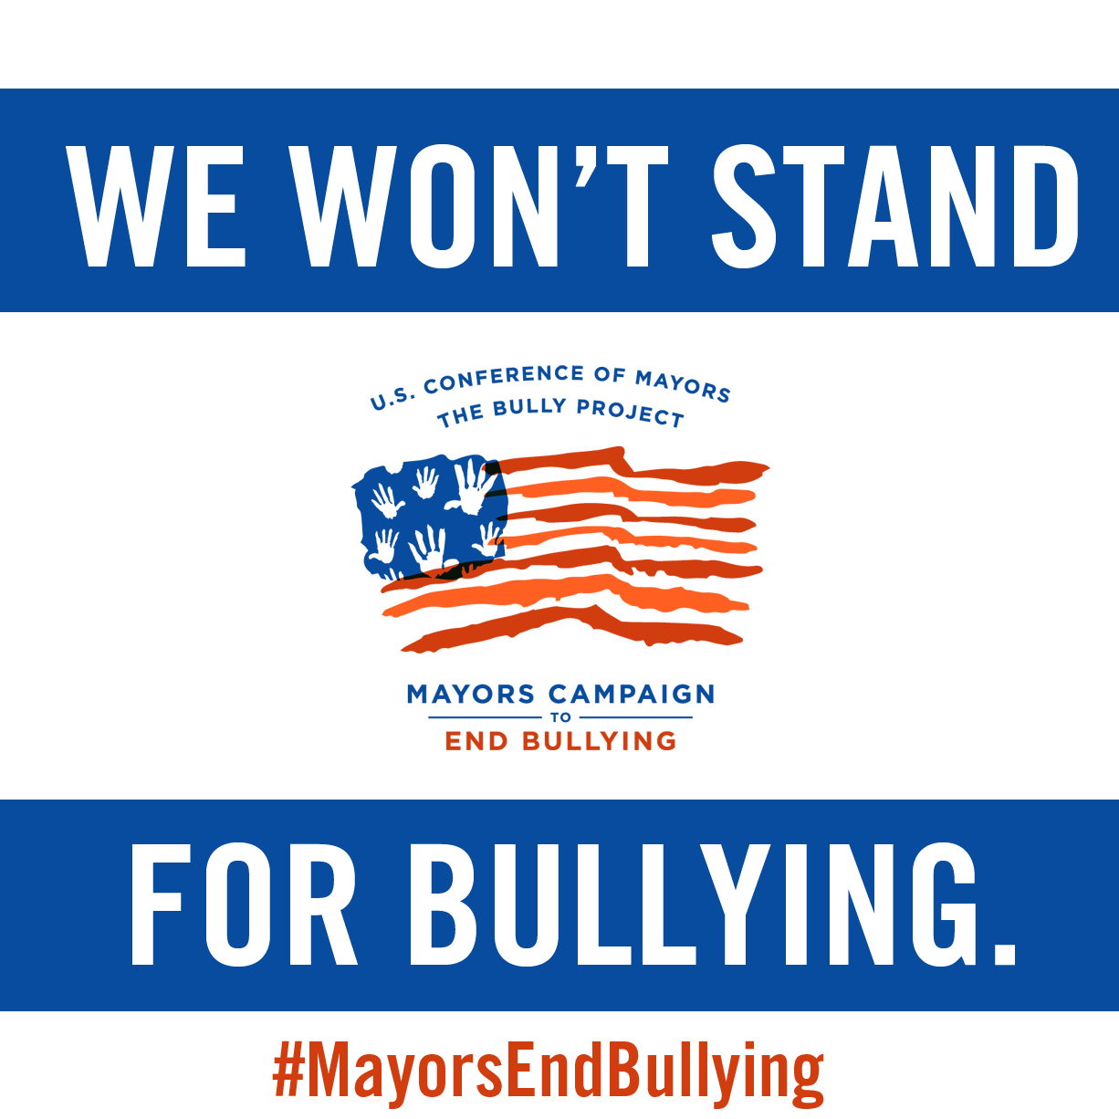

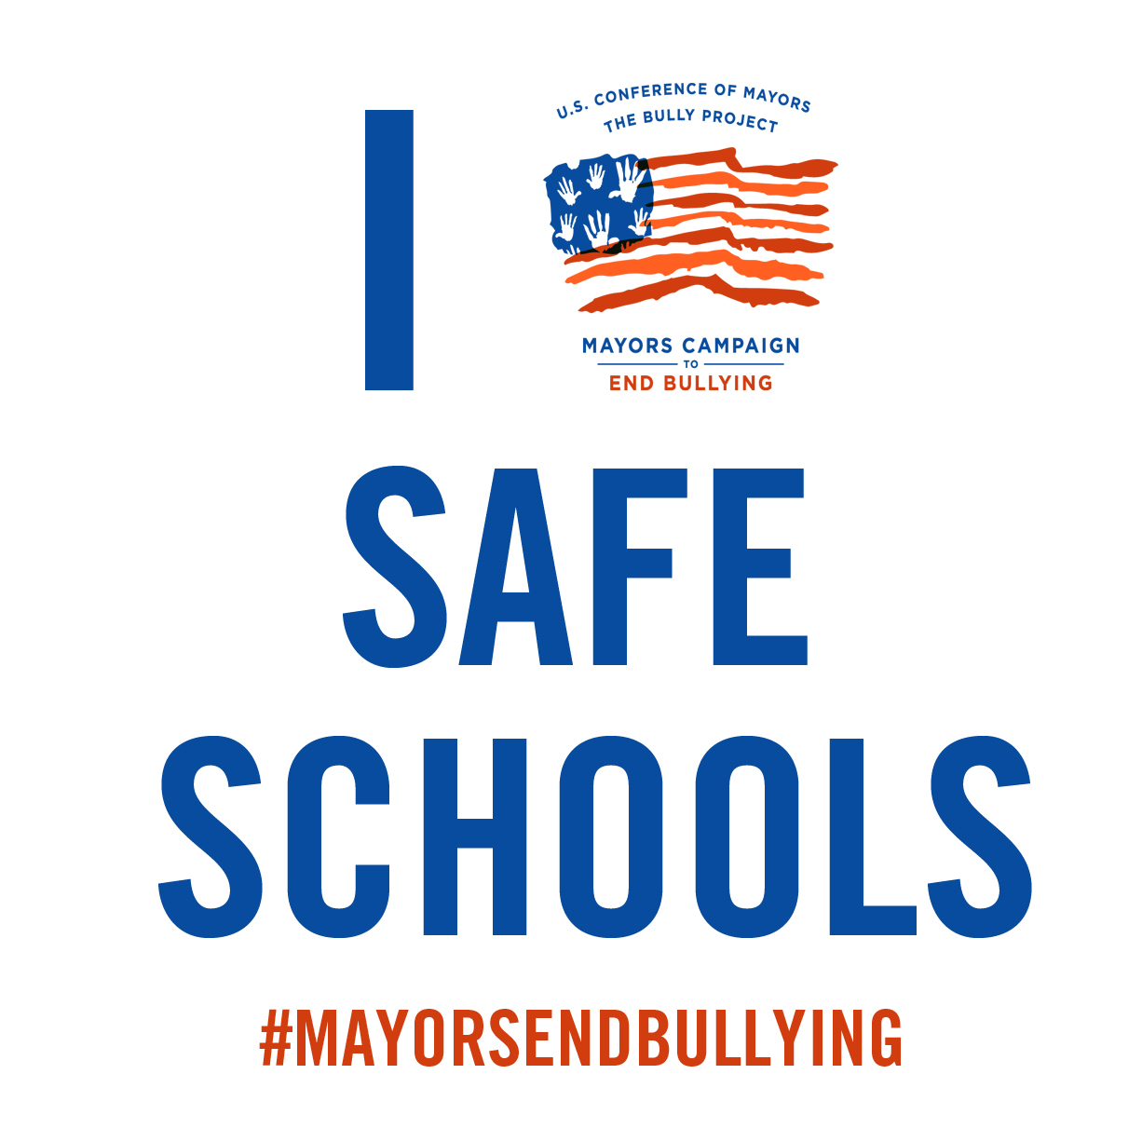

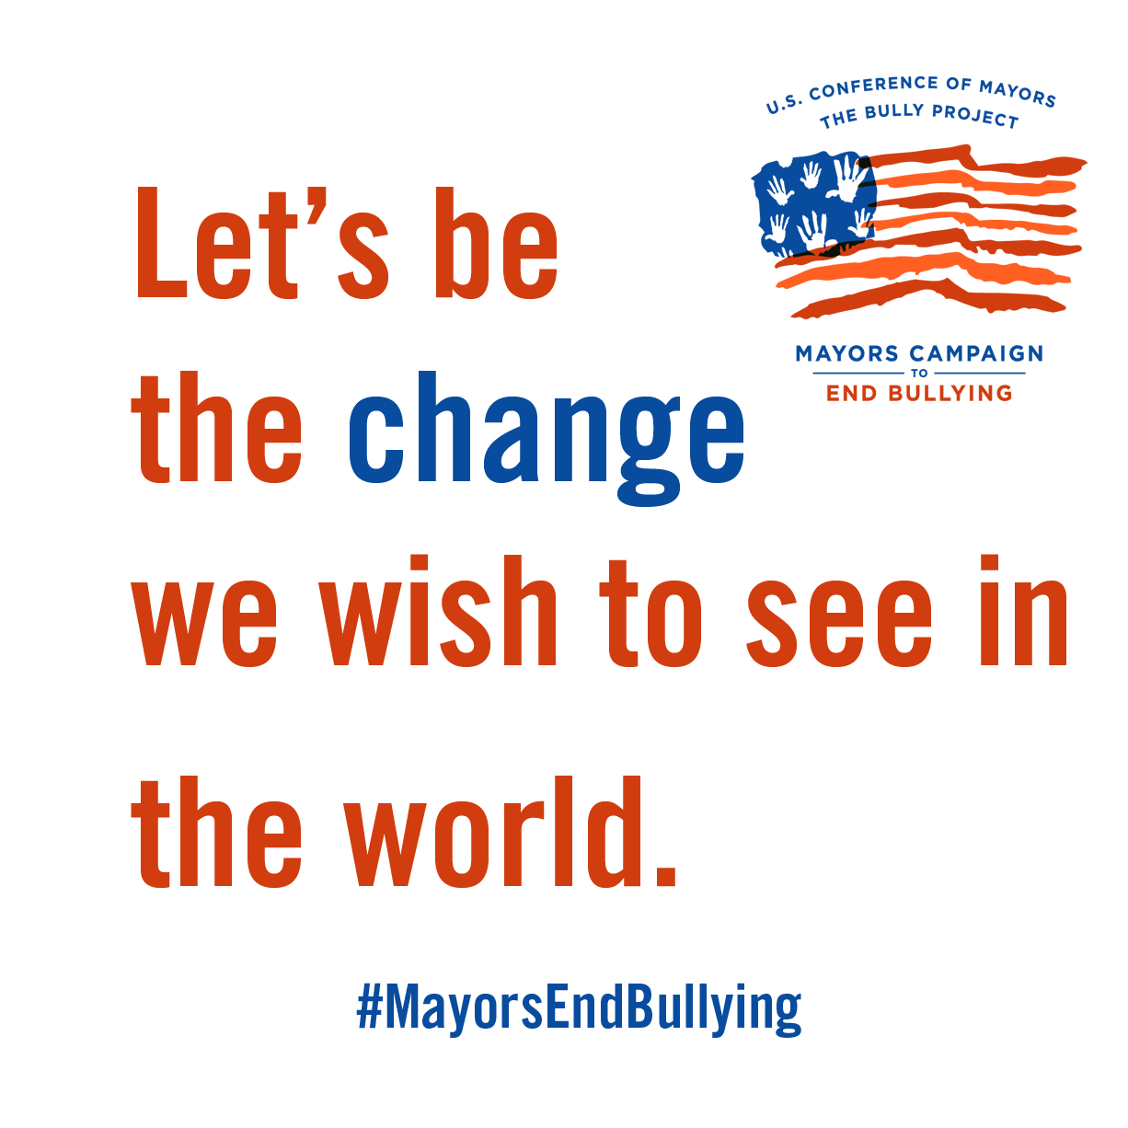

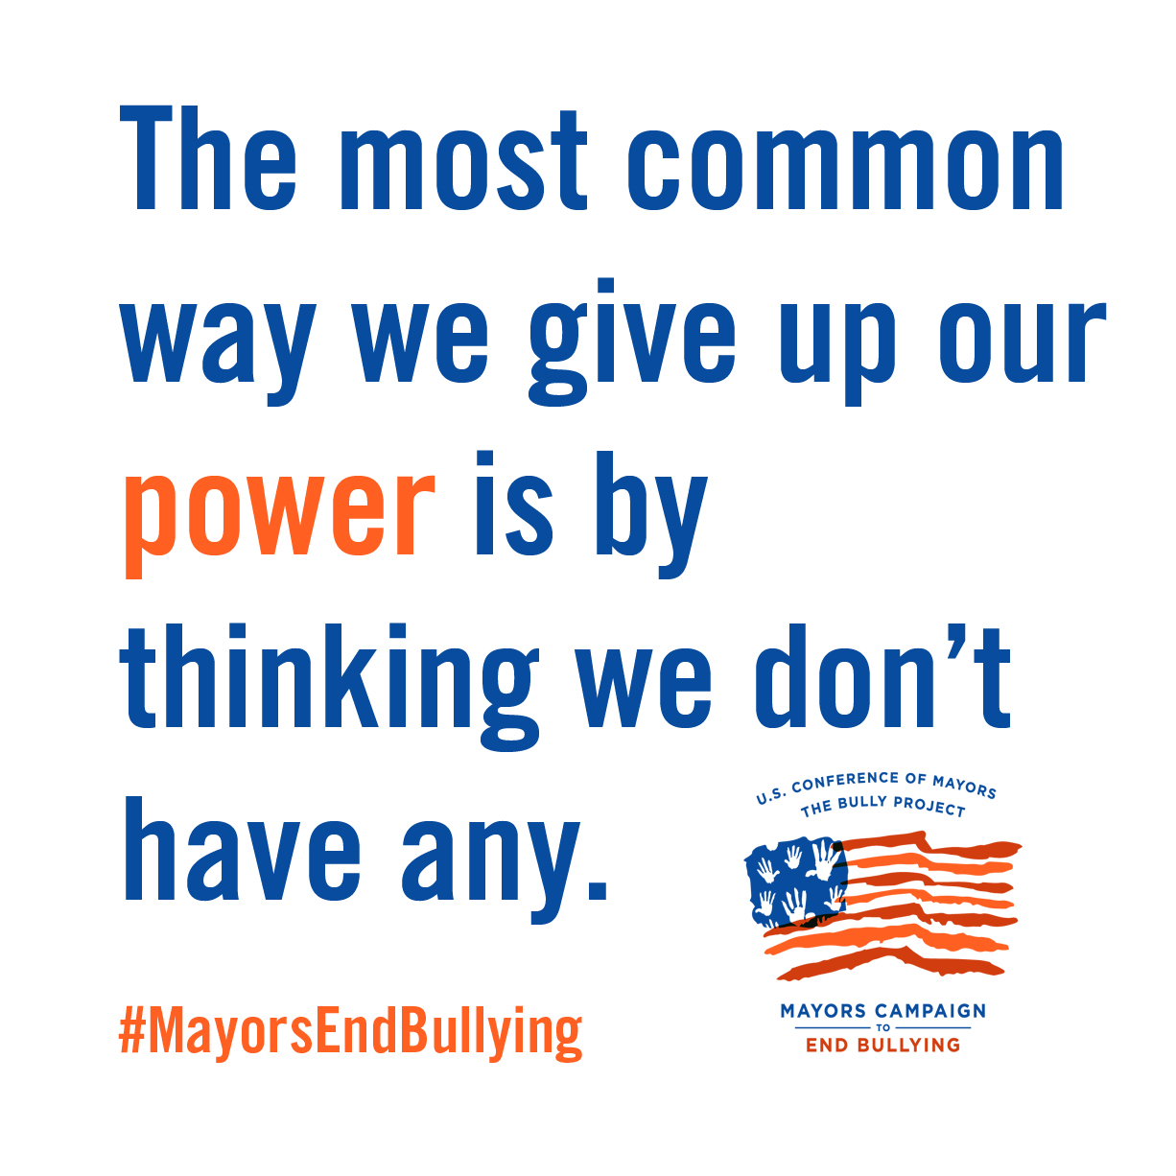

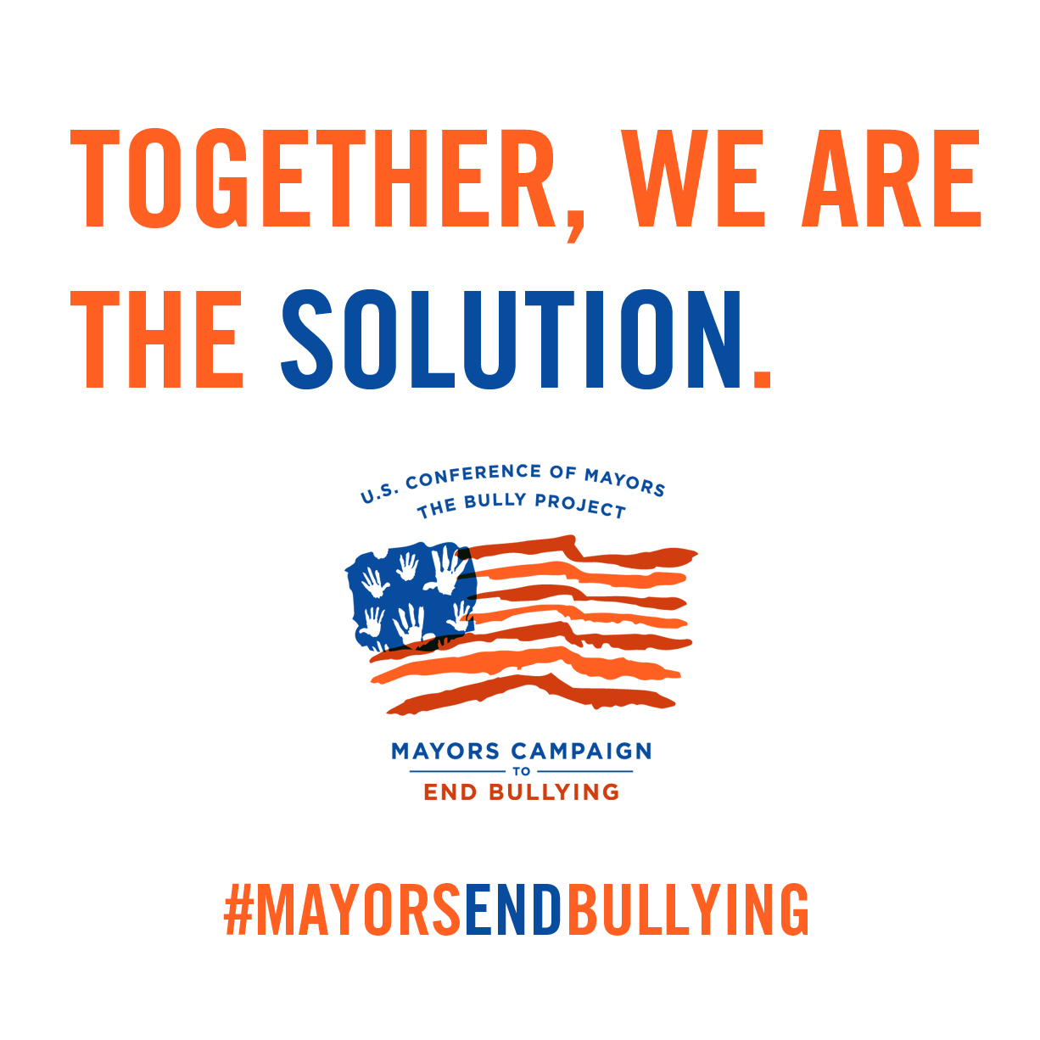

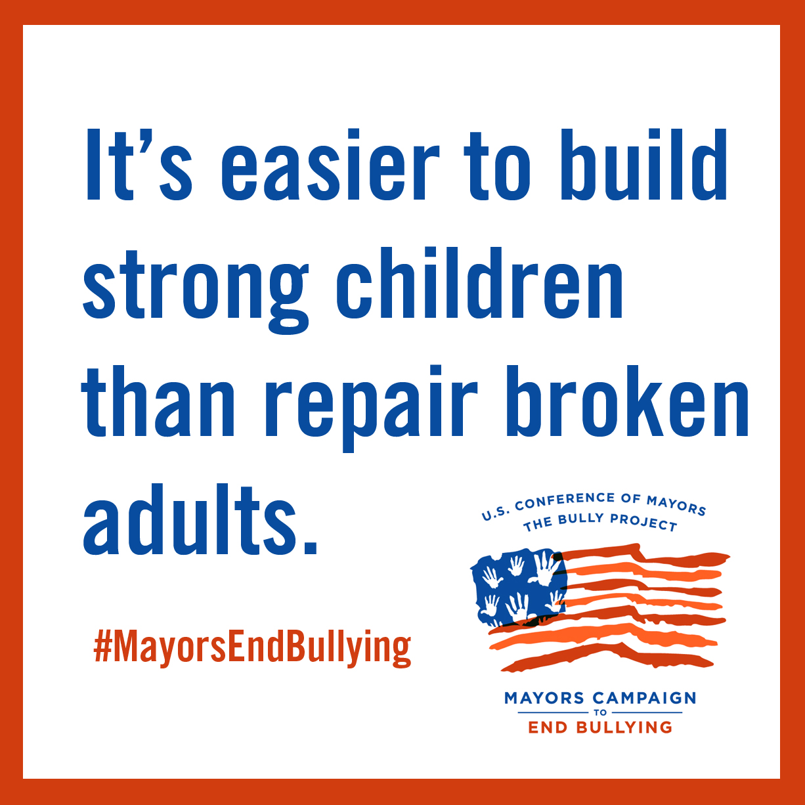

Twitter:

For Mayor’s Office-
#MayorsEndBullying today, so our children won’t have to. Join the movement: http://bit.ly/1v0ORNt

I’m mayor XXXX and I won’t stand for bullying. I’ve just joined the #MayorsEndBullying movement!

Mayor XXX is proud to stand strong with @bullymovie and @usmayors for safe schools. Let’s help our #MayorsEndBullying: http://bit.ly/1v0ORNt

#MayorsEndBullying today, so our children won’t have to. Join the movement: http://bit.ly/1v0ORNt

For Constituents-

Ending the epidemic of bullying requires leadership, and Mayor XXX is stepping up to the plate w/@bullymovie. Help our #MayorsEndBullying: http://bit.ly/1v0ORNt

My mayor is standing with @usmayors and @bullymovie to transform school culture as part of #MayorsEndBullying!! Check it out: http://bit.ly/1v0ORNt

I support my mayor of [towns name] who is standing with others across the country to end bullying. #MayorsEndBullying

Want more social media ideas? Please don’t hesitate to reach out to The BULLY Project at info@thebullyproject.com for additional ideas!

