One Crazy Summer
Chapter 8: A glass of water p. 49-55
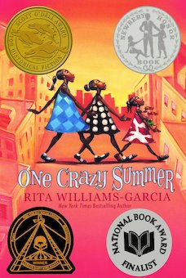

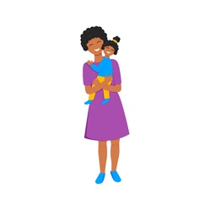 | Engage
When we think mother - how would you describe her?
When you think of Cecile – how would you describe her?
Mother | Cecile

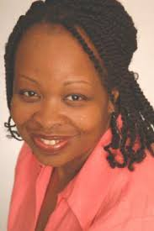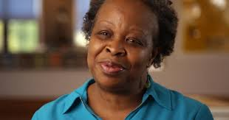 | Watch and Listen  Meet the Author
The author explains why she wrote One Crazy Story

The author explains Why she included a character like Cecile?

Characters- Explain
 | Feelings | Behavior | Description
Cecile
Delphine
Vonetta
Fern

Share
Orally tell the person next to you –
Who is your favorite character in the story and why?

Think and Reflect
- What are the “White Wings?” p.53-54 What do you think they represent?
- Think about : a. what the author said of Cecile b. What Delphine thinks of Cecile- Then write what you think of Cecile as a mother. Do you think Cecile is a good mother? Why or why not?

