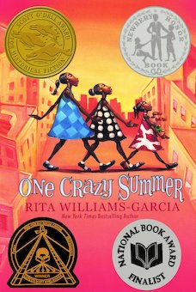
One Crazy Summer Chapter 9:Inseparable

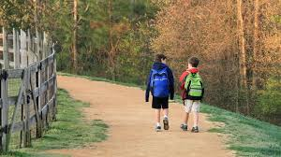 | Engage
Have any of you had to experience a time where you were either alone or with siblings and had to walk a distance to find a place to eat, play, etc.?

Do you go to your local community center? What do you learn there? What do you do there?

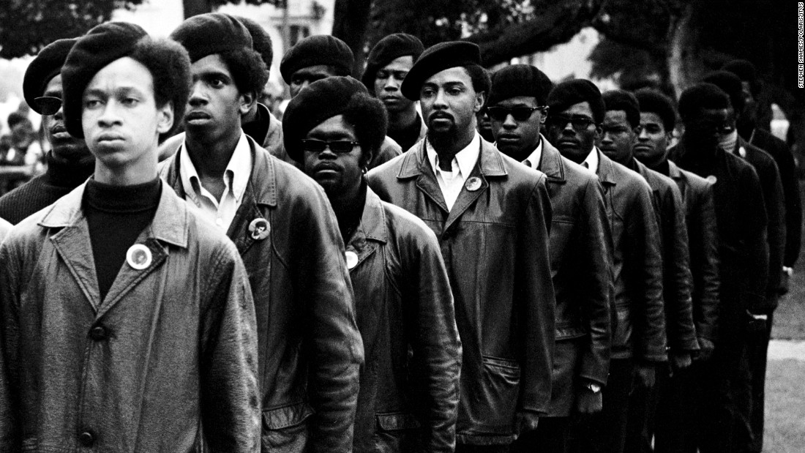  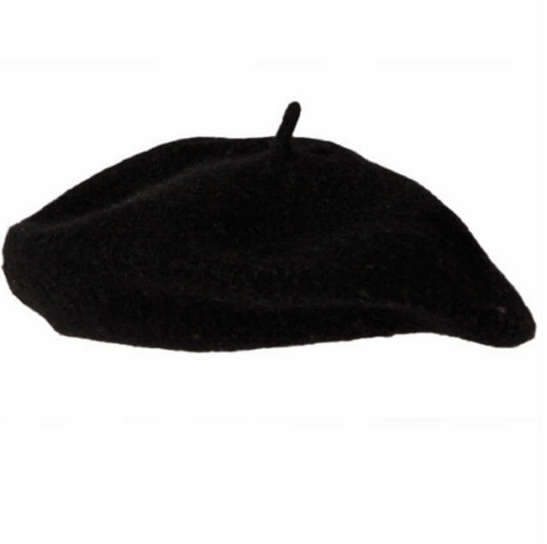 | Vocabulary
Indignant (p.57 ) - Feeling or showing anger or annoyance at something that is unfair.

Militant (p. 57) - Firm in support of a political or social cause.

Beret (p.58) - A beret is a round flattish cap of felt or cloth.

Seize (p.) - 1. take (an opportunity or initiative) eagerly and decisively. 2. strongly appeal to or attract (the imagination or attention).

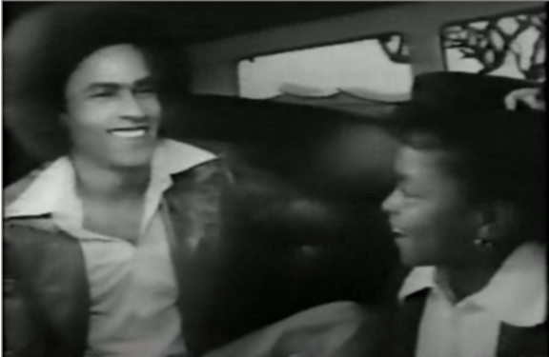 | Did you know...
Did you know…. During the 1970s, the Black Beret became a Revolutionary symbol.

Soldiers during this time wore green berets so the look of the Black Panthers wearing a black beret further symbolizes their position as soldiers on the frontline.

In One Crazy Summer the girls go to the People’s Center which in Oakland was called the Oakland Community Center - Click on the picture of Kelita ( 8 years old) interviewing Huey Newton and learn about her experience in the Community Center.

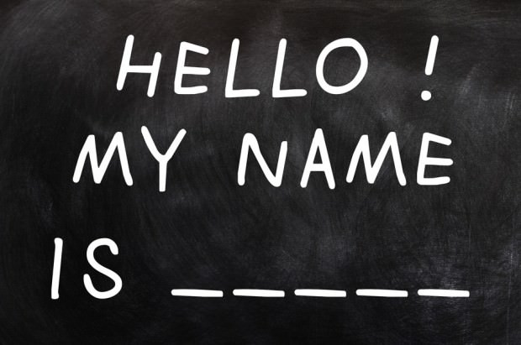 | Explain
 | Why is Cecile - Sister Nzilla? Why do people change their names?

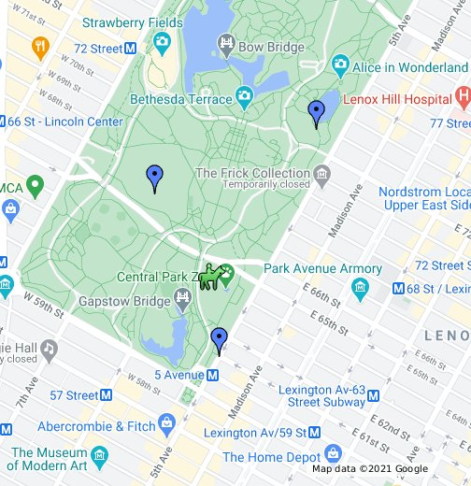 | Apply
 | If you had to go somewhere on your own from where you live, how would you get there? Do you know the names of the streets around you? Do you use visual landmarks like a fire station or a grocery store? Do you use an online map?

Reflect
What do you think is the main conflict or problem the girls face in this chapter ?

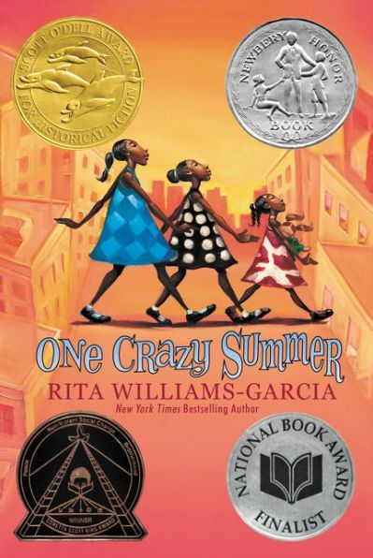 | Predict
 | Do you think that the girls will go home early like they discussed wanting to at the end of the chapter or will they give their mother a chance?

