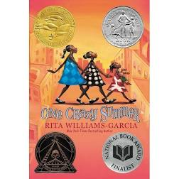

One Crazy Summer
Chapter 1: Cassius Clay Clouds (page 1)

Engage
Have you ever traveled without a family member or guardian? What was it like? If not, what do you think it would be like?

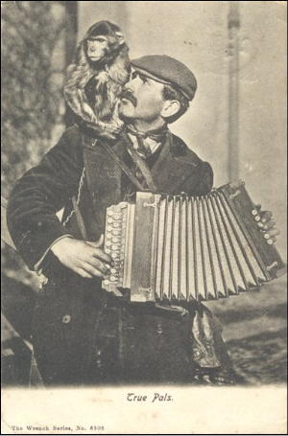  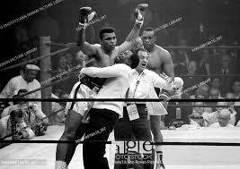 | Vocabulary
Cassius Clay- Muhammad Ali
American professional boxer. (He changed his name in 1964)

Money Grinder Accordion- Accordions are a family of box-shaped musical instruments. A monkey Grinder is one who acts for or does the bidding of someone much more powerful.

Muumuu Dress - a loose, flowy dress typically worn by Hawaiian women.
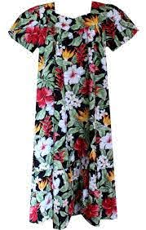

Turbulence - unsteady movement. “The plane shuddered as it entered some turbulence.”

Scripture - the sacred writings of Christianity contained in the Bible.

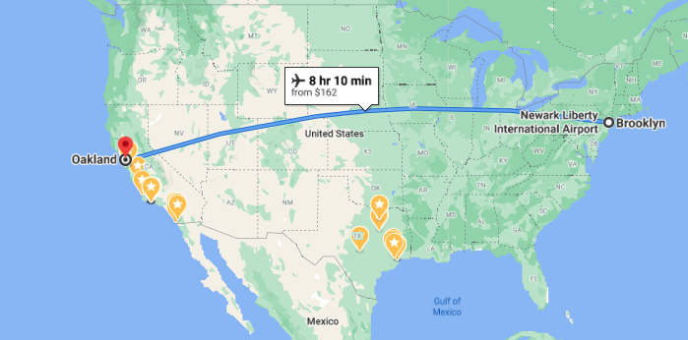 | Geography
Traveling from Brookln, New York to Oakland, California

What region of California is that in? Look at the map.

Characters
- Narrator -- We are not told her age. Is there any evidence from the text that helps you infer the Narrator’s age? Hold old do you think she is?
- Vonetta How old do you think she is
- Fern How old do you think she is?
- Big Ma- grandmother
- Pa- grandfather
- Cecile Johnson- mother of narrator, Vanetta, and Fern
- Uncle Darnell- Cecile’s brother

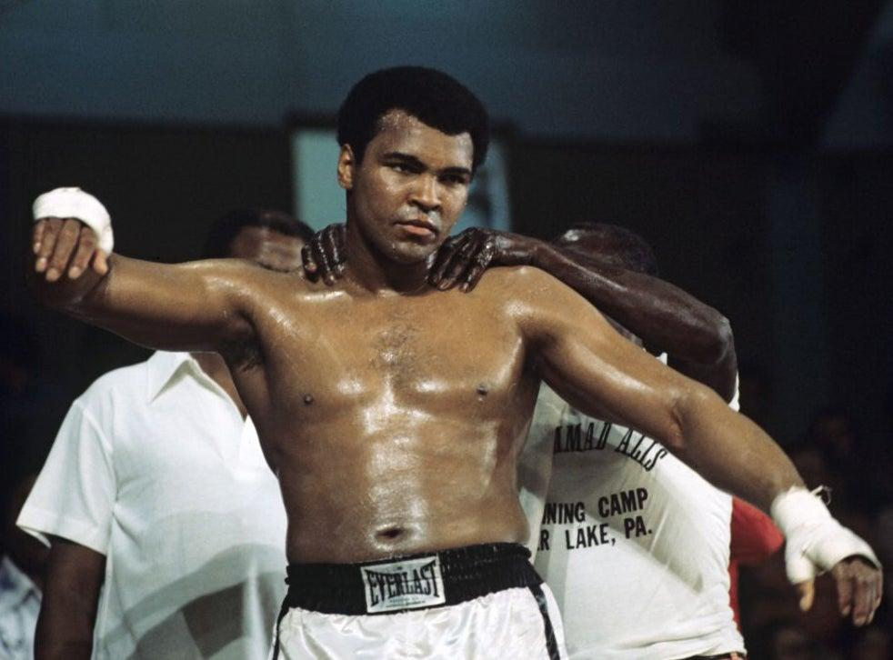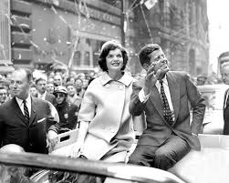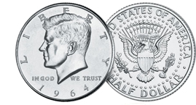 | Did You Know ?
Cassius Clay changed his name to Muhammad-Ali- Listen/watch an internview to why he changed his name.

Did you know a president of the US was assassinated? John F. Kennedy (J.F.K.) was assassinated on November 22, 1963- Listen/Watch what happened.

Silver dollars with J.F.K.'s head on one side.

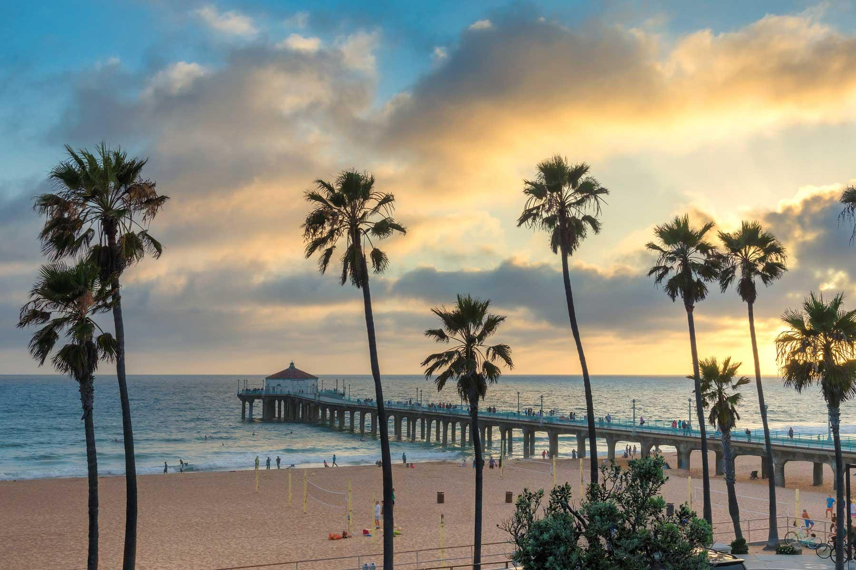 | Making Connections
What does the narrator and her sisters expect California to be like?

Compare this to the book the Circuit- What did Francisco and his family expect California to be like?

What differences are there between both books?

What other connections do you see between this book and another literature book- like The Circuit?

Explain
Why do you think Big Ma is not willing to forgive Cecile but Pa is?

Why is the older sister concerned about the other passengers staring?

Apply
Pick a state that you have never been to before.

List some things you learned about it from school, books, movies, etc., Do you think it’s exactly like you predicted, somewhat different, completely different and why?

Reflect
What did the sisters think their trip to California will be like?

What did Papa give the older sister? Where did she put it?

Predict
How do you think their mother, Cecile ,will react when the sisters arrive to Oakland? How do you think the sisters will react to seeing Cecile?

