One Crazy Summer
Chapter 2: Golden Gate Bridge (page 8)

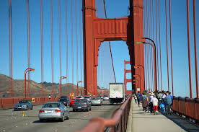 | Engage
 | Have you ever crossed a bridge?

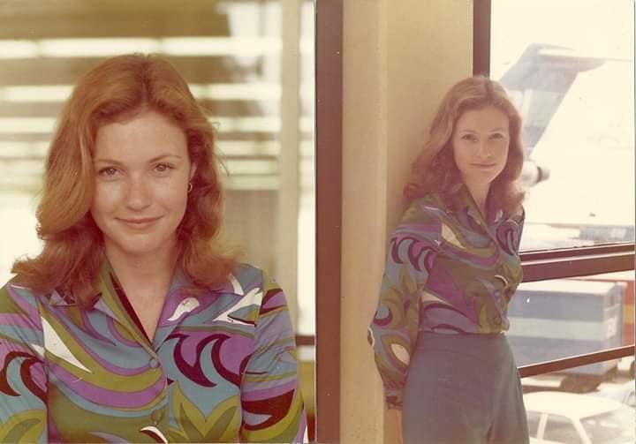  [Stephanie’s aunt flew for Braniff in the 1960’s.] | Vocabulary
Timex- A watch from the Timex Group USA company, a very good and reliable brand.

Stewardess - a woman who is employed to provide meals for and otherwise look after the passengers on a ship or aircraft.

Characters
- Delphine (the Narrator) (11 years old)
- Fern (9 years old)
- Vonetta (7 years old)
- Big Ma (Pa’s mother)
- Pa
- Cecile Johnson (Delphine, Fern, & Vonettea’s mother)

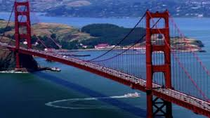 | Did you know?
The Golden Gate Bridge was builded from 1933-1937--Look at pictures and watch video- What did you learn about the Golden Gate Bridge? Why do people need a bridge?

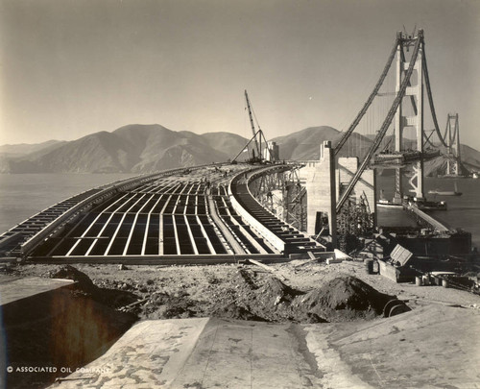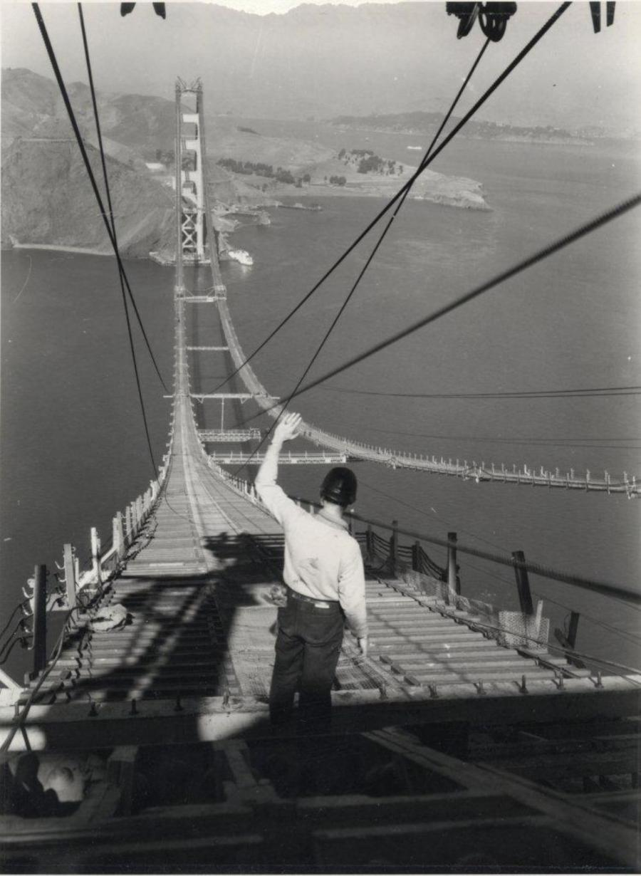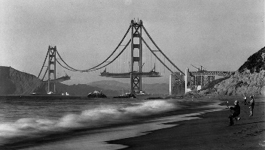

Explain
Why does Delphine have a “plain face”?

Delphine said, “it wasn’t everyday you saw a live picture of what you read about in a textbook.” What does she mean?
Have you ever read about something and then saw it live?

What is the difference between a stewardess and a flight attendant?

If you’ve been on a plane, did you notice what the flight attendants were wearing? How do you think that differed in the past?

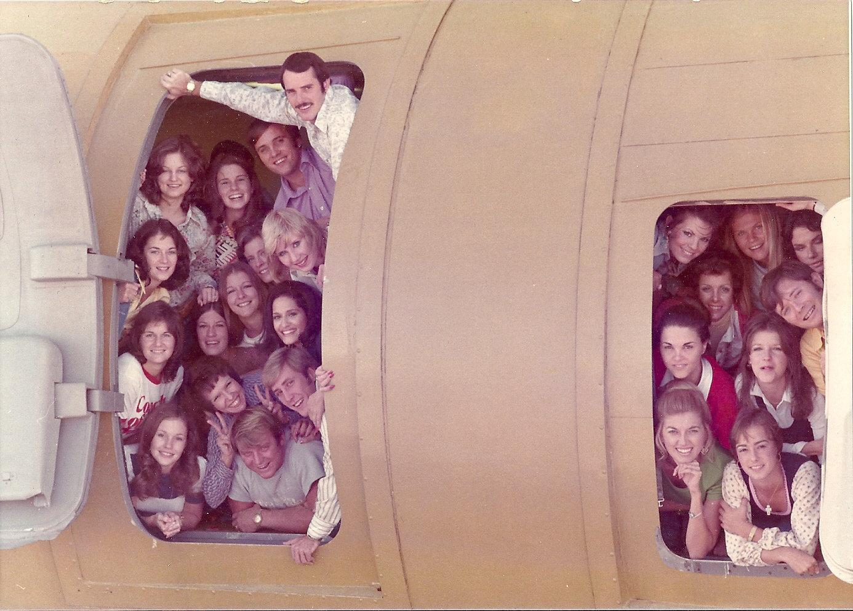
[Stephanie’s aunt is on the bottom left side in the above picture.]
Question: How many men do you see? Do you think they were flight attendants?

What other jobs can you think of that women were primarily doing?

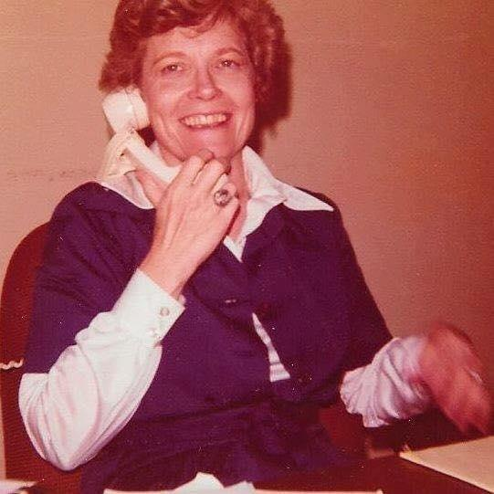
[Stephanie’s grandmother was one of the first female paralegals in Dallas, Texas at the age of 35. She had three children when she held this job. She is now 85 years old.]

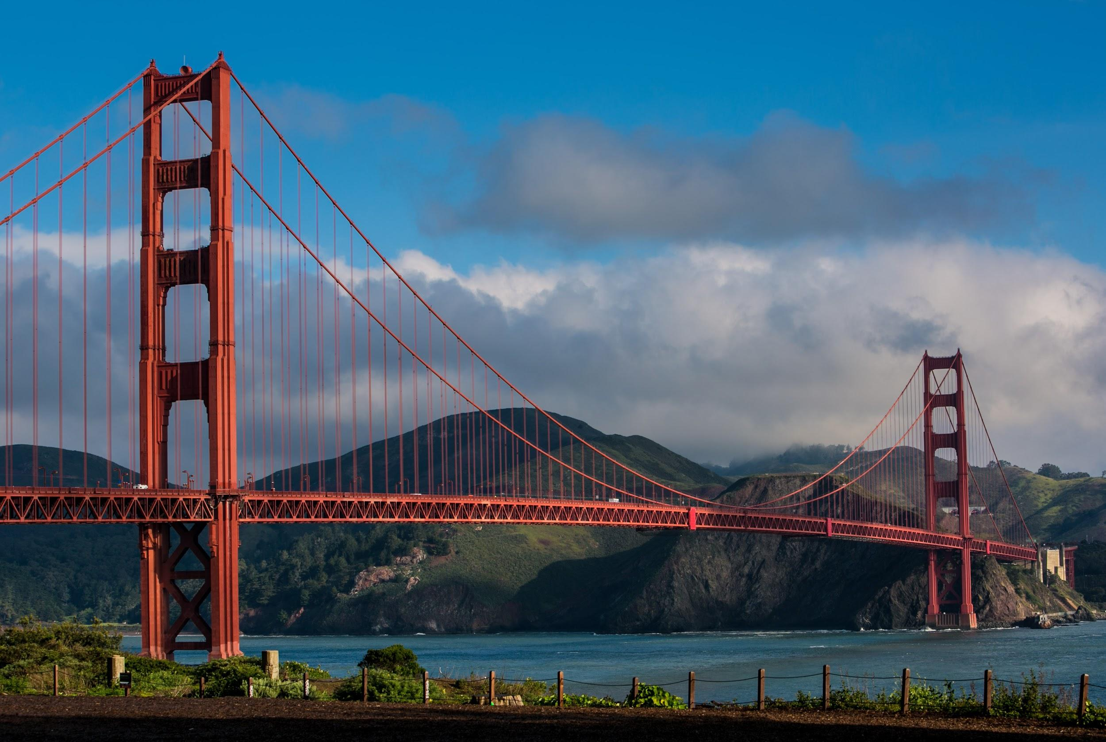 | Making Connections-
 | Have you seen the Golden Gate Bridge? If so, what was it like?

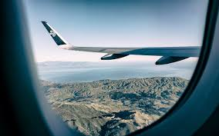 | Apply
If you could travel on a plane somewhere where would you go?
Why?

Reflect
Why are the girls excited to see the Golden Gate Bridge?

How did Delphine get into trouble?

Predict
What do you think Cecile will be like?

Will Cecile be at the airport to pick the girls up?

